starting and operating a photobooth business

Experiential Learning Portfolio

David Verdugo
1538 Molly Circle
Oceanside, CA 92054
LA 201W
December 12, 2016

Table of Contents
1. Educational Goals Statement p. 3

2. Area of Study and Degree Plan p. 5

3. Resume p. 6

4. Experiential Learning Narrative p. 9

5. Documentation p. 13

6. Annotated Bibliography p. 16

Educational Goals Statement

Nearly six years ago I took a leap of faith and began the process of starting my own business. It was never my intention to be a small business owner, my dad owned a retail lighting store while I was growing up and I spent countless hours there bored out of my mind as he slaved away to make ends meet. He always wanted me to follow in his footsteps and to take over the business one day but it always felt like the business owned him instead of the other way around. I had always imagined that I would just get a job like everyone else does and plug away until it’s time for retirement. That idea didn’t last very long…
I struggled in school, not that I didn’t understand the material but more in a sense that if I didn’t see what the point was I lost interest and would “check out”. Unfortunately (or maybe it was for the best) that attitude followed me into the workplace. I always found myself trying to find a better way to do things, and the words “that’s just how we do it here” became like nails on the chalkboard to my soul.
It was a summer of love and my wife and I had attended a handful of weddings, some of which had a photobooth for the guests. Most were poorly done, lacking on one way or another and deep down inside I knew that I could do it better if given the chance. Fast forward 5 years and now I’ve got my own photobooth business with over 100 events and thousands of happy customers, I am now the small business owner I never dreamed of being. The best part of starting my own business is being able to call the shots as I see them, essentially writing my own story instead of having to follow someone else’s playbook. I’ve learned a lot along the way, mostly through trial and error. But as much as I’ve learned already there is always more to gain and this is why I’m back in school finishing my degree.
I never would have imagined myself being in this position I’m in now and for that reason I have decided that flexibility will be my battle cry. I have so many goals that I want to accomplish, not only in the business world but personally as well and I believe that the biggest advantage I can give myself is to complete my education and continue with the mindset of being a lifelong learner. Getting my degree in Integrated Social Sciences will give me a well rounded education, keeping my options open for whatever direction I decide to take when I “grow up.” Keeping a big picture mindset is essential, always ready to take on new opportunities and when that mindset is paired with the skills I will acquire from my education I’ll be ready for anything that life throws at me.

Area of Study and Degree Plan
Goal: BS in Integrated Social Sciences

Credits | Category | Notes
29 | Transfer Credits from Palomar College
32 | Transfer Credits from Santa Barbara City College
15 | Transfer Credits from Cal State University San Marcos
3-6 | Learning Portfolio (LA201W) | Proposed: 3 credits are earned for the successful completion of LA 201W any addition credits are contingent upon the assessment of Learning Portfolio by an academic department.
6 | Courses Taken | ANTH 011, SPAN 2
82 | Current Total | (not including this semester)
33 | Coursework | Required coursework to meet program requirements
37 | Credits needed to graduate | I can see the light at the end of the tunnel!
120 | Total credits required based on semester hours

Objective
David Verdugo
1538 Molly Circle, Oceanside, CA 92054
Phone: 760-846-2040 Email: DavidAVerdugo@gmail.com
www.VerdugoPhotography.com | www.SmilePopParty.com
The short version: I’m looking for opportunities to pair up with awesome people.
Photography is my strength, but I’ve been places and seen things that have made me a pretty well rounded guy…

Experience

Owner: Smile.Pop.Party – www.SmilePopParty.com December 2011 - Present
A modern take on a cult classic. All of the fun of a traditional photo booth without the boundaries of being stuck in a box! We are a portable powerhouse of fun that unleashes the potential of ANY party, allowing you to get crazy!
We (my wife and I) created from the ground up this photo booth company, taking lots of traditional elements and putting our own spin on them to capitalize on the growing trend but personalizing it to eliminate what we found lacking with the common “booth” style and increase more “awesome”. This is my pride and joy and my grubby fingerprints are all over this one from the initial concept to the final execution.

Owner: Verdugo Photography – www.VerdugoPhotography.com May 2006 - Present
I am an Architecture and Interior Design photographer and shoot quite a bit of Real Estate as well. I started out offering all kinds of photography from kid’s parties, sports, portraits, weddings, virtually anything and struggled to get by. Once I started in with the technical side of Architectural photography it all started to make sense to that’s where I’ve stayed ever since. I love working with big studio lights and finding the perfect angle and once all of the elements are in place… CLICK!

Graphic Designer, Emmanuel Faith Community Church; Escondido, CA July 2008 – January 2009
Provide design support from conception to completion, including brochures, fliers, mailings and posters to various ministries through a church with a weekly attendance of over 4,000. Working knowledge of in-house print shop with bindery. Use of Adobe CS3 on PC platform.

Harrah’s Casino: Beverage Server, Bar Back, Security/EMT, Surveillance May 2001 – December 2004
I did a little bit of everything at Harrah’s. I started in the Beverage Department serving drinks and working as a bar back. I needed to work full time to get benefits and had my EMT certification so I transferred into the Security department and worked as the casino/hotel EMT and then eventually transferred into Surveillance. I learned the in’s and out’s of all aspects of Casino and Gaming operations from directly serving the customers drinks, to handling them when they had too many of said drinks and eventually watching it all from a wall of TV monitors and reporting it to the powers that be.

Education

Palomar College 1996 - 1999
Attained my EMT certification and general education work.

Santa Barbara City College 2002 - 2004
Finished my general education work with an emphasis in Psychology

California State University San Marcos 2005
Human Development Major, no degree attained. A year into the program I experienced a “life change” moment where my direction shifted somewhat dramatically from pursuing a career in counseling to the arts with a focus in Graphic Design.

Art Institute – San Diego Campus 2006
Multi-Media Design Major, no degree attained. My education at the Art Institute equipped me with the confidence to move forward and begin working as a Graphic Designer and eventually establish my own business in photography.

The Pennsylvania State University – World Campus 2015 - Present
Working toward my degree in Integrated Social Sciences with a projected graduation in 2018.

Skills
Comic relief has always been my biggest asset, not taking life too seriously but knowing how to get the job done. As a business owner I know that good customer service is what makes the difference between success and failure, having a great product or service is only part of the equation. I have worked in customer service in some way shape or form since I was 17, from retail sales and customer support all the way to running the whole show. I’m not saying I have all of the answers but if I’m given the proper tools there isn’t much I can’t figure out.

Extras

Secretary; Donations & Contributions Committee – Rincon Band of Luiseño Indians 2012 - Present
Philanthropic committee appointed by Tribal Council to discuss and approve donations to various charities and organizations with an annual budget of $350,000. Beyond approving of requests, committee members are also required to attend functions representing the tribe through out the year.

Site Elder – Generation Church - Oceanside, CA 2015 - Present
Responsible for the primary leadership and oversight of the church.
Created the Prayer Ministry for our church and teach quarterly at our Prayer & Worship Night.

Photography
Photos published in San Diego Home/Garden Lifestyles, November 2015 & November 2016.
Photos exclusively featured at La Costa Coffee Roasting Company.
Photos shown at San Diego County Fair, runner-up in Architecture field.

Experiential Learning Narrative

In early 2011 my wife and I were leading perfectly normal lives. I was working full-time as a Real-Estate photographer and she was a stay-at-home mom. We had recently attended a string of events that had a photobooth present and myself, being a photographer (and apparently prideful) had instantly thought that I could do a better job than they did. So, after tossing the idea of starting our own photobooth business around for a few months we decided to go for it. Little did I know there was quite a bit more involved than originally anticipated...
Once we formally decided to move forward with starting the business we first laid out a rough draft of what we wanted to accomplish. The easy step was to first identify what we liked and didn’t like about what we had already seen in the industry. After that we took that info and tried to get a picture of what we wanted our business to look like. Much of this stage was very idealistic and allowed us to dream big without any of the constraints that we’d have to deal with later in the process. One of the biggest pieces that we learned was that there were certain tasks that we needed to struggle through and figure out and others where it would be best to outsource and hire a professional to do things right the first time. We soon found out that this was going to be quite the learning experience.
I am a very analytical person by nature so I started out by researching like crazy. I first started with the basics of what we needed to open up shop so I started with cameras and software. Cameras were easy with my background in photography and finding the right software wasn’t too hard either since I’m a part-time nerd at heart. As things developed the process was full of trial and error with many late nights spent swearing at my computer in futility. It turns out that being a photographer doesn’t directly translate into being a photobooth owner/operator. This process was going to take a little more effort than anticipated. Adaptability and creativity were crucial in this step, as little was working out as easy as anticipated. After that came the not so fun side of the business license, tax ID’s, contract writing and accounting. Fortunately my wife has experience with this and she took on the brunt of that side of the business, which allowed me to focus on the parts where I excelled.
Reflecting back on this experience I see that in any major corporation or even larger business, there are specific departments or at least specific people for each of the many jobs that are required. There are accountants, media and marketing, sales, technical support, customer service and a CEO to make sure everyone is performing as intended. When you work for yourself, you either have to shoulder this entire load or hire someone else to do it for you. At first I tried to do everything on my own since I tend to view myself as a jack-of-all-trades. As time progressed and I found myself either taking too much time trying to learn a particular task, not having the proper tools or just failing completely. Learning how to let go was (and still is) one of the hardest parts of owning a business. I am regularly forced to let go and trust in others. First lesson, there is no “I” in “team.” Learning how to effectively communicate and work with others has been a priceless lesson for me with starting a business. It has been essential in every step of the process, from when we first started dreaming to the initial building process and finally to today when we’re established and looking to expand. We must clearly communicate with suppliers, vendors, planners, clients and most importantly each other. Being back in school the skill of communication is just as valuable here as in the workplace and being able to take what I’ve learned in the “real world” and directly apply to my college career gives me an incredible advantage.
As we got further and further along things started to look more and more like an actual working business. When we thought we were ready to launch we set everything up as if it were a “real event” and invited a few friends over and did a practice run and asked people to critique what we had done so far. That night nothing broke and everyone had fun, which is how we still determine success at each event do. Of course we have changed things over the years, some changes are big but most are things that most people would never notice. I had a friend once tell me that I should constantly be trying to put myself out of business, meaning that I should be innovating new and better ways to do what I do because if I don’t then someone else will. It’s a mindset of constantly looking for ways to improve and it’s a huge reason why I’m back in school today.
Some of the challenges we have faced along the way have been very helpful in solidifying how we do things. I will never forget the first time we experienced a paper jam with a crowd of people waiting in line as I stumbled through fixing it. Now when that happens I can not only fix the jam but also do so while calmly explaining to the line of people that it’ll just be a minute. This endeavor has taught me to anticipate problems, breathe deep and go with the flow because even when it feels like it, it’s not the end of the world. In a nutshell I’ve become a master problem solver. We’ve had everything from computers overheating, losing trailer keys, and drunken patrons getting in our faces. Each time we survived and in the long run customers left happy and satisfied. As important as good problem solving skills are to having a successful business, much more needs to happen behind the scenes to keep yourself from falling into those problem areas. Research has been crucial in keeping us not only away from trouble but in many circumstances ahead of the competition. Research was crucial in the start-up phase when we had nothing but a dream of owning a business and continues to be valuable today as we plan out our next steps. What I’ve learned is that in order to keep customers happy, I have to put myself in their shoes. I may have 101 great ideas but if nobody cares except me, it doesn’t matter one bit for my business and the best way to do that is through research.
If it could do it all over again, I absolutely would, but I’d do things differently. I’d ask for help sooner, I’d spend more time researching and try and back up to see the big picture first instead of just jumping in and course correcting as we moved on. There are so many different ways to cut corners but ultimately in order to do things right you have to spend some money (and time) to make money. But most importantly I would absolutely do it again if given the chance. The lessons I’ve learned from starting a business are invaluable to who I am as a person and get used in every aspect of my life. But, as much as I’ve learned already, I want to keep this momentum going and continue to build upon this experience. Filling in the gaps where gaps exist and reinforce the skills that are already strong. Starting a business has focused my vision and given shape to who I want to become, now it’s time to put those skills I have acquired from this experience to use in the next chapter of life.

Documentation:

p. 14 – photos, from top to bottom L to R. Photo strip examples, Photo of my wife and myself at one of our first events, Business Logo, custom USB & Photobooth.

p. 15 – Business License from the City of Oceanside
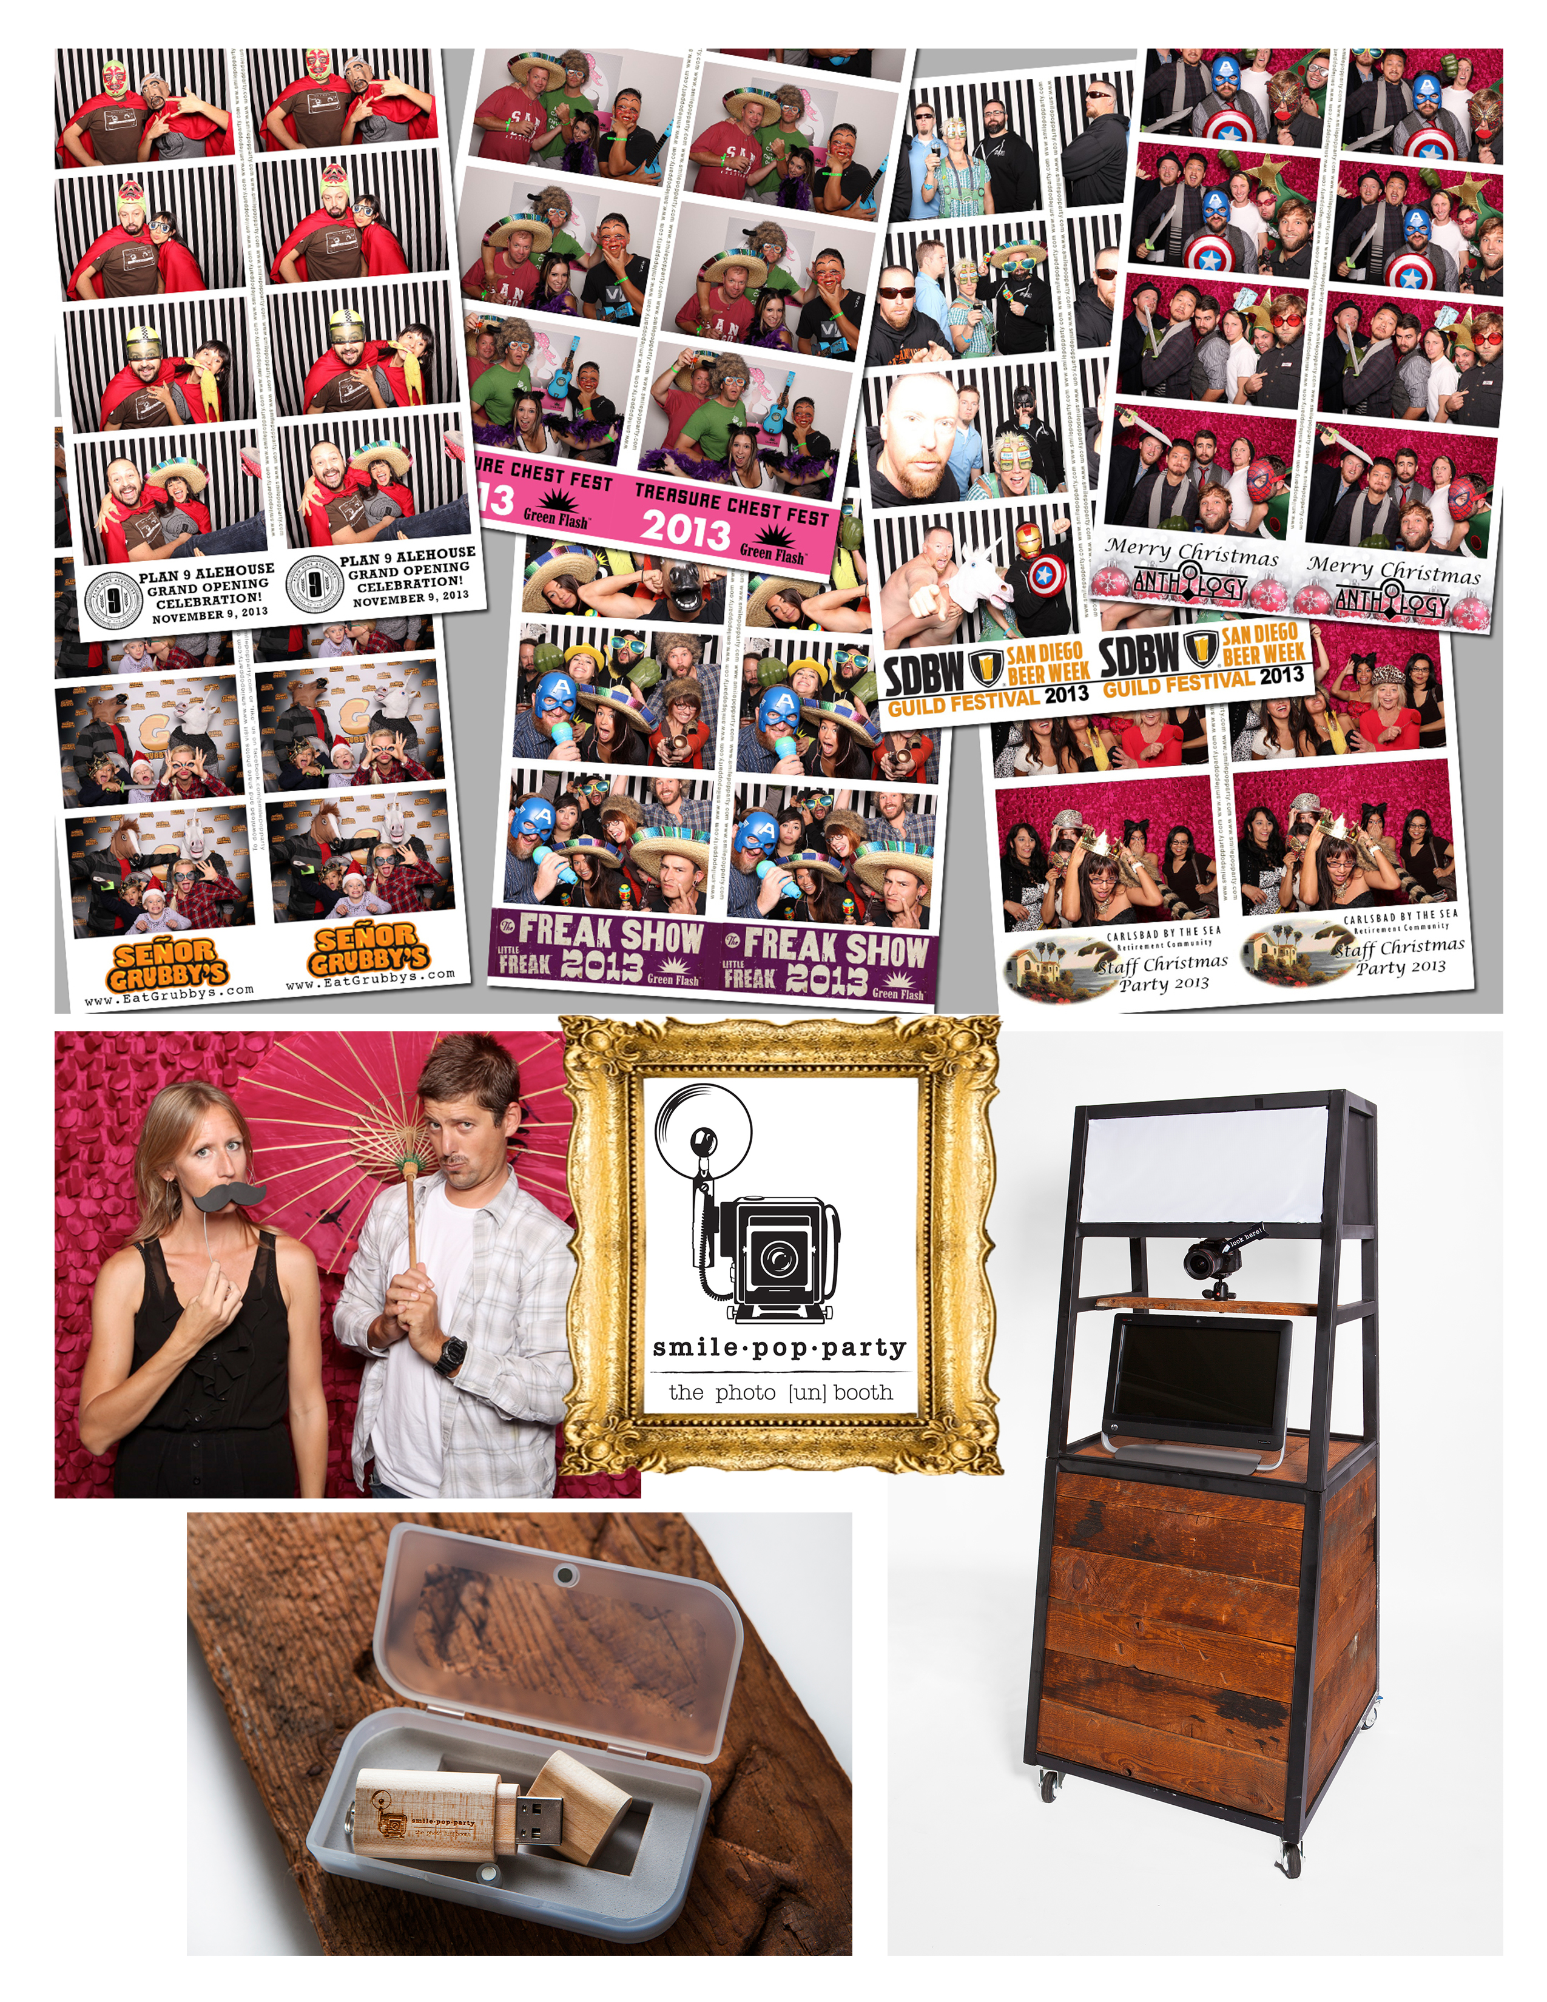
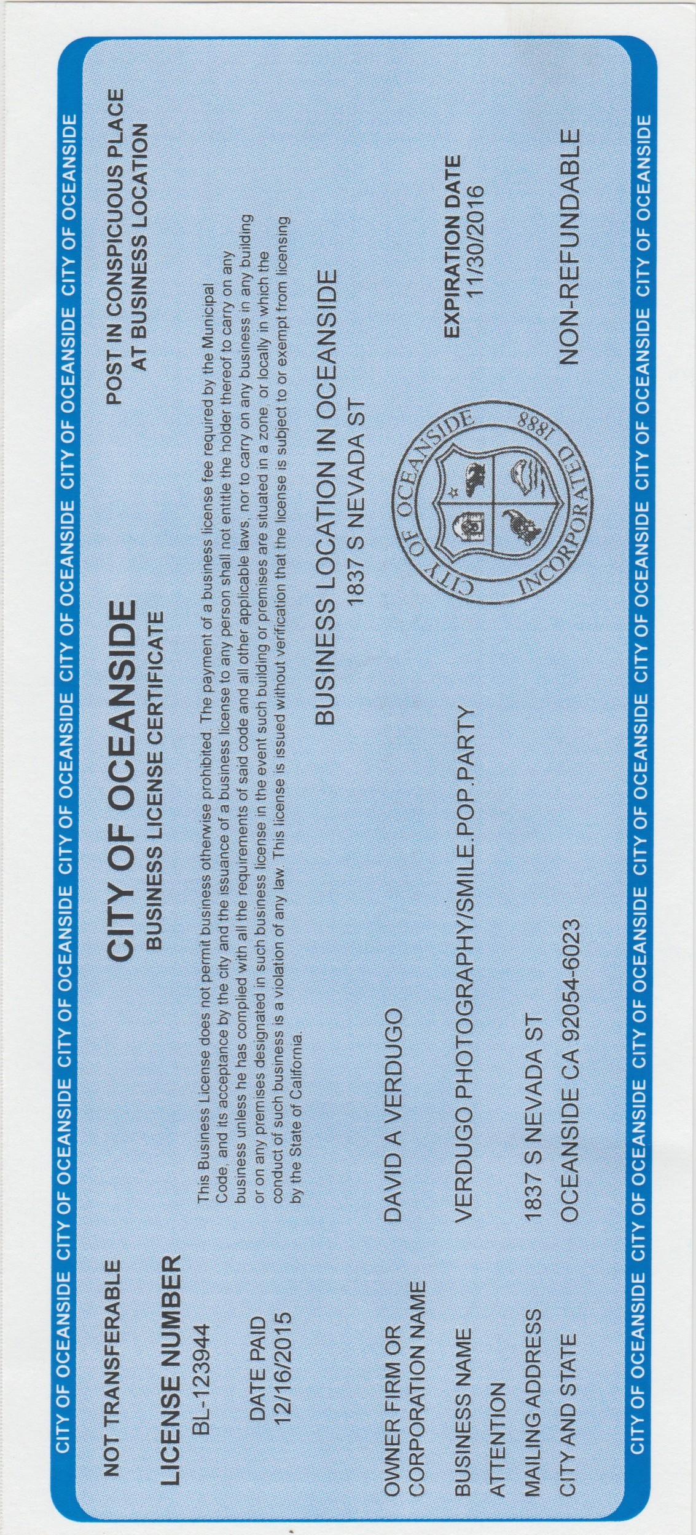
Bibliography

Research question: What steps did you follow when you started a small business?

Pinson, Linda, and Jerry Jinnett. Steps To Small Business Start-Up : Everything You Need To Know To Turn Your Idea Into A Successful Business. Chicago, Ill: Kaplan Publishing, 2000. eBook Collection (EBSCOhost). Web. 3 Oct. 2016.

This book covers all aspects of starting a small business. Beginning with motivations and personal strengths & weaknesses before starting any of the actual work. This book also covers all steps involved from planning to execution including legal issues.

This resource will be invaluable in showing tangible steps starting a business.
This is a relatively current publication although many things have changed in the since 2000 and the advent of our current internet driven culture.

-----

Atherton, A. (2007). Preparing for business start-up: "pre-start" activities in the new venture creation dynamic. Journal of Small Business and Enterprise Development, 14(3), 404-417. doi:http://dx.doi.org.ezaccess.libraries.psu.edu/10.1108/14626000710773510

This article shows the behaviors of established entrepreneurs. The article gives concrete steps and a framework for starting a business.
“This paper examines the dynamics of exploration into and decisions to commit to start-up as a personal option.”

This article will help with many of the questions asked about the mindset of being a small business owner.

-----

Digital Photography Hobbyist
http://digitalphotographyhobbyist.com/start-photo-booth-business/

This web article covers all of the steps necessary to start a photobooth business. Including the author’s own experience in starting his own business. This article lays out all of the necessary steps from research to execution and this article is relevant due to the specific nature of the business.

This article helps my research question by giving concrete steps for starting a photobooth business. Although this resource is very helpful for someone looking to start a photobooth business it is anecdotal in nature and is a glorified blog entry.

-----

Hootbooth – How To Start Your Own Photo Booth Rental Business
http://www.hootboothphotobooth.com/blogs/hoot-news/10713529-how-to-start-your-own-photo-booth-rental-business-part-1

This article divides the steps in takes to start a photobooth rental business. It covers the booth itself, the business model, customers and marketing and pricing.

This article helps my research question by giving concrete steps for starting a photobooth business. This article is presented by a company that sells pre-packaged photobooth units. Although it is a good reference for research it is biased.

-----

The Guardian - Life through a lens: how to start a successful photography business
https://www.theguardian.com/small-business-network/2013/jun/26/starting-photography-studio-business

This article covers the steps necessary and things to consider when starting a photography business. Topics covered are choosing a specialization, equipment, insurance, portfolio creation and marketing.

This article helps my research question by giving concrete examples that are directly related. This article is from a reputable website and featured in their small business network division.

-----

U.S. Small Business Administration – 10 Steps to Starting a Business
https://www.sba.gov/starting-business/how-start-business/10-steps-starting-business

This online resource gives 10 Steps on how to start a business beginning with the planning stage and moving on through execution and growth. This is very much a “nuts and bolts” approach that covers all of the basics that can be modified to your specific field.

This article helps my research question by showing all of the necessary steps to starting and maintaining a successful business. It covers topics such as research, business law, financial strategies, permits, taxes, etc.
-----

Small Business and Self-Employed Tax Center
https://www.irs.gov/businesses/small-businesses-self-employed

This is an online resource presented by the IRS to help Small Businesses navigate the tricky waters of taxes. “Resources for taxpayers who file Form 1040, Schedules C, E, F or Form 2106, as well as small businesses with assets under $10 million.”

This site helps my research question by showing how much work is needed for all of the behind the scenes work it takes to run your business above the board and avoiding being audited. Not being inherently business minded, getting the right information is crucial in setting up your business correctly.

-----

Forbes - Is Online Marketing Really Necessary For Small Businesses?
http://www.forbes.com/sites/jaysondemers/2016/02/22/is-online-marketing-really-necessary-for-small-businesses/#1c7da5ec46ae

This is an article by Forbes in their Entrepreneurs department about online marketing and business trends, exploring the reasoning behind Internet based marketing online due to changing customer demands.

This article helps my research question as it explores the changing marking trends. This is necessary to successfully start and grow a new business.

