The Effect of Exercise on Stress Level and Mood in College Students
Macy Bosshard
November 30, 2015

ABSTRACT: In this study, the effect of exercise on stress and mood was analyzed in college students. Stress and mood were measured on nominal and ordinal scales respectively and analyzed using descriptive statistics and paired T-test. Exercise showed a significant effect (p<0.05) on stress (p=.000, r=.655, df=34). Exercise had no relationship (p<0.05) with mood (p=.118, r=.266, df=34). Overall, this study did show a significant reduction in stress levels after two hours of aerobic exercise. Mood, however, was not significantly affected by exercise. In future research time of day needs to be controlled for and a more elaborate scale for mood should be applied. Also, biomarkers may more accurately measure stress and mood than self report. The purpose of the writing is to fulfill course requirements for BBH 411W and to stand as a personal writing sample, but the findings should not be treated as generalizable research

Introduction:
People experience many different levels of stress, which can negatively and positively affect our health and well being. College students have shown to have the highest levels of stress due to the transitional nature of college, the increase in workload, and being introduced to a new social environment.¹ To relieve this stress, many students may turn to exercise as a coping method. Studies have found that endorphins, specifically beta-endorphin and beta-lipotropin, increase almost eight fold during exercise.² Endorphins are neuropeptides that act on the opiate receptors in the brain, which reduces pain and stress.³ In an experimental cohort study, a treatment group that underwent a full exercise intervention program showed a significant reduction in their physiological responses, blood pressure and heart rate, to a stressor, an arithmetic test, compared to those that did not participate in the intervention.⁴

Because college students are at such an increased risk for stress, they also experience many different moods that can affect their academic achievement, social life, health, alcohol use, and family relationships. Mood disorders such as anxiety and depression, has found to affect 15% of undergraduate college students.⁵ One study found that total mood disturbance was significantly decreased during exercise and during recovery from resting baseline levels in young men.⁶

In this study, I will analyze how two hours of exercise affects stress and mood levels in college aged students. I will take measurements of stress and mood using a nominal scale and an ordinal scale respectively, both before and after practice. I hypothesize that mood will increase significantly after exercise and that stress will decrease significantly after exercise.

Method:
Data was collected before and after a college student volleyball practice at Penn State University. Practice lasted for two hours starting at 8:45 p.m. and ending at 10:45 p.m. on Tuesday, 11/17/15. Before practice, the participants indicated their sex (male or female), stress level 0-10 (0-no stress, 10-highest level of stress) and their mood (0-sad, 1- content, 2- happy, 3- very happy). After practice they indicated their mood and stress levels again using the same scales. Descriptive statistics and correlations were used to analyze both variables.

Results:
Of the 36 participants, 56% were males and 44% were females. The baseline mean for stress level was 4.36 +/- 2.127, while the post treatment mean stress level was 3.25 +/- 1.842. Exercise showed a significant effect (p<0.05) on stress, see Figure 1, (p=.000, r=.655, df=34). The baseline mean for mood was 1.64 +/- .762, while the post treatment mood was 1.89 +/-.785. Exercise had no relationship (p<0.05) with mood, see Figure 2, (p=.118, r=.266, df=34).

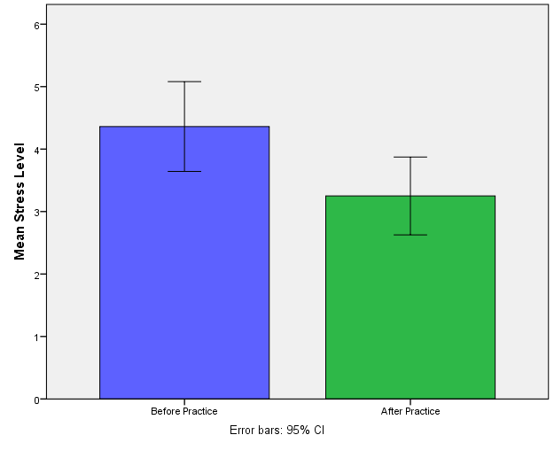
Figure 1. The baseline mean for stress level was 4.36 +/- 2.127, while the post treatment mean stress level was 3.25 +/- 1.842. Exercise showed a significant effect (p<0.05) on stress (p=.000, r=.655, df=34).

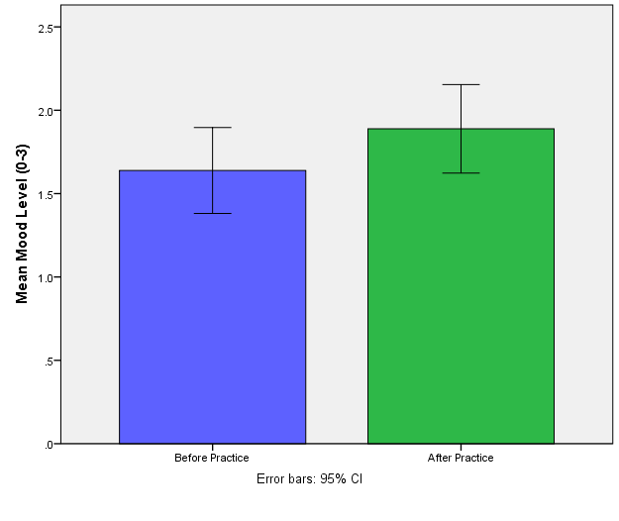
Figure 2. The baseline mean for mood was 1.64 +/- .762, while the post treatment mood was 1.89 +/-.785. Exercise showed no significant effect (p<0.05) on mood, (p=.118, r=.266, df=34).

Discussion:
The results regarding stress agreed with my hypothesis that stress levels will decrease significantly after exercise. This is conclusive with studies previously mentioned in the introduction. Exercise has not only shown to decreases stress, but studies have also found that it aids in reduces symptoms associated with general anxiety disorder, panic disorder, and social phobia.⁷

The results regarding mood did not agree with my hypothesis that mood would significantly increase after exercise. These results were replicated in other studies as well. A study that included over 200 females compared negative and positive affect between those that were regular exercisers and those that were non-exercisers.⁸ Researchers found that regular exercisers had significantly lower scores of negative affect than non-exercisers, but there was no difference of positive affect between the two groups.⁸ Another study showed that there was no difference in psychological mood states between aerobic exercisers, nonaerobic exercisers, and non-exercisers.⁹

There could have been some cofounders in this experiment. Stress levels and mood changes could have been influenced by being around other teammates and by the time of day. All levels were assessed in the evening where cortisol, a stress hormone, tends to drop off. I think that the experimental approach was the best way to go about studying the effect of exercise on stress and mood, but taking biological measurements, such as cortisol levels, could have more accurately assessed the level of stress and mood. Also, only four different options were given to assess mood for the interest of time and simplicity, but more options would’ve allowed for more accurate results. A cohort study would have also been a good way to study the effects of an exercise intervention on overall stress and mood.

Overall, this study did show a significant reduction in stress levels after two hours of aerobic exercise. Mood, however, was not significantly affected by exercise. The next study I will conduct will compare stress and mood levels in high school students to those of the college students and how exercise affects or does not affect those levels.

References:

- Ross, Shannon E., Bradley C. Niebling, and Teresa M. Heckert. "Sources of stress among college students." Social psychology 61.5 (1999): 841-846.

- Rahkila, P. A. A. V. O., et al. "Response of plasma endorphins to running exercises in male and female endurance athletes." Medicine and science in sports and exercise 19.5 (1987): 451-455.

- Stoppler, M. C. "Endorphins: Natural pain and stress fighters." Medicinenet. com/script/main/art. asp? articlekey 55001 (2007).

- Blumenthal, James A., et al. "Aerobic exercise reduces levels of cardiovascular and sympathoadrenal responses to mental stress in subjects without prior evidence of myocardial ischemia." The American journal of cardiology 65.1 (1990): 93-98.

- Eisenberg, Daniel, et al. "Prevalence and correlates of depression, anxiety, and suicidality among university students." American Journal of Orthopsychiatry 77.4 (2007): 534-542.

- Seo, Yongsuk, et al. "Exercise Improves Mood State in Normobaric Hypoxia." Aerospace Medicine and Human Performance 86.11 (2015): 976-981.

- Jayakody, Kaushadh, Shalmini Gunadasa, and Christian Hosker. "Exercise for anxiety disorders: systematic review." British journal of sports medicine (2013): bjsports-2012.

- Aganoff, Julie A., and Gregory J. Boyle. "Aerobic exercise, mood states and menstrual cycle symptoms." Journal of psychosomatic research 38.3 (1994): 183-192.

- Williams, Jean M., and Deborah Getty. "Effect of levels of exercise on psychological mood states, physical fitness, and plasma beta-endorphin."Perceptual and motor skills 63.3 (1986): 1099-1105.

