Looking Deeper into the Toy Box: Understanding Caregiver Toy Selection Decisions
Brenna Hassinger-Das¹
Ashley Quinones¹
Carmela DiFlorio¹
Rebecca Schwartz¹
Nowou Cyrielle Talla Takoukam¹
Marie Salerno¹
Jennifer M. Zosh²

¹Psychology Department, Pace University, New York, New York, 10004, United States of America.
²Pennsylvania State University, Brandywine, Department of Human Development and Family Studies, 25 Yearsley Mill Road, Media, PA 19063, United States of America.

Abstract
Children’s caregivers are their first play partners, and toys influence the quality of these caregiver-child interactions—with research suggesting that electronic toys are not as supportive of these interactions as traditional toys. In this study, we investigate (1) toy use amongst caregivers and infants, with an eye towards investigating the prevalence of traditional vs. electronic toys, (2) caregivers’ preferences when selecting electronic or traditional toys for their children and (3) whether caregivers’ choices are impacted by the claims made by toy manufacturers. Sixty-three primary caregivers participated in a survey asking about their toy selection decisions. Results demonstrate the prevalence of electronic toys (even for the youngest infants) as well as caregivers’ preferences and the potential of toy descriptions to impact caregivers’ toy purchasing decisions. Despite scientific evidence that there may be a developmental cost to electronic toys relative to traditional toys, after highlighting the toys’ developmental benefits, caregivers became more likely to select electronic toys for their infant.

Looking Deeper into the Toy Box: Understanding Caregiver Toy Selection Decisions
- Introduction
Toys are big business. In 2019, the global market size for the toy industry stood at approximately $90.7 billion U.S. dollars (Statista, 2020). It is perhaps no surprise then, that toy retailers are motivated to present their toys as “baby brain boosters” due to the increase of caregivers’ and educators’ awareness of the impact of toys on children’s perception and language (Hirsh-Pasek & Golinkoff, 2008). However, many of these claims are not based on scientific research (Calvert, 2008; Gardner et al., 2012; Healy & Mendelsohn, 2019).
Beyond market size and advertising, caregivers’ selection of toys has the potential to augment aspects of their children’s play and learning. Research suggests that the quality of caregiver-child interactions during play is influenced by toys (Miller et al., 2017; Wooldridge & Shapka, 2012). The type of toys, whether they are traditional (non-electronic) or electronic, must be considered when considering optimal ways for encouraging caregiver-child interaction. Previous research suggests that caregivers tend to be less responsive and less encouraging of their children while engaging in play with electronic toys (Healy & Mendelsohn, 2019; Wooldridge & Shapka, 2012). Further, electronic toys have also been shown to change the language that caregivers use with their child, relative to traditional toys, with caregivers using less varied language and fewer on-topic terms (e.g., spatial language when playing with a shape sorter; Zosh et al., 2015). Additionally, infants sustain their attention longer towards a toy while playing with toys with sound, music, and lights, but they produce more directed vocalizations and gestures when playing with traditional toys (Miller et al., 2017). Given that play is critical for the social and intellectual development of children (e.g., Hassinger-Das et al., 2017; Singer et al., 2008; Vygotsky, 1978) and caregivers’ beliefs and attitudes about play determine, to a significant degree, the toys they purchase for their infants (Michael Cohen Group, 2019), how they play with their children, and how they facilitate children’s opportunities for play (Chak, 2007), it is important to understand what is known about how the kinds of toys (electronic or non-electronic) impact children, how caregivers’ preferences vary across different types of toys and age of child, and if toy advertising impacts those preferences. Here, we investigate these questions.
1.1 Toy Play with Electronic and Traditional Toys
Especially with infants, toys provide an opportunity for caregivers to support cognitive and social development (Healy & Mendelsohn, 2019; Landry et al., 1998) by encouraging infant toy exploration—or sustained attention and physical manipulation of a toy in pursuit of a particular goal, such as grasping or pushing (Ruff & Rothbart, 1996). Caregivers can also comment on children’s interactions with a toy as well as respond to children’s requests for assistance and attention. Tamis-LeMonda and colleagues (2001) found that 9- and 13-month-infants whose mothers responded contingently to their vocalizations and play behaviors expressed their first 50 words, demonstrated combinatorial speech, and talked about the past earlier than infants whose mothers were less responsive. This type of early joint engagement is critical for children’s later language and social development (Hirsh-Pasek et al., 2015).
Similarly, in a longitudinal study with 150 low-SES mother-child dyads from birth to 21 months, researchers found infants' cognitive and language development were associated with providing toys and shared book reading (Tomopoulos et al., 2006). The presence of toys in the homes of 6- and 18-month-olds was predictive of receptive language development at 21 months. Results also supported the importance of caregivers facilitating language during the reading of books and toy play, because the verbal interaction of mother-child dyads was related to the effect of books and toys on development. Lastly, there was an association between decreased likelihood of early intervention eligibility and caregivers reading aloud and playing with toys.
In general, electronic media and toys have been associated with lower amounts of cognitive, language, and gross motor activity in addition to correlating with childhood obesity as well as developmental issues (Christakis et al., 2009; Parish-Morris et al., 2013; Zimmerman & Christakis, 2005; Zosh et al., 2015). Evidence has shown that play with electronic toys may diminish social interaction, thus minimizing the use of gestures, facial expressions, and vocal tones that foster social development (Kim et al., 2003).
A growing body of research demonstrates that electronic and traditional toys support different amounts and types of caregiver and child language. Sosa (2016) studied caregiver-child communication during play sessions with electronic toys versus traditional toys and books with infants aged 10-16 months. Electronic toys were associated with lower quality verbal/language-based interactions—with play with electronic toys eliciting fewer caregiver words, conversational turns, and caregiver responses than play with books or traditional toys. Sosa suggested that there might be less language associated with play with electronic toys because caregivers may tend to let the toys do the talking for them. Indeed, Zosh and colleagues (2015) studied electronic and traditional shape sorters with two-year-old children and discovered that traditional toys elicited more parental spatial talk than did electronic shape toys.
Wooldridge and Shapka (2012) found that during play with electronic toys with 16-24-month-old infants, mothers were less responsive and less talkative than during play with traditional toys. Additionally, the researchers observed a distinct absence of child language during play with electronic toys unless the mother prompted the child or mediated the interaction during play. The quality of interactions observed in the electronic toy condition was significantly lower across three out of four domains measuring parenting behaviors that support child development (responsiveness, teaching, and encouragement, but not affection). These findings suggest it may be easier for caregivers to engage in pretend play or use toys creatively (outside of their intended purpose) when they are non-electronic.
Significantly lower scores on maternal responsiveness, associated with the development of children’s emotional self-regulation (Wooldridge & Shapka, 2012), suggest that play with electronic toys may narrow the ability for children to engage in novel or self-directed play, which may interfere with a child’s learning process. Additionally, lower scores were also observed in the encouragement domain (Wooldridge & Shapka, 2012). The authors noted that play with electronic toys prompted directive and corrective language, rather than encouraging child-led play and exploration. Overall, the lower scores in these domains suggest that the lower-quality interactions during play with electronic toys may negatively impact play experiences of infants and toddlers.
However, a study by Bergen and colleagues (2009) suggested that there may be some positive effects of electronic toys. They examined the stated goals of an electronically-enhanced toy with features including music, sounds of words (e.g., "door"), actions (e.g., a ball chute), and lights, which claimed that the toy would spur communication between the infant and caregiver, as well as exploration, social gameplay, practice play, and humor expression (Bergen et al., 2009). With 26 infant-parent dyads (ages 7-28 months), the researchers studied the types of play and communication with regard to affordances--or properties that imply how the toy should be used or played with--of motor, language, and social interactions during play. Results demonstrated that electronically-enhanced toys increased the complexity of child utterances and language attempts between parents and children (Bergen et al., 2009). Additionally, Bergen and colleagues found that caregivers were more likely to adapt their verbalizations as their infants increased language use and comprehension during play.
Yet, on the whole, research has demonstrated the power of traditional toys to support critical caregiver-child interaction moments more successfully than electronic toys. That is not to say that electronic toys cannot support caregiver talk, but caregivers must be aware of the extra effort needed to ensure that electronic toys provide the same type of enriching experience as their traditional counterparts. The extant research suggests that not all toys are created equal when it comes to facilitating contingent, high quality interactions.
1.2 Toy Access and Caregivers’ Preferences for Electronic and Traditional Toys
Another important factor to consider is that caregivers are the ones making the decisions about toy purchases. Yet, the vast majority of caregivers are unaware of the latest scientific insights about how toy type may impact development or caregiver-child interactions. A concurrent challenge is that today’s caregivers are in the position of navigating a landscape of children’s toys that makes the toy aisles of the 1980s and 1990s seem like child’s play. A search on Amazon.com (U.S. version) in November 2020 for toys for infants aged 0-24 months netted a result of over 60,000 options, and a 2018 analysis of two major U.S. retailers found 444 toys that were targeted toward infants aged 0-24-months (Nguyen et al., 2019). The question then becomes, what do we know about toy access and toy selection preferences of caregivers of young children?
Much of the research supporting the importance of toys for development is borne from the research that examines play between caregivers and children (Weisberg et al., 2013). Because caregivers can help scaffold children’s development and learning through play (Hassinger-Das et al., 2017), policymakers have encouraged caregivers and children—particularly those experiencing poverty—to play with toys together (Healy & Mendelsohn, 2019). Research suggests that children experiencing poverty have less access to appropriate toys—and to playtime in general—than children from higher income backgrounds (Milteer et al., 2012).
The availability of children’s toys in home settings has been studied in the larger context of profiling children’s home environments. Toy availability was a component of the HOME Inventory (Caldwell & Bradley, 1984), with research suggesting that an aggregated measure of toy availability is associated with developmental outcomes (Bradley, 1993) and this result is echoed in other research (Tomopoulos et al., 2006).
With parents of preschool children, research has demonstrated that caregiver beliefs about curiosity and exploration (conceptualized as a part of play) influence how much they support their children’s participation in related activities (Chak, 2007)—suggesting that caregivers’ beliefs are important for shaping children’s play behaviors. There is a long-standing line of research surrounding caregiver toy preference that has been centered around selection of toys based on child gender (Fulcher & Coyle, 2018; Giddings & Halverson, 1981; Weisgram & Bruun, 2018). There is less research surrounding caregiver beliefs about play with toys and its relation to learning. While 80% of caregivers of children aged 1-10 years in a 2018 survey stated that they believe that toys are beneficial for supporting learning (Michael Cohen Group, 2019), other research suggests that caregiver perceptions might be influenced by cultural factors (Parmar et al., 2004).
Recent qualitative work also suggests that at least among caregivers experiencing poverty, assumptions about the benefits of electronic toys for learning may be in direct opposition to what research has demonstrated about the importance of caregiver-child interaction over toy content. Shah and colleagues (2019) found that parents only discussed the links between play, development, and learning when describing play with educational toys or media. Parents did not view caregiver-child interactions during non-electronic play as relating to development or learning. This aligns with other research suggesting that many caregivers may believe that electronic toys, such as those with lights and sound, are beneficial for children’s development (Levin & Rosenquest, 2001).
This leads to the question: How do caregivers make decisions about the types of toys to purchase? This is an important topic given the research reviewed here that demonstrates the benefits of play with traditional toys—as well as policy statements by organizations like the American Academy of Pediatrics (Healy & Mendelsohn, 2019), which echo these findings.
1.3 Effects of Advertising on Caregiver Toy Preferences
With the closing of merchandisers like Toys “R” Us and KB Toys, the majority of toys are now purchased online (Richards et al., 2020; Thompson, 2018). By shopping online, caregivers gain the ability to compare prices of various stores and read user reviews (Smith & Anderson, 2016). However, one downside is that caregivers and children can no longer interact with toys before purchasing and must rely on user reviews, manufacturer descriptions, and advertisements for information about the benefits of toys and their functionality. At the same time, many claims made in toy advertisements and manufacturer descriptions are not connected to research in developmental science (Calvert, 2008; Gardner et al., 2012; Healy & Mendelsohn, 2019).
In a recent study, Richards et al., (2020) surveyed U.S. mothers of 0-12-year-old children and showed that mothers are chiefly concerned with the educational value of the toys when they are making purchasing decisions (Richards et al., 2020). Similarly, the Michael Cohen Group and Parents’ Choice Foundation (2019) found that 72% caregivers of children aged 1-0 said that learning potential was a very important factor in their toy selection. Other research also demonstrates that caregivers are specifically interested in toys that target creativity as well as social development and motor skills (Gallup, 2017). Caregivers are also concerned with finding toys that match their child’s preferences (O’Cass & Clarke, 2002; Field Agent, 2016) and are either gender-neutral or targeted for the same gender as their child (Kollmayer et al., 2018).
In a survey of 523 families, 48% of parents of children aged 5-12 stated that online ratings and reviews have a particularly strong influence on their toy purchasing decisions—as opposed to advertisements, which only 29% of parents said strongly affected their toy purchases (Field Agent, 2016). Richards and colleagues (2020) also found that caregivers rely most on internet reviews for information about toys--without turning to advertising for this information. Some ads that are effective appear to be those that make educational claims--such as the ability to boost children’s social and cognitive development (Gardner et al., 2012). However, in an experimental study of female caregivers of children under the age of 10, Gardner and colleagues found that caregivers who were exposed to an ad touting a toy’s potential for brain development were less likely to see social and intellectual development as important for their children than caregivers who viewed an ad focusing on child development. The authors argued for the removal of “brain talk” from toy advertisements, because they do not encourage caregivers to focus on the educational potential of toys.
Finally, caregivers’ beliefs about the value of toys for play have the potential to significantly impact children’s play. Research suggests that caregivers’ attitudes about play influence how they facilitate their children’s opportunities for play (Chak, 2007), through the introduction of activities such as toy play.
1.4 The Present Study
Research has demonstrated the importance of toy play for infants’ development--and that caregiver-child interactions during play boost cognitive and social development. Yet, claims that manufacturers make about the developmental benefits of toys are not always supported by developmental science (Healy & Mendelsohn, 2019). In this study, we investigate the landscape of infant toy play with the following research questions:
(1) What types of toys do infants and caregivers play with?
(2) What are caregivers' preferences for electronic versus traditional toys?
(3) How do advertisements of the developmental features of toys impact caregivers’ toy selections?
- Method
2.1 Participants
Sixty-three primary caregivers of infants, 0-24-month-old, were recruited to participate in the study (95% female, 78% white). Caregivers were asked to report information about their selected infant (58% female, 60% white, M_{age} = 12.2 months). Additionally, the survey required the caregivers to be able to see images; thus potential participants were excluded if they were blind or visually impaired. Participant recruitment occurred in two ways: at a children’s museum in the Northeastern United States or through Qualtrics link shared on a variety of Facebook group pages for parents and caregivers. The online and paper surveys were the same in all aspects.
An a priori power analysis was completed for the Wilcoxon Signed-Rank Test (matched pairs) using the G*Power program (Faul et al., 2007). The sample size was adjusted according to the Asymptotic Relative Efficiency (ARE) to yield proper power for nonparametric comparisons (Lehmann, 1975; Onghena & Van Damme, 1994). Two-tailed p = values were employed. Power was set to .80. Results from the power analysis showed the final sample size of 63 caregivers would be sensitive to differences in ranks associated with medium effect sizes.
2.2 Procedure
The current study featured a within-subjects design, with all participants encountering the same procedure in the same order: viewing images of toys without descriptions (Toy Only), answering a set of questions about their decision making (Toy Only Survey), viewing toy images with descriptions (Toy + Description), answering the same questions as in the Toy Only Survey but about their decision making after viewing the toys with advertising descriptions (Toy + Description survey; see Figure 1). We elected to not counterbalance the Toy Only and Toy + Description image blocks as to not prejudice participants’ responses based on viewing the descriptions first.
After consenting to participate, caregivers were instructed to select one child 0-24 months of age for whom they are the primary caregiver, and to keep this selected child in mind when answering all questions. Then, after selecting the target child, participants answered demographic questions with this child in mind, including the child's gender, date of birth, racial/ethnic background, and languages spoken at home. They also answered demographic questions about themselves, such as their zip code, age, relationship to the selected child, racial/ethnic background, and level of education.
Caregivers then were asked to report how often the selected child engages in nine activities: playing with blocks, dolls or stuffed animals, electronic toys with (features including lights, music, and batteries), electronic shape-sorters, non-electronic shape-sorters, electronic books, non-electronic books, electronic puzzles, and non-electronic puzzles. Each of the play activities was rated on a 6-point Likert scale that featured the following options: "more than once a day," "once a day," "several times a week," "once or two days a week," "two or three times a month," and "once a month or less." This activity survey has been used in several previous studies (see Dore et al., 2018, Hassinger-Das et al., 2020).
Next, participants viewed the Toy Only images (see Figure 2). The Toy Only set contained eight color images of toys, designed for infants 0-24 months. Four of the eight toys were electronic, with features including lights, sounds, or the requirement of batteries. The remaining four toys were traditional or otherwise identified as "non-electronic" toys (e.g., shape sorters, stacking blocks, or puzzles). Caregivers were prompted to look at the eight images and select, or circle if using the paper version of the survey, four of the eight toys that they would be interested in buying or would have purchased for the selected child. The toys did not disclose any names or descriptions of the toys from the manufacturer or retailer.
Following the Toy Only images, the participants were asked to respond to 14 survey questions that aimed to address caregiver's purchasing behaviors. These questions were generated based on the literature around factors that influence caregivers’ toy selection decisions (see Field Agent, 2016; Michael Cohen Group, 2019), as well as our own specific topics of interest. For example, caregivers were asked to respond to the following statements, "I read toy descriptions before purchasing a toy online" and “I purchase toys based on the gender of the child selected." Responses to the questions were rated on a 5-point Likert Scale and are as follows, "Always," "Often," "Sometimes," "Rarely," and "Never." Several other response statements in the Toy Only survey aimed to address thoughts and opinions about toys and their impact on the physical, cognitive and social development of infants. For example, caregivers were asked to respond to statements such as, "Toys positively impact the physical development of infants." and "Toys negatively impact the cognitive development of infants." These statements were also rated on a 5-Point Likert Scale and include responses such as "Strongly Agree," "Somewhat Agree," Neutral," "Somewhat Disagree," and "Strongly Disagree."
The survey also gauged caregivers' toy preferences with the following statements, "I am more likely to purchase a traditional (non-electronic) toy than an electronic toy for the child selected" and "I prefer purchasing electronic toys rather than traditional toys for the child selected." Lastly, the survey aimed to clarify caregivers' perceptions of how accurate and helpful toy descriptions are by asking, “Toy descriptions are helpful in making purchasing decisions.”
After responding to the survey questions, the participants were exposed to Toy + Description images (images of the same toys as in the Toy Only set, but with the addition of manufacturers’ text descriptions; Figure 3). We changed the order of the toys in the two image sets to discourage order effects. Manufacturers’ descriptions featured promises of the developmental benefits of using the toys, including effects on physical, social, and cognitive development, as well as explanations of the entertainment value or fun to be had while using the product. All descriptions disclosed whether or not the toys featured electronic properties (may contain lights, make noise, or require batteries). After viewing the eight images, participants again were prompted to choose four toys out of the eight for their selected child. During the last step of the procedure, participants responded to the Toy + Description survey, which was identical to the Toy Only survey.
- Results
3.1 What types of toys do infants and caregivers play with?
To examine use of electronic vs. traditional toys, we created summary scores of electronic and traditional toy use. The variable for frequent use of electronic toys was created from caregivers’ answers to the prompts about frequency of toy play with the following toy types: electronic toys, electronic shape-sorters, electronic books, electronic puzzles. Each of the Likert scale responses were scored as follows: 6 - "more than once a day," 5 - "once a day," 4 - "several times a week," 3 - "once or two days a week," 2 - "two or three times a month," and 1- "once a month or less." A total score was created across all the electronic toys. A score of 20 (equivalent to “once a day” for all items) was used to denote frequent use of electronic toys. The variable for frequent use of traditional toys was created from caregivers’ answers to the prompts about frequency of toy play with the following toy types: plays with blocks, dolls or stuffed animals, non-electronic shape-sorters, non-electronic books, and non-electronic puzzles. Each of the Likert scale responses were scored as follows: 6 - "more than once a day," 5 - "once a day," 4 - "several times a week," 3 - "once or two days a week," 2 - "two or three times a month," and 1- "once a month or less." A total score was created across all the traditional toys. A score of 20 (equivalent to “once a day” for all items) was used to denote frequent use of electronic toys.
For the youngest infants (0-6 months of age), 88% of caregivers reported that their children frequently played with electronic toys (once a day or more). This amount was higher than for any of the other age groups (7-12 months = 33%; 13-18 months = 38%; 19-24 months = 46%). Figure 4 depicts caregivers’ reports of infants’ frequent use of electronic and non-electronic toy use by six-month age increments (0-6 months, 7-12 months, 13-18 months, 19-24 months).
3.2 What are caregivers' preferences for electronic versus traditional toys?
Before being exposed to the toy descriptions, caregivers were significantly more likely to select the traditional toys depicted for their child, as opposed to electronic toys, t(58) = -3.95, p < .001, d = -.83. This effect was driven by 0-6-month-olds, t(14) = -3.78, p = .002, d = -.69, and 7-12-month-olds, t(17) = -3.25, p = .005, d = -.52. There were no significant effects of toy type for 13-18-month-olds, p = .901, or 19-24-month-olds, p = .273.
Next, we conducted an ANOVA examining the ability of caregivers’ responses regarding electronic toy play frequency to predict their selection of electronic toys in the initial Toy Only set, while considering child age group, caregiver education level, and caregiver racial/ethnic background. The creation of the variable for frequency of electronic toy use is described above. Child gender, child age group, caregiver education level, and caregiver racial/ethnic background were non-significant predictors, so they were removed from the model. Results showed that caregivers who reported that their child uses electronic toys more frequently were more likely to select electronic toys from the options in the Toy Only set, F(1, 59) = 11.83, p = .001, d = .90.
Next, we conducted an ANOVA examining caregivers’ responses regarding the ability of traditional toy play frequency to predict their selection of traditional toys in the initial toy set, while considering child gender, child age group, caregiver education level, and caregiver racial/ethnic background. The creation of the variable for frequency of traditional toy use is described above. Child gender, child age group, caregiver education level, and caregiver racial/ethnic background were non-significant predictors, so they were removed from the model. There was no significant preference for selecting traditional toys for caregivers who reported that their child more frequently plays with traditional toys, F(1, 59) = .40, p = .52, d = .16.
3.3 How do advertisements of the developmental features of toys impact caregivers’ toy selections?
After reading the toy descriptions, there were no significant differences between caregivers’ choices of the traditional and electronic toys presented (t(55) = 0.00, p = 1.00, d = .00), which stands in contrast to the results reported above to the Toy Only survey. There were no significant differences for any of the four age groups, ps > .111. In a further effort to understand the relationship between toy description and caregivers’ toy selection, we conducted a chi-squared test of association.
Figure 5 depicts the percentage of caregivers who changed their toy selection after reading toy advertising descriptions (from yes to no; or from no to yes). There were no significant differences in caregiver selection of Toy #1 (non-electronic; X²(1) = .45, p = .49, d = .18), Toy #3 (electronic; X²(1) = 1.81, p = .18, d = .37), Toy #4 (non-electronic; X²(1) = .004, p = .94, d = .02), Toy #5 (electronic; X²(1) = .93, p = .333, d = .26), and Toy #8 (non-electronic; X²(1) = 1.015, p = .314, d = .27)--meaning that these toys were not selected more frequently by caregivers in the Toy Only set than in the Toy + Description set. However, for Toys #2 (electronic; X²(1) = 10.05, p = .002, d = .94) and #6 (non-electronic; X²(1) = 24.80, p < .001, d = 1.81), significantly more caregivers chose the toy in the Toy + Description than Toy Only set. The developmental features of the toy that were highlighted within the toy descriptions might have influenced the increase in selection from the Toy Only to the Toy + Description set (see Figure 3 for the descriptions). There was also significant difference in caregiver’s responses for Toy #7 (electronic; (X²(1) = 10.34, p = .001, d = .96), with caregivers selecting this toy less often in the Toy + Description than in the Toy Only set. This suggests that the toy description had a negative effect on caregivers’ opinion of the toy (see Figure 3 for the description).
By examining caregivers’ change in answers to the questions posed after viewing each set of toys, we also assessed the effects of the toy descriptions. There was no significant change (ps > .05) in caregivers’ responses to the following questions: “I read toy descriptions before purchasing a toy online”; “Toy descriptions are helpful in making purchasing decisions”; “I purchase toys that look entertaining for the child selected”; “Toys negatively impact the physical development of infants”; “I purchase toys based on the gender of the child selected”; “Toys negatively impact the cognitive development of infants”; “I am more likely to purchase a traditional toy for the child selected”; “Toys positively impact the social development of infants”; “I prefer purchasing electronic toys rather than traditional toys for the child selected”; and “Toys negatively impact the social development of infants.”
However, caregivers were more likely to agree with three statements after reading the toy descriptions: “Toy descriptions are accurate representations of toys” (z = 2.33, p = .02, d = .63); “My toy purchasing decisions are impacted by the developmental benefits of toys” (z = 2.50, p = .012, d = .68); and “Toys positively impact the cognitive development of infants” (z = 3.162, p = .002, d = .91).
- Discussion
A key piece of the global toy market are toys created specifically for infants. From motor milestones to language acquisition and the critical importance of social development, the “work” that happens during infancy sets the stage for the rest of a child’s life (see Bornstein, 2014, for a comprehensive review). Yet the majority of infant toys are designed and produced by those without expertise in infant development (Healy & Mendelsohn, 2019). This is no small oversight. From studies finding that toy technology impacts caregiver-child interaction (Miller et al., 2017; Wooldridge & Shapka, 2012; Zosh et al., 2015) to questions about the educational value of technological toys (Hirsh-Pasek & Golinkoff, 2008), the changing nature of toys is an important contextual factor to consider.
In light of the current toy landscape, we investigated how toy descriptions affect caregivers’ decision-making about toy purchases and how those decisions relate to their reports about how children use toys at home. The present study demonstrates the potential of toy descriptions to impact caregivers’ toy purchasing decisions.
A significant majority of caregivers (88%) of the youngest infants (0-6 months of age) reported that their children frequently played with electronic toys--a percentage greatly exceeding that for other age groups (7-12 months = 33%; 13-18 months = 38%; 19-24 months = 46%). This is striking, because research suggests that electronic toys may negatively impact caregiver-child interaction (Sosa, 2016; Wooldridge & Shapka, 2012; Zosh et al., 2015). It may be that caregivers offer electronic toys to their infants because they believe that toys with lights, sound effects, and other features are better at holding infants’ attention than traditional toys.
Our results demonstrate that electronic toys are already central in the lives of even the youngest infants. This is particularly interesting given what is known about the importance of contingent interactions (Adamson et al., 2014) and the emerging scientific evidence demonstrating that electronic toys may impair high quality interactions (Sosa, 2016; Wooldridge & Shapka, 2012; Zosh et al., 2015; but see also Bergen, 2009). Indeed, the American Academy of Pediatrics (AAP) released a policy report in 2019 addressing the issue of replacing traditional toys with electronic toys which argued that evidence does not support the idea that electronic toys afford the same developmental benefits as traditional toys (Healy & Mendelsohn, 2019).
Before encountering toy advertising descriptions, caregivers were more likely to select traditional toys than electronic toys, which is interesting in light of the reports of frequency of use. This relation was driven by the responses of caregivers of 0-6 and 7-12-month-olds. However, caregivers of 0-6-month-olds also had the largest percentage of frequent electronic toy use (88%). It may be that caregivers have taken to heart--to some extent--the recommendations from groups like the AAP regarding the benefits of selecting traditional toys for infants, but they are still frequently using the electronic toys that they do purchase. This is an area ripe for additional investigation.
Finally, toy manufacturers have a role in determining caregiver preferences. By highlighting toys’ developmental benefits through advertising descriptions, caregivers became more likely to select electronic toys for infants of all ages. Given evidence that suggests that electronic toys may negatively impact caregiver-child interactions (Wooldridge & Shapka 2012; Zosh et al., 2015), it is crucial that toy benefits are accurately represented so that caregivers can make informed decisions for their children.
Caregivers were also more likely to agree with the following statements after reading the toy descriptions: “Toy descriptions are accurate representations of toys;” “My toy purchasing decisions are impacted by the developmental benefits of toys;” and “Toys positively impact the cognitive development of infants.” This suggests that the toy descriptions had a significant impact on how caregivers viewed the value of the toys for fostering children’s development.
This is in contrast to what caregivers stated in Richards and colleagues’ (2020) recent study. There, caregivers reported that they do not rely on information from advertising to get information about toys. Instead, they use internet reviews to help make decisions about which toys to purchase (Richards et al., 2020). Our findings lend support to the idea that caregivers do not necessarily focus on the developmental benefits of toys without being prompted by manufacturers’ descriptions--but some of this information (though not as detailed) may be present in internet reviews as well.
As demonstrated here, manufacturers’ claims about toys’ benefits are a seemingly powerful method for convincing caregivers that a toy is ideal for their infant. This becomes especially important when considering issues of equity and availability of toys for children. It may be that caregiver perceptions of electronic toy benefits, coupled with the efficacy of advertising messages for electronic toys, create a consumer demand that stands in almost exact opposition to the scientific evidence about what types of toys are most beneficial for children.
4.1 Limitations
One limitation of the current study is the lack of racial/ethnic diversity in the sample (78% white caregivers; 60% white children). Ideally, the sample would contain a larger percentage of caregivers and children from underrepresented populations. The caregiver sample was also highly educated, with 79% having a graduate degree. Future work must expand this work with caregivers with a larger variety of educational backgrounds. Additionally, caregivers who elected to take an online survey may be more comfortable with technology than those who chose not to take part—thus creating the potential for selection bias.
Another limitation might have been the toy images used as the study stimuli. The images were deliberately selected to include traditional and electronic toys produced by well-known companies and sold at a variety of retailers. However, generalizability may be limited and results may not extend to other types of toys--particularly for children at different ages within the infant (0-24 months) designation.
4.2 Conclusions
Given that the toy market is so vast, it is important for those actually making purchasing decisions (e.g., caregivers, educators, etc.) to 1) be aware of how toy type selection has the potential power to augment parent-child interactions and/or learning; and 2) understand how marketing used by toy manufacturers has the potential to significantly affect purchasing decisions. Findings from this study suggest that despite previous research suggesting that there may be a developmental cost to playing with electronic toys relative to traditional toys (Healy & Mendelsohn, 2019; Wooldridge & Shapka, 2012; Zosh et al., 2015), electronic toys are central to the lives of today’s infants, even during the first six months of life. Additionally, after exposure to descriptions that highlighted toys’ developmental benefits, caregivers became more likely to select electronic toys for their infant—regardless of age. This research provides increased understanding of how caregivers use information from toy advertisement descriptions to make decisions about choosing toys to purchase for their infants. Increased translation of scientific studies about toy selection considerations into formats that are accessible by today’s caregivers is an area ripe for development and one with important implications for family rooms and classrooms.

References
Adamson, L. B., Bakeman, R., Deckner, D. F., & Nelson, P. B. (2014). From interactions to conversations: The development of joint engagement during early childhood. Child Development, 85(3), 941–955. https://doi.org/10.1111/cdev.12189
Bergen, D., Hutchinson, K., Nolan, J. T., & Weber, D. (2009). Effects of infant-parent play with a technology-enhanced toy: Affordance-related actions and communicative interactions. Journal of Research in Childhood Education, 24(1), 1-17. https://doi.org/10.1080/02568540903439342
Bornstein, M. H. (2014). Human infancy...and the rest of the lifespan. Annual Review of Psychology, 65(1), 121–158. https://doi.org/10.1146/annurev-psych-120710-100359
Bradley, R. H. (1993). Children's home environments, health, behavior, and intervention efforts:
A review using the HOME Inventory as a marker measure. Genetic, Social, and General Psychology Monographs, 119(4), 437–490.
Calvert, S. (2008). Children as consumers: Advertising and marketing. Future Child, 18(1), 205-235. https://doi.org/10.1353/foc.0.0001
Chak, A. (2007). Teachers' and parents' conceptions of children's curiosity and exploration. International Journal of Early Years Education, 15(2), 141-159. https://doi.org/10.1080/09669760701288690
Christakis, D. A., Gilkerson, J., Richards, J. A., Zimmerman, F. J., Garrison, M. M., Xu, D., Gray, S., & Yapanel, U. (2009). Audible television and decreased adult words, infant vocalizations, and conversational turns. Archives of Pediatrics & Adolescent Medicine, 163(6), 554–558. https://doi.org/10.1001/archpediatrics.2009.61

Dore, R. A., Hassinger-Das, B., Brezack, N., Valladares, T. L., Paller, A., Vu, L., et al. (2018).
The parent advantage in fostering children's e-book comprehension. Early Childhood Research Quarterly, 44, 24–33. https://doi.org/10.1016/j.ecresq.2018.02.002
Faul, F., Erdfelder, E., Lang, A. G., & Buchner, A. (2007). G*Power 3: A flexible statistical power analysis program for the social, behavioral, and biomedical sciences. Behavior research methods, 39(2), 175-191. https://doi.org/10.3758/bf03193146
Field Agent. (2016). Top influencers on toy purchases. Field Agent. https://blog.fieldagent.net/parents-kids-toy-purchase-influences-survey-research
Fulcher, M., & Coyle, E. F. (2018). Working at play: Gender-typed play and children’s visions
of future work and family roles. In E. S. Weisgram & L. M. Dinella (Eds.), Gender typing of children's toys: How early play experiences impact development (p. 257–286). American Psychological Association. https://doi.org/10.1037/0000077-012
Gallup (2017). Time to play – A study on children’s free time: How it is spent, prioritized, and valued. Washington, DC: Author.
Gardner, M. P., Golinkoff, R. M., Hirsh‐Pasek, K., & Heiney‐Gonzalez, D. (2012). Marketing toys without playing around. Young Consumers, 13(4), 381–391. https://doi.org/10.1108/17473611211282626
Giddings, M., & Halverson, C. (1981). Young children’s use of toys in home environments.
Family Relations, 30(1), 69–74.
Hassinger-Das, B., Dore, R. A., Aloisi, K., Hossain, M., Pearce, M., & Paterra, M. (2020).
Children’s reality status judgements of digital media: Implications for a COVID-19 world and beyond. Frontiers in Psychology, 11, 1-10. https://doi.org/10.3389/fpsyg.2020.570068
Hassinger-Das, B., Toub, T. S., Zosh, J. M., Michnick, J., Hirsh-Pasek, K., & Golinkoff, R. M.
(2017). More than just fun: A place for games in playful learning (Invited). Infancia y Aprendizaje, 40, 191-281. https://doi.org/10.1080/02103702.2017.1292684
Healey, A., & Mendelsohn, A. (2019). Selecting appropriate toys for young children in the digital era. American Academy of Pediatrics, 143(1). https://doi.org/10.1542/peds.2018-3348
Hirsh-Pasek, K., Adamson, L. B., Bakeman, R., Owen, M. T., Golinkoff, R. M., Pace, A., Yust, P. K., & Suma, K. (2015). The contribution of early communication quality to low-income children’s language success. Psychological science, 26(7), 1071-1083. https://doi.org/10.1177/0956797615581493
Hirsh-Pasek, K., & Golinkoff, R. M. (2008). Brains in a box: Do new age toys deliver on the promise. Child Development in a Changing Society. Wiley Press, Hoboken, NJ.
Kim, A.-H., Vaughn, S., Elbaum, B., Hughes, M. T., Morris Sloan, C. V., & Sridhar, D. (2003). Effects of toys or group composition for children with disabilities: A synthesis. Journal of Early Intervention, 25(3), 189–205. https://doi.org/10.1177/105381510302500304
Kollmayer, M., Schultes, M. T., Schober, B., Hodosi, T., & Spiel, C. (2018). Parents’ judgments about the desirability of toys for their children: Associations with gender role attitudes, gender-typing of toys, and demographics. Sex Roles, 79(5-6), 329–341. https://doi.org/10.1007/s11199-017-0882-4
Landry, S. H., Smith, K. E., Miller-Loncar, C. L., & Swank, P. R. (1998). The relation of change in maternal interactive styles to the developing social competence of full-term and preterm children. Child Development, 69, 105–123

Lehmann, E. L. (1975). Nonparametrics: Statistical methods based on ranks. Springer.
Levin, D. E., & Rosenquest, B. (2001). The increasing role of electronic toys in the lives of infants and toddlers: Should we be concerned? Contemporary Issues in Early Childhood, 2(2), 242–247. https://doi.org/10.2304/ciec.2001.2.2.9
Michael Cohen Group. (2019). Parents’ Choice Foundation and MCG find similarities in toy selection and purchase habits. MCG. https://www.mcgrc.com/parents-choice-foundation-mcg-release-results-of-new-survey-on-caregivers-toys/
Miller, J. L., Lossia, A., Suarez-Rivera, C., & Gros-Louis, J. (2017). Toys that squeak: Toy type impacts quality and quantity of parent–child interactions. First Language, 37(6), 630-647. https://doi.org/10.1177/0142723717714947
Milteer, R. M., & Ginsburg, K. R. (2012). The importance of play in promoting healthy child
development and maintaining strong parent-child bond: Focus on children in poverty. Pediatrics, 129, e204-e213.
Nguyen, I., Quinones, A., Clement, J., Ferguson, A., Grullon, Z., Lowery, M., Nouri, S.,
Papp, M., Zosh, J. M., & Hassinger-Das, B. (2019, March). Studying the toy box: Examining toys marketed for infants [Poster presentation]. Eastern Psychological Association, New York, New York.
O'Cass, A., & Clarke, P. (2002). Dear Santa, do you have my brand? A study of the brand requests, awareness and request styles at Christmas time. Journal of Consumer Behaviour, 2(1), 37–53. https://doi.org/10.1002/cb.88
Onghena, P., & Van Damme, G. (1994). SCRT 1.1: Single-case randomization tests. Behavior Research Methods, Instruments, & Computers, 26(3), 369-369.
Parish-Morris, J., Mahajan, N., Hirsh-Pasek, K., Golinkoff, R. M., & Collins, M. F. (2013). Once upon a time: Parent-child dialogue and storybook reading in the electronic era. Mind, Brain, and Education, 7(3), 200–211. https://doi.org/10.1111/mbe.12028
Richards, M. N., Putnick, D. L., & Bornstein, M. H. (2020). Toy buying today: Considerations, information seeking, and thoughts about manufacturer suggested age. Journal of Applied Developmental Psychology, 68, 101134. https://doi.org/10.1016/j.appdev.2020.101134
Ruff, H. A., & Rothbart, M. K. (1996). Increasing independence in the control of attention. Attention in early development: Themes and variations, 133-154.
Shah, R., Gustafson, E., & Atkins, M. (2019). Parental Attitudes and Beliefs Surrounding Play
Among Predominantly Low-income Urban Families: A Qualitative Study. Journal of Developmental and Behavioral Pediatrics, 40(8), 606–612. https://doi.org/10.1097/DBP.0000000000000708
Singer, D. G., Golinkoff, R. M., Hirsh-Pasek, K. (2008). Play = Learning: How play motivates and enhances children’s cognitive and social-emotional growth. Oxford University Press.
Smith, A., & Anderson, M. (2016, December 19). Online shopping and e-commerce. Pew Research Center. https://www.pewresearch.org/internet/2016/12/19/online-shopping-and-e-commerce/
Sosa, A. V. (2016). Association of the type of toy used during play with the quantity and quality of parent-infant communication. JAMA Pediatrics, 170(2), 132–137. https://doi.org/10.1001/jamapediatrics.2015.3753

Statista. (2020). Total revenue of the global toy market from 2007 to 2019. Statista. https://www.statista.com/statistics/194395/revenue-of-the-global-toy-market-since-2007/#:~:text=In%202019%2C%20total%20revenue%20of,was%2090.7%20billion%20U.S.%20dollars.&text=Play%20is%20a%20child's%20%22work,entertain%20and%20keep%20children%20occupied.
Tamis-Lemonda, C. S., Bornstein, M. H., & Baumwell, L. (2001). Maternal responsiveness and children's achievement of language milestones. Child Development, 72(3), 748–767. https://doi.org/10.1111/1467-8624.00313
Thompson, D. (2018, January 24). Who bankrupted Toys ‘R’ Us? Blame private equity and millennial parents. The Atlantic. https://www.theatlantic.com/business/archive/2018/01/toys-r-us-closing-stores/551390/
Tomopoulos, S., Dreyer, B. P., Tamis-LeMonda, C., Flynn, V., Rovira, I., Tineo, W., & Mendelsohn, A. L. (2006). Books, toys, parent-child interaction, and development in young Latino children. Ambulatory Pediatrics, 6(2), 72–78. https://doi.org/10.1016/j.ambp.2005.10.001
Vygotsky, L. S. (1978). Mind in society: The development of higher psychological processes. Cambridge, MA: Harvard University Press.
Weisberg, D. S., Hirsh-Pasek, K., & Golinkoff, R. M. (2013). Guided play: Where curricular goals meet a playful pedagogy. Mind, Brain, and Education, 7, 104–112. https://doi.org/10.1111/ mbe.12015
Weisgram, E. S., & Bruun, S. T. (2018). Predictors of gender-typed toy purchases by
prospective parents and mothers: The roles of childhood experiences and gender attitudes. Sex Roles, 79(5–6), 342–357. https://doi.org/10.1007/s11199- 018-0928-2
Wooldridge, M. B., & Shapka, J. (2012). Playing with technology: Mother–toddler interaction scores lower during play with electronic toys. Journal of Applied Developmental Psychology, 33(5), 211-218. https://doi.org/10.1016/j.appdev.2012.05.005
Zimmerman, F. J., & Christakis, D. A. (2005). Children’s television viewing and cognitive outcomes. Archives of Pediatrics & Adolescent Medicine, 159(7), 619–625. https://doi.org/10.1001/archpedi.159.7.619
Zosh, J. M., Verdine, B. N., Filipowicz, A., Golinkoff, R. M., Hirsh‐Pasek, K., & Newcombe, N. S. (2015). Talking shape: parental language with electronic versus traditional shape sorters. Mind, Brain, and Education, 9(3), 136-144. https://doi.org/10.1111/mbe.12082

Subjects

Demographic Questions

Image Set 1
Images Without Descriptions

Survey Questions

Image Set 2
Images With Descriptions

Suvey Questions

Figure 1. Study procedure

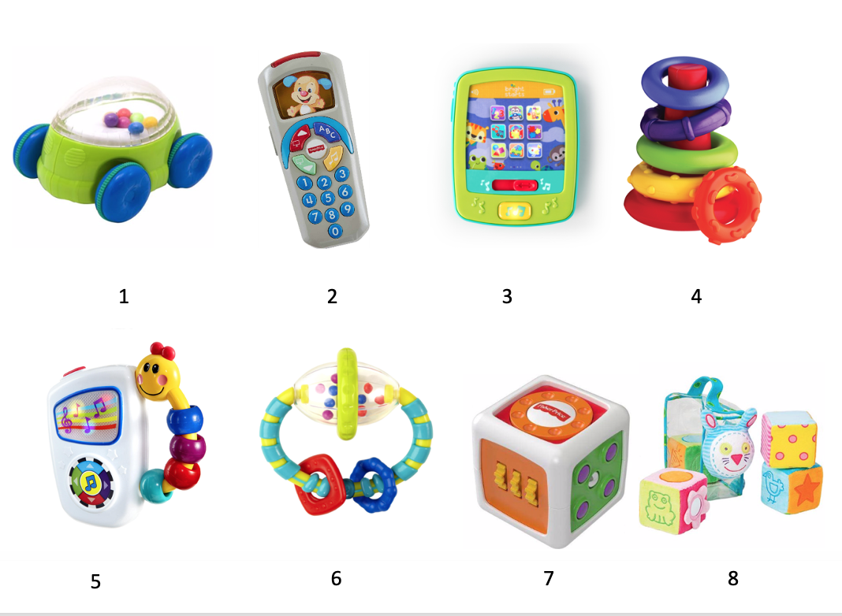
Figure 2. Toy images (Toy Only set).
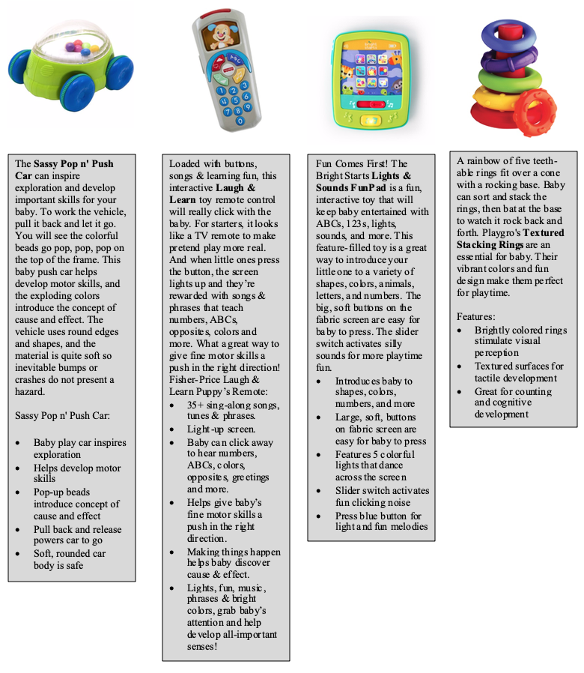
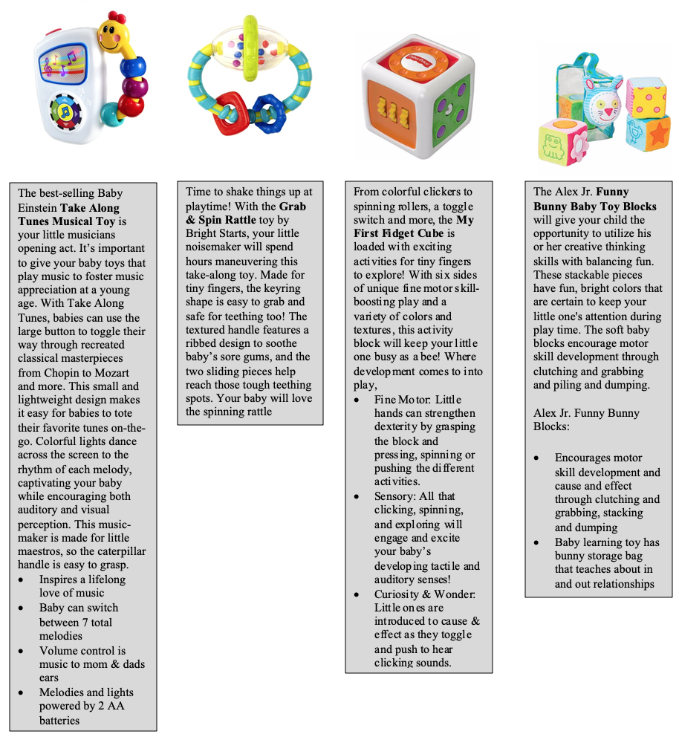Figure 3. Toy images and descriptions (Toy + Description set).

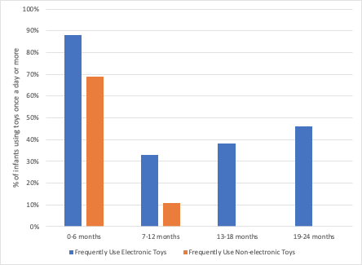
Figure 4. Frequent use (once a day or more) of electronic and non-electronic toys by age group.

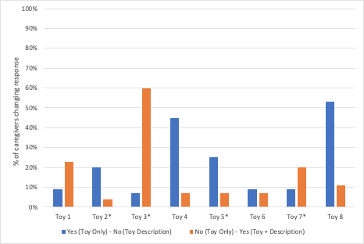
Figure 5. Percent of caregivers who changed their toy selection after reading toy advertising descriptions (from yes to no; or from no to yes). *denotes an electronic toy.

Table 1
Caregiver and Child Demographic Information
 | Caregiver | Child
Gender
Female | 60 | 37
Male | 3 | 26
Racial/ethnic Background
Asian or Pacific Islander | 3 | 2
Black or African American (not of Hispanic Origin) | 2 | 3
Hispanic or Latinx | 8 | 8
White (not of Hispanic Origin) | 49 | 38
Other | 1 | 12
Age (Years)
18-20 | 1 | -
21-29 | 13 | -
30-39 | 42 | -
40-49 | 7 | -
Relationship to Child
Mother | 60 | -
Father | 3 | -
Highest Level of Education
High School Diploma | 2 | -
Trade School | 2 | -
Associate’s Degree (2-year degree) | 2 | -
Bachelor’s Degree | 7 | -
Graduate Degree | 50 | -

