Date: August 6, 2019
Subject: Supplemental Report on location of potentially hazardous wastes buried on the Hazleton Creek Properties site.
Submitted to Pennsylvania Department of Environmental Protection (PADEP) regarding the public comments of General Permit WMGR096NE001
The resolution of the historical concerns would be appreciated and thanks for this consideration. The reason for this specific email would be the scanned copy of the former Crystal Ridge Landfill (now part of HCP) hand-drawn map of hazardous waste drums and unconsolidated waste formerly buried at this site. While the exact nature and amounts of hazardous wastes might be suspect, it would appear that the specific locations and the former documents of the deceased manager should be of concern regarding verification of on-site hazardous waste burial. While one of the documents that has been signed has been scanned a bit blurry in past, this map has been submitted to USEPA and PADEP quite a few years ago. The other documents show the location and one picture of the area of concern. The point of these past submissions would be to supplement this writers’ public comments (July 1, 2019) and assist in the resolution of this issue.

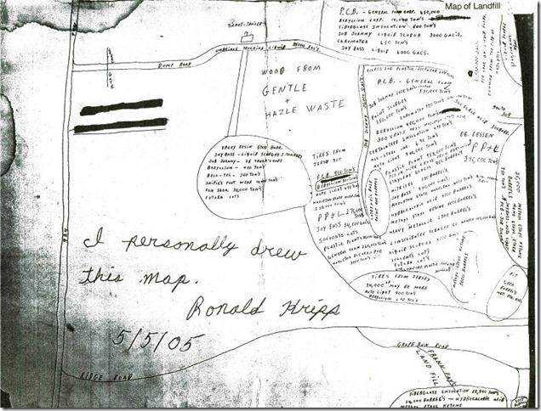
Scan of hand-drawn map submitted to PADEP and USEPA in historical communications
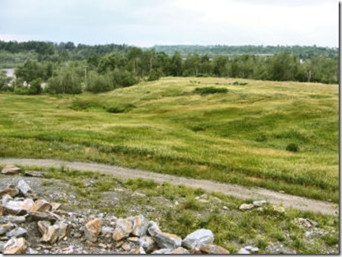
General area of alleged hazardous waste drum burial (approximate 2013)
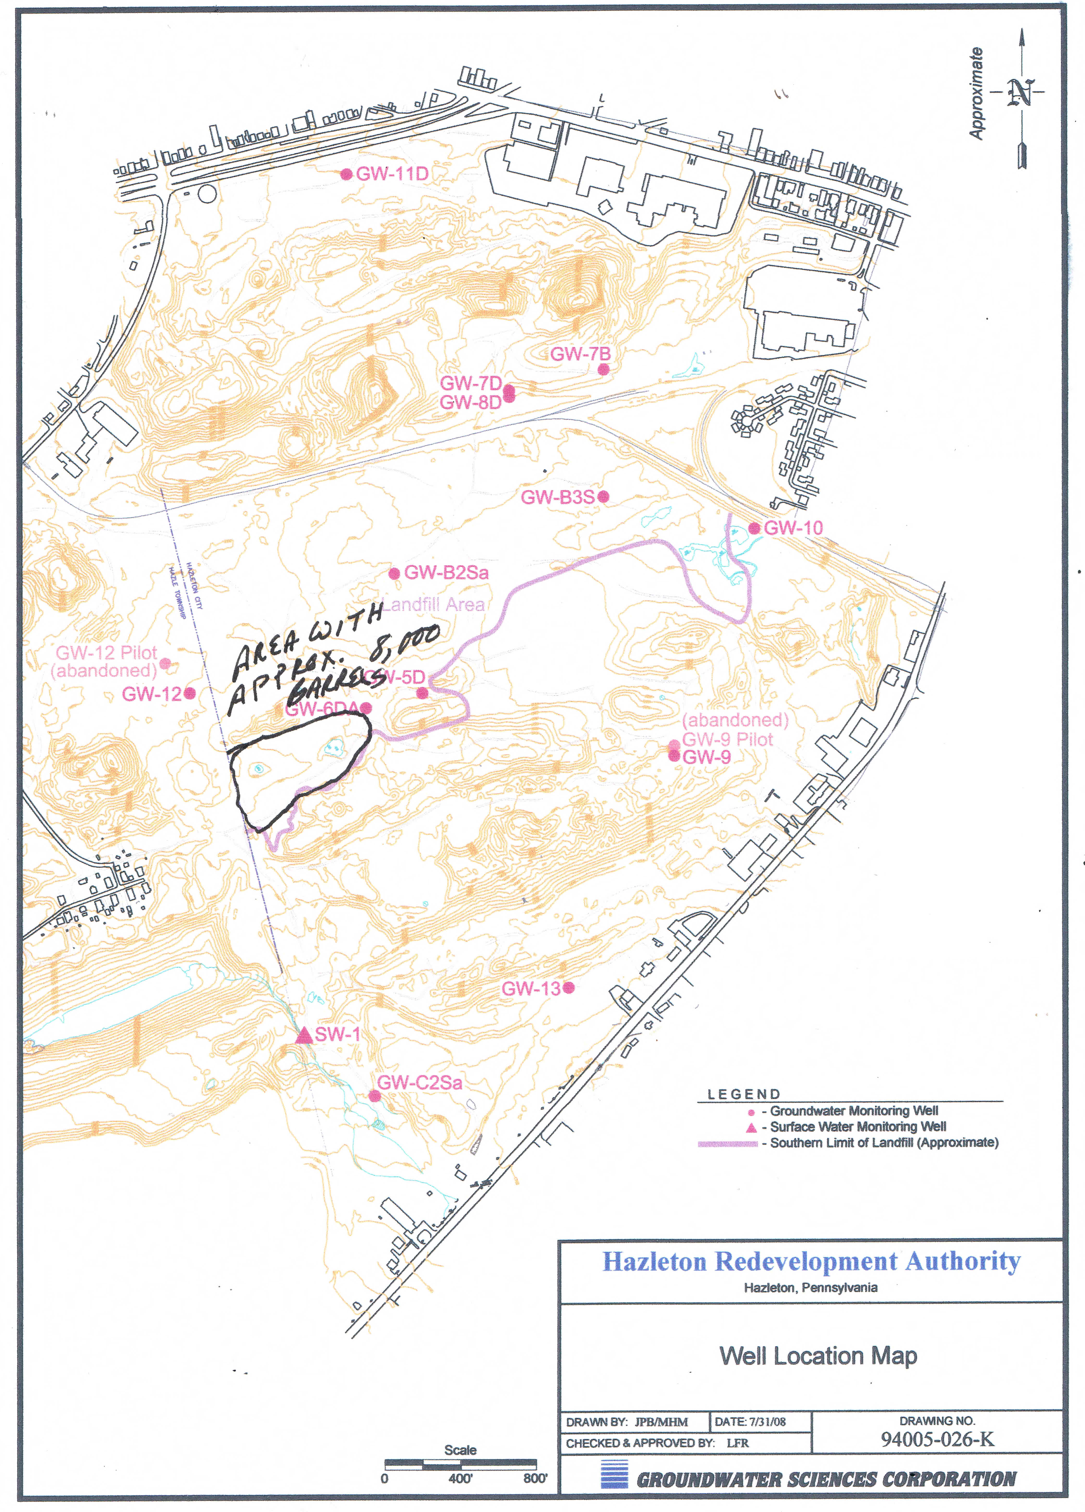
General location map of 8,000 buried drums (date unknown)

