Title page
Emulsions stabilized by highly hydrophilic TiO₂ nanoparticles via van der Waals Attraction
Jing Wang^{a, #}, Yajuan Sun^{a, #,} *, Mingying Yuª, Xihua Lu^{b}, Sridhar Komarneni^{c,*}, Cheng Yang^{a, *}
ª Key Laboratory of Synthetic and Biological Colloids, Ministry of Education, School of Chemical and Material Engineering, Jiangnan University, Wuxi 214122, China
^{b} College of Chemistry, Chemical Engineering and Biotechnology, Donghua University, Shanghai, 201620, PR
^{c} Department of Ecosystem Science and Management and Materials Research Institute, 204 Energy and the Environment Laboratory, The Pennsylvania State University, University Park, PA 16802, USA

Corresponding author:
Sridhar Komarneni, Ph. D., FRSC
Distinguished Professor
204 Energy and the Environment Laboratory
The Pennsylvania State University
University Park, PA 16802
Tel. Phone: 1-814-865-1542
Fax:1-814-865-2326
E-mail: sxk7@psu.edu

Abstract
Hypothesis
Highly hydrophilic nanoparticles are generally considered not suitable for stabilizing Pickering emulsions, since they could not be effectively wetted by the oil phase at the water-oil interface. However, highly hydrophilic nanoparticles with good dispersity are possibly absorbed and packed onto the surface of the oil droplets in water via the van der Waals attraction between the nanoparticles and the oil droplets. Hence, a novel “van der Waals emulsion” should be possible to be stabilized by highly hydrophilic nanoparticles.

Experiments
Oil-in-water emulsions solely stabilized by pristine TiO₂ nanoparticles (i.e., TiO₂ without any modification or additives) were prepared. The emulsification behavior under varying pH, oil fraction, particle content and temperature of the emulsion were explored. Composite wax-based beads, which encapsulated chemical sunscreen and were coated by TiO₂ nanoparticles, were also fabricated using the obtained emulsion as the template.

Findings
The emulsions displayed the highest stability near the isoelectric point of the TiO₂ nanoparticles, which was attributed to the van der Waals attraction between TiO₂ nanoparticles and oil droplets. Such mechanism was supported by a theoretical analysis based on calculation of the Hamaker constants and experimental evidence. Therefore, this work presents a simple, general and green method for preparing particle-stabilized emulsions.

Key words: Pickering emulsion; TiO₂ nanoparticles; van der Waals force; Sunscreen; Isoelectric point

1. Introduction
With superior physical/chemical stabilities, low toxicity, and recyclable emulsifiers, particle-stabilized Pickering emulsions have attracted much research interest finding very wide potential applications in delivering active ingredients, producing stimulus responsive emulsions, as well as fabricating composite functional materials [1-3]. Specifically, Pickering emulsions can be stabilized by solid particles including inorganic nanoparticles (e.g. SiO₂, TiO₂ and Fe₃O₄), naturally-derived nanoparticles (e.g. protein, cellulose, and starch), and synthetic polymer nanoparticles (e.g. PMMA, PS and some amphoteric block copolymers) [4-13]. To serve as an effective Pickering emulsifier, the solid particles need to be amphiphilic to some extent, i.e., which are simultaneously wettable by the oil phase and water phase. Therefore, the previously reported nanoparticle emulsifiers generally exhibited contact angles of around 90° (typically 50°~130°) at the water-oil interface [14]. However, most inorganic nanoparticles are intrinsically hydrophilic, hence surface modification is usually carried out to improve their wettability by the oil phase for better emulsifying performance. For example, Zhao et al. modified nano-SiO₂ particles by methacryloxypropyl-trimethoxysilane [15], and Wang et al. physically modified the surface of montmorillonite for the preparation of stable Pickering emulsions [16]. According to previous studies, it is difficult to stabilize Pickering emulsions solely by nanoparticles with high hydrophilicity [17, 18].
Recently, Marina et al. [19] found that o/w emulsions could be effectively and reversibly stabilized by highly hydrophilic silica particles at pH = 2.5, but such emulsions destabilized at higher pH and were completely broken into separated phases at pH > 6.7. Since the isoelectric point of silica particles was close to pH = 2.5, the electrical double layer (EDL) repulsion between the particles and oil droplets was suppressed, leading to the stabilization of the emulsions. The authors suggested that the emulsifying power of highly hydrophilic particles was governed preferentially by the van der Waals (vdW) attraction between the densely packed particle shells as a whole and the oil droplets enclosed therein, while their stabilizing power was determined by the vdW attraction between individual particles and oil droplets. Such emulsions were referred to as vdW emulsions. The above work has provided a new approach for stabilizing emulsions by highly hydrophilic particles and indicated a wider application potential of hydrophilic particle-stabilized emulsions. However, till now, there have not been any other studies reported on vdW emulsions.
TiO₂ nanoparticles are the most widely used inorganic nanoparticles due to their excellent chemical stability, and UV shielding and anti-bacterial properties [20]. Pickering emulsion systems stabilized by TiO₂ nanoparticles could be directly applied as sunscreen emulsions or functional coatings. In addition, they also provide a template for manufacturing composite materials towards various applications [21, 22]. Unfortunately, in the Pickering emulsions reported, TiO₂ nanoparticles were usually hydrophobically modified, or other auxiliary organic species were added to facilitate the formation of emulsions [7, 23, 24]. Therefore, the method is cumbersome, and not sufficiently green or environmentally friendly. In addition, the hydrophobic modification may also affect the surface activity of TiO₂ nanoparticles in surface-related applications [25]. To date, it remains a huge challenge to prepare stable Pickering emulsions with highly hydrophilic TiO₂ nanoparticles in the absence of any modification and additives.
In this work, it was surprisingly discovered that the commercial pristine TiO₂ nanoparticles could be effectively utilized to stabilize Pickering emulsions near the isoelectric point of TiO₂. The effects of conventional emulsification conditions on this emulsion were studied systematically, and the results revealed that the emulsion was clearly dependent on particle concentration (or number) and system pH. The stability of the emulsion was also tested, and complete disintegration of the emulsion was observed upon freezing-thawing conditions. As for the principle of stability, it was proposed and determined that the emulsion was not stabilized by the traditional hydrophilic or hydrophobic interaction, but stabilized by the vdW interaction between particles and oil droplets. Furthermore, with this emulsion as a template, wax-based composite beads loaded with TiO₂ and encapsulated with avobenzone were prepared for sunscreen application. In general, the Pickering emulsion stabilizing method presented in this study is simple, general, and green, offering a new platform for the construction of functional emulsions as well as the preparation of novel composite materials.
2. Experimental
2.1. Materials
NaOH (AR), HCl (AR), glycerin (AR), chloroplatinic acid (AR), ethanol (AR), Sudan Ⅰ (BS), cetane (GC, ≥ 99.5%), paraffin liquid (AR) were purchased from Sinopharm Chemical Reagent Co. Ltd. Avobenzone (AVB, cosmetic grade) was purchased from DSM (China) Co., Ltd. Carnauba wax (melting point: 82.5 ⁓ 86 °C, food grade) was purchased from Shanghai Jiujie Industrial Co., Ltd. The four types of nano-TiO₂ used in the study were TiO₂-1 (≥ 99.8%, anatase, 10-25 nm, Aladdin), TiO₂-2 (≥ 99.5%, mixed crystal, 10-25 nm, Degussa), TiO₂-3 (≥ 99.0%, 15-25 nm, XFNANO), and TiO₂-4 (≥ 99.0%, rutile, ⁓20 nm, Jiangsu Tianxing New Material Co., Ltd.), respectively. All oil phases were purified by basic alumina.
2.2. Preparation of vdW-Pickering Emulsions
General method for emulsion preparation: Required amount of TiO₂ nanoparticles was ultrasonically dispersed in deionized water, followed by adjusting the pH value to 5 with hydrochloric acid solution of 0.1 mol/L concentration. Afterwards, a certain mass of oil phase was added and homogenized at 15,000 rpm for 2 mins using an IKA®T18 digital homogenizer to prepare the vdW-Pickering emulsion.
In this study, the content of TiO₂ nanoparticles was expressed by the mass fraction in water phase. Oil-water ratio was the volume ratio of oil phase to water phase. Specific experimental conditions were provided in the experiment and discussion section.
2.3. Preparation of Wax/Avobenzone@TiO₂ composite beads
First, 6 g of carnauba wax and 4 g of avobenzone were mixed and heated in a water bath for use; meanwhile, 0.6 g of TiO₂-4 was dispersed in 30 mL deionized water, the pH of which was adjusted to about 5.0. The water bath was then heated to about 90 °C and the oil mixture was ultrasonicated for 2 mins. Afterwards, the hot oil mixture and TiO₂-4 water suspension were mixed together and homogenized for 2 mins to obtain the hot emulsion. Subsequently, the hot emulsion was poured into cool deionized water for rapid solidification. In order to remove the water phase and extra TiO₂-4, the product was washed and suction filtered several times under reduced pressure. Finally, the TiO₂@Wax-Avobenzone beads were obtained after drying at 40 °C for 24 h. It is important to avoid light during preparation and drying of composite beads.
2.4. Characterization
For SEM and TEM characterizations, TiO₂-1, TiO₂-2, TiO₂-3 and TiO₂-4 were dispersed in deionized water followed by pH was adjustment to about 5.0. Then the dispersions were subjected to ultrasonication for 5 mins to homogenize. The homogenized dispersions were dropped on substrates of silicon wafer for SEM observation and copper mesh for TEM observation. The morphologies (especially primary particle size and agglomeration) of TiO₂-1, TiO₂-2, TiO₂-3, and TiO₂-4 were verified by field emission scanning electron microscope (FESEM) using JSM 7401F instrument (Japan JEOL) and high-resolution transmission electron microscope (HRTEM) using JEM-2010 instrument (Japan JEOL).
Fourier infrared spectrometer (FTIR, Nicolet 6700, Thermo Fisher Scientific Co., Ltd.) and Thermo-gravimetric analyzer (TGA/1100SF, METTLER TOLEDO International Trade Co., Ltd.) were employed to determine the surface chemical properties of TiO₂ nanoparticles. Surface tensions of the TiO₂ aqueous dispersions (2.0 wt.%) were measured by a contact angle measurement device (OCA 40, Beijing Eastern Defei Instrument Co. Ltd., Germany) to verify the surface activity of TiO₂, and the three-phase contact angle was used as an indicator to illustrate the wettability of the commercial TiO₂ nanoparticles. Notably, in this experiment, the powder of TiO₂ nanoparticles was made into dense flakes using an infrared tableting machine. The flakes were then placed at the bottom of an optically clear glass container, followed by pouring 2/3 of the purified paraffin liquid into the container. The system was kept still until no bubbles were visible. The zeta potentials (about 0.05 wt.% TiO₂ nanoparticles in water) and secondary sizes (about 0.01 wt.% TiO₂ nanoparticles in water) of TiO₂ nanoparticles were determined using a Zeta potential and particle size analyzer (ZetaPALS, Brookhaven Instruments, America) at 25 °C under different pH values. In order to ensure accuracy, all measurements were performed in triplicate. The composition of TiO₂@Wax-Avobenzone beads were analyzed by TGA analyzer (M-T TGA 1100SF, USA) and UV-vis spectrophotometer (Beijing PuXi TU-1950, China).
The morphologies of emulsions were revealed by optical micrographs obtained with a VHX-1000 digital microscope (Keyence Int. Trading Co. Ltd., Osaka, Japan), as well as by photographing sample bottles containing the emulsions. The size distributions of emulsion droplets were obtained from the corresponding digital microscope images by measuring 200 droplets. The volume mean diameter (d₄₃) of droplets was calculated from the following equation [22]:
D₄₃=∑d_{i}⁴/∑d_{i}³
Where, d_{i} is the diameter of a droplet.
Sun protection factor (SPF) of the sunscreen creams was tested using a UV-2000 ultraviolet transmittance analyzer. The sample test substrate uses a specific single-sided 5 cm × 5 cm PMMA board, and the rough surface simulates the texture of human skin. For SPF measurement, the amount of sunscreen cream applied on each substrate was 2 mg/cm², which was then put into the dark room for 15 mins followed by opening the software for measurement with UV-2000 analyzer. In order to ensure accuracy, we selected five points for each board, and each sample was measured four times.
3 Results and discussion
3.1 Bare TiO₂ nanoparticles
The four types of pristine commercial TiO₂ nanoparticles (TiO₂-1, TiO₂-2, TiO₂-3, and TiO₂-4) purchased from different companies (see details in experimental section) were characterized by SEM and TEM (Fig. 1). TEM images (Fig. 1 a2-d2) show that the primary particle sizes of TiO₂-1, TiO₂-2, TiO₂-3, and TiO₂-4 are almost equivalent (10 ⁓ 25 nm); however, both SEM and TEM observations indicate different agglomeration states of the four TiO₂ samples. While TiO₂-2 and TiO₂-4 were highly dispersed, TiO₂-1 and TiO₂-3 were aggregated into micrometer-sized agglomerates.
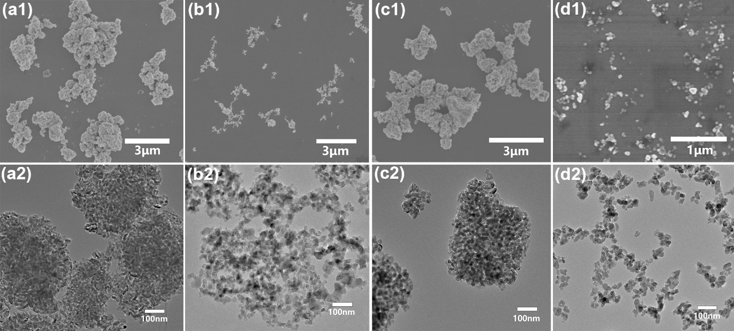
Fig. 1. (a1-d1) SEM and (a2-d2) TEM images of the four types of pristine TiO₂ nanoparticles used in this study.
The zeta potentials of TiO₂ samples in the pH range of 2 to 10 were measured to determine the isoelectric points of the pristine commercial TiO₂ nanoparticles. As shown in Fig. 2a, as the pH value increased, the zeta potentials of the nanoparticles changed from positive to negative. This is mainly caused by the different surface species on TiO₂ nanoparticles in different pH ranges, i.e., Ti-OH²⁺ at low pH and OH-O⁻ at higher pH [25]. The pH_{IEP} (pH value of isoelectric point) values of TiO₂-1, TiO₂-2, TiO₂-3, and TiO₂-4 were measured to be 4.5, 5.5, 5.5, and 5.0, respectively. Near the isoelectric points, the particles became uncharged and were prone to agglomeration due to the thinner electrical double layer, thus exhibiting the largest aggregated particle size (Fig. 2b).
Fig. 2. (a) Variation of Zeta potential and (b) particle size of aggregates of the four TiO₂ samples as a function of pH.
The surface properties of these pristine TiO₂ nanoparticles were characterized by FT-IR spectroscopy to confirm that their surfaces were clean, unmodified, and free of organic species. The FT-IR spectra (Fig. 3a) of these commercial TiO₂ nanoparticles can be divided into two parts: a broad absorption peak at 3000-3600 cm⁻¹ and a sharp absorption peak at 1634 cm⁻¹, which were derived from the adsorbed water and hydroxyl groups on TiO₂ surface (Ti-OH), respectively [26]. No obvious peaks related to organic species could be identified in the FT-IR spectra. Here, attempts were made to measure the three-phase contact angles of the nanoparticles at the water-oil interface; however, when the water droplet came into contact with the TiO₂ flakes, it quickly spread and the flakes swelled (Fig. S1). Although the exact contact angles could not be determined, these experiments imply that the nanoparticles are extremely hydrophilic. Moreover, the interfacial tensions of water upon TiO₂ addition were measured and are presented in Fig. 3b. From a numerical point of view, the addition of TiO₂ nanoparticles basically had no effect on the interfacial tension of water, i.e., these commercial TiO₂ nanoparticles had no interfacial activity.
Fig. 3. (a) FT-IR spectra of the four TiO₂ samples and (b) influence of TiO₂ addition (addition amount: 2 wt%) on the interfacial tension of water.
3.2 vdW-Pickering emulsion stabilized by pristine TiO₂ nanoparticles
Traditional Pickering emulsions are generally stabilized by amphiphilic or modified nanoparticles that can be simultaneously wetted by the oil phase and water phase [27-29]. In the current work, it was found that the extremely hydrophilic pristine TiO₂ nanoparticles presented above could also stabilize oil-in-water (o/w) Pickering emulsions at their isoelectric points, as shown in Fig. 4. Normally, o/w emulsions tend to cream with partially separated aqueous phase in several hours after homogenization as a typical characteristic of particle-stabilized emulsions, as shown in the insets of Fig. 4. There was no significant change in the droplet size of the emulsions during long-term storage, indicating that these emulsions were highly stable against coalescence. The droplet sizes of the emulsions stabilized by TiO₂-1 and TiO₂-3 varied in the range of 30⁓100 and 30⁓200 μm, while those emulsions stabilized by TiO₂-2 and TiO₂-4 were found to be much smaller, i.e., average diameters of 32.3 and 45.6 μm, respectively. In some images, it was clearly observed that the TiO₂ nanoparticles were adsorbed on the surface of oil droplets. However, the turbid aqueous phase implied that not all nanoparticles were adsorbed on the oil droplet surface, but some of them remain dispersed in the aqueous phase. Centrifuge tests indicated that the emulsions with smaller droplet sizes stabilized by TiO₂-2 and TiO₂-4 exhibited significantly higher stability compared with those stabilized by TiO₂-1 and TiO₂-3. The above results suggest that pristine TiO₂ nanoparticles can stabilize Pickering emulsions, and smaller aggregate particle size can lead to the formation of emulsions with smaller droplet size and better stability.
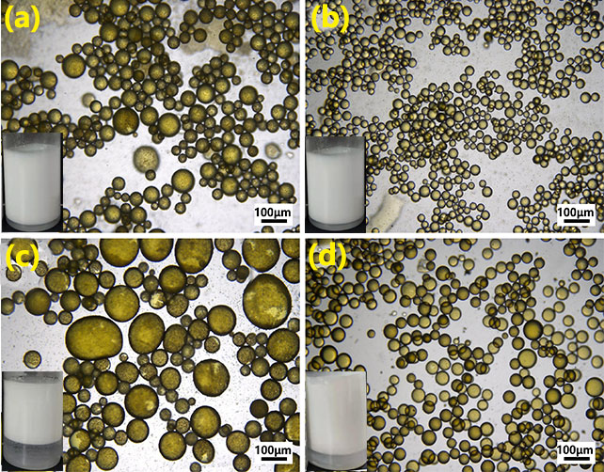
Fig. 4. The optical micrographs and photographs (inset) of Pickering emulsions stabilized by 2.0 wt % of (a) TiO₂-1 at pH = 4.5; (b) TiO₂-2 at pH = 5.0; (c) TiO₂-3 at pH = 5.0; and (d) TiO₂-4 at pH = 5.5. The dyed inner phases by Sudan Ⅰ indicated the o/w emulsion type. Oil fraction = 0.5.
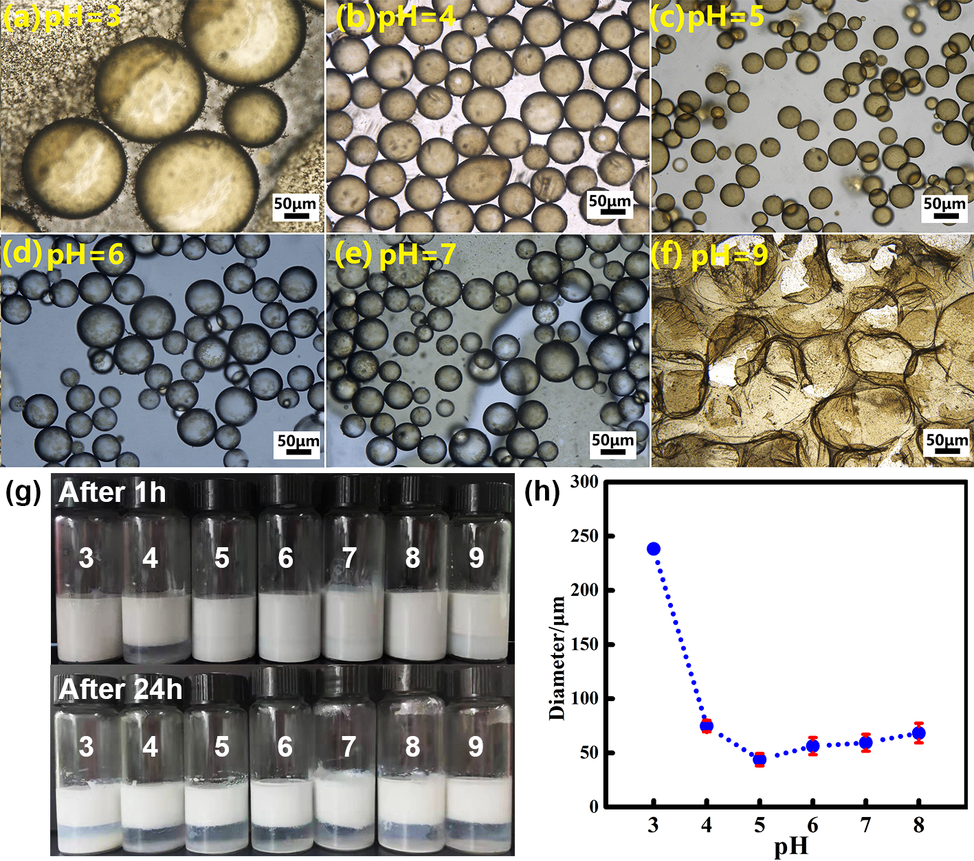
Fig. 5. (a-f) Optical micrographs and (h) photographs of emulsions prepared at pH ranging from 3 to 9 with TiO₂-4 as the emulsifier; and (g) variation of droplet size with pH value.
The dependence of emulsion stability on the surface charge of TiO₂ nanoparticles was investigated by adjusting the emulsion pH value. Fig. 5 a-f present the optical micrographs of emulsions prepared at a pH value of 3.0, 4.0, 5.0, 6.0, 7.0, and 9.0, respectively, with TiO₂-4 as the representative emulsifier; the corresponding macroscopic photographs of the emulsions are shown in Fig. 5h, while the variation of droplet size with pH value is displayed in Fig. 5g. Emulsion with the smallest droplet size and the highest stability was obtained at a pH of 5.0, which is the isoelectric point of TiO₂-4. In contrast, the emulsions became extremely unstable at pH = 3.0 and 9.0 (Fig. 5a and f), which broke easily during observation due to the capillary pressure between the glass coverslips and slides. Similar phenomenon was observed for emulsions stabilized by the other three TiO₂ samples. The above results suggest that uncharged TiO₂ nanoparticles at their pH_{IEP} favor the formation of stable Pickering emulsions. Since the TiO₂ nanoparticles were electrically neutral, highly hydrophilic, and interfacially inactive, the presently obtained emulsions can be considered as vdW Pickering emulsions, i.e., the emulsions are stabilized by uncharged TiO₂ nanoparticles attaching to surface of oil droplets via vdW force. The degraded stability of the emulsions at higher or lower pH away from the isoelectric points is attributed to the electrostatic repulsion among nanoparticles, hindering the dense adsorption of nanoparticles onto oil droplets. Moreover, the vdW force can be easily affected by ambient temperature. When the liquids are transformed to solid at lower temperature, the vdW force would disappear [19]. Therefore, the emulsion stabilized by vdW force would break down. Compared with other traditional emulsions stabilized by surfactants or organic-modified amphiphilic nanoparticles, we found that the obtained emulsions indeed broke down easily upon freezing-thawing operations (Fig. S2), implying that the stabilizing mechanism of the emulsions is possibly related to vdW force.
In the current work, since the electrostatic force is negligible near the isoelectric point, the interaction between the TiO₂ nanoparticles and oil droplets could be described by vdW force. As the diameter of oil droplet is several hundred times larger than that of TiO₂ nanoparticles, interaction between the two counterparts can be represented by a ball-plate model as illustrated in Fig. 6. Thus, the vdW force between the nanoparticles and the oil-water interface can be expressed as [30, 31]:
${\text{W}}_{\text{vdW}}^{{\text{TiO}}_{\text{2}}\text{/Oil}}$ ≈ −Ar/(6x) (1)
where A is the Hamaker constant, r is the size of particle aggregates, and x is the distance between the particle and oil droplet. Assuming that N particles are adsorbed on the surface of an oil droplet and form a single adsorption layer, then
N ≈ R²/r²s (2)
where R is the diameter of the oil droplet. On this basis, the total vdW force on the oil droplet is:
W_{vdW} ≈ −NAr/(6x) ≈ −AR²/(6xr) (3)
The Hamaker constant (A₁₃₂) for the interaction of TiO₂ (substance 1) and oil (n-hexadecane, substance 2) in water medium (substance 3) can be calculated as [32]:
A₁₃₂ = A₁₂ + A₃₃ − A₁₃ − A₂₃$\text{≈}\text{ (}{\text{A}}_{\text{11}}^{\text{1/2}}-{\text{A}}_{\text{33}}^{\text{1/2}}\text{)(}{\text{A}}_{\text{22}}^{\text{1/2}}-{\text{A}}_{\text{33}}^{\text{1/2}}\text{)}$ (4)
where A₁₁, A₂₂, A₃₃ are the self-interaction Hamaker constants of TiO₂ rutile, n-hexadecane, and water, which are reported to be 11.0 ⁓ 31.0×10⁻²⁰, 5.2×10⁻²⁰, and 3.7 × 10⁻²⁰ J, respectively [31, 32]. Therefore, according to equation (4), A₁₃₂ was determined to be 0.47 ⁓ 1.22 × 10⁻²⁰ J. The positive value of A₁₃₂ implies the vdW attraction between TiO₂ and n-hexadecane in water medium.
In the current experiments, the average size r of particle aggregates and diameter of oil droplets were 132 nm and 25 μm, respectively. When TiO₂ nanoparticles move close to the oil droplets into the range within the typical distance for vdW interaction (typically within 1 nm), the vdW force between a single TiO₂ nanoparticle and an oil droplet (${\text{W}}_{\text{vdW}}^{{\text{TiO}}_{\text{2}}\text{/Oil}}$) and the total vdW force (W_{vdW}) could be calculated and were found to be${\text{W}}_{\text{vdW}}^{{\text{TiO}}_{\text{2}}\text{/Oil}}$ ≈ −1.03 ~ −2.68 × 10⁻¹⁹ J and W_{vdW} ≈ −3.71 ~ −9.63 × 10⁻¹⁵ J, respectively. The above analysis indicated that, in the present emulsion system, the vdW attraction force between a single TiO₂ nanoparticle and an oil droplet was much larger than the thermal fluctuation energy k_{B}T (4 × 10⁻²¹ J at 293 K). Therefore, during the emulsification process, TiO₂ nanoparticles tend to attach onto the surface of oil droplets, thereby stabilizing the water-oil interface. It should be noted that the above analysis only considered the case of single-layer particle adsorption, however, the vdW attraction between TiO₂ nanoparticles and oil droplets would be even greater under multi-layer particle adsorption.
Fig. 6. Schematic illustration of the stabilizing mechanism of vdW-Pickering emulsions.
Furthermore, when nanoparticles are adsorbed onto the oil droplet surface, the vdW attraction forces among adjacent nanoparticles also contribute to the emulsion stability. The vdW attraction force between two TiO₂ nanoparticles in water can be expressed as [32]:
${\text{W}}_{\text{vdW}}^{{\text{TiO}}_{\text{2}}\text{/}{\text{TiO}}_{\text{2}}} \text{=} \text{-}{\text{A}}_{\text{131}}\text{R/12H}$ (5)
where A₁₃₁ is the Hamaker constant of TiO₂ in water, which was reported to be 3.9 ⁓ 10 × 10⁻²⁰ J, H is the distance between two particles, and R is the particle diameter (in the current case, 132 nm). Taking H as 1 nm, the vdW attraction force between two TiO₂ nanoparticles${\text{W}}_{\text{vdW}}^{{\text{TiO}}_{\text{2}}\text{/}{\text{TiO}}_{\text{2}}}$ was calculated to be −25 ⁓ − 9.75×10⁻²⁰ J, which is also significantly larger than k_{B}T. As a result, the nanoparticles adsorbed on oil droplets tend to form a robust self-organized and closely-packed “particle cage” to trap the oil droplets, thus preventing them from coalescence.
3.4. Other factors affecting emulsification
The effects of other factors, such as nanoparticle concentration, oil fraction, and temperature, on the emulsification process were also explored. Stable emulsion could not be formed with a nanoparticle concentration of 0.5 wt%. However, as the nanoparticle concentration increased from 1.0 to 10.0 wt%, the size of oil droplets gradually decreased and the emulsion became more stable. At higher particle concentration, higher surface coverage of oil droplets was achieved, leading to enhanced vdW attraction between nanoparticles and oil droplets and thus improved stability of the emulsion. Furthermore, highly concentrated nanoparticles dispersed in the aqueous phase tend to form a three-dimensional particle network, which hinders the coalescence of the oil droplets.
Generally, phase inversion occurs upon tuning the oil fraction in Pickering emulsions stabilized by amphiphilic nanoparticles [33]. However, in the present work, only oil-in-water emulsion could be obtained with the hydrophilic pristine TiO₂ nanoparticles as the emulsifier; when the volume fraction of the oil phase exceeded 75%, the emulsion quickly broke down (Fig. S3). This contrast also implies that the vdW-Pickering emulsion is quite different from traditional Pickering emulsions.
Furthermore, the vdW-Pickering emulsions would remain stable over a wide temperature range. As can be seen in Fig. S4, increasing the temperature from 20 to 80 °C only led to slight increase in the size of emulsion droplets. Such high-temperature stability of the vdW-Pickering emulsions guarantees their wide application in cosmetic production, catalysis, Pickering emulsion polymerization/solidification, etc.
Fig. 7. (a-e) Optical micrographs and (f) droplet size of emulsions prepared at varying TiO₂-4 nanoparticle concentration.
3.4. Potential application of pristine TiO₂-stablized vdW-Pickering emulsions
Owing to their efficient UVB blocking property, TiO₂ nanoparticles are widely used as sunscreens in cosmetic products. In commercial products, TiO₂ nanoparticles are usually combined with some organic sunscreens to achieve high SPF value and broad-spectrum UV shielding. However, the photocatalytic activity of TiO₂ nanoparticles usually leads to the photodegradation of the organic sunscreens. Besides, TiO₂ nanoparticles sometimes present an unnatural whitening effect and unpleasant feeling on skin due to their agglomeration. Herein, in order to solve the above problems, a composite wax-based bead structure was designed, which encapsulates chemical sunscreen and is coated with TiO₂ nanoparticles. While providing high UV blocking capacity, such beads-like composite sunscreen material offers a smooth and natural skin feel/look due to the “ball bearing” and “soft focus” effects. More importantly, the photostability of organic sunscreens can be highly improved, since the TiO₂ nanoparticles are spatially separated with the organic sunscreens and TiO₂ nanoparticles also provide photoprotection effects by reflecting a part of the UV light arriving at the bead’s surface. In this work, such wax-based bead structure was prepared successfully with the presently obtained vdW Pickering emulsions as the emulsion-solidification templates, carnauba wax as the solid oil phase, and avobenzone (denoted as AVB) as a typical organic sunscreen. In brief, AVB and carnauba wax were mixed, melted and emulsified by TiO₂ nanoparticles, and then cooled down to room temperature for solidification of the wax. As a result, wax-based composite beads coated with TiO₂ and encapsulated with avobenzone could be facilely prepared.
Figs. 8a and b reveal the morphology of the prepared composite wax-based beads with an average diameter of around 10 μm. It can be clearly observed from Fig. 8b that the wax beads were densely coated by TiO₂ nanoparticles. TGA analysis and UV-vis spectroscopy analysis revealed that the beads contained 20.0 wt% TiO₂ and 32.0 wt% AVB (see TGA data in Fig. S5). To demonstrate the advantages of this novel composite structure, we prepared sunscreen products containing the composite beads (sunsreen cream A) and tested their SPF value and UV stability. As references, the sunscreen products containing physically mixed wax, AVB and TiO₂ (mixing ratio: 48: 32: 20), and containing wax@TiO₂ as well as wax/AVB were also prepared (denoted as sunsreen creams B, C and D, respectively, their formulations were provided in Supporting information). The SPF value of sunscreen creams A-D were measured to be 54, 56, 13 and 35. This result suggested that the combination of TiO₂ and AVB would provide higher SPF value. Although the composite wax-based beads led to a similar SPF value as compared to the physically mixed sample, they exhibited much higher photostability under UV illumination. As shown in Fig. 8c, the decline of SPF value of sunscreen creams A was much slower than that of cream B. After 4 h UV exposure, the SPF value of cream A was still higher than 25, while the SPF value of cream B dropped to 12. These results suggest that the composite wax-based bead structure exhibited an obvious photoprotecting effect on avobenzone, leading to the improved photostability of the sunscreen cream. The improved photostability of the composite beads could be attributed to the spatial separation of inorganic and organic sunscreens, as well as the UV-blocking effects rendered by the outer layer of TiO₂ nanoparticles. Moreover, such composite wax-based beads could be an ideal substitute for the presently applied synthetic polymer microspheres for loading or encapsulating the sunscreens, leading to potential applications in sustainable, natural, and safe cosmetic products. Therefore, the vdW-Pickering emulsion system developed in this study would provide a platform for the preparation of novel multifunctional composite materials.
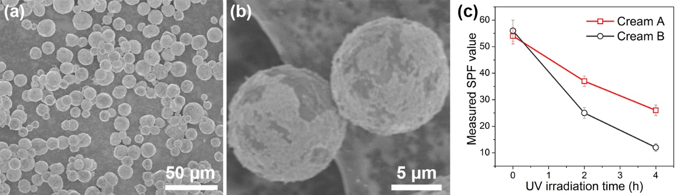
Fig. 8. (a) Low- and (b) high-magnification SEM images of the composite wax-based beads fabricated through the Pickering emulsion-templated emulsion-solidification process, (c) variation of measured SPF values of two prepared sunscreen creams A and B versus UV irradiation time (see details in the supporting information).

4 Conclusions
On the basis of the previously reported van der Waals (vdW) emulsions stabilized by SiO₂ hydrophilic particles [19], this work has demonstrated that vdW emulsions could be produced using highly hydrophilic TiO₂ nanoparticles as the emulsifier, which is new and unexpected. The emulsion stability mechanism was attributed to the vdW interaction between TiO₂ nanoparticles and oil droplets, rather than the interfacial nanoparticle trapping induced by amphiphilic wettability [7, 17, 18]. The above mechanism was supported by a theoretical analysis based on calculation of the Hamaker constants and several experimental parameters such as pH, particles concentration, and the freeze-thaw process were varied to further verify the mechanism. Compared to vdW emulsions stabilized by SiO₂ nanoparticles [19], the TiO₂ stabilized vdW emulsions would be more versatile because of the multifunctional properties and wider application of TiO₂ [20]. However, in contrast to the emulsions stabilized by surface modified TiO₂ nanoparticles, the pristine TiO₂ nanoparticles would show much better UV shielding and surface related properties. As a step towards application, a composite wax-based bead structure, which encapsulated chemical sunscreen and coated by TiO₂ nanoparticles, was fabricated with the emulsion as a template, and applied as a sunscreen. The obtained sunscreen exhibited an excellent UV blocking property and improved photostability. Compared with traditional Pickering emulsions, the pristine nanoparticle-stabilized emulsions are simple, green, scientifically fascinating, and economically significant for practical applications. Further research is underway to explore the generalization of the method and more applications of the vdW emulsions.

Acknowledgements
This work was supported by National Natural Science Foundation of China (No. 51802123, No.51903108), the Natural Science Foundation of Jiangsu Province (No. BK20180630) and the Project funded by China Postdoctoral Science Foundation (No. 2020M671333).
Notes
The authors declare no conflict of interst.
References
[1] S. Lam, K.P. Velikov, O.D. Velev, Pickering stabilization of foams and emulsions with particles of biological origin, Curr. Opin. Colloid Sci 19 (2014) 490-500.
[2] N. Kasiri, M. Fathi, Production of cellulose nanocrystals from pistachio shells and their application for stabilizing Pickering emulsions, Int. J. Biol. Macromol 106 (2018) 1023-1031.
[3] X. Chen, D.J. Mcclements, J. Wang, L. Zou, S. Deng, W. Liu, C. Yan, Y. Zhu, C. Cheng, C. Liu, Coencapsulation of (−)-Epigallocatechin-3-gallate and Quercetin in particle-stabilized W/O/W emulsion gels: Controlled release and bioaccessibility, J. Agr. Food Chem. 66 (2018) 3691-3699.
[4] B.P. Binks, S.O. Lumsdon, Catastrophic phase inversion of water-in-oil emulsions stabilized by hydrophobic silica, Langmuir 16 (2000) 2539-2547.
[5] J. Zhou, X. Qiao, B.P. Binks, K. Sun, M. Bai, Y. Li,Y. Liu, Magnetic Pickering emulsions stabilized by Fe₃O₄ nanoparticles, Langmuir 27 (2011) 3308-3316.
[6] Z. Yang, W. Wang, X. Tai, G. Wang, Preparation of modified montmorillonite with different quaternary ammonium salts and application in Pickering emulsion, New J. Chem. 43 (2019) 11543-11548.
[7] J. Wang, M. Yu, C. Yang, Colloidal TiO₂ nanoparticles with near-neutral wettability: An efficient Pickering emulsifier, Colloids Surf. A 570 (2019) 224-232.
[8] F. Zhu, Starch based Pickering emulsions: fabrication, properties, and applications, Trends Food Sci. Technol. 85 (2019) 129-137.
[9] A. Sarkar, E. Dickinson, Sustainable food-grade Pickering emulsions stabilized by plant-based particles, Curr. Opin. Colloid Sci 49 (2020) 69-88.
[10] J.W.O. Salari, G. Mutsaers, J.J. Meuldijk, Klumperman, Deformation of the water/oil interface during the adsorption of sterically stabilized particles, Langmuir 30 (2014) 7327-7333.
[11] B.P. Binks, S.O. Lumsdon, Pickering emulsions stabilized by monodisperse latex particles: Effects of particle size, Langmuir 17 (2001) 4540-4547.
[12] J. Xu, Y. Sun, J. Chen, S. Zhong, Novel application of amphiphilic block copolymers in Pickering emulsions and selective recognition of proteins, New J. Chem. 42 (2018) 3028-3034.
[13] Y.J. Kim, Y.D. Liu, H.J. Choi, S. Park, Facile fabrication of Pickering emulsion polymerized polystyrene/laponite composite nanoparticles and their electrorheology, J. Colloid Interface Sci. 394 (2013) 108-114.
[14] B.P. Binks, J.H. Clint, Solid Wettability from surface energy components: Relevance to pickering emulsions, Langmuir 18 (2002) 1270-1273.
[15] J. Zhao, Y. Liu, C. Zheng, Q. Lei, Y. Dong, X. Zhao, J. Yin, Pickering emulsion polymerization of poly(ionic liquid)s encapsulated nano-SiO₂ composite particles with enhanced electro-responsive characteristic, Polymer 146 (2018) 109-119.
[16] J. Wang, H. Deng, Y. Sun, C. Yang, Montmorillonite and alginate co-stabilized biocompatible Pickering emulsions with multiple-stimulus tunable rheology, J. Colloid Interface Sci. 562 (2020) 529-539.
[17] B.P. Binks, S.O. Lumsdon, Influence of particle wettability on the type and stability of surfactant-free emulsions, Langmuir 16 (2000) 8622-8631.
[18] H. Jiang, Y. Sheng, T. Ngai, Pickering emulsions: Versatility of colloidal particles and recent applications, Curr. Opin. Colloid Sci 49 (2020) 1-15.
[19] P.F. Marina, C. Cheng, R. Sedev, A. Stocco, B.P. Binks, D. Wang, Van der Waals emulsions: Emulsions stabilized by surface-inactive, hydrophilic particles via van der Waals attraction, Angew. Chem. Int. Ed. 57 (2018) 9510-9514.
[20] G. Zheng, X. Lu, L. Qian, F. Xian, Ultraviolet emission enhancement in ZnO thin films modified by nanocrystalline TiO₂, Opt. Mater. 67 (2017) 139-144.
[21] J. Marto, L. Gouveia, L.M. Goncalves, B.G. Chiariandreo, V.L.B. Isaac, P.C. Pinto, E.I. De Oliveira, A.J. Almeida, H.M. Ribeiro, Design of novel starch-based Pickering emulsions as platforms for skin photoprotection, J. Photochem. Photobio. B 162 (2016) 56-64.
[22] T. Chen, P.J. Colver, S.A.F. Bon, Organic-inorganic hybrid hollow spheres prepared from TiO₂-stabilized Pickering emulsion polymerization, Adv. Mater. 19 (2007) 2286-2289.
[23] M.F. Nsib, A. Maayoufi, N. Moussa, N. Tarhouni, A. Massouri, A. Houas, Y. Chevalier, TiO₂ modified by salicylic acid as a photocatalyst for the degradation of monochlorobenzene via Pickering emulsion way, J. Photochem. Photobio. A 251 (2013) 10-17.
[24] M. Nawaz, W. Miran, J. Jang, D.S. Lee, Stabilization of Pickering emulsion with surface-modified titanium dioxide for enhanced photocatalytic degradation of Direct Red 80, Catal. Today 282 (2017) 38-47.
[25] E. Ukaji, T. Furusawa, M. Sato, N. Suzuki, The effect of surface modification with silane coupling agent on suppressing the photo-catalytic activity of fine TiO₂ particles as inorganic UV filter, Appl. Surf. Sci. 254 (2007) 563-569.
[26] K. Elghniji, Z. Annarabah, E. Elaloui, Novel and facile synthesis of transparent-monolithic TiO₂ gels by sol-gel method based on an esterification reaction, Mater. Sci. Poland 34 (2016) 633-640.
[27] F. Wang, J. Tang, H. Liu, G. Yu, Y. Zou, Self-assembled polymeric micelles as amphiphilic particulate emulsifiers for controllable Pickering emulsions, Mater. Chem. Front. 3 (2019) 356-364.
[28] K. Lebdioua, A. Aimable, M. Cerbelaud, A. Videcoq, C. Peyratout, Influence of different surfactants on Pickering emulsions stabilized by submicronic silica particles, J. Colloid Interface Sci. 520 (2018) 127-133.
[29] P. Sufimaragheh, N. Nikfarjam, Y. Deng, N. Taheriqazvini, Pickering emulsion stabilized by amphiphilic pH-sensitive starch nanoparticles as therapeutic containers, Colloids Surf. B 181 (2019) 244-251.
[30] A. Anandarajah, J. Chen, Van der Waals attractive force between clay particles in water and contaminants, Soils Found. 37 (1997) 27-37.
[31] J. Ren, J. Shen, S. Lu, Particle dispersion science and technology, Beijing: Chemical Industry Press (2005) 66-74.
[32] J.N. Israelachvili, Intermolecular and Surface Forces, Academic Press, New York (2009) 254-263.
[33] D. Zang, P.S. Clegg, Relationship between high internal-phase Pickering emulsions and catastrophic inversion, Soft Matter 9 (2013) 7042-7048.

All Figure captions
Fig. 1. (a1-d1) SEM and (a2-d2) TEM images of the four types of pristine TiO₂ nanoparticles used in this study.
Fig. 2. (a) Variation of Zeta potential and (b) particle size of aggregates of the four TiO₂ samples as a function of pH.
Fig. 3. (a) FT-IR spectra of the four TiO₂ samples and (b) influence of TiO₂ addition (addition amount: 2 wt%) on the interfacial tension of water.
Fig. 4. The optical micrographs and photographs (inset) of Pickering emulsions stabilized by 2.0 wt % of (a) TiO₂-1 at pH = 4.5; (b) TiO₂-2 at pH = 5.0; (c) TiO₂-3 at pH = 5.0; and (d) TiO₂-4 at pH = 5.5. The dyed inner phases by Sudan Ⅰ indicated the o/w emulsion type. Oil fraction = 0.5.
Fig. 5. (a-f) Optical micrographs and (h) photographs of emulsions prepared at pH ranging from 3 to 9 with TiO₂-4 as the emulsifier; and (g) variation of droplet size with pH value.
Fig. 6. Schematic illustration of the stabilizing mechanism of vdW-Pickering emulsions.
Fig. 7. (a-e) Optical micrographs and (f) droplet size of emulsions prepared at varying TiO₂-4 nanoparticle concentration.
Fig. 8. (a) Low- and (b) high-magnification SEM images of the composite wax-based beads fabricated through the Pickering emulsion-templated emulsion-solidification process, (c) variation of measured SPF values of two prepared sunscreen creams A and B versus UV irradiation time (see details in the supporting information).

# These authors contributed equally to this work. * Corresponding authors. Email: cmsun@jiangnan.edu.cn (Y. Sun); sxk7@psu.edu (S. Komarneni); cyang@jiangnan.edu.cn (C. Yang)

