Changes in Gene Expressivity Resulting from Osteoarthritis
Shannon Bradley
November 6, 2015

Abstract
Osteoarthritis was surgically induced in the knees of Sprague-Dawley male rats. Gene expression was analyzed in articular chondrocytes. Knees were classified in three conditions: osteoarthritis group, contralateral control group, and sham control group. Focus was on changes in expressivity in the genes tenascin N (Tnn), chemokine (C-X-C motif) receptor 4 (Cxcr4), and latent transforming growth factor beta-binding protein 2 (Ltbp2).

Objectives
The objective of this assignment was to analyze a dataset, of gene expression in this case, and locate genes with changes in expressivity in response to experimentally induced osteoarthritis. This paper fulfilled credit for Lab Report #4 assignment for BBH 411W.

Disclaimer
The purpose of the writing is to fulfill course requirements for BBH 411W and to stand as a personal writing sample, but the findings should not be treated as generalizable research.

Shannon Bradley
BBH 411W
Dr. Joseph Gyekis
November 6, 2015
Changes in Gene Expressivity Resulting from Osteoarthritis
Introduction
Osteoarthritis (OA) is a musculoskeletal disease characterized by the degeneration of joint cartilage and the underlying bone. Felson et al. stated that OA is the most common form of arthritis, affecting weight-baring joints. He attributed onset to both biomechanical and biochemical factors. Some biomechanical factors include muscle weakness, obesity and joint laxity. In addition, biochemical factors include dietary intake, estrogen levels, bone density, and genetics. Animal models are used to study the pathophysiology of OA in a controlled manner, allowing for closer examination of disease progression. Teeple et al. analyzed various animal models of OA and concluded that they are leading to advanced understanding of the pathophysiology of OA, but there is still room for improvement which will allow for better comparison between models.
Appleton et al. used a rat model to study OA by looking at genome-wide changes in gene expression. From their data I analyzed the changes in expression in three different genes: tenascin N (Tnn), chemokine (C-X-C motif) receptor 4 (Cxcr4), and latent transforming growth factor beta-binding protein 2 (Ltbp2). In humans, Tnn has functions in osteogenesis, as noted by Martina et al. Wei et al. found that when Cxcr4 is bound with stromal cell-derivded factor-1 (Sdf-1), the complex induces OA cartilage degeneration. Cheung et al. stated that due to Ltbp2’s location on chromosome 14q in humans it has the potential to cause variation in bone mineral density and fractures. I plan to reinvestigate the analysis made by Appleton et al. by looking at the changes in three genes, two of which were discussed in their paper (Cxcr4 and Ltbp2) and one which was not discussed (Tnn).

Methods
The genome-wide dataset, provided by Appleton et al., analyzed articular chondrocytes from surgically induced osteoarthritic knees of Sprague-Dawley, a species of rattus norvegicus, male rats. The first group of rats “underwent anterior cruciate ligament transection and partial medial meniscectomy incision on the medial aspect of the right knee joint capsule, anterior to the medial collateral ligament.” The right knees of these rats make up the OA condition, while the left knees of these rats were also tested, making up the contralateral condition. The second group of rats underwent sham surgery where similar incisions on the right knees were made but neither anterior cruciate ligament transection nor medial meniscectomy were performed. This group made up the sham, control group. The rats were randomly assigned to each group. From each group, RNA was extracted from articular chondrocytes and Affymetrix GeneChip expression arrays evaluated gene expression. The authors set 1 as a typical level of expression for all genes, resulting with higher numbers indicating higher expression and lower numbers indicating lower levels of expression.3
The dataset was downloaded from NCBI’s Gene Expression Omnibus (GEO). Each gene has five measures of expression in each of the three conditions. I took the average of these measures to find an average value of sham, contralateral, and OA. Appleton et al. stated that they found the contralateral not to be a suitable control. Based on this conclusion, I used only the sham condition as a control and looked at the ratio of change in expression from sham to OA.
Results
There was a total of ten rats, with five undergoing the sham surgery and the other five undergoing the articular cruciate ligament transection and partial medial meniscectomy. Of the 31,099 genes recorded in the database I focused on Tnn, Cxcr4, and Ltbp2. Table 1 provides the classifications of these three genes by function, process, and component.
 | Function | Process | Component
Tnn | Integrin binding | Axonogensis, cell growth and migration, cell-matrix adhesion | Proteinaceous extracellular matrix
Cxcr4 | C-C chemokine receptor activity, actin binding, cytokine binding, drug binding, myosin light chain binding, ubiquitin binding, ubiquitin protein ligase binding | G-protein coupled receptor signaling pathway, calcium-mediated signaling, chemokine-mediated signaling pathway, regulation of chemotaxis | External side of plasma membrane
Ltbp2 | Calcium ion binding, growth factor binding, heparin binding | Transforming growth factor beta receptor signaling pathway | Extracellular matrix
Table 1. Gene ontology classes of function, process, and component for Tnn, Cxcr4, and Ltbp2
SHAM | Contralateral | OA
0.356 | 1 | 27.43
0.693 | 1.144 | 9.503
0.943 | 2.653 | 24.68
0.544 | 0.551 | 5.715
0.435 | 0.706 | 14.96
Table 2 contains the Tnn expression values for each of the three conditions. Figure 1 represents this information in a scatter plot. The OA group had an expression 27.7 times higher than the sham group. 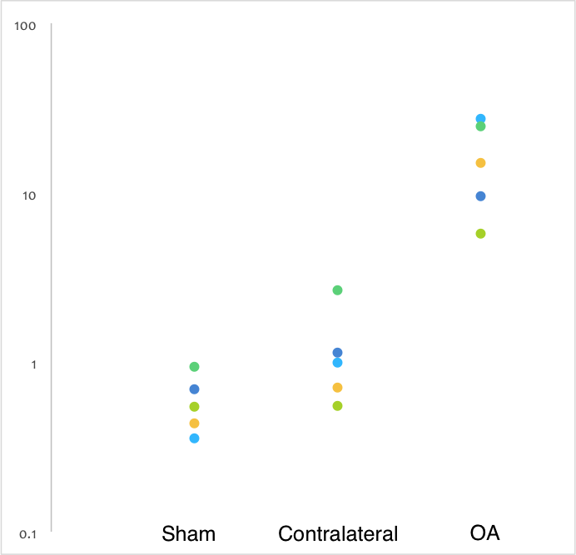
Table 2. Tnn gene expression values
Figure 1. Tnn gene expression across conditions
SHAM | Contralateral | OA
0.7 | 0.804 | 3.313
0.665 | 1.987 | 1.226
0.56 | 1.846 | 3.286
0.735 | 0.596 | 0.927
1 | 2.061 | 1.414
Table 3 contains the Cxcr4 expression values for each of the three conditions. Figure 2 represents this information in a scatter plot. The OA group had an expression 2.64 times higher than the sham group.
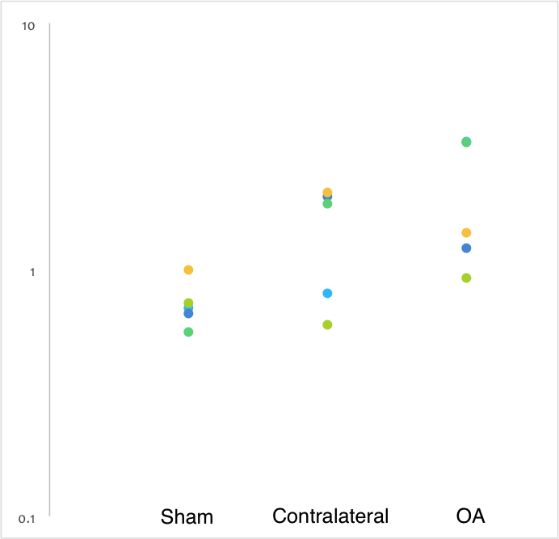
Table 3. Cxcr4 gene expression values
Figure 2. Cxcr4 gene expression across conditions
SHAM | Contralateral | OA
0.615 | 1 | 0.615
1.327 | 0.76 | 1.327
0.764 | 0.771 | 0.764
0.495 | 0.666 | 0.495
0.813 | 1.014 | 0.813
Table 4 contains the Ltbp2 expression values for each of the three conditions. Figure 3 represents this information in a scatter plot. The OA group had an expression 2.32 times higher than the sham group.
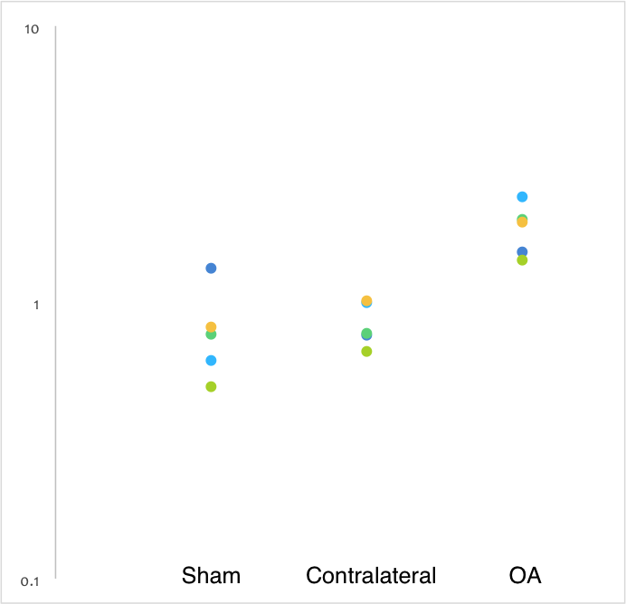
Table 4. Ltbp2 gene expression values
Figure 3. Ltbp2 gene expression across conditions
Figure 4 shows the distribution of changes in expression from the sham group to the OA group for all genes.
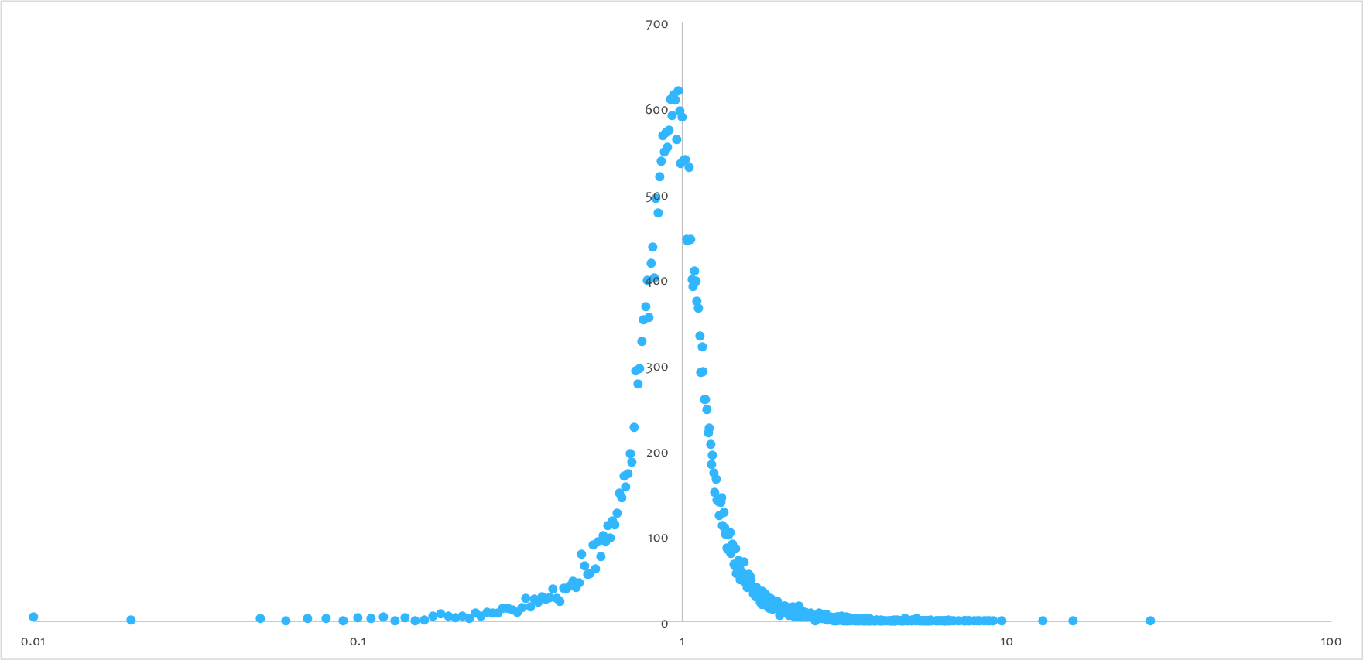
Figure 4. Genome-wide distribution of change in gene expressivity

Discussion
After analysis of Tnn, Cxcr4, and Ltbp2 changes in expressivity of the ten Sprague-Dawley rats, in the 15 knees, I found increase in expressivity for all three genes. As stated by Appleton et al., “4 weeks after surgery this model reproducibly reflects many aspects of early human OA, making it suitable for investigating early changes in cartilage gene expression in this disease.”3 Tnn resulted in the largest change in expression in the genome. I expected a positive change in this gene’s expression since it is associated with osteogenesis. Interestingly, Tnn was not mentioned in the paper. However, not discussing this gene in the paper may be due to authors considering it an outlier, or if there was some fault in the probing of this gene. Cxcr4 expression more than doubled in the OA group. This gene has been associated with cartilage degeneration and I expected expression to be at higher levels in the OA group. In the OA group, Ltbp2 expression also more than doubled. I expected this result as well due to this gene’s association with bone mineral density. Other studies found similar gene expression to this study. Shen et al. associated the SDF-1/Cxcr4 chemokine axis with the regeneration of injured meniscus. Wei et al. found similar results, concluding Ltbp2, along with other genes, was differentially expressed in both animal models and human OA.
The main limitations to this study are that the OA was surgically induced and genome data was collected four weeks after the surgeries were performed. Both of these only allow for compassion to the onset and beginning of OA. The genome-wide distribution of changes in gene expression is expected to be of normal distribution and is observed to be slightly bias towards the low side. This could be a result of sample bias. Another way to carry this study would be to carry out a cohort study and increase the sample size to 30 or more rats in hopes to normalize the distribution of changes of gene expression. Following these rats for a longer period of time, possibly until death, would allow researchers to make comparisons to the pathophysiology of OA observed in humans. Taking multiple measures of gene expression over time could allow for a better understanding of the biochemical, genetic factors involved in OA. The study found a significant increase in expression of Cxcr4 and Ltbp2 in the OA group compared to the sham group, insinuated their influence in OA. I hypothesize Tnn plays a role in OA with its 27.7 increase in expression in the OA group compared to the sham group, but further investigation will have to be carried out to find validity in this hypothesis.

Felson DT, Lawrence RC, Dieppe PA, Hirsch R, Helmick CG, Jordan JM, et al. Osteoarthritis: New Insights. Part 1: The Disease and Its Risk Factors. Ann Intern Med. 2000;133:635-646.
Teeple E, Jay GD, Elsaid KA, Fleming BC. Animal Models of Osteoarthritis: Challenges of Model Selection and Analysis. The AAPS Journal. 2013;15(2):438-446.
Appleton CT1, Pitelka V, Henry J, Beier F. Global analyses of gene expression in early experimental osteoarthritis. Arthritis Rheum. 2007 Jun;56(6):1854-68.
Martina E1, Chiquet-Ehrismann R, Brellier F. Tenascin-W: an extracellular matrix protein associated with osteogenesis and cancer. Int J Biochem Cell Biol. 2010 Sep;42(9):1412-5.
Wei F, Moore DC, Wei L, Li Y, Zhang G, Wei X, Lee JK, Chen Q.Attenuation of osteoarthritis via blockade of the SDF-1/CXCR4 signaling pathway.Arthritis Res Ther. 2012 Jul 31;14(4):R177.
Cheung CL1, Sham PC, Chan V, Paterson AD, Luk KD, Kung AW.Identification of LTBP2 on chromosome 14q as a novel candidate gene for bone mineral density variation and fracture risk association.J Clin Endocrinol Metab. 2008 Nov;93(11):4448-55.
Shen W1, Chen J, Zhu T, Chen L, Zhang W, Fang Z, Heng BC, Yin Z, Chen X, Ji J, Chen W, Ouyang HW. Intra-articular injection of human meniscus stem/progenitor cells promotes meniscus regeneration and ameliorates osteoarthritis through stromal cell-derived factor-1/CXCR4-mediated homing. Stem Cells Transl Med. 2014 Mar;3(3):387-94
Wei T1, Kulkarni NH, Zeng QQ, Helvering LM, Lin X, Lawrence F, Hale L, Chambers MG, Lin C, Harvey A, Ma YL, Cain RL, Oskins J, Carozza MA, Edmondson DD, Hu T, Miles RR, Ryan TP, Onyia JE, Mitchell PG. Analysis of early changes in the articular cartilage transcriptisome in the rat meniscal tear model of osteoarthritis: pathway comparisons with the rat anterior cruciate transection model and with human osteoarthritic cartilage. Osteoarthritis Cartilage. 2010 Jul;18(7):992-1000

