The Pennsylvania State University

The Graduate School

College of Nursing

**ELECTRONIC NICOTINE DEVICES: A Policy analysis**

A Project Paper in

Nursing

by

Carranda Barkdoll, M.S., RN, CRNP

Submitted in Partial Fulfillment

of the Requirements

for the Degree of

Doctor of Nursing Practice

May 2017

**Signature Page**

Doctoral Signatory Page on file in the Graduate School.

**TABLE OF CONTENTS**

Acknowledgements v

Abstract vi

Chapter 1 1

Introduction 1

Background and Significance of Problem 4

Project Purpose 5

Project Question 8

Aim and Objectives 8

Project Plan 9

Key Terminology 10

Summary 11

Chapter 2 13

Policy Framework 13

Search Strategy 15

Review of the Literature 17

Gaps in the Literature 31

Summary 32

Chapter 3 33

Methodology 33

Project Design 33

Method: Analysis of Policies 34

Project Compliance with the University Institutional Review Board 37

Plan for Dissemination 38

Budget 39

Summary 39

Chapter 4 41

Comparison and Gap Analysis 41

Summary 49

Chapter 5 52

Summary, Conclusions, Suggestions for Practice, Education, Research, Policy 52

Summary 52

Conclusions 57

References 59

Appendix A: Representative Marcy Toepel Letter 73

Appendix B: Representative Kathy Rapp Letter 74

Appendix C: IRB Approval 75

Appendix D: House Bill 954 76

Appendix E: Senate Bill 751 83

Appendix F: Senate Bill 80 (567) 85

Appendix G: ENDS Fact Sheet 103

Appendix H: Informational Matrix 104

Appendix I: Legislative Comparison Table 123

Appendix J: Budget Proposal Table 124

Appendix K: Policy Analysis Gap Summary 125

Appendix L: Program Evaluation 133

**Acknowledgements**

First, I would like to express my sincere gratitude to my committee chair, Dr. Marie Boltz, Ph.D., for the continuous support of my DNP project and related research, for her patience, motivation and immense knowledge. I could not have imaged having a better committee chair and mentor for my DNP project.

Besides my chair, I would like to thank the rest of my DNP committee: Dr. Lori Lauver, Ph.D., and Dr. Karen Wolf, Ph.D., for their insightful comments and encouragement, but also for the hard questions that inspired me to widen my research from various perspectives.

My sincere thanks also goes to Dr. Kathy Curci, Ph.D., Dr. Jonathan Foulds, Ph.D., and Dr. Edward Fuller, Ph.D., who provided their expertise and mentorship throughout my DNP project.

I thank my fellow nursing faculty colleagues and the Mont Alto community for their support while I was pursing my DNP degree. In addition, I want to thank my College of Nursing colleagues at The Pennsylvania State University, especially Leslie Hutchins, for her excellent editor’s skills.

Finally yet most importantly, I would like to thank my family for their unwavering support as I pursued my doctoral degree and my life in general.

**Abstract**

There is a non-cigarette tobacco phenomenon sweeping the United States (US) involving electronic nicotine delivery systems (ENDS). Since the introduction of ENDS, nearly 19 million of all US non-smokers and 65 million of US adult smokers have tried ENDS (Ebbert, Agunwamba, & Rutten, 2015). ENDS are becoming increasingly popular among nicotine-naïve and experienced tobacco users who believe that ENDS are less of a health risk than traditional nicotine products. The Federal Drug Administration (FDA) expresses concern about how ENDS are marketed to the public and the possibility that ENDS may promote nicotine addiction, delay or derail serious quitting attempts of combustible tobacco products and encourage youth tobacco use (Ricker, Lee, Darville, & Hahn, 2012). The purpose of the project is to analyze Pennsylvania House Bill (HB 954) and Senate Bill (SB 751), including their alignment with the FDA’s Family Smoking Prevention and Tobacco Control Act, the Clean Indoor Air Act of the Commonwealth of Pennsylvania (PA) and the reintroduced Senate Bill 80 (SB 80[567]), using the Centers for Disease Control and Prevention (CDC) Analytical Framework. The analysis demonstrated that the new legislative regulations align with the FDA regulations and Clean Indoor Air Act regarding ENDs. An educational fact sheet has been developed based on the results of the new legislation and the alignment of the regulatory mandates. The fact sheet can be disseminated to public forums, health care provider groups, and professional organizations (locally, regionally, nationally).

**Chapter 1**

**Introduction**

This chapter will examine the emerging trend of electronic nicotine device systems (ENDS) use, which is unregulated in many states, including until most recently the Commonwealth of Pennsylvania (PA). Some analysts predict that within a decade, sales of ENDS will surpass sales of combustible tobacco products (Etters & Bullen, 2013). As of May 10, 2016, the FDA issued its final ruling to deem ENDS products as meeting the statutory definition of “tobacco product.” Except for accessories, the newly deemed tobacco products are subject to the Federal Food, Drug, and Cosmetic Act (the FD & C Act) (Federal Drug Administration, 2016). In 2014, the formal notice-and-comment rulemaking process at the Federal level (deeming) was initiated defining ENDS as “tobacco products,” subjecting them both to regulatory oversight by the FDA (Ebbert, et al., 2015; FDA, 2014). To address public health concerns about currently unregulated tobacco products, the FDA deeming provision process will: 1) prohibit the sale of ENDS to individuals under the age of eighteen years; 2) require a health and safety warning on packages; 3) ban the distribution of ENDS via vending machines; 4) prohibit free samples; and 5) require pre-market FDA review of all newly manufactured tobacco products (Ebbert, et al., 2015; FDA, 2014). The FDA’s final rule covers all of the 2014 provisions found in the FDA’s Family Smoking Prevention and Tobacco Control Act with the exception of banning flavors and requiring childproofing of e-cartridges.

Electronic nicotine delivery systems (ENDS) are battery operated devices that are either disposable or refillable. ENDS usually contains liquid nicotine, and when heated, the liquid is vaporized into an aerosol and inhaled or drawn in by the user; a process called “vaping” through a mouthpiece (Caponnetto, Saitta, Sweanor, & Polosa, 2015; Etter, Bullen, Flouris, Laugesen, & Eissenberg 2011; Pokhrel, Little, Fagan, Kawamoto, & Herzog, 2014; Vansickel & Eissenberg, 2012). Propylene glycol and glycerin are the primary solvents for the nicotine, and a thin wire made with various metals (tin, iron, nickel, chromium, copper coated with silver) is utilized as heating elements (Brown & Cheng, 2014). Propylene glycol, used to create the vapor in ENDS, causes acute and chronic respiratory effects, and the volatile compound, formaldehyde, a known carcinogen, is found in both the cartridge and vapor (Riker, Lee, Darville, & Hahn, 2012; Callahan-Lyon, 2014).

First and second generation ENDS are rechargeable and disposable, whereas the fourth-generation ENDS that emerged on the market in 2015 are digital delivery devices (Brandon, Goniewicz, Hanna, Hatsukami, Herbst, Hobin …Warren, 2015). To date, there are more than 460 ENDS brands manufactured, with more than 7,700 flavors for purchase on the Internet (Brandon, et al., 2015). The emerging phenomenon of ENDS has turned into a nearly two billion dollars a year industry in the United States, and by the year 2030, global sales are estimated to grow to more than fifty billion (Crowley, 2015).

First introduced in the United States in 2007, ENDS were designed to deliver fewer toxicants and carcinogens than traditional combustible tobacco products (Hajek, Benowitz, Eissenberg, & McRobbie, 2014). Despite this design, lethal doses of nicotine have been found in unmarked ENDS cartridges resulting in unintentional deaths of young children when ingested (Gupta, Gandhi, & Manikonda, 2014). Intentional deaths were documented when nicotine containing e-liquid was injected intravenously (Thornton, Oller, & Sawyer, 2014). Since the introduction of ENDS, the United States Fire Administration has documented 29 cases of exploding lithium batteries in ENDS devices which have caused serious facial burns and lacerations of the face from flying shrapnel (U.S.F.A., 2014).

The American College of Physicians (ACP), American Association for Cancer Research (AACR), and the American Society of Clinical Oncology (ASCO) have recommended the regulation of ENDS (Brandon et al., 2015). Specifically, they are requesting the FDA to ban flavors from all tobacco and ENDS products, to pursue the restriction of marketing, promotion and advertising of ENDS to youth, as well as to prohibit sales of ENDS to individuals under the age of eighteen. In addition, they are requesting the FDA to require childproof packaging of e-cartridges (Ebbert, Agunwamba, & Rutten, 2015). Finally, they are calling for manufacturers to register all ENDS products and ingredient listings with the FDA, including harmful and potentially harmful components along with nicotine concentrations (Brandon, et al., 2015). The ACP, AACR and the ASCO have proposed that federal, state, and local regulators should take action to extend regulations for ENDS into indoor and public place clean air laws, prohibiting ENDS vaping in public places, places of employment, and commercial aircraft (Crowley, 2015).

The taxation of ENDS, however, is the one issue where the ACP, AACR, and ASCO do not share a consensus. The ACP is in support of blanket taxation for all ENDS at all levels of government. Conversely, the AACR and ASCO both support taxation on ENDS products proportionate to their harm, which is associated with the level of nicotine found in e-cartridges (Brandon et al., 2015).

**Background and Significance of Problem**

Although ENDS have only been in existence since 2007, emerging research shows little data on the hazards and safety of the ENDS. The Surgeon General reported that “most people begin to smoke in adolescence and develop characteristic patterns of nicotine dependence before adulthood” (Food and Drug Administration, 2016). As a result, addiction to nicotine is life-long, and youth and young adults generally underestimate the tenacity of nicotine addiction and overestimate their ability to stop smoking when they choose (FDA, 2016). In response to the potential of a life-long addiction to nicotine, the Commonwealth of PA has taken the first steps in addressing these hazard and safety concerns with the passage of House Bill 954 and Senate Bill 751 regulating the sale of ENDS to minors. Both bills amend Title 18 (Crimes and Offenses) of Pennsylvania Consolidated Statutes, in minors, further providing for the offense of sale of tobacco (HB 954, 2015; SB 751, 2015). Under current regulations of ENDS, thirty-eight states currently prohibit the sale of ENDS to minors (Hanson, 2014). The Commonwealth of PA was not among these States until 2015.

Policy analysis typically bridges all political ideologies by reliance on the normative standards of “maximizing welfare” and on social science theorizing and evidence about comparative advantages of different institutions for different purposes (Bardach & Patashnik, 2016). With diverse political ideologies of ENDS regulation across the states ranging from unregulated marketing to complete bans, the issue can be addressed by not just simply echoing issue rhetoric in the problem definition but by utilizing it as raw material for a problem statement which can be analytically useful (Bardach & Patashnik, 2016, p. 5).

The Commonwealth of PA’s response in providing consistency in the regulation of ENDS was the PA House’s passage of the Amendment Bill 954 and the Senate Companion Bill 751 to Title 18, June, 2015. Both bills define ENDS as a “tobacco product” and prohibit the sale of ENDS to individuals under the age of eighteen. The HB further prohibits the use of nicotine on school property by making it a summary offense. The reintroduction of SB 80 (567) further restricts the use of ENDS under the Clean Indoor Air Act (CIAA). With the implementation of the FDA’s deeming of ENDS as tobacco products, it will require dissemination of the information to the stakeholders impacted by the legislative changes. Professional nursing organizations, the Department of Education, healthcare provider groups and public forums need to become knowledgeable about the safety and harm reduction of ENDS use as well as proposed federal and legislative policies.

**Project Purpose**

The purpose of the project was to conduct an analysis of Pennsylvania House Bill (HB 954) and Senate Bill (SB 751), and their alignment with the FDA’s Family Smoking Prevention and Tobacco Control Act, the Clean Indoor Air Act of the Commonwealth of Pennsylvania (PA) and the reintroduced Senate Bill (SB 80[567]). The Center for Disease Control and improves the analytic basis for identifying and prioritizing policies that can improve health and improves the strategic approach to identify and further the adoption of policy solutions (CDC, 2012). In this project, the five domains and overarching domains of the CDC’s framework are used to assess the magnitude of the bill’s impact on protecting the public health as well as guide the development of information essential to dissemination.

The first domain, *problem identification,* guides the clarification and framing of a problem or issue in terms of the effect on population health. Collection, summarization and the interpretation of information relevant to the problem or issue, defining the characteristics of the problem or issue and identifying gaps in the data lends itself to potential policy solutions (CDC, 2012).

The second domain, *policy analysis,* describes the different policy options to address the problem or issue and uses quantitative and qualitative methods to evaluate policy options to determine the most effective, efficient and feasible option. Utilizing research and identifying policy options, policy analysis describes how the policy will impact morbidity and mortality, the costs to implement the policy and how the costs compare with the benefits, and the political and operational factors associated with adoption and implementation of a policy, and finally, assessing and prioritizing policy options (CDC, 2012).

Additional domains describe the operationalization of policy. The *strategy and policy development* domain is used to guide the description of how a policy operates and what is needed for policy enactment and implementation. It defines strategies for engaging stakeholders and policy actors and can possibly help draft a policy (CDC, 2012). *Policy enactment* follows internal or external procedures for getting policy enacted or passed, utilizing the law, regulation, procedure, administrative action, incentive, or voluntary practice (CDC, 2012). *Policy implementation* guides the of policy implementation into operational practice and defines policy implementation standards and the implementation of regulations, guidelines, recommendations, directives and organizational policies. It identifies indicators and metrics to evaluate implementation and impact of a policy and coordinates resources and builds capacity of personnel to implement policy. Finally, it assesses implementation and ensures compliance with policy and support post-implementation sustainability of policy (CDC).

As a final point, two overarching domains thread appropriately through all five domains. First, the *stakeholder engagement and education* identifies and connects with decision-makers, partners, those affected by the policy, and the general public. It allows for the identification of key stakeholders, including supporters and opponents, and assesses for relevant characteristics. It provides for the implementation of communication strategies and delivers relevant messages and materials, and finally, solicits input and gathers feedback (CDC, 2012). An educational fact sheet describing the legislative changes derived from the analytic review of the bills was developed and disseminated to local, regional, and national organizations. The fact sheet that was developed aligned ENDS regulation with Pennsylvania House Bill (HB 954), Senate Bill (SB 751) the reintroduced Senate Bill (SB 80[567]), the FDA’s Family Smoking Prevention and Tobacco Control Act, and the Clean Indoor Air Act of the Commonwealth of Pennsylvania (PA). The key points addressed such regulatory components as age restrictions, child proofing, taxation, stricter labeling, environmental smoking, banning distribution of ENDS via vending machines, and finally, requiring pre-market review products (Ebbert et al., 2015, FDA, 2014).

The second overarching domain, *evaluation,* concludes the process and formally assesses the appropriate steps of the policy cycle, including the impact and outcomes of the policy. It defines evaluation needs, purpose and intended uses and users, conducts evaluations of prioritized evaluation questions, and disseminates evaluation results (CDC, 2012). Evaluation was a critical component of this project. In this evaluation, several “unanticipated consequences” were considered such as the increase in moral hazards, their potential drift toward overregulation, and their capacity to address the ethical cost of optimism. Several strategies, such as reviewing the literature, surveying best practices and conducting an environmental scan to understand what other jurisdictions are doing in comparison to the Commonwealth of PA’s legislation were utilized.

**Project Question**

The information collected from the current evidence was used to address the question: How does the PA House (HB 954) and PA Senate (SB 751) amendment bills and reintroduced PA Senate Bill (SB 80[567]) compare to the Clean Indoor Air Act of the Commonwealth of PA and the FDA’s Family Smoking Prevention and Tobacco Control Act regulations of ENDS?

**Aim and Objectives**

The overall aim of the DNP project was to: 1) produce a comparative analysis of Pennsylvania House (HB 954), Senate (SB 751) and Senate (SB 80 [567]) Bills, and 2) disseminate the related regulatory issues to the stakeholders which includes public forums, health care provider groups, and professional organizations (locally, regionally, nationally).

A deliverable of the project was an informational fact sheet describing the new legislation that addresses the following categories: age restrictions, child proofing, taxation, stricter labeling, environmental smoking, the banning distribution of ENDS via vending machines, and lastly, the requirement for pre-market review of new ENDS products (Ebbert et al., 2015; FDA, 2014). These categories are consistent with FDA’s Family Smoking Prevention and Tobacco Control Act.

The five domains of the CDC’s Policy Analytical Process, (policy identification, policy analysis, strategy and policy development, policy enactment, and policy implementation) and two overarching domains, (stakeholder engagement and education, and evaluation) were used to guide analysis of the project. Relevant policies were identified and analyzed, including their development and current status. Consistent with the framework, which emphasizes engaging and educating stakeholders, the project yielded key points on safety and harm reduction for nicotine-naïve and experienced users.

**Project Plan**

The step-by-step plan of the project was: 1) review the available literature; 2) gather information (through meeting with legislators to discuss House Bill 954, Senate Bill 751 and Senate Bill 80[567] ); 3) utilize a gap analysis matrix to identify similarities and differences in the bills with the Clean Indoor Air Act of the Commonwealth of PA and the FDA’s Family Smoking Prevention and Tobacco Control Act using the CDC’s Policy Analytic Framework; 4) develop an educational fact sheet; and 5) disseminate information to key stakeholders.

The plan for the project includes the completion of an extensive literature review. The review of the literature included the known epidemiology of ENDS, including host (adult & youths) agent’s characteristics such as toxicology as well as environmental hazards and associated health effects. There is limited research on the long-term effects of ENDS on adults, youth and pregnant women which makes it difficult to provide best practices for educating the public on the pros and cons of ENDS. The limited information on best practices has led national organizations such as the ACP, AACR, and the ASCO to call for the FDA to deem ENDS as “tobacco products” which would subject ENDS to some regulatory oversight as combustible tobacco products. Another regulatory oversight of deeming is that ENDS will be subject to taxation which is a disincentive for their use. Furthermore, their recommendation that federal, state and local regulators should take action to extend indoor and public place clean air laws that prohibit ENDS vaping in public places, places of employment, and commercial aircraft (Crowley, 2015) is presented. Finally, the recent introduction of taxation on ENDS by the Commonwealth of PA and other states will be examined in the literature review as well.

The information collected, consistent with the CDC’s Policy Analytic Framework, was used in the DNP project to determine alignment between the best evidence-based recommendations and the proposed legislation. The PA House and Senate bills, as well as the FDA’s Family Smoking Prevention and Tobacco Control Act and the Clean Indoor Air Act of the Commonwealth of PA, were thoroughly analyzed and used to examine the relationship of the bills with the current evidence-based research related to harm reduction and the safety and hazards of ENDS. An educational fact sheet has been developed regarding the comparative analysis of the new legislation. The content has been disseminated to the stakeholders impacted by the new legislation.

**Key Terminology**

**Electronic Nicotine Delivery Systems (ENDS)**:a device that looks and feels like cigarettes, but does not burn tobacco. They are battery operated devices that are either disposable or refillable that usually contains liquid nicotine and when heated the liquid is vaporized into an aerosol and inhaled or drawn in by the user (Etter, 2010).

**Vaping**: a process in which the solvent is heated with a thin wire made with various metals (tin, iron, nickel, chromium, copper coated with silver) and the user inhales or draws in the vapor or mist (Brown & Cheng, 2014).

**E-liquid**: the liquid found in an ENDS cartridge, which contains propylene glycol or vegetable glycerin (food additives) along with flavoring and nicotine.

**E-cartridge**:a refillable or disposable container or “tank” which holds e-liquid in advance generation devices, eGO’s or mods.

**Tobacco Products**: any product made or derived from tobacco that is intended for human consumption, including any component, part, or accessory of a tobacco product (except for raw materials other than tobacco used in manufacturing a component, part or accessory of a tobacco product (FDA, 2016).

**Federal Food, Drug and Cosmetic Act and Tobacco Control Act**: prohibits the movement in interstate commerce of adulterated and misbranded food, drugs, devices, and cosmetics, and for other purposes (FDA, 2014).

**Clean Indoor Air Act of the Commonwealth of PA**:prohibits smoking in a public place or a workplace and lists examples of what is considered a public place. The bill allows for some exceptions, including a private residence (except those licensed as a child care facility), a private social function where the site involved is under the control of the Sponsor (except where the site is owned, leased, or operated by a state or local government agency), and a wholesale or retail tobacco shop. It also imposes penalties for those establishments in noncompliance, as well as those individuals smoking in prohibited areas (Pennsylvania Department of Health, 2008).

**CDC’s Policy Analytical Process Framework**: a framework that utilizes five domains and two

overarching domains for policy cycle analysis. The overarching domains are: stakeholder engagement and education and evaluation. The five domains of policy analysis are: problem identification, policy analysis, strategy and policy development, policy enactment and policy implementation.

**Summary**

The landscape of ENDS is evolving rapidly. Virtually nonexistent a decade ago, ENDS have skyrocketed in popularity allowing small companies to enjoy “a sort of free market utopia” (Sharfstein, 2015). The emergence of nicotine-laced ENDS has caught many, including government regulators and policy makers, by surprise (Fillon, 2015). This has led each State to implement regulations controlling ENDS, with consideration given to the FDA’s new regulations which deem electronic cigarettes as “tobacco product.” The use of the CDC’s Policy Analytical Process Framework is an effective way to analyze the FDA’s regulatory final ruling in deeming electronic cigarettes as “tobacco products.” In addition, the CDC’s policycan define, identify, analyze and prioritize a potential solution for the safety and harm reduction concerns surrounding the use of ENDS.

**Chapter 2**

This chapter describes the CDC Policy Analytical Process Framework that was used to guide the project. It includes an examination of the policy framework, search strategies, review of literature, synthesis of findings, and the key findings from the literature as it relates to the Tobacco Control Act (TCA). Finally, the identified gaps in the literature in relationship to the key findings and the TCA are discussed.

**Policy Framework**

The CDC Policy Analytical Process Framework was used to guide the project. The framework provides a multidisciplinary view allowing for normative reasoning as follows: “Our problem is not to do what is right. Our problem is to know what is right” (Dunn, 2016, p. 4). The CDC framework has five defined domains and two overarching domains that are not linear, but a policy cycle that overlaps (Figure 1). The cyclical process begins with the definition of the problem and proceeds through process domains that include: policy analysis, policy development, enactment of policy, and implementation. The domains provide a mechanism for analyzing and prioritizing a policy, and finally, adopting the best option. The first domain, problem identification, gathers data on the characteristics of a problem or issue. The domain allowed for the identification of the phenomenal use of ENDS and the potential impact on public health.

The second domain, policy analysis, explores types of research, provides possible policy options relevant to a problem or issue, and the potential strategies for gathering evidence regarding the policy (Centers for Disease Control, 2012). This domain is reflective in an in-depth literature review as well as a thorough review of the FDA’s deeming policy of ENDS as “tobacco product.”

The third domain, strategy and policy development, addresses the cost benefits of the regulatory changes adopted into State law and what the strategies are for the development and implementation of policy changes. The costs benefits become apparent with the Commonwealth in acting a “sin” and “floor” taxation on ENDS which was enacted August, 2016. The focus of the fourth domain, policy enactment, establishes a mechanism that follows internal and external procedures for getting a policy enacted or passed. It assists with the careful balance needed to be maintained between the need to protect the consumers and the possibility now being offered to smokers to use a new, acceptable and potentially effective device to stop smoking (Etter, 2010). This domain allowed for a look at the polarization of the experts in public health in regards to harm reduction vs. hazards and safety issues.

The fifth domain, policy implementation, enacts a law with regulation, procedure, administrative action, incentive, or voluntary practice, and translates policy into operational practice (CDC, 2014). This domain was enacted in the examination of the alignment of the Commonwealth of PA legislative bills and FDA’s Family Smoking Prevention and Tobacco Control Act, and the Clean Indoor Air Act of the Commonwealth of Pennsylvania (PA).

In addition to the five domains, the CDC framework identified two overarching domains that are considered to be relevant to and applied to the five domains. The two overarching domains include stakeholder engagement and education and evaluation. The overarching domains of the framework address the development and formally assess the appropriate steps of the policy cycle, including the impact and outcomes of the policy (CDC, 2012). Although all of the domains are important in the analytical review of HB 954, SB 751 and SB 80 (567), and based on the critical analysis for the literature, domain one, two, five and the two overarching domains have the most bearing on this DNP project. Consistent with these domains, the project identified the characteristics of the problem or issue; utilized an in-depth literature review for evidence-based research; and conducted a comparative analysis of the state and federal regulations. Finally, the project identified and engaged relevant stakeholder and organizations throughout the process and allowed for the dissemination of evidenced based research. In conclusion, the framework guided the gathering of information to identify barriers and solutions in educating stakeholders on harm reduction, safety and hazards of ENDS use.

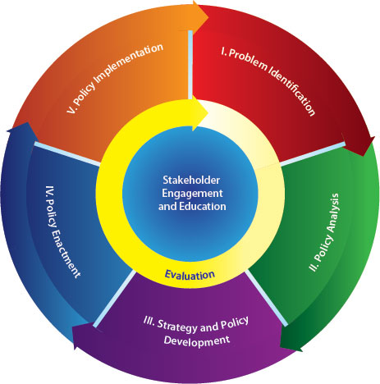

*Figure 1.* Domains of the CDC Policy Process. Adapted from the Centers for Disease Control and Prevention. Overview of CDC’s Policy Process. Atlanta, GA: Centers for Disease Control and Prevention, US Department of Health and Human Services; 2012.

**Search Strategy**

The databases accessed for the review were PubMed, CLINAHL, Medline, EBM Reviews, and the National Clearing House. Search terms used alone or in combination included “Electronic Cigarettes/adverse effects" OR "Electronic Cigarettes/epidemiology" OR "Electronic Cigarettes/instrumentation" OR "Electronic Cigarettes/methods" OR "Electronic Cigarettes/organization and administration" OR "Electronic Cigarettes/standards" OR "Electronic Cigarettes/statistics and numerical data" OR "Electronic Cigarettes/trends" OR "Electronic Cigarettes/utilization.” With the passage of the FDA TCA as of May, 2016, it was necessary to complete a secondary search utilizing Google Scholar using the search term combinations of “Tobacco/adolescents” OR “Tobacco regulations” OR “FDA” or “Tobacco/brain function.” Articles considered in both searches for inclusion in the review were: (1) written in English, (2) utilized ten years after publication; however, the databases on ENDS started in 2007, (3) needed to be full text and publicly available, (4) published in peer review journals, and (5) only non-animal clinical trials.

The initial search of the databases yielded three hundred and forty-one articles. Adding the additional terms reduced the number of articles to forty-two that were relevant to the characteristics and design of non-combustibles, toxicology, public health issues, health effects, safety and hazards, and regulatory implications. Twenty-four additional publications were identified for inclusion in a manual search of reference lists of those studies. From the seventy publications, fifteen articles were identified as aligning with the legislative regulations and the FDA’s Family Smoking Prevention and Tobacco Control Act. The articles were also reviewed for the level of evidence, sample size, research design utilized, research findings and a critique of the research studies’ strength (Appendix H).The secondary search of Google Scholar yielded twelve articles that utilized systematic review and meta-analysis focusing on adolescent and nicotine impairment of brain function as well as the FDA approach to tobacco regulations.

**Review of the Literature**

The proposed project focused on the complexity of regulating ENDS and the difficulty of defining ENDS as a “tobacco product.” The addictive and toxic properties of tobacco products have been clearly known and widely accepted for decades (Ashley & Backinger, 2012). As a result, the Family Smoking Prevention and Tobacco Control Act (TCA, H.R. 1256) of 2009 signed by the Obama administration resulted in the reissuance of the 1996 FDA Tobacco Rule that was originally struck down by the Supreme Court in 2000. The rule placed new restrictions on youth access to tobacco products, ended all remaining brand-name sponsorships at sporting and other entertainment events, and limited tobacco advertising in publications with a significant youth readership to black-on-white text only (TCA, 2009). Required labeling requirements on cigarettes and smokeless tobacco products would have to be more explicit and conspicuous and would give the FDA the authority to develop regulations restricting the sale, distribution, advertising and promotion of tobacco products to the extent permitted by the First Amendment (TCA, 2009). Under the Federal Food, Drug and Cosmetic Act (FFDCA), the FDA would have to demonstrate that any proposed tobacco product regulation was appropriate for the protection of public health as well as considering the risks and benefits of the population as a whole (TCA, 2009).

Under the Tobacco Control Act (2009), manufacturers are required to obtain FDA approval in order to market a new tobacco product unless the FDA determined that it was substantially equivalent (SE) to a product already on the market or a minor modification of an existing product. The bill prohibits the use of descriptors such as “light” and “mild” in marketing. In addition, manufacturers claiming reduced risk must substantiate the claim with clinical evidence and agree to FDA surveillance (TCA, 2009). Further, the bill bans the use of all artificial and natural flavors in cigarettes, except menthol. The continued use of menthol was a compromise that was negotiated with Phillip Morris in order to secure the company’s support for the tobacco control legislation (2009).

This project originated when a literature review revealed that with the recent emergence of ENDS in the last decade, there was no long-term research related to the epidemiology of ENDS. Also lacking are the characteristics of the host (adult & youths) agent’s characteristics such as toxicology, environmental hazard, and associated health effects. Accordingly, ENDS have emerged as a public health concern in the United States (US) with the oversight of ENDS being regulated by individual states. As a result of the literature review, the project analyzed Pennsylvania House (HB 954), Senate (SB 751) and Senate (SB 80 [567]) Bills and their alignment with the FDA’s Family Smoking Prevention and Tobacco Control Act and the Clean Indoor Air Act of the Commonwealth of Pennsylvania (PA) using the CDC’s Policy Analytical Process Framework.

**Legislative comparison**. The FDA’s Family Smoking Prevention and Tobacco Control Act was utilized as the springboard for constructing the legislative comparison table (Appendix I). The FDA’s Family Smoking Prevention and Tobacco Control Act encompassed all of the current regulatory considerations for ENDS use. The Clean Indoor Air Act of Commonwealth of PA, House Bill 954, Senate Bill 751, and Senate Bill 80 (567), along with the FDA’s Family Smoking Prevention and Tobacco Control Act, were inserted into an overview table that allowed for the identification of a constellation of characteristics at one glance. This overview table also allowed for a basis of identifying patterns between the five legislative bills.

**Synthesis of content***.*A critical analysis and synthesis of the studies provided certain insights about ENDS such as the safety and hazards of ENDS, toxicology profile of ENDS, and the potential for harm reduction. The studies were published within the last seven years which produced limitations regarding the long-term effects of ENDS use. The majority of the research analyzed has small sample sizes (N=11 to N=81) and included qualitative and quantitative studies utilizing cross-over trial and longitudinal designs. The survey and questionnaire designs had substantially large participant’s numbers (N=1177 to N=6495); however, several researchers indicated potential weakness in their results related to recall and selection bias as most of the participants were current or former smokers. Only one study conducted by Barbeau, Burda and Seigel (2013) utilized the Grounded Theory approach. The study conducted by Caponnetto, et al. (2013), was the only random control (RCT) which was conducted with Italian smokers. Cheng (2014) noted that most of the recent studies have concentrated on the sale of ENDS in the foreign markets indicating a strong need for evaluation of what is currently sold in the US market.

The articles reviewed regarding cognitive changes of the adolescent brain and tobacco included several large systemic reviews and/or meta-analyses studies. The studies concluded that adolescence represents a distinct period of vulnerability for nicotine-induced neural damage. Impairment of acetylcholine and other neurotransmitters which impact brain cell development and synaptic function are noteworthy as well. In a study conducted by Jacobsen, Krystal, Mencl et al. (2005), adolescent daily smokers experienced acute impairment of verbal memory and working memory after smoke cessation. There were also chronic decrements in cognitive performance that are consistent with preclinical evidence that neurotoxic effects of nicotine are more severe when exposure occurs at earlier periods of development.

**Study Characteristics**

The results of the review on ENDS and regulations of ENDS are categorized as: 1) history of ENDS, 2) age-restrictive sales, 3) negative effects of ENDS, 4) restricting the marketing of ENDS, 5) FDA approval of new products, and 6) education: characteristics of the users.

**History of ENDS.**

ENDS, invented by Lik Hon, a Chinese pharmacist from Hong Kong in 2003, became available in the US in 2007 (Hajek, Etter, Benowitz, Eissenberg, & McRobbie, 2014). The Tobacco Control Act of 2009 led to a reduction of tobacco use resulting in lost revenue for the tobacco industry. Because of the TCA point-of-sale strategies, the tobacco industry began to channel even more of its marketing budget into the retail environment of ENDS (TCLC, 2014). Driven by the rapid evolution of ENDS, and driven by competition, growth in sales initially started by word of mouth and user enthusiasm (Hajek et al., 2014). However, over the last decade, ENDS have become widely available globally; particularly notable is the explosion of sales over the Internet (Hajek et al., 2014; Adkinson, O’Connor, Bansal-Travers, Hyland, Borland…Fong, 2013). The emerging phenomenon of ENDS has turned into a nearly two billion dollar a year industry in the United States, and by the year 2030, global sales are estimated to grow to more than fifty billion (Crowley, 2015).

ENDS are handheld devices that deliver nicotine to a user through the battery-powered vaporization of a nicotine/propylene glycol solution (Cahn & Siegel, 2010). ENDS do not burn tobacco, they do not emit smoke, but rather, a user inhales and exhales a vapor, also called a plume, fog or aerosol (Riker, Lee, Darville, & Hahn, 2012). The first-generation ENDS are rechargeable and disposable and resemble conventional cigarette’s shape and size. Second and third generation ENDS are typically refillable with e-liquid; eGos are larger and have a “tank” that is refillable with nicotine-containing e-liquid; and mods, which are even larger, have a stronger battery and are almost endlessly customizable (Zhu, Sun, Bonnevie, Cummins, Gamst,...Lee, 2014). Fourth generation ENDS that emerged on the market this year are digital delivery devices with microprocessors and memory chips. The fourth-generation devices are being used to deliver specific product quantities or concentrations through Bluetooth technology, as well as disseminating data collection to third parties regarding personal information, smoking topography and possible health-related data (Brown & Cheng, 2014; Brandon et al., 2015). To date, there are an estimated 466 ENDS brands and more than 7,700 flavors available on the Internet (Brandon et al., 2015; Wilt, 2015). There is a net increase of 10.5 brands of ENDS and 242 new flavors per month, moreover that older brands tend to highlight their advantage over conventional cigarettes and that newer brands emphasized consumer choice in multiple flavors and product versatility (Zhu et al., 2014).

**Age-restrictive Sale**

Advocates of tobacco harm reduction have pointed to ENDS as viable substitutes for cigarettes because they produce fewer toxins in the vapor delivered to the user (Adkison et al., 2013). Proponents of the use of ENDS cite that the absorption of nicotine is slower than combustible tobacco. The small study (N=16) conducted by Eissenberg (2010), reported that despite the minimal increase in plasma nicotine in several brands of ENDS containing 16 mg of nicotine, there was a significant decrease (p<0.001) in craving post 5 minutes, 15 minutes, 30 minutes, and 45 minutes with the use of these products. Duke and colleagues (2014) noted that currently no studies had been conducted that carefully investigated the effect of different nicotine doses of ENDS to determine participant preference and effect. However, concerns exist regarding long-term safety, inadequate data on contents and emissions, especially with long-term use, and unsupported product claims as a smoking-cessation aid (Adkison et al., 2013).

Most dual users report using the ENDS to limit the number of combustible tobacco products or as an attempt to use ENDS as a smoke cessation aid and for harm reduction (Corey, Ambrose, Apelberg, & King, 2015). Nevertheless, users acknowledge the ENDS may not be “entirely safe” and are “addictive” but believe they are safer and less addictive than cigarettes.

Adult, youth, and pregnant cigarette smokers are drawn to ENDS because they cost less and are perceived to have reduced toxicity and more freedom of use. ENDS are also seen as a way to help with smoke cessation or to reduce cigarette use. However, nicotine exposure in youth interferes with the critical development of the brain, causes addiction and is likely to lead to sustained tobacco use (Corey et al., 2015). For pregnant women, no amount of nicotine is safe causing preterm births, low-birth-weight babies and stillborn births (Kennedy, 2015). Research conducted on animal models has indicated that exposure to a substance such as nicotine can disrupt prenatal brain development and may have long-term consequences on cognitive function (FDA, 2016).

**Negative effects of ENDS.**

***Toxicology.*** ENDS are marketed and perceived as a less harmful alternative to conventional cigarettes; however, there is currently a lack of clear, comprehensive, and quantitative evidence on the toxicants in ENDS aerosols (Goel et al., 2015). Cigarette smoking typically results in nicotine and cotinine levels of 10-50 ng/ml and 250-300 ng/ml. However, e-liquid refill nicotine levels have been noted to be varying from 25mg/ml to 750mg/ml (Thornton, Oller, & Sawyer, 2014). Etter and colleagues (2011) reported nicotine-containing liquid and bottles of this liquid may be dangerous as each can contain up to 1 gram of nicotine: the fatal dose of nicotine is estimated to be 30-60 mg for adults and 10 mg for children. Accidental overdoses have been on the rise due to the flavored e-liquid such as strawberry and cookies and cream with the smell being appealing to young children (Foulds, 2015). Fortunately, nicotine does not taste good, so many children do not continue to consume the e-liquid; however, unfortunately, even a small dose can be lethal for a child (Foulds, 2015). Confounding the public health concerns of overdosing, the United States has the highest inaccuracy in product labeling of e-liquid content and the least regulatory framework for manufacturers (Goniewicz et al., 2015).

Even though ENDS may be less harmful than tobacco smoking, an analysis of e-cartridges has demonstrated carcinogens like nitrosamines, diethylene glycol (antifreeze), anabasine, myosmine, and beta-nicotryine (Etter, 2010). The volatile compound formaldehyde, a known carcinogen as well, is found in both the cartridge and vapor (Callahan-Lyon, 2014; Riker, Lee, Darville, & Hahn, 2012). Depending on the brand of cartridge's humectants to produce the vapor of ENDS, each brand contains different amounts of propylene glycol (theater fog) and glycerol (Etter et al., 2011). Propylene glycol and glycerin are the primary solvents for the nicotine, and a thin wire made with various metals (tin, iron, nickel, chromium, copper coated with silver) is utilized as heating elements (Brown & Cheng, 2014).

Puff topography noted that ENDS release the free radical phenyl-N-tert-butylnitrone (PBN) in both the vaping aerosols of all e-liquids and voltages of ENDS (heating/burning of a dry wick). ENDS users tend to take larger and longer puffs with a slower flow rate than conventional cigarette smokers and puff 200 times a day or vape 25 times per day which results in 2 x 1015 radicals per day (Goel et al., 2015). Free radical exposure from air pollution is estimated to be 2 x 1014, which indicates a ten times greater exposure to free radicals from electronic cigarettes than air pollution.

***Respiratory effects.*** There is limited scientific evidence on human health effects of ENDS; however, aerosol exposure may be associated with respiratory function impairment (Callahan-Lyon, 2014). The most common complaints when initiating ENDS was mouth and throat irritation and dry mouth (Caponnetto et al., 2013). ENDS users reported the most frequent adverse effects over time were dry mouth, chapped lips, throat and nasal irritation, headaches, and bad breath (Baweja et al., 2015). For individuals that have asthma, the micro-particles such as chemicals and metals from the heated ENDS cause asthmagenic particles which can cause exacerbation of asthma (Schivo, Avdalovic, & Murin, 2014).

The positive aspects reported by ENDS users were an improvement in overall health after initiating ENDS, reduced craving and a decreased use of nicotine use. In comparison, positive physiological aspects noted were: easier breathing, no hacking cough, improvement in taste and smell, and a noted reduction in hypertension (Baweja et al., 2015).

***Accident and unintentional injury.*** In 2015, a one-year-old male was the first unintentional fatality from nicotine ingestion in the United States (Grana, 2015). According to the CDC, calls to poison control centers related to ENDS spiked in recent years, from one call per month in September, 2010, to two hundred and fifteen calls in the month of February, 2014. Fifty-one percent of the calls involved children under the age of five years (Chatham-Stephens et al., 2014). Callahan-Lyon (2014) noted that exposure for non-users, especially children, were at risk of toxicity from refill cartridges; the flavoring may increase appeal and the total nicotine content is potentially life threatening. The potential for life-threatening toxicity in children has opponents pursuing improvements in child proofing and stricter labeling of e-liquids. Choking on ENDS components has been reported and is a potential pediatric hazard. Lastly, ENDS explosions during use and charging have been reported to FDA and by the media (Durmowicz, 2014). The risk of injury resulting from ENDS explosions includes facial and respiratory burns, shrapnel wounds, as well as house and car fires (United State Fire Administration, 2014).

**Restricting Marketing of ENDS: Regulatory Considerations.**

The rapid emergence of ENDS has caught many opponents by surprise, including the government regulators and policy makers (Fillon, 2015). Under current regulations of ENDS, Hanson (2014) reports that 38 states currently prohibit the sale of ENDS to minors; however, until recently, the Commonwealth of PA was not among the states. Until 2015, only Philadelphia prohibited ENDS in non-hospitality workplaces, restaurants and bars. Minnesota, New Hampshire, New Jersey, Utah and Suffolk County, New York all have a state and local act that prohibits some aspects of sales to minors, free sampling, and marketing, or they have extended the Clean Indoor Air Act to cover ENDS. Minnesota and California are the only two states that impose criminal penalties for the sale of ENDS to minors (Tobacco Control Legal Consortium, 2011, California Senate Bill 648, 2014). The Tobacco Control Legal Consortium (TCLC) partners with organizations such as the American Heart and Lung Associations, the CDC, and the Campaign for Smoke-Free Kids providing legislative drafting and policy assistance to community leaders and public health organizations. The TCLC is a legal network which utilizes experts from eight affiliated legal centers who assist communities with tobacco law-related issues ranging from smoke-free policies to tobacco control funding laws to regulation of flavored cigarettes (Public Health Law Center, 2015).

To address public health concerns about unregulated tobacco products such as ENDS, the FDA deeming provision process proposes to: 1) prohibit the sale of ENDS products to individuals under the age of eighteen years; 2) require health and safety warning on packages; 3) ban vending machines in establishments that have individuals under the age of eighteen; 4) ban free samples; 5) require pre-market review of all new tobacco products; and 6) require child-proof packaging of e-cartridges (Ebbert et al., 2015; FDA, 2014). ENDS, as of May, 2016, are now regulated by the Federal Drug Administration (FDA). These new regulations stem from the 2014 formal Federal notice-and-comment rulemaking provision process (deeming) identifying ENDS as “tobacco products” subjecting them to regulatory oversight (Ebbert, Agunwambs, & Rutten, 2015; Federal Drug Administration, 2014; Federal Drug Administration, 2016).

Organizations such as the American College of Physicians (ACP), American Association for Cancer Research (AACR) and the American Society of Clinical Oncology (ASCO) have called for regulation of ENDS. All three organizations have recommended that the FDA use its regulatory authority under the Family Smoking Prevention and Tobacco Control Act to cover ENDS (Crowley, 2015). Flavoring should be banned from all tobacco products (Crowley, 2015 & Brandon et al., 2015) along with restricting the marketing, promotion, and advertising of ENDS to individuals under the age of eighteen. They also request that manufacturers be required to register with the FDA all products and ingredient listings, including harmful and potentially harmful components, as well as nicotine concentrations of ENDS (Brandon et al., 2015). Federal, state, and local regulators should take action to extend indoor and public place clean indoor air laws that prohibit ENDS vaping in public places, places of employment, and commercial aircraft (Crowley, 2015), require child-proof packaging of e-cartridges (Ebbert, Agunwamba & Rutten, 2015), and finally, taxation of ENDS proportionate to their harm (Brandon et al., 2015).

**FDA Approval of New Products: Public Health Issues.**

The public health issues surrounding ENDS use are similar to the issues found with tobacco product use. Environmental hazards, universal health side effects of vaping, increased use of poison control calls for unintentional overdoses, increased choking incidences, lithium battery explosions and the effects of second and third-hand smoke all pose public health concerns. Although ENDS do not contain many of the toxic substances in cigarette smoke, a recent FDA review reported that various chemical substances and ultrafine particles are known to be toxic or carcinogenic. Tobacco-specific nitrosamines (TSNAs) and diethylene glycol (DEG) were both prevalent in ENDS, creating a potential health hazard (Cahn & Siegel, 2010). Also, according to Cheng (2014), these carcinogenic products are known to cause respiratory and heart distress and have been identified in ENDS aerosols, cartridges, refill liquids, and environmental emissions. Notably, sample e-liquid cartridges contained misleading information on product ingredients such as unreported nicotine (Cheah, Chong, Tan, Morsed, & Lee. 2015).

Proponents point out levels of the toxicants in ENDS to be significantly lower than that of cigarette smoke and, in many cases, comparable to the trace amounts found in a medicinal nicotine inhaler (Brandon et al., 2015). Nicotine is a known potentially lethal toxin, and poisoning related to ENDS can occur by unintentional ingestion, inhalation, or absorption through the skin or eyes, as well as intentional intravenous use. Opponents thus are calling for a stricter child-proofing law for e-liquid cartridges (Bhatnagar et al., 2014).

The emissions of nicotine and toxicants from ENDS are noted to be significantly lower than those of combustible cigarettes. While the lack of combustion likely reduces toxicant exposure for ENDS users compared to traditional cigarettes, users, and others, may experience secondhand or third-hand exposures through direct physical contact with product components or inhaling secondhand aerosol (Callahan-Lyon, 2014). Factors that contribute to the inhalation of secondhand smoke from ENDS include climate conditions, air flow, room size, number of users in the vicinity, type(s) and age of systems being used, battery voltage, puff length, interval between puffs and the user characteristics (e.g., age, gender, experience, health status) (Callahan-Lyon, 2014). However, there are few studies on the short and long-term effects regarding secondhand vapor smoke. To date, there are no published studies evaluating the long-term effects of third-hand exposure to ENDS aerosol in indoor environments (Brandon et al., 2015). Using ENDS indoors led to significantly less third-hand exposure to nicotine compared to smoking tobacco cigarettes (Bush & Goniewicz, 2015). Opponents of ENDS view them as a way to by-pass the indoor combustible smoking ban and are seeking to regulate ENDS under the Clean Indoor Air Act. Support for ENDS bans varied by risk perceptions (addiction potential and health hazards), lifetime ENDS use history, and the intent to use ENDS in the future (Kolar, Rogers, & Hooper, 2014).

**Education: Characteristics of Users.**

The public health community has noted that Internet searches for “electronic nicotine device systems” increased by five-hundred percent in just two years suggesting that ENDS are very popular, especially with the youth population and individuals seeking alternative harm reduction (Etter et al., 2011). In a recent report by the CDC, according to the 2014 National Youth Tobacco Survey (NYTS), sixty-three percent (1.58 million) of middle school and high school age participants had used flavored ENDS in the past 30 days at the time of the survey (CDC, 2014). The survey also noted that one in four US high school students reported using ENDS and that one in eight had used ENDS in the past 30 days (CDC). Most youths in the NYTS perceived ENDS use as less harmful to their overall health and minimal abuse potential in comparison to tobacco product use. The popularity of ENDS is also increasing rapidly among cigarette smokers, with a six percent increased use in all adults and a twenty-one percent increase in the adult smokers who reported using ENDS (Pokhrel, Little, Fagan, Kawamoto, & Herzog, 2014). However, the rapidly growing phenomenon of youth ENDS use represents a potential threat to public health, such as abuse liability. Factors that contribute to abuse liability include reinforcing efficacy (will people work to obtain a desired effect?), pharmacokinetics (how fast does the drug get to the brain?), dependence potential (does termination produce withdrawal?), and adverse effects (does it make users sick?) (Etter et al., 2011, Brandon, et al., 2014). Abuse liability is a potential concern for adults as well. However, most adult ENDS users are also reported tobacco users and utilize ENDS for dual use, smoke cessation, relapse prevention, or to circumvent smoking restrictions. Well–formulated, evidence-based clinical practice guidelines exist for tobacco dependence treatment, but at best, the abstinence rates are low, and relapse is high. Tobacco cessation experts cite the need for sound scientific studies on the use of ENDS to help with smoking cessation (Riker et al., 2012).

**Synthesis of the findings from the review of the literature**

Data extracted from the fifteen articles was clustered into themes from the literature that address the limited, long-term research of ENDS, smokers and non-smokers, current and former smokers, ENDS users, and the recent legislative regulations placed on ENDS by the Commonwealth of PA and the FDA's TCA. The participants in the studies reviewed were predominately Caucasian males and females with an average age of 29.8. to 47.6 years of age respectively (Bullen et al, 2010; Eissenberg, 2010). All of the studies, with the exception of one, used current (average of 18-20 cigarettes per day) (Bullen et al., 2010; Elssenberg, 2010) and former smokers (average of 10 years) (Bullen, et al., 2010). Those participants that used ENDS took approximately 175 puffs per day (an average of 12 cigarettes per day) (Etter, 2010) and had used ENDS approximately more than 30 days in a lifetime (Yingst et al, 2015). The majority of current smokers had or were considering ENDS for smoke cessation. Levels of evidence observed were level one with one random clinical trial reviewed. The rest of the studies fell into either levels two, three, four or five of evidence categories.

The research questions mentioned in each article had similar themes, which looked at ENDS delivery systems and the preferred device(s) of a user. The research also looked at nicotine levels in e-cartridges and if the higher concentration of nicotine leads to long periods of use of ENDS. Several of the studies addressed the patterns of use, behaviors and characteristics of ENDS users, current beliefs of ENDS use in both current and former cigarette smokers, and the effectiveness of ENDS as a smoke cessation aid. Public health concerns were demonstrated in the literature by the public’s perception of the efficacy and safety of ENDS, the effects of secondhand and third-hand smoke from ENDS vapor, and long-term health effects of ENDS use. The recent explosion of growth in both ENDS device brands and flavors available for purchase through the Internet was demonstrated in one article. In conclusion, all of the articles identified the limitation of the lack of long-term research subsequently calling for continued research in the toxicology, public health concerns, ENDS health effects and the need for legislative oversight of ENDS.

**Gaps in the Literature**

ENDS have the potential for a significant impact on public health, yet there is limited research to establish the efficacy and toxicity of ENDS (Etter, 2010). The overarching knowledge gaps threaded throughout the literature included several troubling concerns.

1. There is a lack of understanding of the design and functions of ENDS.
2. The inconsistent labeling and packaging of e-cartridges limits the knowledge of the materials found in ENDS.
3. There is the need to better understand the hazards associated with fires and explosion of the ENDS.
4. The function and capabilities of the software, sensors and microprocessor incorporated in ENDS is unknown.
5. Knowledge of product life cycles, degradation over time, third-party component performance and misuse is needed.
6. There is a lack of understanding concerning the impact of second and third-hand smoke concerns, as infants, pregnant women, and people with cardiovascular disease are more susceptible to the potentially harmful “vaping” substance.

Further research is warranted to see if small amounts of nicotine from ENDS are detrimental to these vulnerable populations (Brown & Cheng, 2014; Bush & Goniwicz, 2015; Eissenberg, 2010). Consistent data on the safety and efficacy of ENDS for increasing long-term smoking abstinence is also needed. The potential effectiveness of ENDS for the treatment of tobacco dependence predominantly depends on the route, speed, and amount of nicotine delivery (Ebbert, Agunwamba, & Rutten, 2015). Pepper and Brewer (2014) suggest that future research should examine whether perceptions of ENDS safety changes as more objective safety data becomes available, what public health messages are best for discouraging use among vulnerable populations, and whether different types of ENDS (disposable vs. refillable) attract different user populations.

**Summary**

The key findings from the literature addressed the patterns of use, behaviors and characteristics of ENDS users, current beliefs of ENDS use in both current and former cigarette smokers, and the effectiveness of ENDS as a smoke cessation aid. The gaps in the literature revealed a lack of understanding of the design and function of ENDS, the inconsistency of labeling and packaging, the need for a better understanding of the hazards associated with ENDS use, and the impact of second and third-hand smoke on valuable populations.

The legal status and regulation of ENDS is not consistent across the US. Regulating them is complex. They are classified neither as a tobacco product, nor as food, nor are they registered as a medication. Although the sale, use, and advertising of electronic nicotine devices systems are permitted in the United States, some individual states have imposed restrictions. The lack of consistent regulation makes it difficult to track the impact of regulatory policies as well as track associated health care effects and costs. (Callahan-Lyon, 2014).

**Chapter 3**

**Methodology**

This chapter describes the design of the project including the methods used to analyze bills approved in the Pennsylvania House Bill (HB 954), Senate Bill (SB 751), and Senate Bill (SB80 [567]). Using the CDC’s policy process framework, HB 945 and SB 751 were compared with the FDA’s Family Smoking Prevention and Tobacco Control Act, the Clean Indoor Air Act of Commonwealth of PA and the reintroduced SB 80(567). Ethical considerations, a plan to disseminate results, and budgetary considerations are presented.

**Project Design**

A policy analytic design using the guidelines of the CDC’s policy process framework drove the DNP project. The process included an initial review of the literature on ENDS which established what is currently known about ENDS. The literature review also examined the U.S. Congressional H.R. 1256 which reinstated the 1996 tobacco rule, which provided the provisions of restricting youth access to tobacco products, enforcing labeling requirements, and the restrictions on advertising. These provisions mirror the regulations that have been placed on ENDS with the FDA’s recent deeming regulations. With the FDA’s TCA deeming regulations that went into effect May 10, 2016, an examination of the bills’ alignment with the FDA’s Family Smoking Prevention and Tobacco Control Act, the Clean Indoor Air Act of Commonwealth of PA and the reintroduced SB 80(567) was conducted. A fact sheet of key points gathered from all five bills has been disseminated to the appropriate stakeholders.

Pennsylvania House Bill 954, introduced by Minor Whip Kathy Rapp as an amendment to Title 18 bill, speaks to the regulation of the sale of ENDS to individuals under the age of eighteen and the restriction of using ENDS on school property. HB 954 was reviewed and was passed in June, 2015. Senate Bill 751 companion bill was introduced by Senator Stewart Greenleaf as an amendment to Title 18 (Crimes and Offenses) of the Pennsylvania Consolidated Statutes to include ENDS as a “tobacco product.” SB 751 was sent to the Judiciary Committee for review and was passed October, 2015 (Appendix D and E). Senate Bill 80 (SB 567), reintroduced by Senator Greenleaf for the 2015-2016 senate session, looked at revising the Clean Indoor Air Act eliminating exceptions to the bans on tobacco products (Appendix F).

**Method**

**Analysis of Policies**

Policy analysis is methodologically eclectic, allowing practitioners of policy analysis the freedom to choose among a wide range of scientific methods, qualitative as well as quantitative, as long as these yield reliable knowledge (Dunn 2016, p. 3). The CDC Analytic Policy Framework plays an important role in identifying and describing policy options to address public health problems, analyzing policies to understand their potential health, economic and budgetary impacts, and identifying evidence-based policy solutions and gaps in the evidence base, as well as improving the strategic approach to identify and further the adoption of policy solutions (CDC, 2012).

The problem identification domain was used to clarify and frame the problem or issue regarding effects on population health. The problem or issue with the use of ENDS is that there is no long-term research that describes their potential harm unlike cigarettes and smokeless tobacco products, which have more than 4,000 known chemical components, of which 60 components are cancer-causing (TCA, 2009). This led to the Campaign for Tobacco-Free Kids, which is the leading anti-tobacco lobby group. The Campaign believed that the tobacco companies have taken advantage of the lack of regulations by marketing their products to youth, deceiving the public about the addictiveness of their products and discouraging current tobacco users from quitting. The call for the FDA to deem ENDS as a tobacco product reflects the viewpoint that “big tobacco” is repeating the same deception with ENDS (FDA, 2016). As part of the process, the first domain guided the collection, interpretation, and summarization of information relevant to the problem of ENDS use as well as looking for gaps in the data (CDC, 2012). Problem identification was incorporated into a literature review focusing on research related to ENDS along with the review of the Tobacco Control Act of 2009.

In the policy analysis domain, the focus is on the analysis of the policy options to address the problem. The domain uses quantitative and qualitative methods to evaluate policy options to determine the most effective, efficient, and feasible option (CDC, 2012). This was identified by utilizing a matrix which identified the key characteristics of each bill. A comparative analysis reviewed similarities and differences in House Bill 954 and Senate Bill 751, both amending bills for Title 18 (Crimes and Offenses) of the Pennsylvania Consolidation Statues, the FDA’s Family Smoking Prevention and Tobacco Control Act, the Clean Indoor Air Act of the Commonwealth of PA and the reintroduction of Senate Bill 80 (567) (Table 1).

The strategy and policy development domain, guides the enacts and implements policy, was evident in the actions of the state legislature to clarify operational issues, identify and educate stakeholders, specifically with a background white paper that summarizes data related to health impact, feasibility, and budget and economic impact of prioritized policy (CDC, 2012). Policy enactment, which falls under domain four, was acknowledge in the DNP project but was instituted by the Commonwealth of PA legislature when the FDA’s TCA regulations went into effect. Finally, domain five, policy implementation, focuses on regulations, guidelines, directives or organization policies (CDC, 2012). This domain guides the translation of policy into operational practice and defines the implementation standards which was the catalyst for the one-page fact sheet with the synthesized comparison and contrast of the three legislative bills, the FDA’s Family Smoking Prevention and Tobacco Control Act, and the Clean Indoor Air Act of the Commonwealth of PA.

The two overarching policy process domains—first, the stakeholder’s engagement and education, and second, evaluation, are threaded throughout the entire five domains of the policy analysis. Health care providers are key stakeholders, including supporters and opponents (e.g., community members, decision-makers, nonprofit, and for-profit agencies) (CDC, 2012). Lastly in the policy process is an essential element, the evaluation of the impact and outcomes of policy to inform the evidence base. The evaluation process includes a focus on capacity building to engage stakeholders and others in evaluation process (CDC).

The informational matrix was used to identify the thematic categories for the DNP project (Appendix H). Thematic analysis allowed for the summarization and consolidation of data which allowed for the interpretation of meanings and explores particularities of the data (Kuckartz, 2014). The thematic categories, through critical analysis and synthesis of the studies, identified the complexity in understanding the use of ENDS, the lack of evidence-based research on the safety and harm of ENDS and potential long-term effects with ENDS use. The CDC’s Policy Analytic Framework and the informational matrix were used to identify policy options that address potential public health problems related to use of ENDS. A comparative analysis of the policies was conducted in order to understand their potential health, economic and budgetary impacts in the Commonwealth of PA. Lastly, evidence-based solutions were identified in the literature synthesis as well as gaps in the research regarding ENDS.

Finally, the legislative comparison table (Table 1) allowed for the development of a fact sheet. If a public relations paper is developed to its full potential, it can be a very powerful tool that provides credible information on a given topic. A public relations paper can argue a specific position or propose a solution, inspire, and motivate, as well as address an outside interest of an organization. The principles of a public relations paper guided the development of a fact sheet providing information on ENDS. A template, “the Community Tool Box,” (CTB) was adapted to develop the public relations fact sheet (University of Kansas, 2015). The CTB considers what the message is that needs to be conveyed and makes the topic attention-grabbing which can mobilize a group of stakeholders into action. The following are considered: Who is the audience, what information do they need, and what sort of reaction would be expected? Also, the title is key to the success of the paper as it maximizes the number of targeted prospects who would read it. Additionally, the research must be up to date, narrowly focused and verified from a reliable source (2015).

**Project Compliance with the University Institutional Review Board**

Permission from the Office of Regulatory Compliance of the Pennsylvania State University was obtained prior to the commencement of the DNP project. The DNP project did not involve human research IRB criteria, and the project was deemed exempt. The HRP 594 form and DNP project application were completed for a new study submission. Both forms are found on the CATS (Centralized Application Tracking System) and are formal tracking only.

There are several stakeholders involved in the DNP project—Dr. Jonathan Foulds (Penn State Department of Psychology and College Medicine), an expert in ENDS, and Dr. Edward Fuller (Penn State Department of Education), an expert in policy analysis, have both agreed to review and provide validity for policy process analysis. Finally, letters of support were received from the Honorable House of Representatives, Marcy Toepel, and Minor Whip, Kathy Rapp, agreeing to be resources for ENDS information as well as provide insight into the regulatory process for the Commonwealth of PA legislature.

**Plan for Dissemination**

Dissemination of the CDC Policy Analytic Framework and the synthesized fact sheet has been delivered through podium and poster presentations to the stakeholders throughout the Commonwealth of PA. An assessment of the number of participants attending a podium or poster presentation has been used to ascertain the development of a post presentation evaluation tool (Appendix L) allowing for an evaluation of how well the information is being dispersed throughout the Commonwealth of PA. A one-page handout was made available for podium and poster presentations covering the characteristics and design of non-combustibles, the toxicology of ENDS, public health concerns of ENDS use, possible negative health effects of ENDS, safety and hazards related to the use of ENDS, and lastly, the Commonwealth of PA’s regulatory implications of ENDS (Appendix G). To ensure sustainability, contacts were made with the leadership of the Pennsylvania Coalition of Nurse Practitioners (PACNP) and the Pennsylvania Student Nurses Association (PSNA) ascertaining if the organizations would be willing to accept a one-page fact sheet of synthesized information to the membership. The presentation, “Electronic Nicotine Devices: The New Phenomena,” was accepted April, 2016 for delivery on November 4, 2016, at the PACNP 2016 Annual Conference. Finally, several local and regional stakeholders have been included as potential opportunities for dissemination of ENDS information: Geisinger Medical Center, UPMC Health Services, The Pennsylvania State University Health Services, and The Pennsylvania College of Medicine, Summit Health Organization of Franklin County, PA, Beta Sigma Tau National Honor Society, and Graduate symposiums.

**Budget**

The estimated budget reflects the direct cost of photocopying a fact sheet, travel, and lodging. No indirect cost was identified for the project. A grant proposal was developed for submission to the Professional Educational Development Fund available through Penn State Mont Alto and the Sigma Theta Tau International Honor Society of Nursing Small Research Grant. Applying to both covers most of the direct costs of the DNP project (Appendix J). No grant monies were received from Sigma Theta Tau International Honor Society of Nursing. However, the Professional Education Development Funds through Penn State Mont Alto covered the cost of travel, lodging and the photocopying for the Pennsylvania Coalition for Nurse Practitioners 2016 Annual Conference retrospectively.

**Summary**

The DNP project is a policy analysis of HB 954 and SB 751 looking at the alignment of the bills with the FDA’s Family Smoking Prevention and Tobacco Control Act and the Clean Indoor Air Act of the Commonwealth of PA. Senate Bill 80 (567) was analyzed, looking at the revisions to the Clean Indoor Air Act, which will eliminate exceptions to the ban on tobacco products. An informational matrix was used to summarize and consolidate the data on ENDS regulations. The CDC’s Policy Analytical Framework domain one, two, five and the two overarching domains was used to facilitate the policy analysis. The adoption of CTB rules for creating a fact sheet was utilized to develop an attractive, engaging, informative, and convincing one-page handout to be disseminated to different stakeholders in the Commonwealth of PA. Ultimately, the project’s sustainability was maintained through organizational requests and conference proposals.

**Chapter 4**

**Comparison and Gap Analysis**

The aim of this project was to compare and contrast the proposals to regulate ENDS in the Pennsylvania legislature and to determine their alignment with the FDA’s Family Smoking Prevention and Tobacco Control Act, the Clean Indoor Air Act of the Commonwealth of Pennsylvania (PA) and the reintroduced Senate Bill (SB 80[567]). The CDC’s Policy Analytical Framework was used to guide the comparative analysis of HB 954 and SB 751 submitted in the spring legislative session of 2015 and approved on October 15, 2015. This chapter will describe the content of the policies and how the results of the legislation will regulate ENDS. The chapter will compare and contrast the bills as well as identify the alignment and gaps of the FDA’s Family Smoking Prevention and Tobacco Control Act and the Clean Indoor Air Act of the Commonwealth of Pennsylvania (PA) and where they fall in line with the legislatives bills. The following eight areas identified in Chapter 3 are examined: sales restriction, sales location, product labeling, product marketing, toxicology components, childproofing, flavoring, and clean air regulation. Table 1 shows the areas that are addressed in each policy analysis section, which are discussed in this chapter and also summarized in Appendix K.

|  |  |  |  |  |  |  |  |  |
| --- | --- | --- | --- | --- | --- | --- | --- | --- |
| Table 1.  *Comparative Analysis of Legislative Bills* | | | | | | | | |
| Legislative Bill/Date | Restriction of sale to individuals under the age of 18 | Restriction for ENDS Products | Product Labeling | Product Marketing | Toxicology Labeling | Childproofing | Flavoring | Clean Indoor  Air  Regulations |
| **Clean Indoor Air Act 2007** | **-** | **-** | **-** | **-** | **-** | **-** | **-** | **+** |
| **FDA Tobacco Control Act 2016** | **+** | **+** | **+** | **+** | **+** | **-** | **+** | **-** |
| **House Bill 954 2015** | **+** | **+** | **-** | **+** | **-** | **-** | **-** | **-** |
| **Senate Bill 751 2015** | **+** | **-** | **-** | **-** | **-** | **-** | **-** | **-** |
| **Senate Bill 80 (567)**  **2016** | **-** | **-** | **-** | **-** | **-** | **-** | **-** | **+** |

The Surgeon General reports, “Most people begin to smoke in adolescence and develop characteristic patterns of nicotine dependence before adulthood” (Food and Drug Administration, 2016, p. 29). As a result, addiction to nicotine is life-long, and youth and young adults generally underestimate the tenacity of nicotine addiction and overestimate their ability to stop smoking when they choose (FDA, 2016). Beginning in 2015, the Commonwealth of PA took the first steps in addressing the hazard and safety concerns of electronic cigarettes. House Bill 954 and Senate Bill 751 addressed the regulation of the sale of ENDS to minors. Both bills amend Title 18 (Crimes and Offenses) of Pennsylvania Consolidated Statutes, in minors, further providing for the offense of sale of tobacco (HB 954, 2015; SB 751, 2015). On May 10, 2016, the FDA issued its final ruling to deem ENDS products as meeting the statutory definition of “tobacco product.” Except for accessories, the newly deemed tobacco products are subject to the Federal Food, Drug, and Cosmetic Act (the FD & C Act) (Federal Drug Administration, 2016). The FDA’s federal ruling will supersede the Commonwealth House and Senate bills’ authority and will provide stricter regulations of ENDS. As a result, Senator Greenleaf has reintroduced Senate Bill 80 (567) with revisions to strengthen the Clean Indoor Air Act eliminating exceptions to the state-wide smoking ban (Pennsylvania State Senate Memoranda, 2016). To date HB 954 and SB 751 have been passed by the Commonwealth of PA and are waiting for the approval of the reintroduced SB 80 (567) during the 2016 Congressional session.

**Policy Gap Analysis**

**Age-Restriction of ENDS Sales to minors or individuals under the age of 18**

The sales restrictions are similar in both legislative bills and the FDA’s regulations which prohibit the sale of ENDS to individuals under the age of 18 and require retailers to ask for proof of photo identification for anyone that looks between the ages of 25 and 27. These requirements are consistent with the regulation that controls alcohol consumption. The PA Consolidation Statutes cover minors in that it provides for a summary offense for the sale of tobacco to minors and for the offense of tobacco use in schools and on school property. The drafted amendments to the existing tobacco product bill were feasible and effective methods to allow legislators to address the public health concern of ENDS use in the Commonwealth of PA youth population. However, there is no age restriction or regulation on the sale of ENDS accessories, meaning the accessory does not contain tobacco, is not made or derived from tobacco and is not intended or reasonably expected to affect or alter the performance, composition, constituents, or characteristics of a tobacco product (FDA, 2016) (Appendix K).

**Restriction for ENDS Products**

The location of ENDS vending machines is addressed in HB 954 and the FDA’s regulations which prohibit vending machines in areas that can be accessed by minors. The FDA prohibits vendors and vending machines from providing free samples as well as prohibits gifting. HB 954 is the only bill that prohibits displays, restricts the handling of tobacco products prior to purchase by the retailer only, and requires products to be in line sight of a cashier or other employee during business hours. It also prohibits the use of ENDS on school properties (public vocational and intermediate units) (Appendix K).

**Labeling of ENDS Products**

In an effort to reduce the number of illnesses and premature deaths associated with tobacco product use, the FDA will require critical information regarding the health risk of using ENDS. Warnings must appear on at least thirty percent of the two principal display panels of the packages. This will include information on the ingredient listing submissions and reporting potentially harmful constituents (HPHC’s) required under the FD&C Act (FDA, 2016). The regulations will also take enforcement actions against manufacturers that sell and distribute products with substantiated modified risk tobacco products (MRTP) claims or false or misleading claims in their labeling or advertising (FDA, 2016). ENDS are subject to a required premarket review of modified risk tobacco products. Finally, the FDA will prohibit the labeling of ENDS with the words “light, “low” and “mild” descriptors which may mislead consumers and lead them to initiate tobacco product use which they would otherwise quit (2016). The State bills do not speak to the labeling and submission of the contents of ENDS (Appendix K).

**Marketing of ENDS products**

House Bill 954 and the FDA both address the marketing of ENDS, which includes prohibiting the gifting or free sampling of e-liquid by ENDs retailers in the Commonwealth of PA. During the comment period of the deeming process of ENDS, the FDA received expressed concerns from tobacco control policy consortiums and legal specialists regarding the effect of continued marketing of tobacco products that have not been reviewed under the applicable public health standards or the Tobacco Control Act (FDA, 2016). In response, the Energy and Commerce Committee, the Health Subcommittee and the Oversight and Investigations Subcommittee, and the US House of Representatives called for a more protective compliance period than the one contemplated in the Notice of Proposed Rule Making (NPRM), arguing that the proposed compliance period “puts youth at risk” (FDA, 2016). This has led the FDA to take

the following action: 1) prohibit false and misleading advertising; 2) require disclosure of health-related documents; 3) require registration of manufacturers and disclosure of product lists; 4) require an application for pre-market review of tobacco products seeking a substantial equivalence (SE) exemption and marketing order; and 5) require premarket review of tobacco products (PMTA) seeking a marketing order (FDA, 2016).

The FDA will also be able to take enforcement action against manufacturers who sell and distribute products with unsubstantiated modified risk tobacco products (MRTP) claims. The final rule will also require that a warning will be placed on at least twenty percent of the area of advertisements. For newly deemed products that are on the market on the effective date of the final ruling, and were not on the market on February 15, 2007, the FDA is providing a 12-month initial compliance period from manufacturers for submitting an SE exemption request, an 18-month initial compliance period for manufacturers to submit an SE application and a 24- month initial compliance period for manufacturers to submit a PMTA (FDA, 2016)(Appendix K).

**Childproofing of ENDS Products**

Comments on child-proofing or providing child-resistant packaging is discussed throughout the Federal Register’s docket on deeming ENDS. Approximately 1,700 incidents of liquid exposures were reported to U. S. poison control centers over a three-year period which led the FDA to recognize the need for warnings for exposure to potentially lethal levels of nicotine. However, it was noted that the poison risk of nicotine was that of being exposed to other household products and maybe even significantly lower risk than exposure to other household items (FDA, 2016). The FDA’s position on the child-resistant packaging is to have it regulated under the Consumer Protection Act and Act S. 142, the Child Nicotine Poisoning Prevention Act of 2015, signed by President Obama.

Both HB 954 and SB 751, introduced regulating ENDS in the Commonwealth, do not address the need for childproofing or child-resistant packaging; however, the Child Nicotine Poisoning Prevention Act of 2015 would supersede both bills (Appendix K).

**Toxicology of ENDS Products Labeling**

Neither HB 954 nor SB 751 address regulating the potential toxicants found in ENDS; their focus is on defining ENDS as a tobacco product and restricting the sale to minors. The FDA noted in detail the potential exposure to toxicants, especially when inhaled. Referencing numerous studies in the document, the toxicants with the greatest concerns were exposures to diacetyl, pentanedione, acetoin, and aldehydes, all noted to be carcinogenic or highly toxic to human cells (FDA, 2016). The FDA’s concerns of toxicant exposure are addressed by requiring warning labels, requiring the disclosure of harmful and potentially harmful constituents and prohibiting the use of “light,” “mild,” “low,” or similar descriptors on ENDS packages. The FDA’s TCA 2016 regulations require a visible “WARNING.” The warning needs to: 1) state that the product contains nicotine, and that nicotine is addictive, will be placed on each package; 2) be visible through cellophane or another clear wrapping; 3) be displayed on two principal panels and comprise at least thirty percent of the panel; 4) include print at least 12 font in size and be legible in Helvetica bold or Arial bold; and 5) include text in either black print with a white background or white text on a black background, centered, with the same orientation on the package. Finally, the FDA recognizes that while the state and local governments have their own relevant statutes that can subject newly deemed tobacco products to different warning requirements, the statutes can not preempt the FD & C Act relating to tobacco products standards (FDA, 2016) (Appendix K).

**Flavoring of ENDS Products**

The call by the FDA and many States to establish regulations of tobacco products under the Family Smoking Prevention and Tobacco Control Act was signed by President Obama in June, 2009. The challenge was to establish a solid regulatory framework for reducing the use of tobacco products by children and adolescents (Cruz & Deyton, 2010). The initial initiative for the TCA was to ban the manufacture and sale of all cigarettes with characterizing fruit, candy and clove flavors, as it was noted that young adults use flavoring more frequently. As for adults, the flavoring seems to reduce the addictive potential and reduce harm (Curz & Deyton, 2010). The final initiative was a broad restriction on the sale, distribution, advertising and marketing of tobacco products to youth (2010). However, even with the implementation of a strong regulatory framework, the landscape has shifted from combustible tobacco products to ENDS, which until May of 2016, were not regulated as tobacco products and subsequently, the use of ENDS exploded into the US market.

The FDA acknowledges that there is an appeal for flavors and that the use of flavored tobacco products has an important role in the initiation and continued use of tobacco products, despite known health risks (FDA, 2016). The banning of flavoring has polarized the public health community as some have emphasized the potential for electronic cigarettes to cause damage to the lungs and/or serve as a gateway to traditional tobacco products, particularly among minors (Tax Foundation, 2016).

Conversely, other public health proponents perceive ENDS as a viable smoking cessation method for some smokers contributing to improvements in public health. The FDA determined that the availability of alternatives to traditional tobacco flavors in some products (e.g., ENDS) may potentially help some adult users who are attempting to transition away from combustible products (FDA, 2016**).** Recognizing that this may put youth and young adults at risk, the FDA will be staggering the initial compliance period so as to address all comments on flavoring. This approach will hopefully balance the concerns regarding the extended availability of all newly deemed tobacco products without scientific review, concerns regarding flavored tobacco products’ appeal to youth and emerging evidence that some adults may potentially use certain flavored tobacco product to transition away from combusted tobacco use (FDA, 2016). Both HB 954 and SB 751 do not address flavoring. The Commonwealth has considered the banning of flavoring in combustibles by removing menthol and tobacco flavoring from tobacco products.

The FDA’s recommendations will be used to regulate tobacco products in the Commonwealth due to concerns about do-it-yourself mixing of flavors or obtaining flavors from the black market (Appendix K).

**Clean Indoor Air Regulations**

The FDA’s deeming regarding the safety of the aerosol that is emitted from ENDS found that secondhand smoke aerosols have been found to contain at least ten chemicals known to cause cancer, birth defects or other reproductive harm (FDA, 2016). However, other comments suggest that the propylene glycol or glycerin vaped is not more harmful than components acknowledged to be GRAS (generally recognized as safe) (2016). As a result, the FDA has concluded that any actions will not have a significant impact on the human environment and that an environmental impact statement is not required (2016). Both HB 954 and SB 751 do not address the Clean Indoor Air Act, however, because ENDS are now considered a “tobacco product.” Senator Greenleaf has reintroduced Senate Bill 80 (567) which amended the Clean Indoor Air Act (CIAA) found under the Fire and Panic Act of 1927. This bill will strengthen the CIAA by eliminating exceptions to the statewide smoking ban by adding electronic cigarettes to the law (SB 80, 2016). Under the proposed legislation, the following exceptions will be

removed: 1) drinking establishments, 2) licensed gaming facility, 3) private clubs, 4) residential facilities, 5) fundraisers, 6) tobacco promotion events, 7) full-service truck stops, and 8) workplaces of manufacturer, importer or wholesaler of tobacco products (SB80, 2016) (Appendix K).

**Summary**

A summation of the evidence-rationale for the regulations, along with a comparative analysis of the policy gaps, are found in Appendix K. The comparison of the amendment bills with the FDA’s final ruling of ENDS as tobacco products are also evaluated. HB 954, SB 751 and SB 80 (567) focus on specific aspects for regulating ENDS from simply defining ENDS as a “tobacco product,” to regulating the sale to minors, to the marketing of ENDS, and to stricter regulations under the CIAA. The FDA’s final ruling is a comprehensive set of definitions, comments, rationales for regulations, and the potential burdens for the consumers, retailers, and government as the regulation goes into effect beginning August 8, 2016. Although the FDA received comments on childproofing, they will not enforce childproofing. HB 954, SB 751 and SB 80 (567) also did not address childproofing or enforcement. Flavoring of e-liquid has polarized the public health community as reflected in the FDA deeming comments by staggering the initial compliance period so as to address all comments on flavoring either to assist with smoke cessation or to prevent adolescent addiction. HB 954, SB 751 and SB 80 (567) do not directly address flavoring; however, the Commonwealth of PA has placed a “floor” and “sin” tax on all electronic cigarettes and e-juice which will restrict the consumption of both products.

With the implementation of the FDA’s final ruling, the first lawsuit was filed on May 11, 2016, by Nicopure Labs LLC, a leading manufacturer of American-made e-liquids. The lawsuit was in the federal district court in Washington, D.C., challenging the “deeming” rule, stating that it was “unlawful” and “unreasonable” (Wheeler, 2016). A Republican legislator in the West Virginia House of Delegates and e-cigarette user is also suing the agency over the regulary rules deeming ENDS as a tobacco product. In that suit, filed in the federal district court for the southern district of West Virginia at the beginning of June 2016, the individual argues that he used e-cigarettes and other vaping devices to quit smoking and as a result will “likely return to the unhealthy habit of using tobacco products” as a result of the rule (Wheeler, 2016).

The Commonwealth of PA and the FDA have taken the first steps in legislative actions to reduce the death and disease from tobacco products. Deeming all ‘‘tobacco products’’ (including components and parts but excluding accessories of the newly deemed products) to be subject to the FD&C Act and the Commonwealth of PA statutes can result in significant public health benefits. Finally, given the complexity the findings, a fact sheet to provide a concise synthesis of the proposed bills and the proposed FDA’s deeming of ENDS as tobacco products is warranted.

**Chapter 5**

**Summary, Conclusions, Suggestions for Practice, Education, Research, Policy**

This chapter presents a summary of the gaps in the current policies that regulate ENDS. A discussion of the legislative implications of the Commonwealth of PA’s HB 954, SB 751 and SB 80 (567), the FDA’s Family Smoking Prevention and Tobacco Control Act and the Clean Indoor Air Act are discussed. The project's recommendations, researcher’s reflections, suggestions for practice, education, research and policy and conclusion are included.

**Summary**

Nearly a decade ago, the Family Smoking Prevention and the Tobacco Control Act granted the FDA the authority to regulate all tobacco products but only required the FDA to regulate cigarettes, cigarette tobacco, smokeless tobacco and roll your own tobacco (TCLC, 2016). On May 5, 2016, the US FDA took an important step to protect public health by issuing a final regulation to begin regulating ENDS, deeming them as a product that is made or derived from tobacco that is intended for human consumption (2016). Given the limits on FDA authority, as well as the slow pace of the federal regulatory process, state and local governments retain a critical role in implementing bold, evidence-based tobacco control policies to protect the health in their communities (2016). The potential benefits of regulatory action at the state level was the catalyst of the DNP project question: How did the PA House (HB 954) and PA Senate (SB 751) amendment bills and reintroduced PA Senate bill (SB 80[567]) compare to the Clean Indoor Air Act of the Commonwealth of PA and the FDA’s Family Smoking Prevention and Tobacco Control Act regulations of ENDS?

**Findings and Interpretations**

P**olicy Gaps**

A review of the literature has found a gap in the lack of epidemiological studies about the risks of ENDS. There is a need to examine the dose effects of ENDS to uses as well as secondary exposure effects to non-users. Consideration in future studies should consider the dose effects as well as the longitudinal effects of ENDS as follows: Are the longitudinal effects of ENDS less harmful to one’s health than cigarettes? Is the dependence on ENDS related to the concentration of nicotine in e-liquid? Do the proportion of adolescents and young people who try ENDS become frequent and/or addicted users? Lastly, do ENDS assist in smoking cessation or increase dual use among smokers?

The bills introduced in the 2016 legislative cycle, the Clean Indoor Air Act of the Commonwealth of PA and the FDA’s Family Smoking Prevention and Tobacco Control Act regulations have deemed ENDS as tobacco products. Consequently, they are subjected to the same regulatory oversight under the 2009 Tobacco Control Act. The intent is that the regulations protect the health of the public. In doing so, they reduce death, disease, prevent adolescent addiction, provide harm reduction, and ensure safety.

The comparative analysis found that the CIAA does not address the components of the state and federal regulations of ENDS. However, it refers to the TCA Statutes that define ENDS as a tobacco product. This led to the reintroduction of SB 80[567] that revised and strengthened the current CIAA by eliminating exceptions to the Commonwealth of PA’s statewide smoking ban and adding ENDS to the law. As a result of the reintroduction of a strengthened CIAA, the Commonwealth of PA joins 30 other states that have some indoor smoking ban. The restrictions offered by the proposed regulations would provide for a level playing field that does not exist in the current CIAA as some establishments had to comply with the law and others did not. The restrictions would encompass drinking establishments, licensed gaming facilities, private clubs,

residential facilities, fundraisers, tobacco promotion events, full-service truck stops, the workplace, and finally, prohibits the use of ENDS on patios at food and drinking establishments (Greenleaf, 2014). Any violations of the new CIAA would result in a penalty ranging from $250 to $1,000 (SB 80[567], 2015).

Considerations for the risk of adolescent tobacco addiction, as evidenced in PA HB 954, PA SB 751, and the Family Smoking Prevention and Tobacco Control Act, have the provision for an age restriction of sales to persons under age 18 and requires a photo identification of any individual that appears to be younger than 27 years old. HB 954 and the Family Smoking Prevention and Tobacco Control Act have provisions restricting the ENDS products and product marketing. No other regulations were found to be consistent utilizing the comparative analysis.

The FDA deeming regulation did not address childproofing, flavoring and clean air. The FDA chose not to regulate childproofing noting that it is the domain of the Consumer Protection Agency. The decision to regulate or restrict flavoring was postponed by the FDA. This delay was in response to the numerous comments supporting flavoring as there was some evidence that flavoring assisted with smoking cessation. Because of the huge number of comments, the FDA extended the timeframe to render an opinion on the restriction of flavoring. Finally, the FDA felt that there was not enough evidence in regards to the environmental impact of ENDS vaping, and made the decision not to impose regulations on clean air.

**Researcher Reflections**

There is a continuing debate in public health about the use of ENDS. Those that oppose the use of ENDS, especially regarding their use by adolescents, see it as the “wild west.” They claim that the same advertising for conventional tobacco that triggered experimentation among young people is playing out with ENDS experimentation today (Dennis, January 5, 2016). Those that support ENDS see vaping as a healthier alternative that helps adults quit cigarette

smoking and thus is associated with less overall tobacco-related deaths. They further posit that the vaping culture displaces the smoking culture (Dennis, December 8, 2016). The ENDS debate will continue for years to come until there is significant long-term evidence that addresses these questions: 1) What are the effects of ENDS use? 2) Are ENDS a gateway to smoking for adolescents and young adults? 3) Are ENDS less harmful than tar-laden, chemical filled cigarettes? and 4) Do they assist with smoke cessation?

**Suggestions for Practice, Education, Research, Policy**

Key stakeholders, such as health care providers, need to be knowledgeable about the risk of ENDS and the current and potential regulatory approaches to ENDS (Appendix G). The information provided in the project talking points can be utilized by healthcare providers in educating their patient populations about the possible safety and harm risks associated with ENDS use. The healthcare professional may also consider advising smokers unable or unwilling to quit through other routes to switch to ENDS as a safer alternative to smoking and a possible pathway to complete cessation of nicotine use (Hajek et al., 2014). Lastly, this information can allow the public to consider the possible long-term effects of ENDS.

There has been ongoing research for about a decade on ENDS use. Unlike tobacco products such as cigarettes which have been studied for over 50 years, the ENDS research is in an infancy stage. The potential for them to do harm, similar to that of combustible tobacco products, has public health opponents concerned. The potential long-term effects and risks associated with ENDS use are not yet known (King et al., 2015). The known side effects described by ENDS users are minor and include dry mouth, itching and dizziness. To date, there has not been longitudinal research that examines the long-term consequences of ENDS use. In contrast, cigarettes have been studied for at least a half-century, and the health and economic burdens of smoking in the US are well known. The need for longitudinal research of

ENDS, similar to that of tobacco-cigarette use, is readily apparent. Both proponents and opponents of ENDS use as an alternative to cigarettes agree that high-level dual use is a potentially likely outcome but disagree that smoking cessation is a benefit.

Looking ahead to future policy development related to ENDS and the limitation of the FDA authority, several post deeming policy gaps are noted. These gaps are key options to protect the health of a community and include: 1) raising taxes on ENDS; 2) prohibiting the use of ENDS in public spaces; 3) establishing minimum sizes and minimum prices on tobacco products; 4) raising the minimum legal age for tobacco products to 21; 5) prohibiting the sale of ENDS in pharmacies; 6) reducing the number of tobacco retailers in a community; 7) restricting the location of tobacco retailers within a community so they are not near other tobacco retailers or schools; and 8) prohibiting the sale of classes of tobacco products such as all combustible tobacco products and all flavorings, including menthol (TCLC, 2016).

Several post deeming policy considerations have been instituted by the Commonwealth of PA such as the introduction of a 40 percent “sin” and “floor” tax on ENDS products and the strengthening of the CIAA. However, other FDA policy regulations have not been addressed, and proponents of ENDS cite that the restrictive policy measures could, in fact, encourage ENDS users to switch back to cigarettes or turn to the illicit market for certain newly deemed tobacco products. The illicit market could make products more available and more attractive to youth and young adults. There is also the concern that the illicit market would worsen if the FDA were to ban certain e-liquid flavorings, resulting in consumers mixing their own e-liquids (FDA, 2016, p. 125).

**Conclusions**

There is no doubt that using ENDS has become more widespread in both adolescents and adults. The ENDS phenomenon has captured the attention of the popular press, tobacco control researchers, advocates, and policy makers alike. As with most products seen as potential harm reduction devices, ENDS have sparked controversy: on the one hand, they are being promoted by some as effective tools for promoting smoking cessation, and on the other hand, they raise concerns about potentially increasing uptake among youth or renormalizing smoking (Biener & Hargraves, 2014, p. 127).

The rising prevalence of ENDS is occurring much faster than the growth in our understanding of how these products are being used and their likely health effects. It is important for health care professionals to stay watchful and provide education regarding the need to reduce health risk behaviors. Not all ENDS are the same and are not a single product but rather a class of products that can vary enormously in their nicotine delivery (Foulds, 2015). The Family Smoking Prevention and Tobacco Control Act (TCA) was passed into law in 2009. The Act identified three public health goals: 1) prevent youth initiation of tobacco; 2) decrease harm and/or addictiveness of tobacco product; and 3) encourage tobacco use cessation (Ashley & Backinger, 2012). These issues continue to polarize the public health community even today.

The legislative regulations that were reviewed in this analysis did not address all aspects that can protect the public health of a community. However, it is a start in the right direction to ensure that the strongest possible language and conditions are beneficial to public health without concessions to the tobacco industry (Yang & Novotny, 2009). To conclude, there needs to be an investment in future research to evaluate health risk behaviors of ENDS use.

**References**

Adkison, S., O'Connor, R., Bansal-Travers, M., Hyland, A., Borland, R., Yong, H.... Fong, G. T. (2013). Electronic nicotine delivery systems: International tobacco control four-country survey.*American Journal of Preventive Medicine, 44*(3), 207-215. doi: 10.1016/j.amepre.2012.10.018

Al-Delaimy, W., Myers, M., Leas, E., Strong, D., & Hofstetter, C. (2015). E-Cigarette use in the past and quitting behavior in the future: A population-based study. *Am J Public Health American Journal of Public Health,* *105*(6), 1213-1219.

Ashley, D. & Backinger, C. (2012). The Food and Drug Administration's Regulation of Tobacco. *American Journal of Preventive Medicine,* *43*(5). doi: 10.1016/j.amepre.2012.08.004

Barbeau, A., Burda, J., & Siegel, M. (2013). Perceived efficacy of e-cigarettes versus nicotine replacement therapy among successful e-cigarette users: A qualitative approach. *Addiction Science & Clinical Practice, 8*(1), 5-5. doi:10.1186/1940-0640-8-5

Bardach, E. & Patashnik, E. M. (2016, 5th, ed.). *A practical guide for policy analysis: The eightfold path to more effective problem solving*. Los Angeles: SAGE.

Baweja, R., Curci, K., Yingst, J., Veldheer, S., Hrabovsky, S., Wilson, S., . . . Foulds, J. (2015). Views of experienced electronic cigarette users. *Addiction Research and Theory*. doi:10.3109/16066359.2015.1077947

Bhatnagar, A., Whitsel, L., Ribisl, K., Bullen, C., Chaloupka, F., Piano, M. . . . Benowitz, N. (2014). Electronic cigarettes: A policy statement from the American Heart Association. *Circulation,* *130*, 1418-1436. doi:10.1161/CIR.0000000000000107

Biener, L. & Hargraves, J. L. (2014). A longitudinal study of electronic cigarette use among a population-based sample of adult smokers: Association with smoking cessation and motivation to quit. *Nicotine & Tobacco Research,17*(2), 127-133. doi:10.1093/ntr/ntu200

Birch, J. (2014). Are E-cigarettes heroes or harmful? A look at the science. Retrieved November 23, 2015, from https://www.yahoo.com/health/are-e-cigarettes-heros-or-harmful-a-look-at-the-109612248742.html

Brandon, T., Goniewicz, M., Hanna, N., Hatsukami, D., Herbst, R., Hobin, J…Warren, G. W. (2015). Electronic nicotine delivery systems: A policy statement from the American association for cancer research and the American society of clinical oncology.*Journal of Clinical Oncology: Official Journal of the American Society of Clinical Oncology, 33*(8), 952-963. doi:10.1200/JCO.2014.59.4465

Brown, C. & Cheng, J. (2014). Electronic cigarettes: Product characterization and design considerations. *Tobacco Control,* 4-10. doi:10.1136/tobaccocontrol-2013-051476

Bullen, C., Mcrobbie, H., Thornley, S., Glover, M., Lin, R., & Laugesen, M. (2010). Effect of an electronic nicotine delivery device (e cigarette) on desire to smoke and withdrawal, user preferences and nicotine delivery: Randomised cross-over trial. *Tobacco Control,* *19*, 98-103. doi:10.1136/tc.2009.031587

Bunnell, R., Agaku, I., Arrazola, R., Apelberg, B., Caraballo, R., Corey, C... . King, B. A. (2015). Intentions to smoke cigarettes among never-smoking US middle and high school electronic cigarette users: National youth tobacco survey, 2011-2013.*Nicotine & Tobacco Research: Official Journal of the Society for Research on Nicotine and Tobacco, 17*(2), 228-235. doi:10.1093/ntr/ntu166

Bush, D. & Goniewicz, M. L. (2015). A pilot study on nicotine residues in houses of electronic cigarette users, tobacco smokers, and non-users of nicotine-containing products. *International Journal of Drug Policy,* *26*(6), 609-611.

Dunn, W. (2016, 5th ed.). *Public policy analysis: An introduction*. Boston: Pearson.

Duke, J., Lee, Y., Kim, A., Watson, K., Arnold, K., Nonnemaker, J., & Porter, L. (2014). Exposure to electronic cigarette television advertisements among youth and young adults.*Pediatrics, 134*(1), e29. doi:10.1542/peds.2014-0269

Cahn, Z. & Siegel, M. (2010). Electronic cigarettes as a harm reduction strategy for tobacco control: A step forward or a repeat of past mistakes? *Journal of Public Health Policy J Public Health Pol,* *32*(1), 16-31.

Caldwell, B., Sumner, W., & Crane, J. (2012). A Systematic Review of Nicotine by Inhalation: Is There a Role for the Inhaled Route? *Nicotine & Tobacco Research,* *14*(10), 1127-1139. doi:10.1093/ntr/nts009

California Senate Bill 648, 1-7 §§ 2013-2014 (2014).

Callahan-Lyon, P. (2014). Electronic cigarettes: Human health effects. *Tobacco Control,* 36-40. doi:10.1136/tobaccocontrol-2013-051470

Caponnetto, P., Campagna, D., Cibella, F., Morjaria, J., Caruso, M., Russo, C., & Polosa, R. (2013). EffiCiency and safety of an eLectronic cigAreTte (ECLAT) as tobacco cigarettes substitute: A prospective 12-month randomized control design study.*PloS One, 8*(6), e66317.

Caponnetto, P., Saitta, D., Sweanor, D., & Polosa, R. (2015). What to consider when regulating electronic cigarettes: Pros, cons and unintended consequences.*The International Journal on Drug Policy, 26*(6), 554. doi: 10.1016/j.drugpo.2015.03.001

Centers for Disease Control and Prevention. (2012). Overview of CDC’s policy process. Atlanta, GA: Centers for Disease Control and Prevention, US Department of Health and Human Services.

Chatham-Stephens, K., Law, R., Taylor, E., Melstrom, P., Bunnell, R…Schier, J. (2014). Notes from the Field: Calls to Poison Centers for Exposures to Electronic Cigarettes — United States, September 2010–February 2014. Retrieved February 27, 2016, from http://www.cdc.gov/mmwr/preview/mmwrhtml/mm6313a4.htm

Cheah, N., Chong, N., Tan, J., Morsed, F., & Yee, S. (2015). Electronic nicotine delivery systems: Regulatory and safety challenges: Singapore perspective. *Tobacco Control,* 119-125. doi: 10.1136/tobaccocontrol-2012-050483

Cheng, T. (2014). Chemical evaluation of electronic cigarettes.*Tobacco Control, 23 Suppl 2*(3), ii11.

Commonwealth of Pennsylvania Cong. Committee of Conference. *Clean Indoor Air Act*. By S. Greenleaf and C. McLhinney. 2007 sess. Cong. 2099. N.p.: 2008. Print

Commonwealth of Pennsylvania. House General Assembly of Pennsylvania. *House Bill 954- Title 18 Amendment*. By K. Rapp. 2015 sess. Cong. 1689. N.p.: 2015. Print

Commonwealth of Pennsylvania. Senate General Assembly of Pennsylvania. *Senate Bill 751- Title 18 Amendment*. By S. Greenleaf. 2015 sess. Cong. 771. N.p.: 2015. Print

Commonwealth of Pennsylvania. Senate General Assembly of Pennsylvania. *Senate Bill 80 (567) Amendment of Clean Indoor Air Act*. By S. Greenleaf. 2015 sess. Cong. 540. N.p.: 2015. Print

U.S.Cong., Congressional Research Service. (2009). *FDA tobacco regulation: The family smoking prevention and tobacco control act of 2009* (pp. 1-30) (S. Redhead & V. Burrows, Authors) [Cong. Doc. R40475 from 111th Cong.].

Cooke, A., Fergeson, J., Bulkhi, A., & Casale, T. B. (2015). The electronic cigarette: The good, the bad, and the ugly. *The Journal of Allergy and Clinical Immunology. in Practice,3*(4), 498. doi: 10.1016/j.jaip.2015.05.022

Corey, C., Ambrose, B., Apelberg, B., & King, B. (2015). Flavored Tobacco Product Use Among Middle and High School Students — United States, 2014. Retrieved February 27, 2016, from http://www.cdc.gov/mmwr/preview/mmwrhtml/mm6438a2.htm

Crowley, R. (2015). Electronic Nicotine Delivery Systems: Executive Summary of a Policy Position Paper from the American College of Physicians. *Annals of Internal Medicine Ann Intern Med,* *162*, 583-584. doi:10.7326/M14-2481

Cruz, M. & Deyton, L. (2010). A New Regulatory Challenge: Youth and Tobacco. *Pediatrics,* *125*(5), 1066-1067. doi:10.1542/peds.2010-0538

Dennis, B. (2016, January 5). It's the wild west out there.' e-cigarette advertising reaches 70 percent of middle and high schoolers, CDC says. Retrieved February 13, 2017, from https://www.washingtonpost.com/news/to-your-health/wp/2016/01/05/its-the-wild-west-out-there-e-cigarette-advertising-reaches-7-in-10-middle-and-high-schoolers-cdc-says/?utm_term=.06463c7da214

Dennis, B. (2016, January 5). It's the wild west out there.' e-cigarette advertising reaches 70 percent of middle and high schoolers, CDC says. Retrieved February 13, 2017, from https://www.washingtonpost.com/news/to-your-health/wp/2016/01/05/its-the-wild-west-out-there-e-cigarette-advertising-reaches-7-in-10-middle-and-high-schoolers-cdc-says/?utm_term=.06463c7da214

Durmowicz, E. (2014). The impact of electronic cigarettes on the paediatric population. *Tobacco Control,* *23*(Supplement 2), Ii41-Ii46.

Ebbert, J., Agunwamba, A., & Rutten, L. (2015). Counseling patients on the use of

electronic cigarettes. *Mayo School of Continuous Professional Development*, 128-134

Eissenberg, T. (2010). Electronic nicotine delivery devices: Ineffective nicotine delivery and craving suppression after acute administration. *Tobacco Control,* 87-88. doi:10.1136/tc.2009.033498

Etter, J. (2010). Electronic cigarettes: A survey of users. *BMC Public Health,* 1-7. doi: 10.1186/1471-2458-10-231

Etter, J., Bullen, C., Flouris, A., Laugesen, M., & Eissenberg, T. (2011). Electronic nicotine delivery systems: A research agenda. *Tobacco Control,* 243-248. doi: 10.1136/tc.2010.042168

Etter, J. & Bullen, C. (2014). A longitudinal study of electronic cigarette users.*Addictive Behaviors, 39*(2), 491-494. doi: 10.1016/j.addbeh.2013.10.028

Fillon, M. (2015). Policymakers work to develop e-cigarette guidelines and restrictions: *Journal of the National Cancer Institute JNCI.J,* *107*(7), 2-3. doi:10.1093/jnci/djv192

Federal Drug Administration: Deeming tobacco products to be subject to the federal food, drug, and cosmetic act, as amended by the family smoking prevention and tobacco control act; Regulations on the sale and distribution of tobacco products and required warning statements for tobacco products 2014, 79 Fed. Reg. 23142 (April 25, 2014), (to be codified at 21 CFR Parts 1100, 1140, and 1143).

Federal Drug Administration: Deeming tobacco products to be subject to the federal food, drug, and cosmetic act, as amended by the family smoking prevention and tobacco control act; Regulations on the sale and distribution of tobacco products and required warning statements for tobacco products 2016, 79 Fed. Reg. 10685 (May 10th,2016), (codified 21 CFR Parts 1100, 1140, and 1143).

Foulds, J. (2015). Use of electronic cigarettes by adolescents. *Journal of Adolescent Health,57*(6), 569-570. doi:10.1016/j.jadohealth.2015.09.004

Foulds, J., Veldheer, S., Yingst, J., Hrabovsky, S., Wilson, S. J., Nichols, T., & Eissenberg, T. (2015). Development of a questionnaire for assessing dependence on electronic cigarettes among a large sample of ex-smoking E-cigarette users.*Nicotine & Tobacco Research: Official Journal of the Society for Research on Nicotine and Tobacco, 17*(2), 186-192. doi:10.1093/ntr/ntu204

Freiberg, M. (2012). Federal approaches to the regulation of noncigarette tobacco products. *American Journal of Preventive Medicine,* *43*(5). doi: 10.1016/j.amepre.2012.07.036

Giroud, C., de Cesare, M., Berthet, A., Varlet, V., Concha-Lozano, N., & Favrat, B. (2015). E-Cigarettes: A Review of New Trends in Cannabis Use. *International Journal of Environmental Research and Public Health*, *12*(8), 9988–10008. http://doi.org/10.3390/ijerph120809988

Goel, R., Durand, E., Trushin, N., Prokopczyk, B., Foulds, J., Elias, R., & Richie, J. (2015). Highly Reactive Free Radicals in Electronic Cigarette Aerosols. *Chem. Res. Toxicol. Chemical Research in Toxicology,* *28*(9), 1675-1677.

Gorber, S., Schofield-Hurwitz, S., Hardt, J., Levasseur, G., & Tremblay, M. (2009). The accuracy of self-reported smoking: A systematic review of the relationship between self-reported and cotinine-assessed smoking status. *Nicotine & Tobacco Research,* *11*(1), 12-24. doi:10.1093/ntr/ntn010

Grana, R. (2015, January 26). Electronic cigarettes in a public health context [Powerpoint sides]. Retrieved February 27, 2016, from http://ResearchReality.cancer.gov

Guarino, B. (2017, February 13). Report: A quarter of teenagers who use e-cigarettes have tried 'dripping' Retrieved February 13, 2017, from http://www.post-gazette.com/news/health/2017/02/13/Report-A-quarter-of-teenagers-who-use-e-cigarettes-have-tried-dripping/stories/201702130073

Gupta, S., Gandhi, A., & Manikonda, R. (2014). Accidental nicotine liquid ingestion: Emerging paediatric problem. *Archives of Disease in Childhood,* *99*(12), 1149-1149. doi:10.1136/archdischild-2014-306750

Hanson, K. (2014). Electronic cigarettes and alternative nicotine products. Retrieved November 23, 2015, from http://www.ncsl.org/research/health/electronic-cigarettes-and-alternative-nicotine-products.aspx

Hajek, P., Etter, J., Benowitz, N., Eissenberg, T., & Mcrobbie, H. (2014). Electronic cigarettes: Review of use, content, safety, effects on smokers and potential for harm and benefit. *Addiction,* 1801-1810. doi:10.1111/add.12659

Health Affairs. (2014). E-cigarettes and federal regulation. Policy makers have begun developing rules for how popular alternative to traditional cigarettes can be marketed and sold. Retrieved November 23, 2015, from http://www.healthaffairs.org/healthpolicybriefs/

Husten, C. & Deyton, L. (2013). Understanding the Tobacco Control Act: Efforts by the US Food and Drug Administration to make tobacco-related morbidity and mortality part of the USA's past, not its future. *The Lancet,* *381*(9877), 1570-1580. doi:10.1016/s0140-6736(13)60735-7

Jacobsen, L., Krystal, J., Mencl, W., Westerveld, M., Frost, S., & Pugh, K. (2005). Effects of smoking and smoking abstinence on cognition in adolescent tobacco smokers. *Biological Psychiatry,* *57*(1), 56-66. doi: 10.1016/j.biopsych.2004.10.022

Kennedy, M. (2015). Pregnant women may be unaware of possible e-cigarette risks. Retrieved February 27, 2016, from http://www.reuters.com/article/us-health-pregnancy-ecigarettes-idUSKBN0OR27520150611

King, B., Patel, R., Nguyen, K., & Dube, S. (2015). Trends in awareness and use of electronic cigarettes among US adults, 2010-2013.*Nicotine & Tobacco Research: Official Journal of the Society for Research on Nicotine and Tobacco, 17*(2), 219-227. doi:10.1093/ntr/ntu191

King, B., Samet, J., Wiesman, J., & Myers, M., (2015, October 20). CDC’s public health grand rounds presents: “E-cigarettes: An emerging public health challenge [Webinar]. Retrieved from www2a.gov/TCEOnline

Koh, H. (2012). Realizing the Vision for Tobacco Control. *American Journal of Preventive Medicine,* *43*(5). doi: 10.1016/j.amepre.2012.08.008

Kolar, S., Rogers, B., & Webb Hooper, M. (2014). Support for indoor bans on electronic cigarettes among current and former smokers. *International Journal of Environmental Research and Public Health,* 12174-12189. doi:10.3390/ijerph111212174

Kozlowski, L. T. (2008). The proposed tobacco regulation: The triumph of hope over experience? *Tobacco Control,17*(2), 74-75. doi:10.1136/tc.2008.025155

Kuckartz, U. (2014). Qualitative text analysis: A guide to methods, practice and using software. Los Angeles: SAGE.

Leone, F. & Ferkol, T. (2015). Such are the impositions of quackery: e-cigarettes. *Annals ATS Annals of the American Thoracic Society,* *12*(6), 787-788. doi:10.1513/AnnalsATS.201504-252ED

Manzoli, L., Flacco, M., Fiore, M., Vecchia, C., Marzuillo, C., Gualano, M.... Villari, P. (2015). Electronic cigarettes efficacy and safety at 12 months: Cohort study:E0129443.*PLoS One, 10*(6) doi: 10.1371/journal.pone.0129443

Marynak, K., Baker Holmes, C., King, B., Promoff, G., Bunnell, R., & McAfee, T. (2014). State laws prohibiting sales to minors and indoor use of electronic nicotine delivery systems. *Morbidity and Mortality Weekly Report, CDC,* *63*, 1145-1150.

Mills, E., Wu, P., Lockhart, I., Wilson, K., & Ebbert, J. (2010). Adverse events associated with nicotine replacement therapy (NRT) for smoking cessation. A systematic review and meta-analysis of one hundred and twenty studies involving 177,390 individuals. *Tobacco Induced Diseases Tob Induced Dis,* *8*(1), 8. doi:10.1186/1617-9625-8-8

Meyers, D., Neuberger, J., & He, J. (2009). Cardiovascular effect of bans on smoking in public places. *Journal of the American College of Cardiology,* *54*(14), 1249-1255. doi: 10.1016/j.jacc.2009.07.022

Newsmax. (2014). As big tobacco takes up e-cigarettes, Investors look ahead read more: As big tobacco takes up e-cigarettes, investors look ahead important: Can you afford to retire? Retrieved March 22, 2016, from http://wwwhttp://www.newsmax.com/Finance/Big-Tobacco-E-cigarettes-Investors-Smoking/2014/09/12/id/594239/.bnymellonmarketeye.com/big-tobacco-eyes-e-cigarettes/ Revised 2016

Pennsylvania Department of Health. (2008). Clean indoor air act. Retrieved January 31, 2016, from http://www.portal.state.pa.us/portal/server.pt/community/clean_indoor_air/14187

Pepper, J. & Brewer, N. (2014). Electronic nicotine delivery system (electronic cigarette) awareness, use, reactions and beliefs: A systematic review.*Tobacco Control, 23*(5), 375-384. doi:10.1136/tobaccocontrol-2013-051122

Pokhrel, P., Little, M., Fagan, P., Kawamoto, C., & Herzog, T. (2014). Correlates of use of electronic cigarettes versus nicotine replacement therapy for help with smoking cessation. *Addictive Behaviors,* 1869-1873. doi: 10.1016/j.addbeh.2014.07.034

Prochaska, J. & Grana, R. (2014). E-Cigarette use among smokers with serious mental illness. *PLoS ONE,* *9*(11), 1-12.

Public Health Law Center. (2015). Tobacco control legal consortium. Retrieved January 31, 2016, from http://publichealthlawcenter.org/programs/tobacco-control-legal-consortium

Rath, J. M., Villanti, A. C., Abrams, D. B., & Vallone, D. M. (2012). Patterns of Tobacco Use and Dual Use in US Young Adults: The Missing Link between Youth Prevention and Adult Cessation. *Journal of Environmental and Public Health,* *2012*, 1-9. doi:10.1155/2012/679134

Remark Office OMR. (2010). Sample form: Workshop feedback form. Retrieved April 3, 2016, from http://www.gravic.com/remark.

Riker, C., Lee, K., Darville, A., & Hahn, E. (2012). E-cigarettes: Promise or peril? *Nursing Clinics of North America,* 159-171. doi:10.1016/jcnurs.2011.10.002

Ruderman, M. (2016). Video - Johns Hopkins Bloomberg School of Public Health. Retrieved January 31, 2016, from http://www.jhsph.edu/research/centers-and-institutes/womens- and-childrens-health-policy-center/de/policy brief/video

Saitta, D., Ferro, G., & Polosa, R. (2014). Achieving appropriate regulations for electronic cigarettes. *Therapeutic Advances in Chronic Disease,* *5*(2), 50-61. doi:10.1177/2040622314521271

Sarna, L. & Bialous, S. (2009). Chapter 16: Opportunities for nursing research in tobacco research. In *Advancing nursing science in tobacco control* (pp. 393-409).

Schivo, M., Avdalovic, M. V., & Murin, S. (2014). Non-cigarette tobacco and the lung. *Clinical Reviews in Allergy & Immunology, 46*(1), 34-53. doi:10.1007/s12016-013-8372-0

Sharfstein, J. (2015). Electronic cigarettes: Gateway to understanding the FDA? *Milbank Quarterly,* *93*(2), 251-254.

Smith, R. (2003). Becoming a public relations writer: A writing process workbook for the profession. Mahwah, N.J. Routhledge

Steinberg, M., Zimmermann, M., Delnevo, C., Lewis, M., Shukla, P., Coups, E. J, & Foulds, J. (2014). E-cigarette versus nicotine inhaler: Comparing the perceptions and experiences of inhaled nicotine devices. *Journal of General Internal Medicine, 29*(11), 1444-1450. doi:10.1007/s11606-014-2889-7

Talih, S., Balhas, Z., Eissenberg, T., Salman, R., Karaoghlanian, N., Saliba, N., & Shihadeh, A. (2015). Effects of user puff topography, device voltage, and liquid nicotine concentration on electronic cigarette nicotine yield: Measurements and model predictions. *Nicotine & Tobacco Research,* 150-157. doi:10.1093/ntr/ntu174

Thornton, S., Oller, L., & Sawyer, T. (2014). Fatal intravenous injection of electronic nicotine delivery system refilling solution. *Journal of Medical Toxicology,* 202-204. doi: 10.1007/s13181-014-0380-9

Tobacco Control Legal Consortium. (2011). Regulating e-cigarettes. Retrieved November 23, 2015, from www.tclconline.org

Tobacco Control Law Consortium. (2014). Point-of-sale strategies: A tobacco control guide. Retrieved February 18, 2017, from https://cphss.wustl.edu/Products/Documents/CPHSS_TCLC_2014_PointofSaleStrategies1.pdf

Tobacco Control Law Consortium. (2016). The deeming regulations: FDA authority over e-cigarettes, cigars, and other tobacco products. Retrieved May 6. 2016, www.publichealthlawcenter.org

Trehy, M., Ye, W., Hadwiger, M., Moore, T., Allgire, J., Woodruff, J., & Westenberger, B. (2011). Analysis of electronic cigarette cartridges, refill solutions, and smoke for nicotine and nicotine related impurities. *Journal of Liquid Chromatography & Related Technologies,* 1442-1458. doi: 10.1080/10826076.2011.572213

University of Kansas (2015). Community tool box: Creating public relations fact sheets on local issues. Retrieved April 29, 2016, from http://ctb.ku.edu/en

U.S. Fire Administration (2014). Electronic cigarette fires and explosions. Retrieved March 14, 2015, from

<http://www.usfa.fema.gov/downloads/pdf/publications/electronic_cigarettes.pdf>

Vapor Products and Tax Policy. (2016). Retrieved from http://taxfoundation.org/sites/taxfoundation.org/files/docs/TaxFoundation-FF505

Vansickel, A. & Eissenberg, T. (2012). Electronic cigarettes: Effective nicotine delivery after acute administration. *Nicotine & Tobacco Research,* 267-270. doi:10.1093/ntr/ntr316

Wilt, C. & Koo, L. (2015). Electronic cigarettes-The primary care provider's response. Retrieved February 27, 2016, from http://www.clinicaladvisor.com/features/electronic-cigarettesthe-primary-care-providers-response/article/425360/

# Wheeler, L. (2016). Lawsuits mount against FDA regs. on e-cigarettes. Retrieved from http://thehill.com/regulation/court-battles/287056-lawsuits-mount-against-fda-regs-on-e-cigarettes

Wimmer, H. (2015). E-Cigarettes a new challenge for public health and for school nurses. *National Association of School Nurses,* 26-28. doi: 10.1177/1942602X14560374

Yang, J. S. & Novotny, T. E. (2009). Policy Coherence in US Tobacco Control: Beyond FDA Regulation. *PLoS Medicine,6*(5). doi:10.1371/journal.pmed.1000079

Yingst, J., Veldheer, S., Hrabovsky, S., Nichols, T., Wilson, S., & Foulds, J. (2015). Factors associated with electronic cigarette users' device preferences and transition from first generation to advanced generation devices. *Nicotine & Tobacco Research: Official Journal of the Society for Research on Nicotine and Tobacco, 17*(10), 1242. doi:10.1093/ntr/ntv052

Zhu, S., Sun, J., Bonnevie, E., Cummins, S., Gamst, A., Yin, L., & Lee, M. (2014). Four hundred and sixty brands of e-cigarettes and counting: Implications for product regulation.*Tobacco Control, 23 Suppl 3*(Supplement 3), iii3-iii9. doi:10.1136/tobaccocontrol-2014-051670

**Appendix A: Representative Marcy Toepel Letter**



**Appendix B: Representative Kathy Rapp Letter**



**Appendix C: IRB Approval**

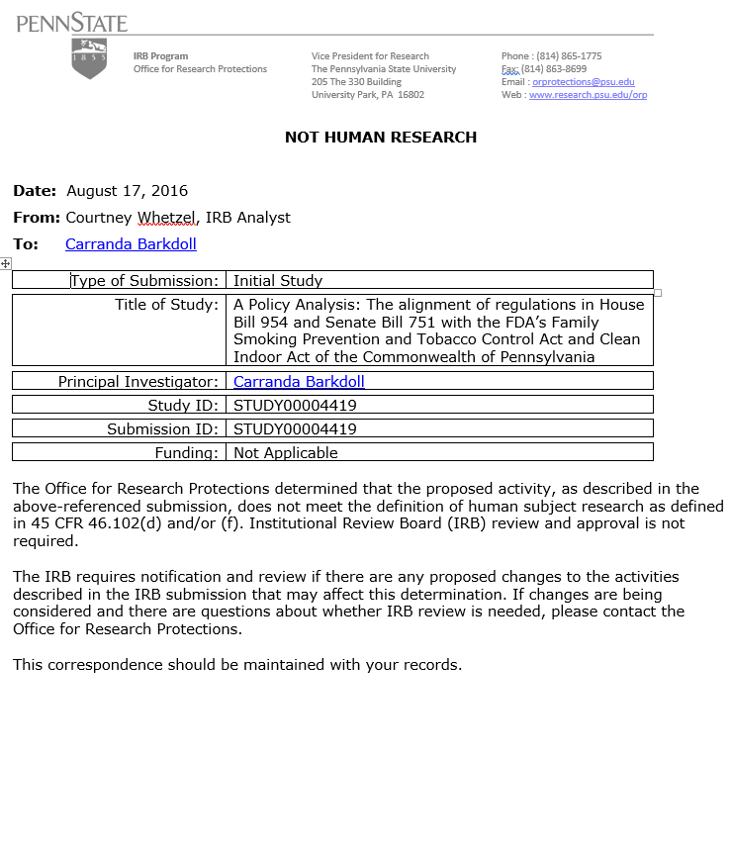

**Appendix D: House Bill 954**

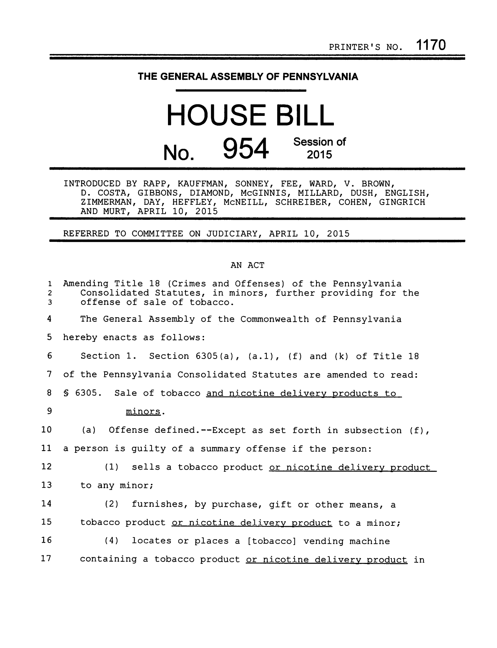

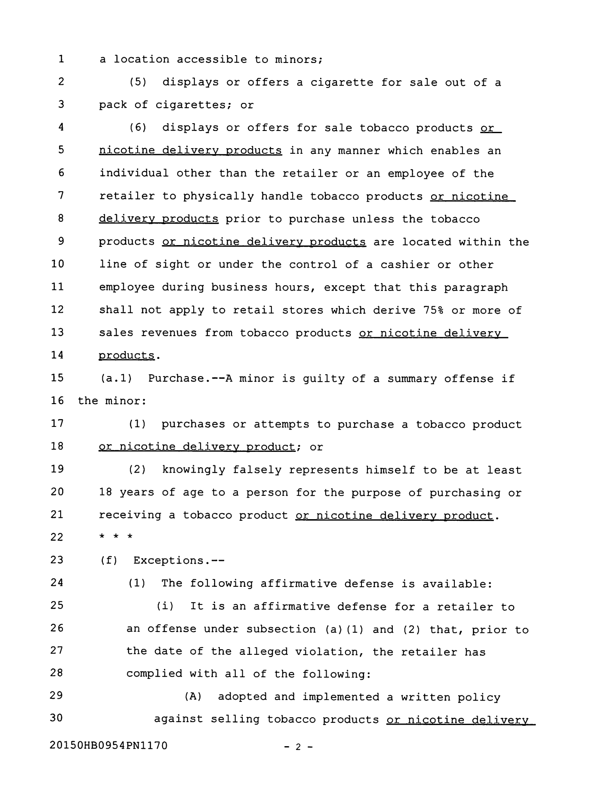

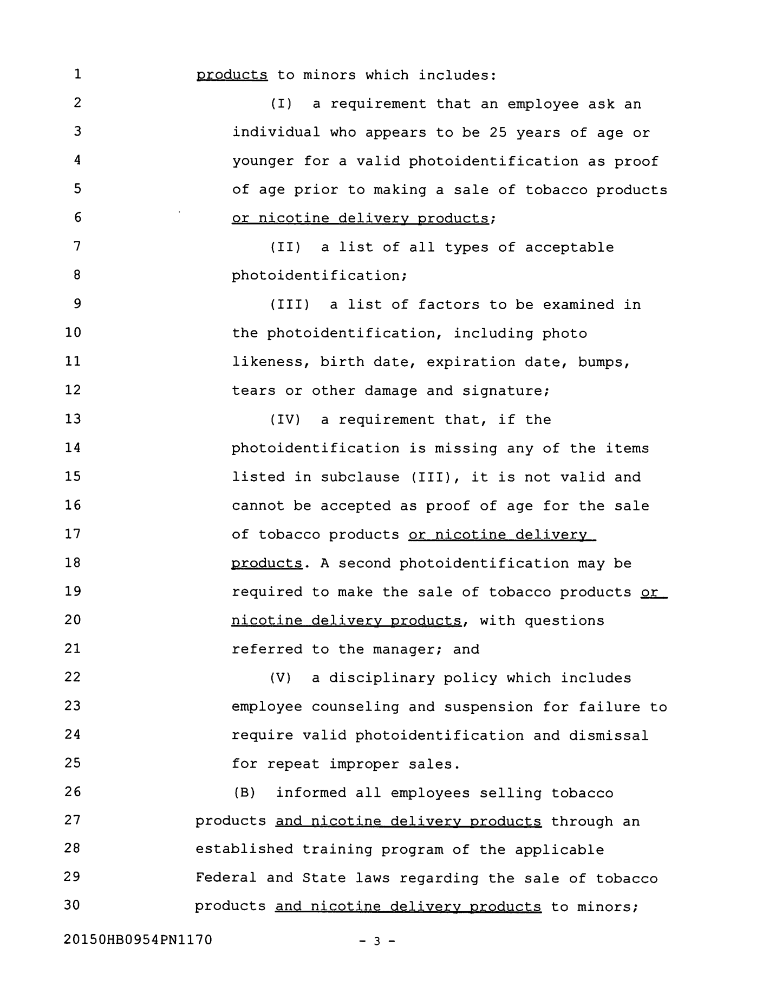

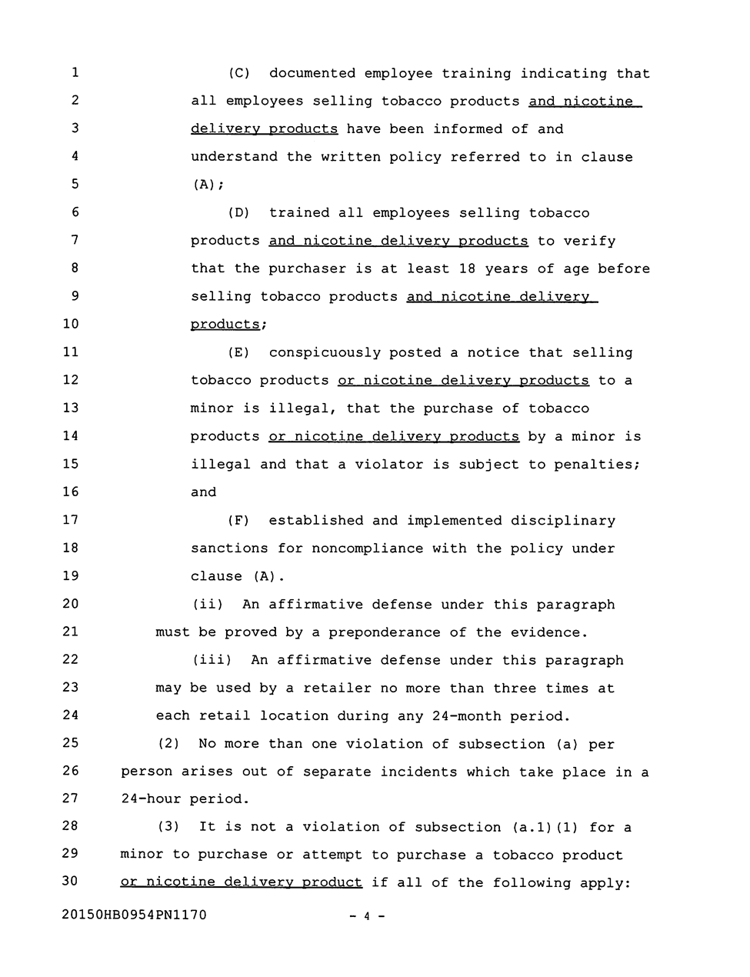

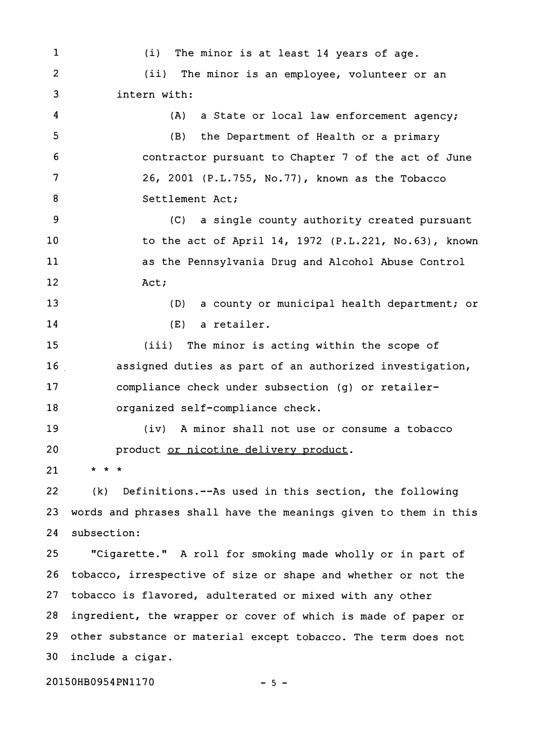

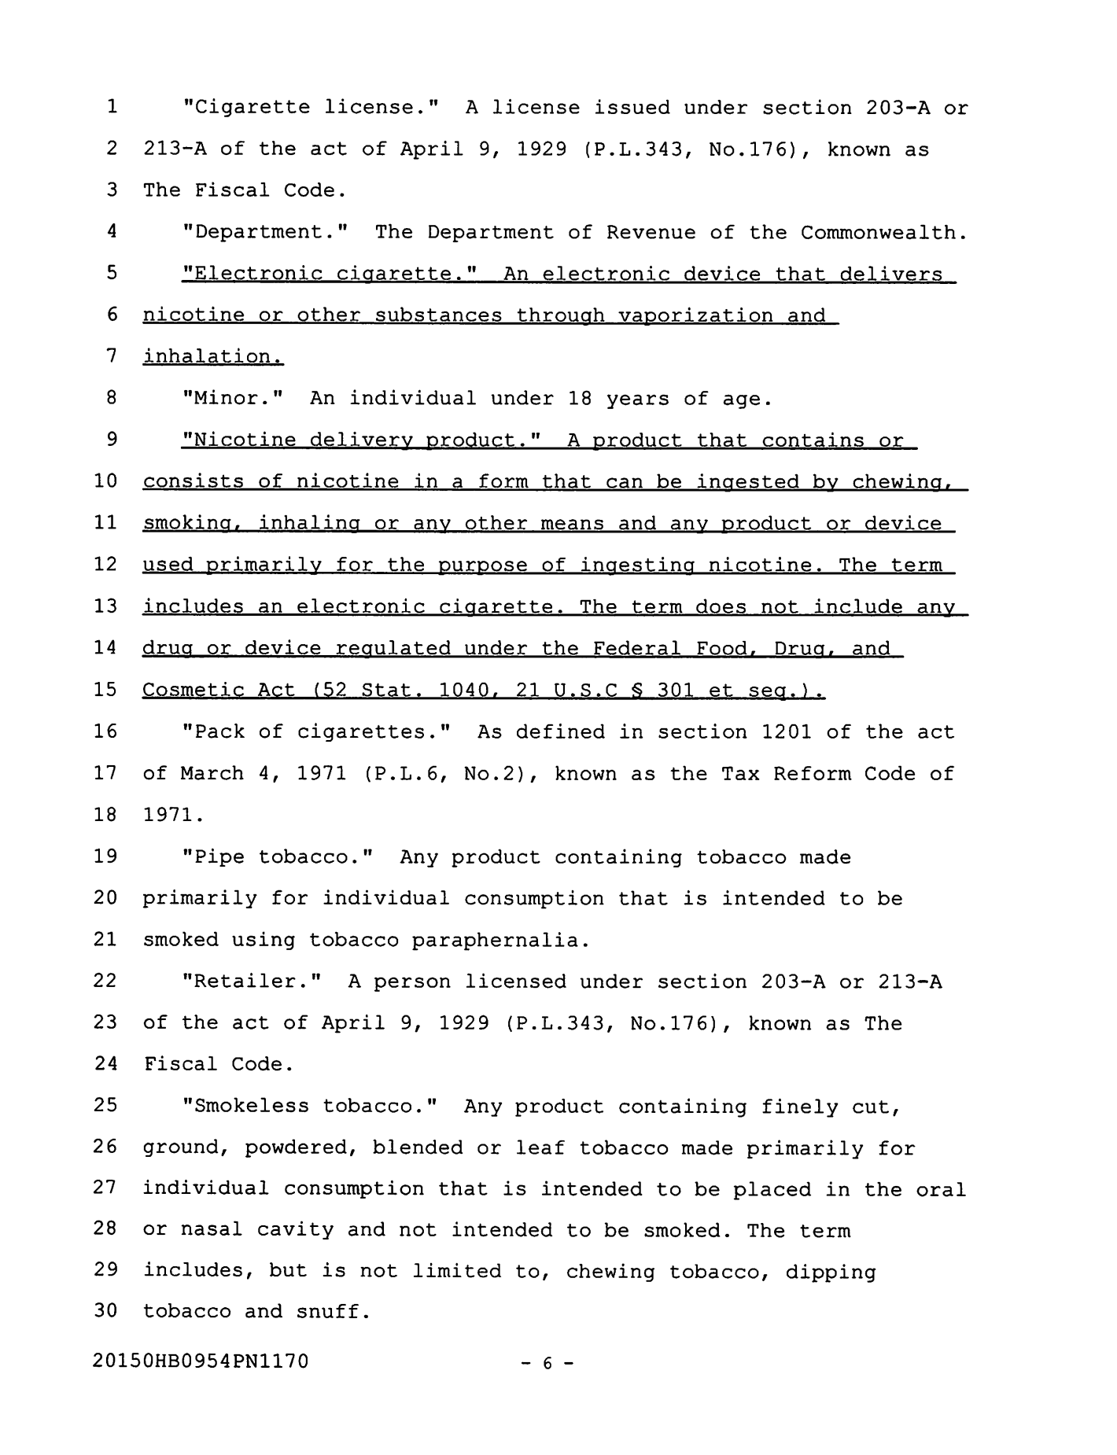

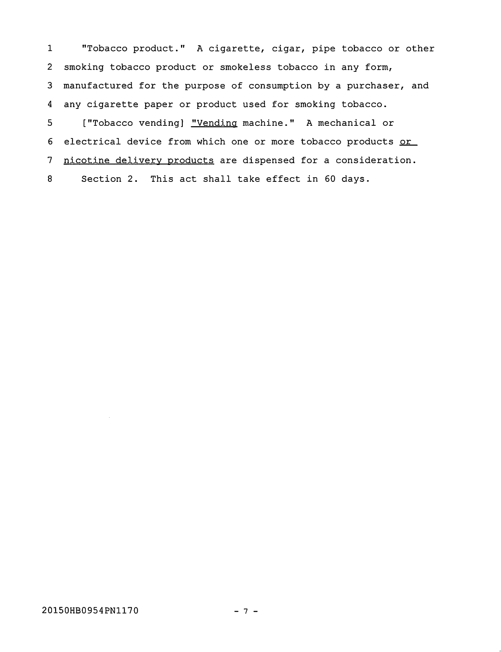

**Appendix E: Senate Bill 751**

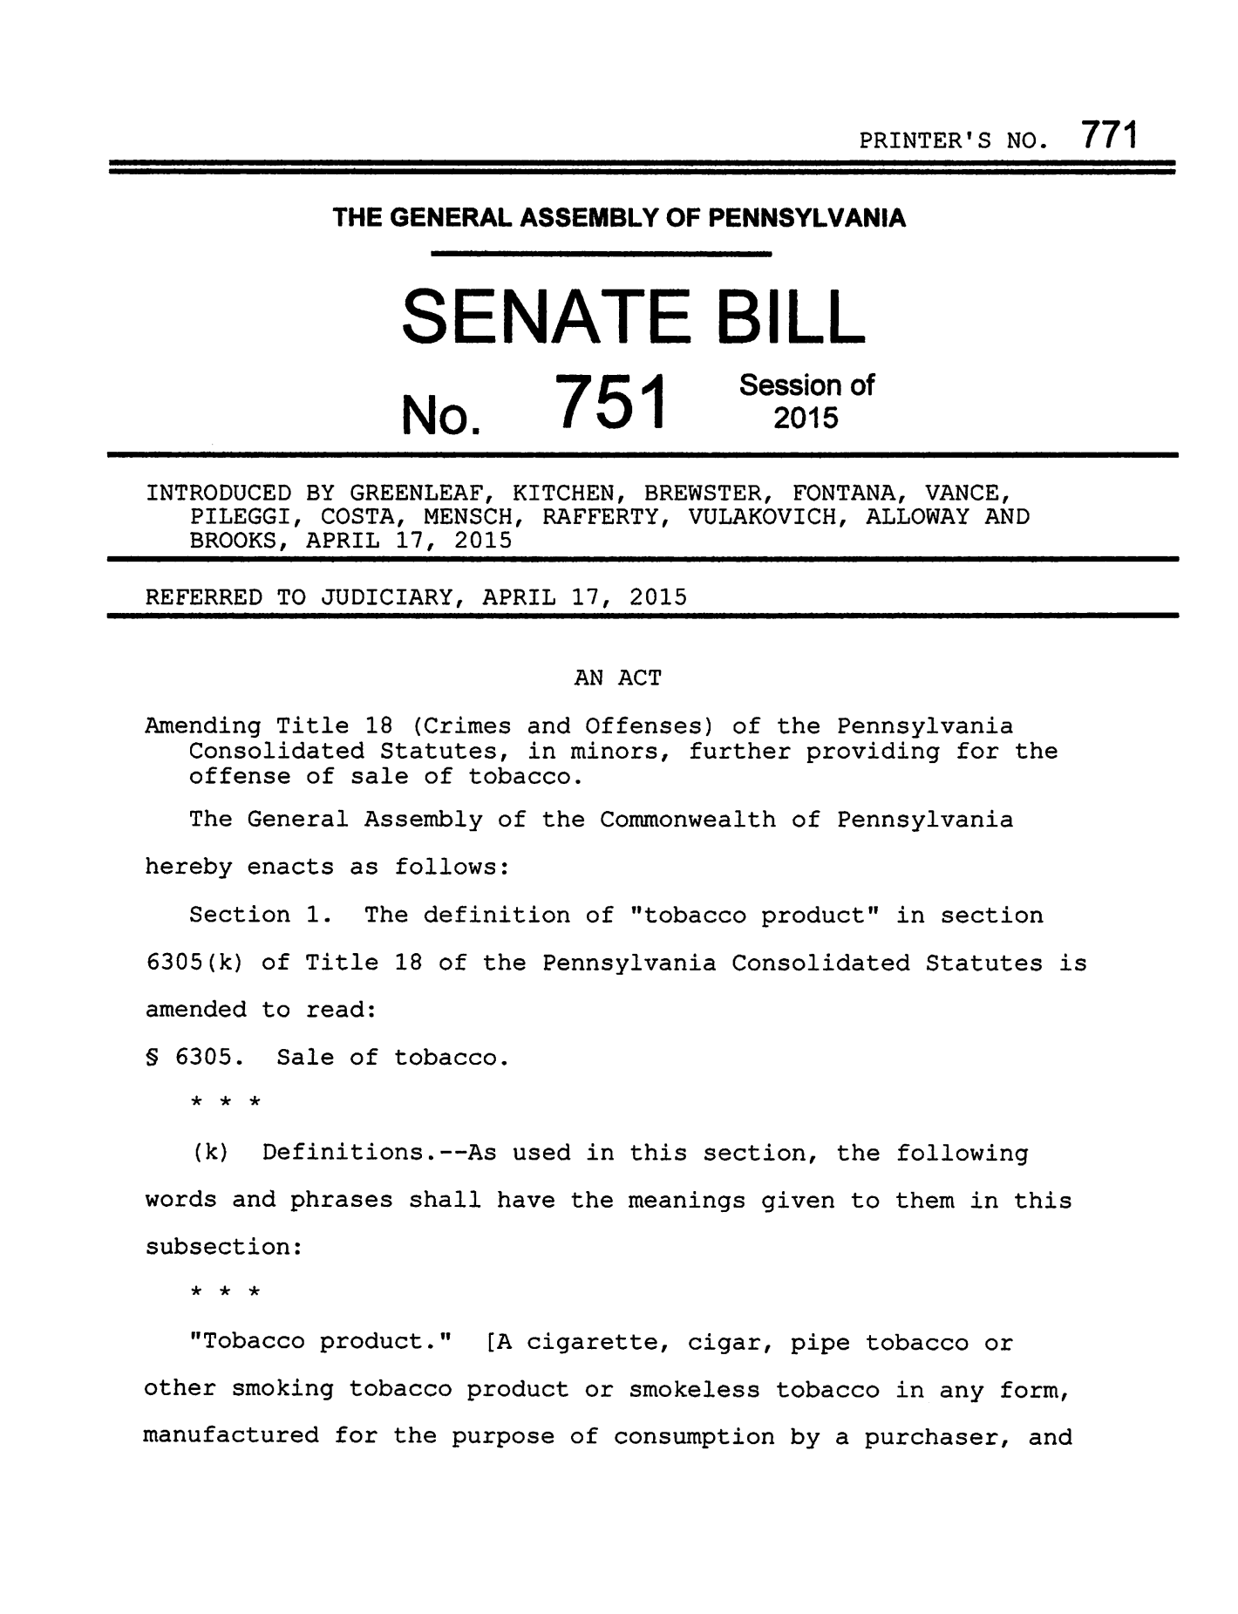

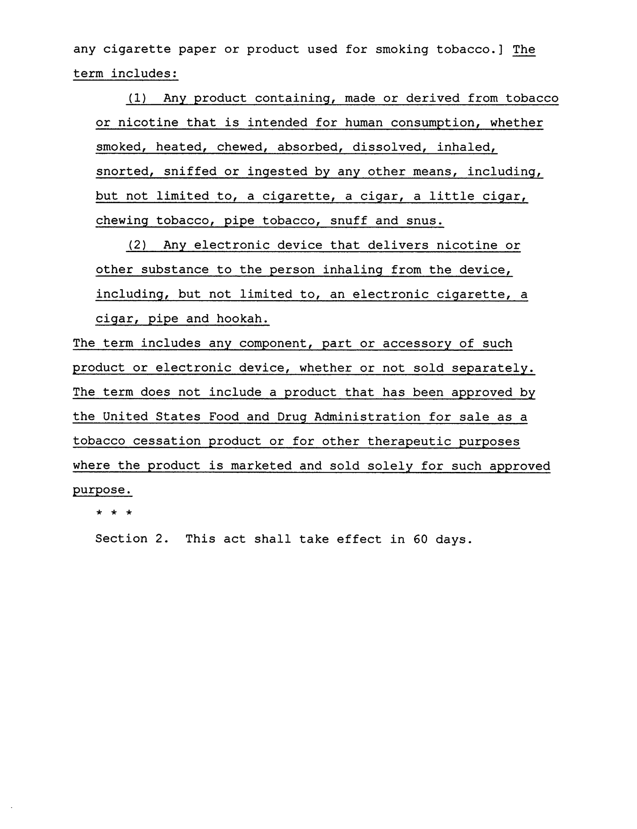

**Appendix F: Senate Bill 80 (567)**

|  | PRINTER'S NO. 540 |
| --- | --- |

**THE GENERAL ASSEMBLY OF PENNSYLVANIA**

SENATE BILL

|  |  |  |
| --- | --- | --- |
| No. | 567 | Session of  2015 |

INTRODUCED BY GREENLEAF, YAW, BLAKE AND COSTA, FEBRUARY 25, 2015

REFERRED TO PUBLIC HEALTH AND WELFARE, FEBRUARY 25, 2015

AN ACT

Amending the act of June 13, 2008 (P.L.182, No.27), entitled "An act regulating smoking in this Commonwealth; imposing powers and duties on the Department of Health and local boards of health; providing penalties; preempting local action; and making a related repeal," further prohibiting smoking in public places; providing for local ordinances; and repealing certain provisions of the Fire and Panic Act.

The General Assembly of the Commonwealth of Pennsylvania hereby enacts as follows:

Section 1. The title of the act of June 13, 2008 (P.L.182, No.27), known as the Clean Indoor Air Act, is amended to read:

AN ACT

Regulating smoking in this Commonwealth; imposing powers

and duties on the Department of Health and local boards of health; providing penalties; [preempting] repealing provisions relating to preemption of local action; providing for effect on local ordinances; and making [a related repeal] related repeals.

Section 2. Sections 2, 3(b) and (c), 4, 5(d), 6(c) and 10 of the act are amended to read:

Section 2. Definitions.

The following words and phrases when used in this act shall have the meanings given to them in this section unless the context clearly indicates otherwise:

["Cigar bar." Any of the following:

(1) An establishment which, on the effective date of this section, operates pursuant to an eating place retail dispenser's or restaurant liquor license under the act of April 12, 1951 (P.L.90, No.21), known as the Liquor Code, and is physically connected by a door, passageway or other opening and directly adjacent to a tobacco shop.

(2) An establishment which, at any time, operates pursuant to an eating place retail dispenser's license, malt or brewed beverage distributor's license or restaurant liquor license under the Liquor Code, and has total annual sales of tobacco products, including tobacco, accessories or cigar storage lockers or humidors of at least 15% of the combined gross sales of the establishment.]

"Cigar bar." An establishment with a permit or license to sell alcoholic beverages pursuant to the act of April 12, 1951 (P.L.90, No.21), known as the Liquor Code, that satisfies all of the following:

(1) Generates 60% or more of its quarterly gross revenue from the sale of alcoholic beverages for consumption on the premises by the customers.

(2) Generates 25% or more of its quarterly gross revenue from the sale of cigars for consumption on the premises by customers.

(3) Has a humidor on the premises.

(4) Does not permit individuals under 18 years of age.

Revenue generated from other tobacco sales, including cigarette vending machines, shall not be used to determine whether an establishment satisfies the definition of a cigar bar.

"Cigar lounge." An establishment without a license to sell alcoholic beverages that satisfies all of the following:

(1) Derives more than 80% of its quarterly gross revenue from the sale of cigars for consumption on the premises by customers.

(2) Has a humidor on the premises.

(3) Does not allow individuals under 18 years of age to enter the premises.

(4) May serve food and nonalcoholic beverages for consumption on the premises by customers.

Revenue generated from other tobacco sales, including cigarette vending machines, shall not be used to determine whether an establishment satisfies this definition.

"Department." The Department of Health of the Commonwealth.

"Drinking establishment." [Any of the following:

(1)] An establishment which [:

(i)] operates pursuant to an eating place retail dispenser's license, restaurant liquor license or retail dispenser's license under the act of April 12, 1951 (P.L.  
90, No.21), known as the Liquor Code [;]. The term also includes a night club.

[(ii) has total annual sales of food sold for on-premises consumption of less than or equal to 20% of the combined gross sales of the establishment; and

(iii) does not permit individuals under 18 years of age.

(2) An enclosed area within an establishment which, on the effective date of this section:

(i) operates pursuant to an eating place retail dispenser's license, restaurant liquor license or retail dispenser's license under the Liquor Code;

(ii) is a physically connected or directly adjacent enclosed area which is separate from the eating area, has a separate air system and has a separate outside entrance;

(iii) has total annual sales of food sold for on-premises consumption of less than or equal to 20% of the combined gross sales within the permitted smoking area of the establishment; and

(iv) does not permit individuals under 18 years of age.

The term does not include a nightclub.]

"E-cigarette." Any electronic oral device, such as one composed of a heating element, battery or electronic circuit, which provides a vapor of nicotine or any other substances and the use or inhalation of which simulates smoking. The term shall include any such device, whether manufactured, distributed, marketed or sold as an e-cigarette, e-cigar or e-pipe or under any other product name or descriptor.

"Enclosed area." All space between a floor and a ceiling that is bounded on at least two sides by walls, doorways or windows, either open or closed. A wall includes any retractable divider, garage door or other physical barrier, whether temporary or permanent and whether or not containing openings of any kinds.

["Full-service truck stop." An establishment catering to long-haul truck drivers that provides shower facilities for a fee.

"Gaming floor." Any portion of a licensed facility where slot machines have been installed for use or play as approved by the Pennsylvania Gaming Control Board. The term does not include an area adjacent to the gaming floor, including any hallway, reception area, retail space, bar, nightclub, restaurant, hotel, entertainment venue or office space.]

"Licensed facility." As defined in 4 Pa.C.S. § 1103 (relating to definitions).

"Night club." A public hall or hall for which admission is generally charged and which is primarily or predominantly devoted to dancing or to shows or cabarets as opposed to a facility that is primarily a bar, tavern or dining facility.

"Patio." Any outdoor deck, patio or similar outdoor service area which is part of a food or drinking establishment.

"Private club." An organization [which is any of the following:

(1) A reputable group of individuals associated together as an organization for legitimate purposes of mutual benefit, entertainment, fellowship or lawful convenience which does all of the following:

(i) Regularly and exclusively occupies, as owner or lessee, a clubhouse or quarter for the use of its members.

(ii) Holds regular meetings; conducts its business through officers regularly elected; admits members by written application, investigation and ballot; and charges and collects dues from elected members.

(iii) Has been in continuous existence for a period of ten years as such an organization.

(2) A volunteer ambulance service.

(3) A volunteer fire company.

(4) A volunteer rescue company.], whether incorporated or not:

(1) Which is the owner, lessee or occupant of a building or portion thereof used exclusively for club purposes at all times.

(2) Which is operated solely for a recreational, fraternal, social, patriotic, political, benevolent or athletic purpose, but not for pecuniary gain.

(3) Which only sells alcoholic beverages incidental to its operation.

(4) The affairs and management of which are conducted by a board of directors, executive committee or similar body chosen by the members at an annual meeting.

(5) Which has established bylaws or a constitution to govern its activities.

(6) Has been granted an exemption from the payment of Federal income tax as a club under section 501 of the Internal Revenue Code of 1986 (Public Law 99-514, 26 U.S.C. § 501).

"Public meeting." A meeting open to the public. The term includes a meeting under 65 Pa.C.S. Ch. 7 (relating to open meetings).

"Public place." An enclosed area which serves as a workplace, commercial establishment or an area where the public is invited or permitted. The term includes:

(1) A facility which provides education, food or health care-related services.

(2) A vehicle used for mass transportation. This paragraph includes a train, subway, bus, including a chartered bus, plane, taxicab and limousine.

(3) A train station, subway station or bus station.

(4) A public facility. This paragraph includes a facility to which the public is invited or in which the public is permitted and a private home which provides child-care or adult day-care services.

(5) A sports or recreational facility, theater or performance establishment.

(6) A truck stop.

(7) A residential facility.

(8) A private club.

(9) A drinking establishment.

(10) A licensed facility.

(11) A patio.

"Residential facility." The term includes any of the following:

(1) A long-term care facility regulated under 42 CFR § 483.15 (relating to quality of life).

(2) Residential adult care facility.

(3) Community mental health care facility.

(4) Drug or alcohol treatment facility.

(5) Day treatment programs.

"Smoking." [The carrying by a person of a lighted cigar, cigarette, pipe or other lighted smoking device.] Inhaling, exhaling, burning or carrying any lighted or heated cigar, cigarette or pipe or any other lighted or heated tobacco plant product intended for inhalation, in any manner or in any form. The term includes the use of an e-cigarette which creates a vapor in any manner or in any form or the use of any oral smoking device for the purpose of circumventing the prohibition of smoking in this act.

"Tobacco shop." A business establishment whose sales of tobacco and tobacco-related products, including cigars, pipe tobacco and smoking accessories, comprise at least [50%] 80% of the gross annual sales where sale of nontobacco items is incidental. This term does not include a stand-alone kiosk or establishment comprised solely of cigarette vending machines.

["Volunteer ambulance service." As defined in section 102 of the act of July 31, 2003 (P.L.73, No.17), known as the Volunteer Fire Company and Volunteer Ambulance Service Grant Act.

"Volunteer fire company." As defined in section 102 of the act of July 31, 2003 (P.L.73, No.17), known as the Volunteer Fire Company and Volunteer Ambulance Service Grant Act.

"Volunteer rescue company." As defined in section 102 of the act of July 31, 2003 (P.L.73, No.17), known as the Volunteer Fire Company and Volunteer Ambulance Service Grant Act.]

"Workplace." An indoor area serving as a place of employment, occupation, business, trade, craft, professional or volunteer activity[.], including, but not limited to, work areas, private offices, employee lounges, restrooms, conference rooms, meeting rooms, classrooms, employee cafeterias, hallways, construction sites, temporary offices and work vehicles.

Section 3. Prohibition.

* * *

(b) Exceptions.--Subsection (a) shall not apply to any of the following:

(1) A private home, private residence or private vehicle unless the private home, private residence or private vehicle is [being used at the] used at any time for the provision of child-care services, adult day-care services or services related to the care of children and youth in State or county custody.

[(2) Designated quarters:

(i) within a lodging establishment which are available for rent to guests accounting for no more than 25% of the total number of lodging units within a single lodging establishment; or

(ii) within a full-service truck stop.]

(3) A tobacco shop.

[(4) A workplace of a manufacturer, importer or wholesaler of tobacco products; a manufacturer of tobacco-related products, including lighters; a tobacco leaf dealer or processor; or a tobacco storage facility.

(5) Any of the following residential facilities:

(i) A long-term care facility regulated under 42 CFR 483.15 (relating to quality of life). This subparagraph shall not apply if 42 CFR 483.15 is abrogated or expires.

(ii) A separate enclosed room or designated smoking room in a residential adult care facility, community mental health care facility, drug and alcohol facility or other residential health care facility not covered under subparagraph (i).

(iii) A designated smoking room in a facility which provides day treatment programs.

(6) Subject to subsection (c)(2), a private club, except where the club is:

(i) open to the public through general advertisement for a club-sponsored event; or

(ii) leased or used for a private event which is not club sponsored.

(7) A place where a fundraiser is conducted by a nonprofit and charitable organization one time per year if all of the following apply:

(i) The place is separate from other public areas during the event.

(ii) Food and beverages are available to attendees.

(iii) Individuals under 18 years of age are not permitted to attend.

(iv) Cigars are sold, auctioned or given as gifts, and cigars are a feature of the event.

(8) An exhibition hall, conference room, catering hall or similar facility used exclusively for an event to which the public is invited for the primary purpose of promoting or sampling tobacco products, subject to the following:

(i) All of the following must be met:

(A) Service of food and drink is incidental.

(B) The sponsor or organizer gives notice in all advertisements and other promotional materials that smoking will not be restricted.

(C) At least 75% of all products displayed or distributed at the event are tobacco or tobacco-related products.

(D) Notice that smoking will not be restricted is prominently posted at the entrance to the facility.

(ii) A single retailer, manufacturer or distributor of tobacco may not conduct more than six days of a promotional event under this paragraph in any calendar year.

(9) A cigar bar.

(10) A drinking establishment.

(11) Unless otherwise increased under this paragraph, 25% of the gaming floor at a licensed facility. No earlier than 90 days following the effective date of this section or the date of commencement of slot machine operations at a licensed facility, whichever is later, a licensed facility shall request a report from the Department of Revenue that analyzes the gross terminal revenue per slot machine unit in operation at the licensed facility within the 90-day period preceding the request. If the report shows that the average gross terminal revenue per slot machine unit in the designated smoking area equals or exceeds the average gross terminal revenue per slot machine unit in the designated nonsmoking area, the licensed facility may increase the designated smoking area of the gaming floor in proportion to the percentage difference in revenue. A licensed facility may request this report from the Department of Revenue on a quarterly basis and may increase the designated smoking area of the gaming floor accordingly. At no time may the designated smoking area exceed 50% of the gaming floor. The board shall have jurisdiction to verify the gross terminal revenues included in the report to ensure compliance with the requirements under this paragraph. Movement of the licensed facility from a temporary facility to a permanent facility shall not require the licensed facility to revert to the minimum percentage set forth under this paragraph.]

(12) A designated outdoor smoking area within the confines of a sports or recreational facility, theater or performance establishment.

(13) A cigar bar or cigar lounge that, as of the effective date of this paragraph, operated as a cigar bar or cigar lounge and satisfies all of the following requirements:

(i) Smoke from the cigar bar or cigar lounge does not migrate into an enclosed area where smoking is prohibited pursuant to this act.

(ii) The cigar bar or cigar lounge is located in a freestanding structure that shares no common walls with other establishments and is occupied solely by the cigar bar or cigar lounge.

(iii) The cigar bar or cigar lounge satisfactorily reports on a quarterly basis to the department on a form prescribed by the department one of the following:

(A) the revenue generated from the sale of cigars for consumption on the premises by customers; or

(B) the sale of cigars and alcoholic beverages for consumption on the premises by customers as a percentage of quarterly gross revenue.

The department shall determine whether any additional documentation is required by the cigar bar or cigar lounge to verify revenue data submitted by the cigar bar or cigar lounge.

(iv) The cigar bar or cigar lounge does not expand in size or change its location after the date of this paragraph.

This paragraph shall not apply to any business that is established for the purpose of avoiding compliance with this act. Any cigar bar or cigar lounge that fails to satisfy any of the requirements of this paragraph, including the gross revenue requirements, in any one calendar quarter shall immediately lose its exception status and shall not be eligible for the exception in the future.

(c) Conditions and qualifications for exceptions.--

[(1)] In order to be excepted under subsection (b), a [drinking establishment,]cigar bar, cigar lounge or tobacco shop must submit a letter to the department, accompanied by verifiable supporting documentation,[to the department] claiming an exception under subsection (b). Exception shall be based upon the establishment's books, accounts, revenues or receipts, including those reported to the Department of Revenue for sales tax purposes, from the previous year or stated projected annual revenues, which shall be verified within six months.

[(2) In order to qualify for the exception under subsection (b)(6), a private club must take and record a vote of its officers under the bylaws to address smoking in the private club's facilities.]

Section 4. Signage.

(a) General rule.--"Smoking Permitted" or "No Smoking" signs or the international "No Smoking" symbol, which consists of a pictorial representation of a burning cigarette in a circle with a bar across it, shall be prominently posted and properly maintained where smoking is regulated by this act by the owner, operator, manager or other person having control of the area. A "Smoking Permitted" sign shall be prominently posted and maintained at every entrance to a public place where smoking is permitted under this act.

(b) Cigar bars and cigar lounges.--

(1) A person who manages, operates or controls a cigar bar or cigar lounge shall post or cause to be posted health warning signage that states:

WARNING: Cigar smoking causes lung cancer, heart disease and other diseases and cancers. Cigars contain nicotine, tar and carcinogens. Cigar smoking is not a safe alternative to cigarette smoking.

(2) The health warning signage shall be clearly visible to persons entering the cigar bar or cigar lounge and visibly posted in 48-point font size or greater in every room where smoking is permitted. The owner of the cigar bar or cigar lounge shall provide the health warning required by paragraph (1) on every menu available to customers, and the warning shall be clearly stated in 14-point font size or greater.

Section 5. Enforcement.

* * *

(d) Access to records.--A [drinking establishment,] cigar bar and tobacco shop shall make available all books, accounts, revenues, receipts and other information to the department, the Department of Revenue, the State licensing agency or a county board of health as necessary to enforce this act. All information submitted to the Department of Health, a county board or other Commonwealth agency with enforcement duties under this act [, including information to verify the on-site food consumption of a drinking establishment,] shall be confidential and shall not be subject to the [act of June 21, 1957 (P.L.390, No.212), referred to as the Right-to-Know Law] act of February 14, 2008 (P.L.6, No.3), known as the Right-to-Know Law.

Section 6. Violations, affirmative defenses and penalties.

* * *

(c) Commonwealth administrative penalties.--

(1) If the department or a State licensing agency [or a county board of health] determines that a person has violated subsection (a), the person shall be subject to a penalty not to exceed $250.

(2) If the department or a State licensing agency [or a county board of health] determines that a person has violated subsection (a) within one year of receiving a penalty under paragraph (1), the person shall be subject to a penalty not to exceed $500.

(3) If the department or a State licensing agency [or a county board of health] determines that a person violated subsection (a) within one year of receiving a penalty under paragraph (2), the person shall be subject to a penalty not to exceed $1,000.

(4) This subsection is subject to 2 Pa.C.S. (relating to administrative law and procedure).

(5) The penalties collected under this subsection shall be retained by the department or the State licensing agency initiating the enforcement action.

* * *

Section 10. Administration.

(a) Regulations.--The department shall promulgate regulations to implement this act.

(b) Revision of forms.--The Department of Revenue may revise the form for reporting sales tax revenue to require separate reporting of sales of [alcohol and] tobacco and tobacco-related products for purposes of claiming exemptions under this act.

Section 3. Section 11 of the act is repealed:

[Section 11. Preemption of local ordinances.

(a) General rule.--Except as set forth in subsection (b), the following apply:

(1) This act shall supersede any ordinance, resolution or regulation adopted by a political subdivision concerning smoking in a public place.

(2) No political subdivision shall have the authority to adopt or enforce any ordinance, regulation or resolution which is in conflict with this act.

(b) Exception.--Subsection (a) shall not apply to a city of the first class. A city of the first class may not change or amend its ordinance to conflict with any provision of this act.]

Section 4. The act is amended by adding a section to read:

Section 12. Effect on local rules and ordinances.

This act shall not be construed to restrict the power of a political subdivision to adopt and enforce any rule or ordinance that exceeds the minimum applicable standards set forth in this act.

Section 5. Section 29 of the act is amended to read:

Section 29. [Repeal] Repeals.

(a) Intent.--The General Assembly declares that the repeal under subsection (b) is necessary to effectuate this act.

(b) [Provision] Provisions.--

(1) Section 10.1 of the act of April 27, 1927 (P.L.465, No.299), referred to as the Fire and Panic Act, is repealed.

(2) Section 15.1 of the Fire and Panic Act is repealed insofar as it refers to section 10.1 of that act and to the extent of any inconsistency with this act.

Section 6. This act shall take effect in 60 days.

**Appendix G: ENDS Fact Sheet**

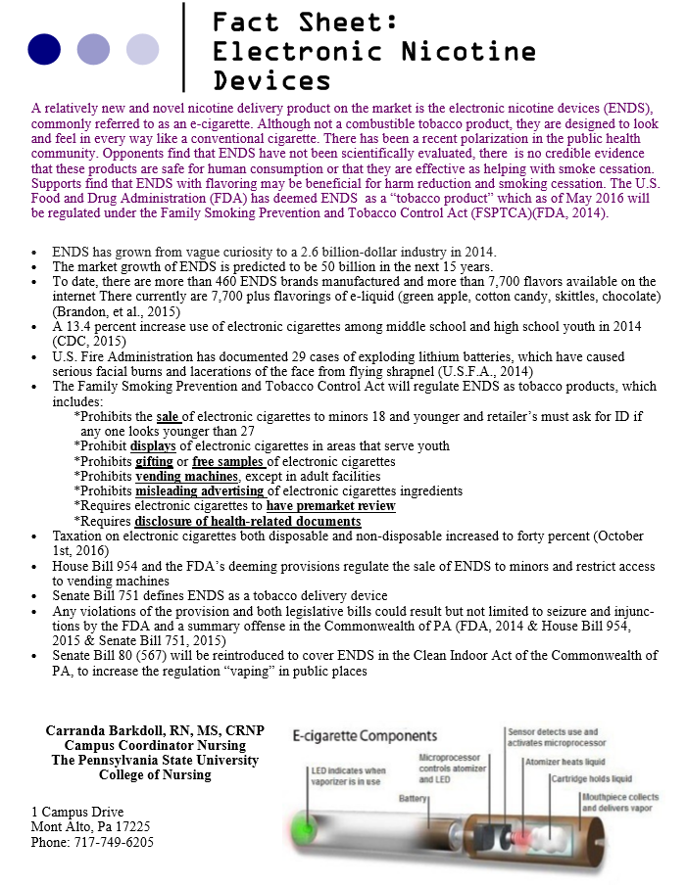

**Appendix H: Informational Matrix**

*Critical Analysis and Synthesis of the Studies*

|  |  |  |  |  |  |  |
| --- | --- | --- | --- | --- | --- | --- |
| ***Citation*** | ***Research Question/ Hypothesis*** | ***Site/Sample*** | ***Design & Methods*** | ***Variables & Measures*** | ***Findings*** | ***Critique*** |
| Bullen, C., Mcrobbie, H., Thornley, S., Glover, M., Lin, R., & Laugesen, M. (2010). Effect of an electronic nicotine delivery device (e cigarette) on the desire to smoke and withdrawal, user preferences and nicotine delivery: Randomized cross-over trial. *Tobacco Control,* *19*, 98-103. doi:10.1136/tc.2009.031587 | To measure short-term effects of an electronic nicotine delivery device on desire to smoke,  withdrawal symptoms, acceptability,  pharmacokinetic, properties and adverse effects | 40 adult dependent smokers of 10 or more years. Participants were recruited through phone interviews. 53% were women with a mean age of 47.6 years. Participants smoked an average of 20.2 cigarettes per day.  Study took place at the University research center in Auckland, New Zealand | Single blind randomized repeated measures cross-over  trial. Participants were randomized to use ENDS containing 16 mg or 0 mg nicotine capsules. Other nicotine product used during the four-day study, at 3 days apart, with an overnight abstinence from the use of each  product. | The primary outcome was a change in the desire to smoke. Measure as under an area under the curve on an 11-point analog scale before and at intervals over 1-hour use. Secondary outcome included withdrawal, acceptability and adverse effects. Also, nicotine blood levels were drawn from 9 participants. The study used both genders. Exclusions: recent MI, angina, DM, severe allergies, poorly controlled asthma/other airway diseases, poorly controlled  mental health  disorders, current chemical dependency and pregnancy. | The desire to smoke and withdrawal symptoms: Participants using the 16 mg capsule and who smoke over a 60 min. the period had a decreased desire to smoke more than those using the 0 mg (95% CI 0.25 to 1.38;  P=0.006). In the  Comparisons of 16 mg to 0 mg, the desire to smoke became significant between 25 and 60 mins. (95% CI 0.33 to 2.25; p=0.009. Notable was a reduction in irritability, restlessness and difficulty concentrating with the use of 16 mg more so than the 0 mg but not significant. There was no significance noted in withdrawal between ENDS and inhaler product. With a second analysis of the ENDS, 16mg, inhalator, cigarettes and 0 mg no significant difference was noted.  Product preference:  The 16 mg capsules were found to be more pleasant than than the inhaler (95% CI 0.23 to2.74; p=0.016) and would recommend to a friend. Embarrassment in using the ENDS was noted not to be significant. 58% preferred using the ENDS, 25% preferred the inhaler and 13% like neither. Pharmacokinetics: The 16 mg capsule users had a modest increase in blood nicotine levels.  Adverse events: mouth and throat irritation with the inhaler (88%) and less significant with the 0 mg capsule. Between active and placebo ENDS there was a significant difference (p=0.01). Nausea reported with the use  of the 16 mg capsule, but not significant compared to the other products. | The study did address the research questions and noted that using the 16 mg ENDS did reduce the desire to smoke. The ENDS in the first hour of use appears to act more like an inhalator than a cigarette. No excessive adverse events were noted. The N=40 was a small sample size. The authors of the research study use graphs to represent some of their findings which make it easier to evaluate the data. It was noted that the study used both genders, but no other demographics other than being a smoker was noted. No theoretical framework was mentioned in the study. A questionnaire was used for demographics, smoking, characteristics and medical screening. |
| Elssenberg, T. (2010). Electronic nicotine delivery devices: Ineffective nicotine delivery and craving suppression after acute administration. *Tobacco Control,* *19*(1), 87-88. | The author's question was: how do two brands of electronic nicotine delivery devices influence plasma nicotine levels, heart rates and cigarette cravings in cigarette smokers and then compare these effects to those produced by smokers’ usual brand of cigarettes. | 16 naïve to e-cigarettes were used in the study. The demographics were 5 women, 8 non-whites, mean age=29.8, and a mean use of cigarettes per day was 18.5. The author was at the Virginia Commonwealth University and the lab utilized was at VCU. However, no mention of the site was noted in the study. | A four Latin-squared ordered conditions (used in an experimental design) separated by 48 hours. The participant used own brand cigarettes, sham smoking (unlit cigarette), NJOY and Hydro each with a 16mg cartridge | Two flavors were used-menthol and regular to match the preferred flavor of the participant. A new cartridge and fully charged battery were used for each session. Participants abstained from smoking for greater than 12 hours; this was confirmed by expired air CO less than 10 ppm. A vein catheter was inserted into each participant’s forearm to monitor heart rate and obtained blood samples.  Blood samples were taken at 5, 15, 30 and 45 mins. At 60 mins, blood was drawn and a second bout was started with identical blood draws. | For plasma nicotine and ‘craving for a cigarette/nicotine’, significant condition×bout (Fs (3, 45) >12.4; p<0.001) and condition×time (Fs(12,180) >11.8; p<0.001) interactions were observed. Relative to before bout 1, own brand cigarettes increased plasma nicotine and decreased craving significantly at most post-administration time points (ps<0.05).  Hydro and NPRO failed to increase nicotine levels significantly and NPRO decreased craving significantly 5 minutes (p<0.05). Mean plasma nicotine levels in the sham condition never were greater than 2.0. (Elssenberg, 2010) | The research question was addressed in that there was not a significant increase in nicotine levels or a decrease in desire to smoke using e-cigarettes. However, the author did note that there is a wide variety of e-cigarettes with different levels of nicotine and this could influence a smoker’s cessation. The sample size was small, N=16. It was recommended that there needs to be research on different e-cigarette~~s~~ products.  No theoretical framework was noted in this study |
| Etter, J. (2010). Electronic cigarettes: A survey of users. *BMC Public Health,* *10*, 231-231. | The study was to assess usage patterns of e-cigarettes, reasons for use, and user’s opinions of these products. | 81 ever users of e-cigarettes from France, Canada, Belgium and Switzerland. 77% of the respondents were males, 63% were former smokers and 37% were current smokers. The mean use of e-cigarettes was 100 days and drew 175 puffs per day, which is equal to approximately 12 cigarettes/day. | The researcher used a web-site based open- ended question survey delivered in French. The websites had links to provide information on e-cigs or sold e-cigs. The survey was reviewed by the Geneva University Hospital and was exempted from approval. | The survey asked about the use of e-cigs were past or current users. What brand they used most often, how often, the level of nicotine, and flavors most utilized.  They were questions why they use e-cigs for quitting, health reasons, or smoke in smoke-free area. Other demographic information was sex, age, and country. The comments reviewed were had very positive use of e-cigs to neutral-to avoiding e-cigs. | The top 4 subjective comments from the most positive to the most negative were:  **Positive (208) responses**-taste, beneficial to health, no unpleasant odors or bad breath, a pleasure to inhale.  **Negative (154) responses**-poor quality and frequent failures, batteries discharge to rapidly, too expensive, bad taste.  Adverse effects reported were dry mouth and throat, vertigo, headache and nausea.  The limitation was that the survey was a self-selected sample of Internet users. It was unknown if the method over-sampled satisfied users, long-term users or heavy users.  There needs to be more research looking at toxicity, efficacy and the public health impact of e-cigs. | The author’s qualitative research gathered substantial amounts of subjective information that did provide an answer to their research question. The sample size was small with a N=81. No theoretical framework was noted in this study. There was a good use of tables to provide an overview of the demographics and the positive and negative opinions of utilizing e-cigarettes. It would be recommended that a Likert scale is used to examine the responses of “brilliant to avoid” for more validity. One concern is confirmation bias that could have been used to support the research question.  The survey utilized a large amount of open-ended commenting which leads itself to the subjective opinion of the single researcher. |
| Adkison, S., O'Connor, R., Bansal-Travers, M., Hyland, A., Borland, R., Yong, H... Fong, G. (2013). Electronic nicotine delivery systems: an International tobacco control four-country survey.*American Journal of Preventive Medicine, 44*(3), 207-215. doi:10.1016/j.amepre.2012.10.018 | Examine patterns of ENDS awareness, use, and product-associated beliefs among current and former smokers in four countries | 5,939 current and former smokers from Canada (n=1581), U.S. (n=1520), U.K. (n=1325), and Australia (n=1513) | A telephone survey and web survey was conducted between 7/10 and 6/11, 2011 and the data was analyzed in 2012. Participants were >  18 years of age, smoked at least 100 cigarettes in a lifetime and at least 1 cigarette in last 30 days. A cross-country analysis model was used for a superior fit | The Wave 8 survey asked questions about awareness and use of e-cigs. Logistic regression was used to evaluate the independent influence of awareness, trial and use. Adjusted the sample weights for sampling probability and distribution of gender, age and race of the smoker. | 46.6 % (n=2757) respondents had heard of ENDs. 7.6% (n=450) had tried END’s. Younger, higher-income, well-educated respondents more likely to report awareness. Men that smoked menthol cigarettes and used the Internet were more aware of e-cigs.  Younger females were more likely to try e-cigs.  Continuous e-cig use was noted in those with the highest education.  Significance was noted in the perception of harm. The U.S. had the highest perception of harm *X*2(2, n=1825) = 58.155 (p<0.001). Limitation-only former and current smokers | The research question was answered. That there is a high awareness in countries where e-cigs are legal (U.S. and U.K). ENDS also have the potential to be used as a smoke cessation aid. The sample size was sufficient with a N=5,939. Tables were used effectively to make the data easier to review. No theoretical framework was utilized. The research recognized that if regulatory authorities approve the direct claims about reduced harm, then the reduction in cigarette smokers to the net public health effect will be positive. |
| Barbeau, A. M., Burda, J., & Siegel, M. (2013). Perceived efficacy of e-cigarettes versus nicotine replacement therapy among successful e-cigarette users: A qualitative approach. *Addiction Science & Clinical Practice, 8*(1), 5-5. doi:10.1186/1940-0640-8-5 | E-cigarettes may be effective in helping smokers quit and prevent relapse. Also, factors that influence the efficacy of smoking cessation aids and to assess the socio-cultural and behavioral facets of addiction that the e-cig may provide | The sample size was N=11 (9 men, and 2 women). Participants were recruited from a posting on an e-cigarette forum (www.e-cigarette-forum.com/  Forum and vaperclub.com) The focus groups were to take place in Boston, MA. | A qualitative study conducted using 2 focus groups. One researcher asked the questions and the second researcher took notes. | Participants were 18-64 years. 9 participants identified themselves as non-Hispanic white. Some had college-associate degree, four-year or graduate degrees. History of smoking was 1-40 years. A short survey of the smoking history and e-cigarette use was administered to each participant. No one was excluded from the focus groups. | 5 themes were identified to be efficacious in helping tobacco users to quit smoking.  Bio-behavioral feedback-e-cigarettes mimicked smoking cigarettes- “throat hit”  Social benefits-vaping communities/forums were important  Hobby elements-Most did not see e-cigarettes as a means to quitting.  Personal identity-e-cigs allowed them to redefine themselves from smokers to vapers.  Difference between smoking cessation and nicotine cessation-Participants saw themselves quitting smoking by not quitting nicotine—patches and gum are temporary, but e-cigarette use is optional | The Grounded Theory was the conceptual framework used. The sample size was small n=11 and is not representative of all e-cigarette users. The focus groups were small due to funding and access to e-cigarette users. There is an inherent bias in the focus groups that would likely favor e-cigarettes. The bias could also lead to an overestimation of using the e-cigarette as a cessation tool. There was only one table used which gave examples of narrative group participants. |
| Baweja, R., Curci, K., Yingst, J., Veldheer, S., Hrabovsky, S., Wilson, S…. Foulds, J. (2015). Views of experienced electronic cigarette users. *Addiction Research and Theory*. doi:10.3109/16066359.2015.1077947 | Improve the understanding of experienced e-cig user’s perceptions of e-cigs and to identify factors they believe are important to form a public health perspective. | 1,177 participants completed an online survey about electronic cigarettes, and 200 were randomly selected for the study. It was conducted by Penn State College of Medicine, Dept. of Psychology and Virginia Commonwealth University. | The survey was posted on WebMD and e-cigarettes forum.com The survey was anonymous. It was a mixed methods design using both quantitative and qualitative data analysis. | Participants were current e-cig users.  Compared how smoke/smoked traditional cigarettes.  Described any other e-cigs that are important.  Described any effects as a result of using e-cigs.  Provide any other information about e-cigs that feel important.  Quantitative data was analyzed with SPSS v.22.0 and Qualitative was analyzed using thematic analysis. Evaluated, met weekly to compare codes and look for salient themes. | Difference between smoking cessation and nicotine cessation-Participants saw themselves quitting smoking by not quitting nicotine patches and gum are temporary, but e-cigarette use is optional | Limitations-self-select and enthusiastic about using e-cigarettes. The research question was answered, illustrating how experienced e-cig user’s transition between different devices. There was no theoretical framework noted and no mention of future research. The article did have a table that prevented duplication in the literature. |
| Caponnetto, P., Campagna, D., Cibella, F., Morjaria, J. B., Caruso, M., Russo, C., & Polosa, R. (2013). EffiCiency and safety of an eLectronic cigAreTte (ECLAT) as tobacco cigarettes substitute: A prospective 12-month randomized control design study. PloS One, 8(6), e66317. | Evaluate the efficacy and safety of an electronic cigarette | 300 eligible smokers were included in the study. 3 groups were utilized. The study was conducted in Italy. | This was a three-arm double-blind, controlled randomized clinical trial to assess the efficacy of the “Categoria” e-cigarette. The hospital pharmacy was in charge of the randomization and packaging of the cartridges. | The participants were randomized into 3 groups and given a different nicotine product. Inclusion was: smoke > 10 factory made cigarettes for the past 5 years, 18-70 years, in good health, not currently attempting to quit smoking. Exclusion was: symptomatic CVD or respiratory disease, current or past alcohol abuse, use of NRT or smokeless tobacco, pregnancy or breastfeeding. Fagerstrom Test for Nicotine Dependence and Clover-Nilsson Smoking Behavioral Questionnaire were used. CO was monitored, along with V/S, body wt. and adverse effects | There was no statistical significance between groups related to inclusion and exclusion. CO levels dropped significantly at 6-week visit. There was no significant difference between reduction and quit rates between groups. Switching nicotine cartridges from 7.2 mg to 5.4 mg was not noted to be significant in a reduction or quitting.  At 12-weeks there was a 14% complete abstinence from tobacco smoking documented in groups A & B and 4 % in group C. 5 most documented adverse effects were: a dry cough, mouth and throat irritation, shortness of breath, headache. It was found that smokers are not intending to quit e-cigarettes, with or without nicotine, decreased cigarette use. | This study answered the research question effectively. The study met the rapid critical appraisal checklist-making it a strong RCT study. The sample size was good, but it did not identify the demographics of the 300 smokers. There was no theoretical framework noted. The study had different tables and graphs to allow for better evaluation of the data. |
| Etter, J., & Bullen, C. (2014). A longitudinal  study of electronic cigarette users.*Addictive Behaviors, 39*(2), 491-494. doi:10.1016/j.addbeh.2013.10.028 | With the evolution of e-cigarettes, will the behaviors change over 12 months in user of e-cigarettes | A baseline cohort of N=477 at one month, and at one year an N=367. Respondents were > 18 years. This was a study conducted by a web-based survey. Distribution of respondents: U.S. (34%), France (24%), U.K (8%), Switzerland (6%), other countries (28%) | A longitudinal Internet study from 2011 to 2013. The participants were enrolled on websites dedicates to e-cig and cigarette users. A questionnaire in English and French was posted to Stop-Taba.ch. Information was collected at one month and at one year | The study provided the most detailed information to date on the ‘natural behavior’ of an internal cohort of vapers over time (Etter & Bullen, 2014). The participants were self-reporters and were self-selected former smokers. | 1,329 answered the baseline question. At one month, 477 repsonded-62% response rate. 367 at one year responded-47% response rate. The respondents were older than the non-respondents; income was slightly higher and among daily smokers was more motivated to quit than non-respondents. There was no difference in the education between respondents and non-respondents. Most respondents were using e-cigarettes every day (76%) and current users had been vaping at least 3 months. Dual users reduced consumption of cigarettes by 10.5/day. 98% were still vaping at one month and 89% still at one year. Limitations: self-report, self-selection. Results may not apply to new generation e-cigs | The research question was answered--that e-cigs provide an alternative to smoking. However, the study was not able to establish a causal link between vaping and smoking behaviors. No theoretical framework was noted. There was an attrition of 110 respondents. There was respondent bias to consider because of the self-select, self-report survey utilized. A more representative sample could be considered and a larger survey group could be utilized in a future study. The tables utilized were effective to evaluate the demographics and respondent’s behaviors.  Finally, new brands and models of e-cigarettes appear regularly, so the study results cannot be applied to ‘next generation” brands or models |
| Bush, D., & Goniewicz, M. L. (2015). A pilot study on nicotine residues in houses of electronic cigarette users, tobacco smokers, and non-users of nicotine-containing products. *The International Journal of Drug Policy, 26*(6), 609-611. doi:10.1016/j.drugpo.2015.03.003 | The research question was to verify whether nicotine from e-cigarettes can be deposited on surfaces in house of e-cigarettes users | 22 participants from the Buffalo City area agreed to provide access to their homes for sample collections.  8 non-smoking homes  6 cigarette-smoking homes  8 electronic cigarette vaping homes-Cigarettes could not have been smoked in e-cig user’s home for at least a year | Subjects were recruited for a pilot study from a group of a participant in a large cross-sectional study. The aim was to measure biomarkers of exposure.  10 cm x 10 cm surface swipe samples were collected from windows, walls and floors. Samples were transferred into amber vials with Teflon caps | The volunteer's diversity in the household was  Caucasian (N=19),  African American (N=3),  Men (N=5) and Women (N=9). Age range 30-70.  Living in low income (N=6) and mid/higher income (N=16). Lived alone (N=7)  Lived with family (N=15). After wipes had been spiked with quinoline, nicotine was extracted with KOH in menthol and then analyzed by a gas chromatography. The amount of nicotine was .05 *µg* to 100 *µg.* A Kruskal-Wallis test was used for statistical significance of the nicotine levels in each household. | Half of the households of the cigarette users had measurable levels of nicotine on surfaces. Nicotine surface levels in e-cig households were lower. Average concentration was 7.7+17.2 vs. 1303 + 2676 *µg/*m2; p<0.05. There was no significant difference in nicotine surface levels in e-cig and non-smoker households. There was significance in nicotine surface levels between cigarette and non-cigarette households.  There was no significance in the levels of nicotine found on the different surfaces (p> 0.05). Third-hand smoke is low risk with e-cigarettes. | This was a pilot study that should be replicated with a larger sample size. The question was answered with noted nicotine level noted of all three surface samples. However, the e-cig and non-smoker surface levels were much lower than the cigarette homes. No theoretical framework was noted.  The research was conducted outside the lab, so environments could have affected the results of the surface sampling. |
| Kolar, S. K., Rogers, B. G., & Hooper, M. W. (2014). Support for indoor bans on electronic cigarettes among current and former smokers.*International Journal of Environmental Research and Public Health, 11*(12), 12174-12189. doi:10.3390/ijerph111212174 | To evaluate if there is a safety risk of secondhand smoke with the use of e-cigarettes. | 265 current and former smokers were recruited from a telephone survey. The survey was conducted by the University of Miami. | The study was a cross-sectional survey, and participants were recruited through the Internet advertisements, flyers, and community outreach. | The participants had to be 18 years or older, read and speak English and current or former smoker. The study looked at: Demographics and smoking status, Risk perception, E-cigarette awareness, lifetime use, and behavioral intentions regarding indoor smoking bans. Chi-square and Fisher’s exact tests were utilized to evaluate risk perception and indoor smoking restrictions. The analysis of the data was considered exploratory. | There was a significant difference in support for cigarettes and e-cigs use bans. In the workplace, support for a complete ban was noted, but for e-cigarettes, there was an endorsement for a partial restriction on. 55 and older participants were more in favor of a complete ban on e-cigs indoors. Support for a ban on indoor e-cig smoke differed with income and smoking status. Support for a ban also was higher in those that saw e-cigs as addictive and may cause a significant health risk. No significant differences were found in support for indoor cigarette smoking bans-irrespective of e-cig use and behavioral intentions. | Although the study spoke to safety, little was to report, the research focused on the support for a ban on indoor e-cigarette smoking. There was a significant amount of data that was placed in tables for evaluation. No theoretical framework was noted. Limitations were noted the survey was conducted on the Internet, it was a self-selecting and self-reporting survey. The diversity of the survey made for a stronger sample. |
| Steinberg, M. B., Zimmermann, M. H., Delnevo, C. D., Lewis, M. J., Shukla, P., Coups, E. J., & Foulds, J. (2014). E-cigarette versus nicotine inhaler: Comparing the perceptions and experiences of inhaled nicotine devices. *Journal of General Internal Medicine, 29*(11), 1444-1450. doi:10.1007/s11606-014-2889-7 | To compare the e-cigs with nicotine inhalers for perceived benefits, harms, appeal and as a smoke cessation tool | Forty-one current smokers recruited from central New Jersey. The participants were recruited through flyers, email, and word-of-mouth. Eligibility was assessed by a phone screening. | A cross-over trial where participants use e-cig and inhaler each for 3 days in random order with a washout period in between. *t*- tests were used to determine the difference between the e-cigs and inhaler.  ANOVA with Bonferroni corrections was used to compare the mCEQ scores for cigarettes, e-cigarettes and inhalers | Inclusion- 18 or older smoker that had never used an e-cig or inhaler. Exclusion- recent MI or angina, poorly controlled asthma or COPD, active substance abuse, pregnancy or current use of cessation medication. Data was collected at three-time points-baseline, post e-cigs use and post inhaler use. The subjects completed the Modified Cigarette Evaluation Questionnaire (mCEQ). | The majority of the participants were female (66%) with a mean age of 47. 61% were white, 24 % were African-American and 10% were Latino.  The e-cigarette had a higher total satisfaction score (13.9 vs. 6.8 [p < 0.001] The e-cigarette received higher ratings for helpfulness, acceptability, and “coolness.” More subjects would use the e-cigarette to make a quit attempt (76 %) than the inhaler (24 %) (p < 0.001). Eighteen percent (7/38) of subjects abstained from smoking during the 3-day periods using the e-cigarette vs. 10 % (4/38) using the inhaler  (p = 0.18). (Steinberg, Zimmermann, Delnevo, Lewis, Shukla, Coups, & Foulds, J. 2014). | The research question was answered. Several different tables and graphs were used to display data making it easier to read. Limitation of the study--as a pilot study, the sample size was small. A cessation trial was not conducted. Withdrawal could have impacted the data. Further suggestion for research was to explore harm reduction and to look at more data concerning efficacy and safety of e-cigs. |
| Pokhrel, P., Little, M. A., Fagan, P., Kawamoto, C. T., & Herzog, T. A. (2014). Correlates use of electronic cigarettes versus nicotine replacement therapy for help with smoking cessation.*Addictive Behaviors, 39*(12), 1869-1873. doi:10.1016/j.addbeh.2014.07.034 | What are the characteristics of smokers who are likely to choose e-cigarettes as a cessation aid?  Also, what strategies would impact valid information on the safety and utility of using e-cigarettes? | 834 current smokers who were residents of Hawaii | A cross-sectional study that compared the demographics, smoking, and cessation of multiethnic smokers. Looked at smokers that tried e-cigarettes and quit, tried both e-cigs and (Nicotine-Related Therapy) NRT and had only used the NRT. | The participants were recruited from the local media,  18 years or older, were able to read English, had a mailing address, smoked at least 100 cigarettes in their lifetime, and self-identified current smoker. There was a 93% response to the questionnaire. SAS was utilized to analyze the data. ANOVA was conducted to evaluate a difference in the variables of the 3 categories of smokers. Tukey’s Studentized Range was used to control for Type 1 experiment-wise error rate. Logistic Regression was run parallel for e-cigs only. | Smokers who are attracted to use e-cigarettes but not FDA-approved NRT products may differ from smokers who are likely to have used NRT products but not e-cigarettes in terms of demographic (e.g., age, ethnicity) and smoking- or cessation-related characteristics (e.g., nicotine dependence, quit attempts) (Pokhrel, Little, Fagan, Kawamoto, & Herzog, 2014).  E-cig users were younger, higher income Native Hawaiian or Asian American, also used for smoke cessation aid. NRT users were older, lower income, longer lifetime smokers and white, had used NRT for smoke cessation | Some of the questions were answered, but the researchers noted that there was a lack of detailed assessment in their study. The limitations noted were that the questionnaire was a self-selected and recruitment was only in one state. The causal inference could not be made because it was a cross-sectional study. The sample size was small. A table of demographics was utilized and not repeated in the body of the literature. Future research was noted. Need to continue characterizing smokers who are likely to use e-cigarettes for smoking cessation. No theoretical framework was noted in this study. |
| Foulds, J., Veldheer, S., Yingst, J., Hrabovsky, S., Wilson, S. J., Nichols, T. T., & Eissenberg, T. (2015). Development of a questionnaire for assessing dependence on electronic cigarettes among a large sample of ex-smoking E-cigarette users.*Nicotine & Tobacco Research: Official Journal of the Society for Research on Nicotine and Tobacco, 17*(2), 186-192. doi:10.1093/ntr/ntu204 | The study aimed to assess the validity of e-cig dependence index by examining the relationship of the e-cig dependence index with the concentration of nicotine in the liquid being used. The hypothesis was that e-cig dependence would be higher in those that used higher concentrations of nicotine and in those who have used e-cigs for a longer period of time. | 3,609 current users of e-cigs who were ex-cigarette smokers were invited to volunteer to participate in the study. | A 158-item online survey was used, and with the survey, a 10-item Penn State Dependence Index was embedded. REDCap was used to support data capture. The data was analyzed with SAS 9.3 statistical package. Paired *t*-tests (two-tailed) were used to compare continuous variables and chi-squared tests were used to compare categorical variables. | The study’s main descriptive variables were predominantly white, male and living in the US. | Both Quantitative and  Qualitative analysis was used. The participants found the design, the ability to customize, and the quality of the vapor to be the most important characteristics of the device. The positive aspect of e-cig use was that it helps to quit smoking, improved overall health, and reduced cost. | Limitations of the study included the non-representative nature of the volunteer sample. Those that took the survey found out about it on specialty websites and were most likely “pro-e-cig” users. There was a noted lack of validity and reliability of the PSU Dependence Index as it had not been used in other studies. An inherent weakness in the design was noted, in that the participants could attempt to justify their current behavior by making it seem expectable to be dependent on e-cigs because of their former smoking history. There was no theoretical framework noted and no mention of future research. The article did have a table that prevented duplication in the literature. |
| Yingst, J. M., Veldheer, S., Hrabovsky, S., Nichols, T. T., Wilson, S. J., & Foulds, J. (2015). Factors associated with electronic cigarette users' device preferences and transition from the first generation to advanced generation devices. *Nicotine & Tobacco Research: Official Journal of the Society for Research on Nicotine and Tobacco, 17*(10), 1242. doi:10.1093/ntr/ntv052 | Examine the frequency with which e-cig user’s transition between device types and to identify device characteristics and user preferences that may influence device transition. | 6,495 participants submitted the survey, they were reviewed, and a total of 4,421experienced e-cig users participated. The participants used e-cigs 30 days in their lifetime. The study took place at Hershey Medical Center and the College of Medicine. | A survey was used for a cross-sectional study and delivered via WebMD, and e-cigarettes  Forum.com. Data was checked for duplicates. Non-current and/or past smokers were removed. Participants were removed if not used e-cigs at least 30 days in a lifetime, did not report nicotine liquid concentration or what device they utilized. | Data was analyzed using SAS 9.3. Means and percentage were calculated to identify differences between current first generation devices (FGD) and advanced generation devices (AGD). Two tail *t*-test was used to compare continuous variables. Chi-test was used to compare categorical variables. A P value < 0.05 was used as a cut-off for statistical significance. Variables-FGD and AGD difference with current users. | Most e-cigs users (n=2603, 58.9 %) began with FGD and subsequently transitioned (63.7%) to AGD-most preferred a vaping style device. Only 5.7 % switched to get a better “hit.”  Battery capabilities and flavors also influenced device choice. The interviewers noted that the participants reported the devices to be too complex and had to learn the best vaping techniques.  Penn State Electronic Cigarette Dependence Index-indicated participants using AGD’s had a greater e-cig dependency and were less likely to smoke conventional cigarettes. | Limitations-self-select and enthusiastic about using e-cigarettes. The research question was answered, illustrating how experienced e-cig user’s transition between different devices. There was no theoretical framework noted and no mention of future research. The article did have a table that prevented duplication in the literature. |
| Zhu, S., Sun, J. Y., Bonnevie, E., Cummins, S. E., Gamst, A., Yin, L., & Lee, M. (2014). Four hundred and sixty brands of e-cigarettes and counting: Implications for product regulation.*Tobacco Control, 23 Suppl 3*(Supplement 3), iii3-iii9. doi:10.1136/tobaccocontrol-2014-051670 | The study had two aims: provide a basic description of how e-cigarette brands have presented themselves and what is being offered to consumers, and what claims are made about any presumed advantages over cigarettes. Secondly, compare the brands sold on the Internet in 2012 with those that were available in 2014. | No participants were used in this study. Only search engines were utilized. Three search engines were used—Google, Bing and Yahoo. | A comprehensive Internet search was completed using English only websites. The timeline was from May-August 2012 and December 2013-January 2014. Three search engines were used, Google, Bing and Yahoo-looking for models, flavors, nicotine strengths, ingredients and product claims. Sites that resold e-cigs were not used. Websites were coded if carrying at least one e-cigarette product. Brands were divided into two groups: Older brands (2012 and 2014); Newer bands (2014). Logistic regress was used to assess difference in rates between old and new brands and *t*-test was used to test for difference in counts of flavors and nicotine strengths. All calculation were done using R V.2.15.0 | The measures were the brands, flavors (Tobacco, Menthol, Tobacco-Menthol, Fruit, Dessert/Candy, Alcohol/Drink, Snacks/Meals and others), ingredients (propylene glycol and vegetable glycerin as well as water and nicotine), Nicotine strengths (low, medium, high). Claims made: E-cigarettes are less harmful than conventional cigarettes, are a replacement for non-smoking areas, are cheaper than cigarettes, direct and indirect smoke cessation claim, a disclaimer that e-cigs are not a smoke cessation aid. | Most reported trying multiple times to quit smoking and had been using e-cigs, on the average, for over a year. Three-fourths had tried an average of five different types of e-cigs.  The study demonstrated that although e-cig users have e-cig sessions, they were very similar to cigarette sessions. However, the E-cig Dependence Index overall scores were lower. It was noted that those who were long term users of e-cigs had higher e-cig dependence scores. Most e-cig users used the advance device with a manual button. Using zero nicotine liquid had significantly lower e-cig dependence scores than those who used 1-12 mg/ml , who scored significantly lower than those using 13 or greater mg/ml nicotine liquid (*p*<.003). E-cig use appears to vary by product characteristics and liquid nicotine concentration and may increase over time.  It was noted that by January 2014 there were 466 brands all with their own website and 7,764 flavors. Over a 17- month period, there was a net increase of 10.5 brands and 242 new flavors. Older brands were more likely than new brands to offer cigalikes (86.9% vs. 52.1%, p<0.01) and newer brands were more likely to offer versatile eGO and mods (75.3% vs. 57.8%, p<0.01). Older brands were more likely to claim they were healthier and cheaper than cigarettes, ~~and~~ were a good substitute where smoking was banned, and were effective smoking cessation aids.  Older brands highlighted their advantages over conventional cigarettes, whereas newer brands emphasized consumer choice in multiple flavors and product versatility. | There were no limitations noted in the study. However, the timeframe was only 17 months, and it would seem that there would be a continued net gain over a short timeframe. The study was a comprehensive review of e-cigs sold on the Internet and spoke to the need for regulatory oversight. There was no theoretical framework noted and no mention of future research. The article did have a table that prevented duplication in the literature. |

**Appendix I: Legislative Comparison Table**

Table 1.

*Comparison of Legislative Bills*

|  |  |  |  |  |  |  |  |  |
| --- | --- | --- | --- | --- | --- | --- | --- | --- |
| Legislative Bill/Date | Restriction of sale to individuals under the age of 18 | Tobacco Product Definition | Restrict Marketing of Ends | Warning labels | Placement of Vending Machines | FDA approval of new products | Tobacco Products on School Properties | Education Required for retail of ENDS |
| Clean Indoor Air Act 2007 | No | No | Yes | No | No | No | No | No |
| FDA Tobacco Product Act 2016 | Yes | Yes | Yes | Yes | Yes | Yes | No | Yes |
| House Bill 954 2015 | Yes | Yes | No | No | Yes | No | Yes | Yes |
| Senate Bill 751 2015 | No | Yes | No | No | No | No | No | No |
| Senate Bill 80 (567)  2015 | No | Yes | No | No | No | No | No | No |

Appendix J: Budget Proposal Table

|  |  |  |  |  |  |
| --- | --- | --- | --- | --- | --- |
| Personnel | Role of Project | Type of appt. | % of Effort | Base Salary | Grant Request |
| Carranda Barkdoll | Principal Investigator | Full time faculty | 100 % | N/A | $1,185.00 |
| **General Costs** |  |  |  |  |  |
| Brochures | 500 one page handouts @  Heavyweight paper  Ink – color | $20.00  $50.00 |  |  |  |
| Travel  (anticipated) | Harrisburg-Capital (120 miles) Meet with Representatives Toepel and Rapp  Hershey Medical Center (143.6 miles) Meet with Dr. Foulds  University Park (218 miles) Meet for comprehensive exam  Pocono Manor-PCNP Conference (361 miles) | $64.00  $75.00  $117.00  $195.00  $191.00 |  |  |  |
| Lodging  (anticipated) | Hotel stay for conference | $231 x 2 = $462.00 |  |  |  |
| Misc. |  | $11.00 |  |  |  |
| Total Direct Costs |  | $1,185.00 |  |  |  |
| Net Loss | N/A |  |  |  |  |
| Net Profit | N/A |  |  |  |  |

Table 2

*Budget Proposal*

|  |
| --- |
| Principal Investigator: Carranda Barkdoll, RN, MS, CRNP |
| Funding Agency: Professional Educational Development Funding & STTI |
| Submission Date: September 2016 |
| Earliest Date: August 2016 |

Adapted from Melnyk and Fineout-Overholt Grant Application (2015)

**Appendix K: Policy Analysis Gap Summary**

|  |  |  |  |  |  |
| --- | --- | --- | --- | --- | --- |
| **Sales and Age Restriction** | | | | | |
| **Regulation Focus** | **Evidence-rationale for Regulation** | **House Bill 954** | **Senate Bill 751** | **FDA** | **Proposed Senate Bill 80 (567)** |
| **Sales-age restriction** | The Deeming Regulation: FDA Authority Over E-Cigarettes (2016)  Brandon, T., et al. (2015)  Federal Drug Administration (2014)  Health Affairs (2014)  King, B, et al (2015)  Marynak, K., et al (2014)  Saitta, D, et al (2014)  Tobacco Control Legal Consortium (2011) | *Summary offense if sold to any minor and use of a tobacco product on school property  *Requires employee to ask for photo verification of anyone who appears 25 years old or younger and a second photo ID is required if any further questions of age | *Prohibit the sale to minors 18 years old and younger | *Minimum sales age of 18 and age verification under age 27 |  |

|  |  |  |  |  |  |
| --- | --- | --- | --- | --- | --- |
| **Sales and Location** | | | | | |
| **Regulation Focus** | **Evidence-rationale for Regulation** | **House Bill 954** | **Senate Bill 751** | **FDA** | **Proposed Senate Bill 80 (567)** |
| **Sales-location** | The Deeming Regulation: FDA Authority Over E-Cigarettes (2016)  Federal Drug Administration (2014)  Saitta, D, et al (2014)  Tobacco Control Legal Consortium (2011) | *Prohibit vending machines in areas accessible to minors  *Prohibit displays or offers for sale to individuals  * No one other than retailer can handle tobacco products prior to purchase  * Products must be in line sight of cashier or another employee during business hours  *Prohibited use on school properties (public, vocational and intermediate units) |  | *Prohibition on vending machine sales except for adults-only facilities  *Prohibit free samples and gifting |  |

**Sale and Labeling**

|  |  |  |  |  |  |
| --- | --- | --- | --- | --- | --- |
| **Regulation Focus** | **Evidence-rationale for Regulation** | **House Bill 954** | **Senate Bill 751** | **FDA** | **Proposed Senate Bill 80 (567)** |
| **Sales-labeling** | The Deeming Regulation: FDA Authority Over E-Cigarettes (2016)  Federal Drug Administration (2014)  Saitta, D, et al (2014)  Tobacco Control Legal Consortium (2011) |  |  | *Prohibit false and misleading advertising  *Require premarket review of modified risk tobacco products  *Require disclosure of ingredients, substances, compounds and additives |  |

|  |  |  |  |  |  |
| --- | --- | --- | --- | --- | --- |
| **Sales and Marketing** | | | | | |
| **Regulation Focus** | **Evidence-rationale for Regulation** | **House Bill 954** | **Senate Bill 751** | **FDA** | **Proposed Senate Bill 80 (567)** |
| **Sales-marketing** | Federal Drug Administration (2014)  Health Affairs (2014)  Marynak, K., et al (2014)  Saitta, D, et al (2014)  Tobacco Control Legal Consortium | *Prohibit gifting of tobacco product to minors |  | *Prohibit false and misleading advertising  *Require disclosure of health-related documents  *Required registration of manufacturers and disclosure of product lists  *Application for pre-market review of tobacco products seeking a substantial equivalence exemption and marketing order  *Require premarket review of tobacco products seeking a PMTA marketing order |  |

|  |  |  |  |  |  |
| --- | --- | --- | --- | --- | --- |
| **Child-proofing** | | | | | |
| **Regulation Focus** | **Evidence-rationale for Regulation** | **House Bill 954** | **Senate Bill 751** | **FDA** | **Proposed Senate Bill 80 (567)** |
| **Child-proofing** | Chatham-Stephens, K. et al  (2014)  Federal Drug Administration (2014)  Gupta, S, et al (2014) |  |  | *Does not cover child proofing. Have left this to the Consumer Protection Act |  |

|  |  |  |  |  |  |
| --- | --- | --- | --- | --- | --- |
| **Toxicology Components** | | | | | |
| **Regulation Focus** | **Evidence-rationale for Regulation** | **House Bill 954** | **Senate Bill 751** | **FDA** | **Proposed Senate Bill 80 (567)** |
| **Toxicology- component** | Birch, J. (2014)  Callahan-Lyon, P. (2014)  Cheng, T. (2014)  Cooke, A., et al (2015)  Goel, R., et al (2015)  Hajek, P. et al (2014)  Talih, S., et al (2015)  Trehy, M. et al (2011) |  |  | *Required warning labels  *Required disclosure of harmful and potentially harmful constituents  *Prohibit the use of “light,” “mild,” “low,” or similar descriptors |  |

|  |  |  |  |  |  |
| --- | --- | --- | --- | --- | --- |
| **Flavoring** | | | | | |
| **Regulation Focus** | **Evidence-rationale for Regulation** | **House Bill 954** | **Senate Bill 751** | **FDA** | **Proposed Senate Bill 80 (567)** |
| **Flavoring** | Zhu, S. et al  (2014) |  |  | *Does not prohibit the flavoring in electronic cigarettes |  |

|  |  |  |  |  |  |
| --- | --- | --- | --- | --- | --- |
| **Clean Indoor Air Regulations** | | | | | |
| **Regulation Focus** | **Evidence-rationale for Regulation** | **House Bill 954** | **Senate Bill 751** | **FDA** | **Proposed Senate Bill 80 (567)** |
| **Clean Indoor Air Regulations** | Yingst, J.M. et al (2016)  Commonwealth of Pennsylvania Congress. Committee of Conference. Clean Indoor Air Act (2007)  Kolar, S., et al (2014)  Marynak, K., et al (2014)  Pennsylvania Department of Health (2008) |  |  |  | *Will remove exceptions to the current CIAA: drinking establishments, licensed gaming facilities, private clubs, residential facilities, fundraisers, tobacco promotion events, full-service truck stops, workplaces, manufacturers, importers and wholesalers of tobacco products  *Prohibit smoking on patios |

**Appendix L: Program Evaluation**

**Organization:** Penn State DNP Program

**Presentation conducted by:** Mrs. Carranda Barkdoll RN, MS, CRNP

**Presentation subject:** Electronic Cigarettes

**Program evaluation done by:** (Optional)

The below mentioned evaluation questions are prepared to figure out whether the presentation has helped you acquire the required knowledge about the electronic cigarettes. Please go through these and choose an appropriate answer: (Please circle)

Do you think the presentation was prepared well?

Yes

No

How would you rate the presentation on a scale of 1 to 5 (Where 5 is the highest and 1 the lowest point)?

1

2

3

4

5

How according to you did the person giving the presentation conducted the entire session?

Very Well

Satisfactory

Average

Below Average

Are you confident about the phenomena of electronic cigarettes after attending the presentation?

Yes

No

Do you think the things could have been explained in a better way?

Yes

No

Suggestions if answered_____________________________________________

Did you find any loopholes in the presentation? If yes, then please mention the same in short. Please use other side if needed.

___________________________________________________________________

Were all your queries answered during and after the presentation?

Yes

No

Ideas for future presentation? Please use other side if needed.

Thank you for the opportunity to present to your organization. Carranda Barkdoll