Flow and Residence Time Distribution in Small-Scale Dual-Layer Depth Filter Capsules

Minyoung Kim¹, Negin Nejatishahidein¹, Ehsan Espah Borujeni², David J. Roush³,
Andrew L. Zydney¹, Ali Borhan¹

¹Department of Chemical Engineering
The Pennsylvania State University
University Park, PA 16802

^{2,3}Biologics Process Research and Development
Merck & Co., Inc.
Kenilworth, NJ 07033, USA

Submitted to
Journal of Membrane Science

Correspondence: Ali Borhan
308 Chemical & Biomedical Engineering Bldg
The Pennsylvania State University
University Park, PA 16802
E-mail: borhan@psu.edu

Abstract
Depth filtration is widely used for clarification of liquid feeds, including the purification of biopharmaceuticals. The performance characteristics of these depth filters can be strongly influenced by the local flow and pressure distribution within the filter capsule, but there is currently little information on these phenomena in commercial depth filter modules. This work used a combination of computational fluid dynamics (CFD), residence time distribution (RTD) measurements, and dye binding experiments to obtain detailed information on the pressure and flow distribution within a small-scale SupracapTM depth filtration capsule, containing two layers of depth filter media with different pore size, that is of high interest in bioprocessing. The results confirmed the presence of four distinct flow paths through the capsule, with less than 40% of the flow passing completely through even a single layer of the depth filter media and only 11% passing through both layers. Model calculations were in good agreement with the measured RTD and images of dye binding, providing further confirmation of the flow phenomena. These studies provide important insights into the performance characteristics of these depth filters, while providing a framework that can be applied to analyze the pressure and flow distribution in other membrane and depth filtration modules.

Keywords: Depth filtration, CFD, Flow distribution, Bioprocessing, Clarification

- Introduction
Depth filters are widely used for clarification of process streams encountered in the biopharmaceutical, wastewater treatment, dairy, and beverage industries [1] – [3]. Depth filters can provide high removal of particulate matter on both the filter surface and throughout the tortuous pore matrix [4]. Previous studies have demonstrated the potential of using depth filtration for clarification of mammalian cell culture broth [5] – [7], removal of HCP and DNA impurities [8] – [10], clearance of retrovirus and parvovirus [11], and reduction of high and low molecular weight species [12].
The performance of a depth filter will depend on the local pressure / flow distribution within the capsule that houses the filter. For example, Collins et al. [13] measured the pressure variation within a large-scale depth filtration system employing a stacked array of ten 2 m² capsules each with an added pressure sensor. Some module configurations showed more than a 2.5-fold variation in pressure between the different capsules, which would be expected to provide a similar variation in local filtration rate. However, this specially-designed system only allowed pressure measurements at several distinct locations, potentially under-estimating the actual pressure variations throughout the system. Krupp et al. [14] subsequently evaluated the pressure and flow profiles within this system using a simple model accounting for the hydrostatic and hydrodynamic pressure drops, with the latter determined using a Darcy’s law expression. The authors also proposed a process for using this model to estimate the filter capacity and scale-up based on limited experimental data for filter clogging.
A much more detailed description of the local pressure / velocity distribution can be obtained using computational fluid dynamics (CFD) for the specific geometry of interest. For example, Iliev et al. [15] used a multiscale modeling approach to evaluate the effects of particle deposition on the flow and pressure profiles in fibrous depth filter media. Other studies have used CFD to evaluate flow and mass transfer in spacer-filled channels [16], hollow fiber cartridges [17], and spiral wound modules [18]-[20], among other membrane devices.
Although CFD studies can provide highly detailed information on the fluid velocity profiles, it is difficult to properly validate the model calculations since one typically has data only for the average filtration rate as a function of the inlet and outlet pressures. Wang et al. [21] obtained additional validation of their CFD model for flow in an electrochemical membrane bioreactor by measuring the residence time distribution (RTD), with the results used to identify dead zones within the bioreactor. RTD measurements have also been used to study the performance of hollow fiber membrane contactors [22] and spiral wound reverse osmosis modules [23], although there have, to the best of our knowledge, been no measurements or analysis of the RTD in any commercial depth filter modules.
The objective of this study was to use a combination of CFD, RTD measurements, and dye binding experiments to evaluate the pressure and flow distribution within a small-scale SupracapTM depth filtration capsule that is of high interest in bioprocessing. This filter contains two layers of lenticular filter media with different pore size. The combination of these experimental and computational studies provides important insights into the performance characteristics of these depth filters, while providing a framework that can be applied to analyze the pressure and flow distribution in other membrane and depth filtration modules.

2. Experimental procedures
2.1. Residence Time Distribution (RTD)
The RTD was determined for SupracapTM 50 capsules (Pall Corp., Port Washington, NY) containing PDH4 depth filtration media with 22 cm² exposed surface area. The PDH4 media consists of a dual layer structure with a lenticular grade 700 filter (K 700P), with 6-15 µm nominal pore size, directly on top of a grade 50 filter (KS 50P), with 0.4 – 0.8 µm nominal pore size (Figure 1). The capsule is designed so that the flow enters between Layers 2 and 3 (K 700P), moves through the two layers of PDH4 media, passes along the upper and lower surfaces, and then exits through a central annulus. The SupracapTM 50 capsules were initially flushed with 180 L/m² DI water obtained from a Direct-Q® 3 UV Water Purification System (MilliporeSigma, Billerica, MA) followed by an additional 90 L/m² of 200 mM Phosphate Buffered Saline (PBS, AM9625, Thermo Fisher Scientific, Waltham, MA). The buffer was then flushed from the filter / capsule using pressurized air at 4 psi for approximately 10 min.
The RTD was evaluated using Cibacron blue dye (Sigma-Aldrich, B1064) dissolved in DI water at a concentration of 3 g/L; the high concentration was used to rapidly saturate any binding / adsorption sites within the filter media. Data were obtained at constant flow rates of 1.0 and 4.0 ml/min (corresponding to filtrate flux of 0.45 and 1.8 L/m²/min), which were set using a Masterflex L/S Peristaltic roller pump (Gelsenkirchen, Germany) placed upstream of the SupracapTM 50 capsule. The feed was started with DI water and then rapidly switched to the dye solution at t = 0. Permeate samples were collected for offline analysis of the dye concentrations by UV–vis absorbance at 622 nm using a 96-well GENiosFL microplate reader (Tecan, Hombrechtikon, CH). All experiments were performed at room temperature (20-25 °C).
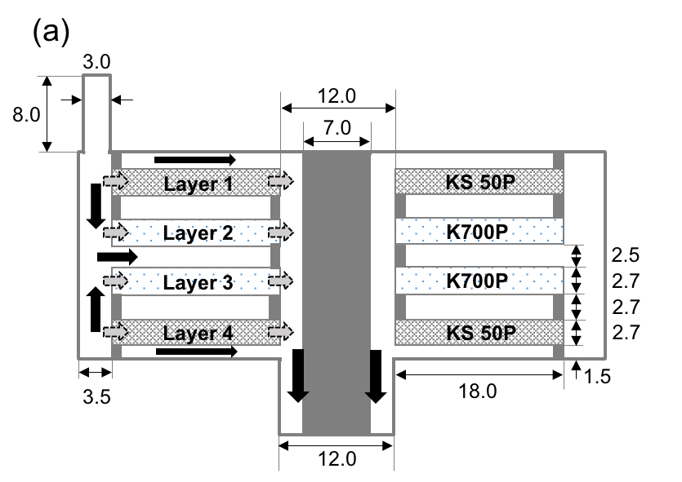
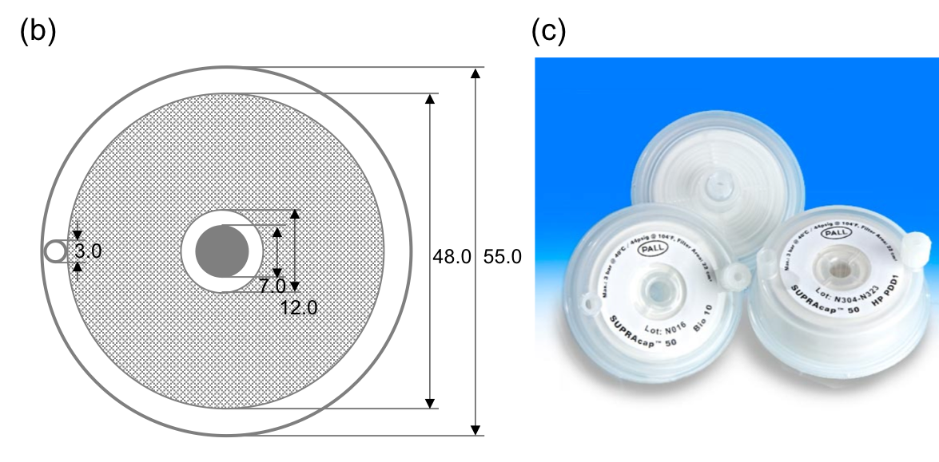
Figure 1. (a) Side view and (b) top view of the model configuration for the (c) Pall SupracapTM 50 depth filter capsule (https://shop.pall.com/us/en/biotech/depth-filtration/zidgri78l9d). The PDH4 media has two separate layers of grade 700 filter (K700P with 6-15 µm pore size) and grade 50 filter (KS50P with 0.4 – 0.8 µm pore size) with a small gap between the layers. Grey and black arrows represent porous media flow and bulk flow, respectively. All lengths are in mm.

2.2. Dye binding
Additional information on the flow distribution within the Pall SupracapTM 50 capsule was obtained using dye binding studies. A dilute (3 g/L) solution of the Cibacron Blue dye was filtered through the capsule and images were taken of the upper and lower surfaces of the capsule as a function of time. At the end of the experiment (when all the feed was filtered through the capsule), the capsule was cut open using a Dremel (4000-2/30) High Performance Rotary Tool and the individual layers of the PDH4 media were examined to map the location of bound dye.

3. CFD simulations
To understand the flow structure within the depth filtration capsule, three-dimensional CFD simulations were performed in the model geometry shown in Figure 1, which was virtually reconstructed from a cut-open device. The cylindrical capsule contains four washer-shaped filter layers with nominal permeability of 3.1 x 10⁻¹⁴ m² for the top and bottom layers (KS 50P) and 3.1 x 10⁻¹³ m² for the two internal layers (K 700P) based on corresponding water flow rates of 93 L/min/m² and 935 L/min/m² at a differential pressure of 100 kPa (14.5 psi) as reported by the manufacturer. (https://shop.pall.com/us/en/biotech/depth-filtration/zidgri78l9d)
The 2.7 mm-thick KS 50P and K700P filter media are arranged symmetrically about the mid-plane, with the two filter media in the top and bottom halves separated by a 2.7 mm spacing. The filter media are radially bounded by outer and inner open cylindrical annuli through which the feed and permeate streams flow, respectively. The top of the upper filter layer is separated from the upper surface of the capsule by a 1.5-mm spacing that is open to the inner (permeate) annulus, while the inner filter layers are separated by a 2.5-mm spacing that receives fluid from the outer (feed) annulus. A similar geometry exists on the bottom. The open space between the KS 50P (Layers 1 and 4) and K 700P (Layers 2 and 3) is radially blocked from the feed and permeate annuli, allowing net flow only in the axial direction. The feed enters the outer open annulus of the capsule through a 3-mm diameter cylindrical feed port on top of the capsule, while the permeate is removed from the inner open annulus at the bottom of the capsule. Disregarding the asymmetric placement of the feed port, the capsule configuration is otherwise axisymmetric.
Steady incompressible flow of a Newtonian fluid of density ρ and viscosity μ through the open spaces in the capsule is described by the steady-state continuity and Navier-Stokes equations:
$$∇∙u=0 (1)$$
$$ρu∙∇u=-∇p+μ∇^{2}u (2)$$
where p and u denote the pressure and velocity, respectively. The filter layers were modeled as homogeneous porous media, with laminar flow within the filter media described by Darcy’s law:
$$∇p=-\frac{μ}{κ}u (3)$$
where $κ$ is the permeability of the porous medium, which is assumed to be uniform in each filter layer. The assumption of an isotropic permeability is consistent with SEM images of cross-sections through the PDH4 media [24]. These equations are solved subject to no-slip conditions on all solid boundaries within the capsule, zero viscous normal stress at the outlet, and uniform velocity profile with a prescribed volumetric flow rate at the inlet.
The computational domain was created and meshed in ICEM-CFD (Ansys, Inc., Canonsburg, PA), and the resulting mesh structure was subsequently imported into Fluent (Ansys, Inc., Canonsburg, PA) to solve the governing equations using a pressure-based finite volume method. Convergence to steady state was achieved when the residuals for the governing equations were reduced to less than 10⁻⁵. Mesh refinement near the walls was performed until the converged solution became insensitive to mesh size. For the flow rates considered in this study, a refined mesh consisting of about 21 million tetrahedral elements was found to be sufficient for capturing the flow field.
After computing the steady state velocity distribution within the capsule, the residence time distribution was determined by introducing a tracer (Cibacron Blue in the experiments) at the inlet and monitoring the tracer concentration at the outlet as a function of time. For a dilute binary mixture, the tracer distribution within the capsule is governed by the time-dependent species (tracer) conservation equation
$$\frac{∂C}{∂t}+u∙∇C=D∇^{2}C (4)$$
where C is the tracer mass fraction, u is the steady-state velocity distribution computed earlier, and D is the binary diffusion coefficient of tracer in water. For the Cibacron Blue tracer used in the experiments, the value of D was estimated to be 3.9 x 10⁻¹⁰ m²/s using the Stokes-Einstein equation for a hard sphere with density of 1.8 g/cm³ and the molecular weight of 774 Da (http://www.chemspider.com/Chemical-Structure.150712.html). Equation (4) was marched in time starting with a step increase in tracer concentration at the inlet at time t = 0, subject to no-flux conditions at solid boundaries within the capsule and zero diffusive flux at the outlet. The flow-weighted mass fraction of tracer at the outlet of the module was monitored in time to compute the residence time distribution.

- Results and Discussion
4.1 Flow structure
Streaklines of flow within the capsule, color-labeled by flow speed, are shown in Figure 2 for a flow rate of 1.0 ml/min (see also supporting video 1). Two different views, parallel and perpendicular to the plane of symmetry of the capsule, are shown in this figure. The flow structure for a flow rate of 4.0 ml/min (supporting video 2) is qualitatively similar to that shown in Figure 2. The flow Reynolds numbers based on the average inlet velocity and inlet tube diameter are 0.7 and 2.8 for flow rates of 1.0 ml/min and 4.0 ml/min, respectively.
The fluid entering the outer annulus through the feed port behaves qualitatively similar to an impinging jet that spreads azimuthally outward (relative to the inlet) within the annulus, thereby creating a predominantly-tangential flow within the outer annulus that is symmetric about the capsule’s symmetry plane. The tangential flows on the two sides of the symmetry plane converge at an azimuthal location diametrically opposed to the inlet port to form a stagnation point flow that is driven into the central gap between the internal K 700P media. Fluid within the outer annulus can also enter this gap at other azimuthal locations. From the central open space, fluid moves through the filter media and exits the module through the inner annulus.

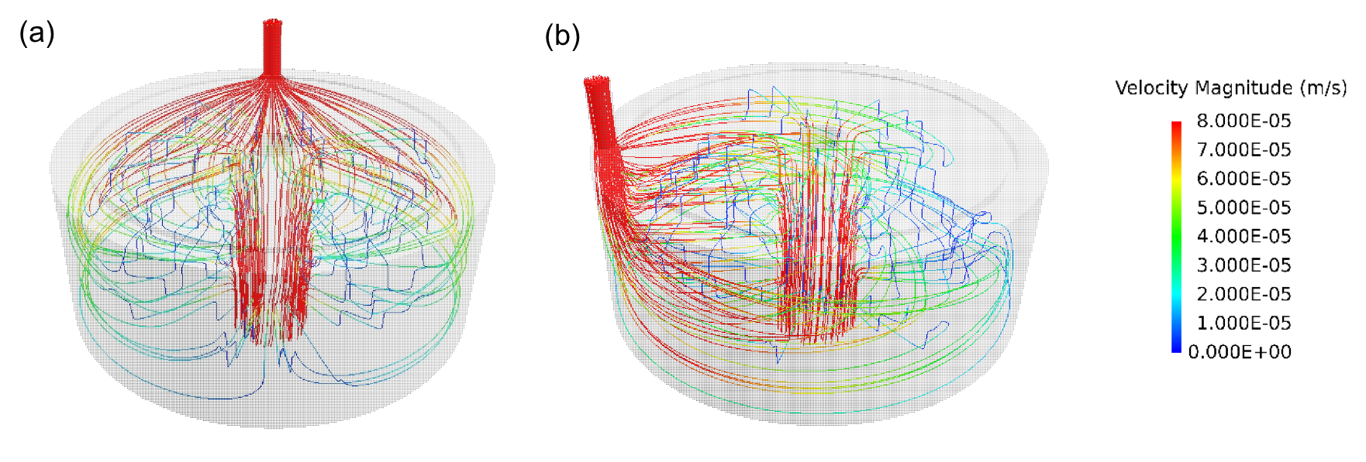
Figure 2. (a) Parallel and (b) perpendicular views (relative to the symmetry plane) of streaklines showing flow within the capsule at a flow rate of 1.0 ml/min, color-labeled by velocity magnitude.

The corresponding pressure distribution within the capsule, viewed parallel and perpendicular to the symmetry plane, is shown in Figure 3. The pressure drop across the filter as a whole is 210 Pa at a flow rate of 1 ml/min and 840 Pa at 4 ml/min. Since the permeability of the top and bottom (KS 50P) media is an order of magnitude lower than that of the two internal (K 700P) media, most of the pressure drop occurs axially across the KS 50P media. With notable exceptions in the immediate vicinity of the inner edge of the K700P media and both edges of the KS 50P media, the pressure is radially uniform within the filter media. The large pressure gradients at the inner edge of the internal layers and both edges of the top and bottom layers are indicative of radial bypass through the edges of the filter media.

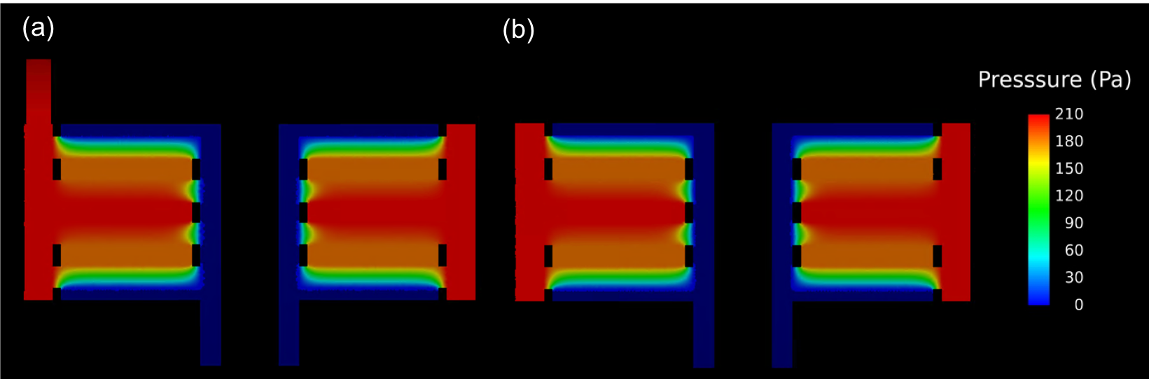
Figure 3. (a) Parallel and (b) perpendicular views (relative to the symmetry plane) of pressure distribution within the capsule at a flow rate of 1.0 ml/min.

The ideal flow path in the SupracapTM 50 capsule would be one that takes the fluid from the outer annulus into the central gap between the internal K 700P media, followed by axial flow through both filter media into the permeate collection reservoirs at the top and bottom of the capsule before leaving the capsule through the inner annulus (labeled as path 2 in Figure 4). However, as suggested by the pressure distribution in Figure 3, there are three other flow paths arising from radial bypass through the edges of the filter media. These bypass flows are identified by paths 1, 3, and 4 in Figure 4; the fractions of the flow passing through each path are summarized in Table 1. Path 1 corresponds to radial bypass from the outer annulus to the permeate collection reservoir through the outer edge of the KS 50P media, and accounts for 11% of the total flow. This implies that the K S50P layer would perform about 11% of the clarification by itself (at the start of the filtration, i.e., before any filter fouling), without the K 700P layer providing a “polished” feed. Paths 3 and 4 represent radial bypass into the inner annulus through the inner edges of the KS 50P and K 700P media, respectively. Remarkably, only 36% of the flow follows the ideal path (completely through both layers of filter media) at flow rates of 1.0 and 4.0 ml/min. The predominant flow path is Path 4, which allows 51% of the flow to leave the capsule through the inner edge of the internal filter layers. More than 60% of the flow is able to leave the capsule without passage through even a single complete layer of filter media (from bottom to top), although these bypass flow paths do traverse significant radial distances within an individual layer of the filter. The presence of defects in sealing of the filter media could potentially exacerbate these problems, creating additional non-uniformity in the flow distribution through the PDH4 media.
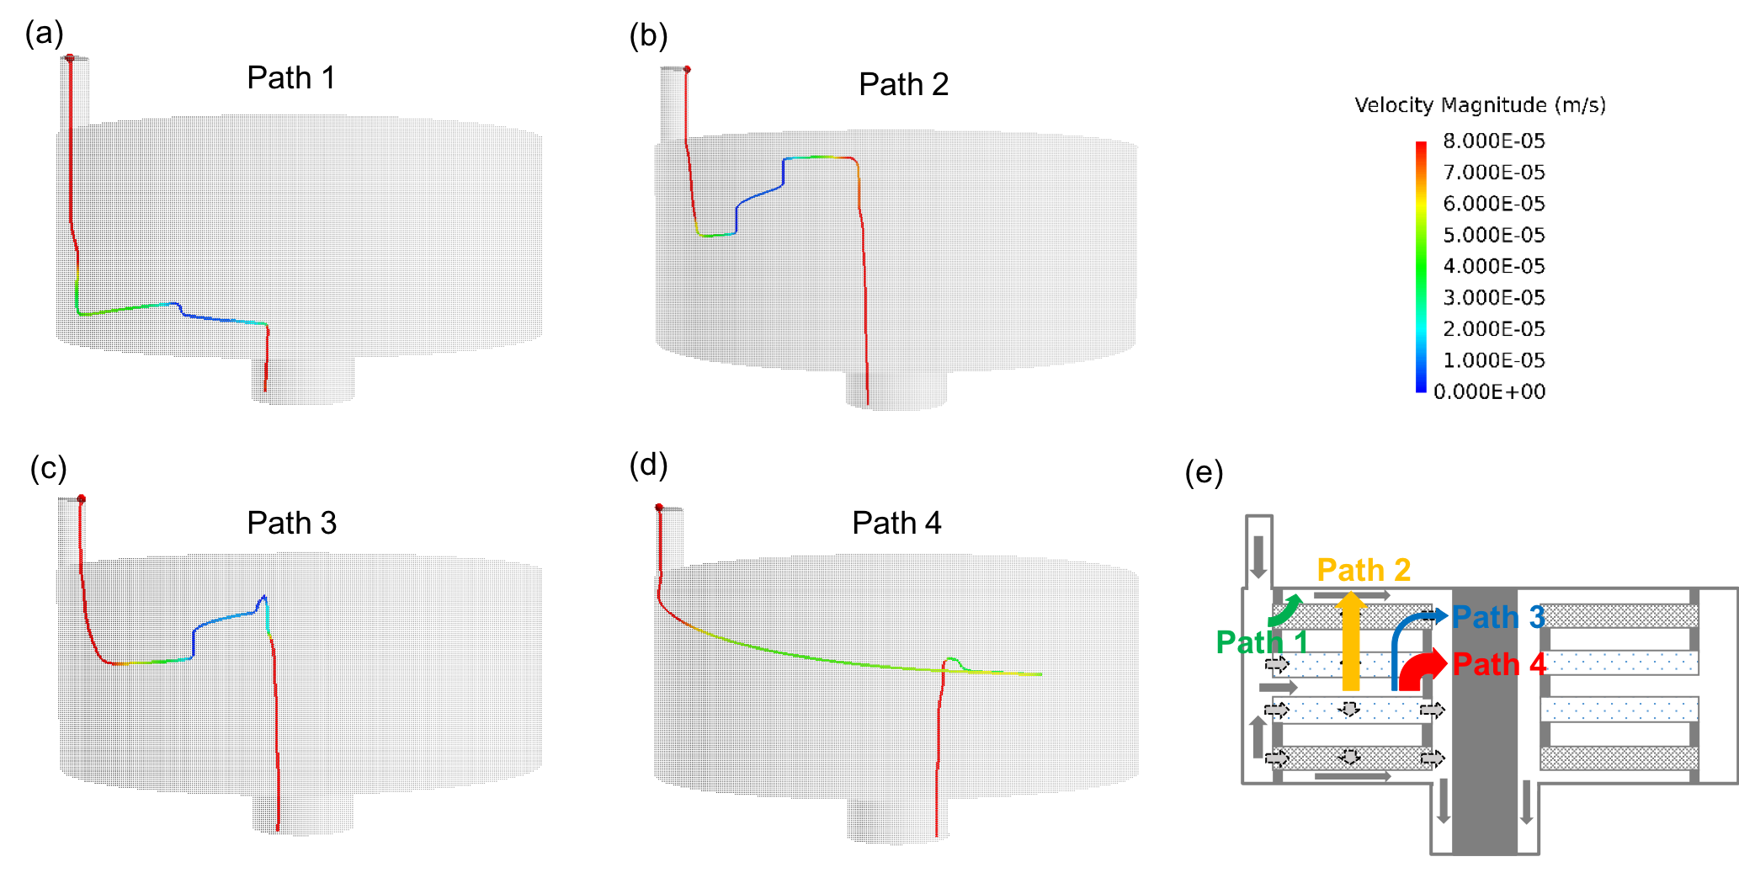
Figure 4. Streaklines showing different flow paths through the SupracapTM 50 capsule at a feed flow rate of 1 mL/min: (a) Path 1, (b) Path 2, (c) Path 3, (d) Path 4.

In addition to simulations of the actual PDH4 media, we also evaluated the flow distribution for capsules containing (i) 4 layers of the K 700P media, (ii) 4 layers of the KS50P media, and (iii) media in which each layer has a permeability that is 10X that of the permeability of the PDH4. The resulting flow fractions for the different paths are summarized in Table 1. The flow fractions for the different paths in the module depend only on the ratio of the permeabilities of the media layers used in each half of the capsule, with the results for the capsule having 10x the permeability of the PDH4 being identical to that of the actual capsule. Filters in which the two layers have similar permeability show significantly less bypass through Path 4, with an increase in the fraction following Path 1. Results for capsules in which the two layers have the same permeability show that bypass through Path 4 is reduced by 80% (compared to PDH4), rendering Path 1 the predominant bypass route.

Table 1. Flow fraction (%) for different paths in capsules containing PDH4 media, K700 media alone, KS50P media alone, and media with 10X the permeability of PDH4 media.
 | PDH4 | K700 / K700 | KS50P / KS50P | 10X Permeability of PDH4
Path 1 | 10.5 | 34.7 | 34.7 | 10.5
Path 2 | 36.0 | 50.6 | 50.6 | 36.0
Path 3 | 2.3 | 3.7 | 3.7 | 2.3
Path 4 | 51.2 | 11.0 | 11.0 | 51.2

It is important to note that all of the calculations presented in Figures 2 to 4 (and Table 1) are for the pristine (unfouled) filter. Fouling due to the presence of solids in the feed stream (as in the case of cell culture fluid) would significantly alter the flow distribution in the depth filter by increasing the resistance to flow in the fouled regions. Since Path 4 has the largest flow fraction and the smallest area, we would expect fouling to reduce the flow through this path first, causing a larger fraction of the flow to be shifted through Path 2 (the ideal path) and also through Path 1. The net result would be a more uniform flow distribution as the filter fouls, similar to the results in Table 1 for filters in which both layers have the same permeability. Since fouling will likely occur non-uniformly in each layer, the actual flow distribution through the partially fouled filter will be even more complex than that shown in Figures 2 to 4.
Figure 5 shows images of the upper and lower surfaces of the four layers of media within the SupracapTM 50 capsule that was used in the dye-binding experiments. The layers are numbered from top to bottom. The lower surface of Layer 2 and the upper surface of Layer 3 both show a nearly uniform blue color, as do the upper surface of Layer 1 and the lower surface of Layer 4; these are the filter surfaces exposed to the inlet feed and the exit permeate. In contrast, the upper surface of Layer 2 and the lower surface of Layer 3 show non-uniform color that is localized mostly around the inner edge of the filter media, consistent with the CFD analysis showing that much of the flow leaves through the inner edge of these layers (path 4). Similarly, the bottom surface of Layer 1 and the top surface of Layer 4 are only blue around the outer edge of the filter media, confirming that fluid enters these layers from the outer radial surface and largely bypasses the filter media through path 1, consistent with the results of the CFD analysis.

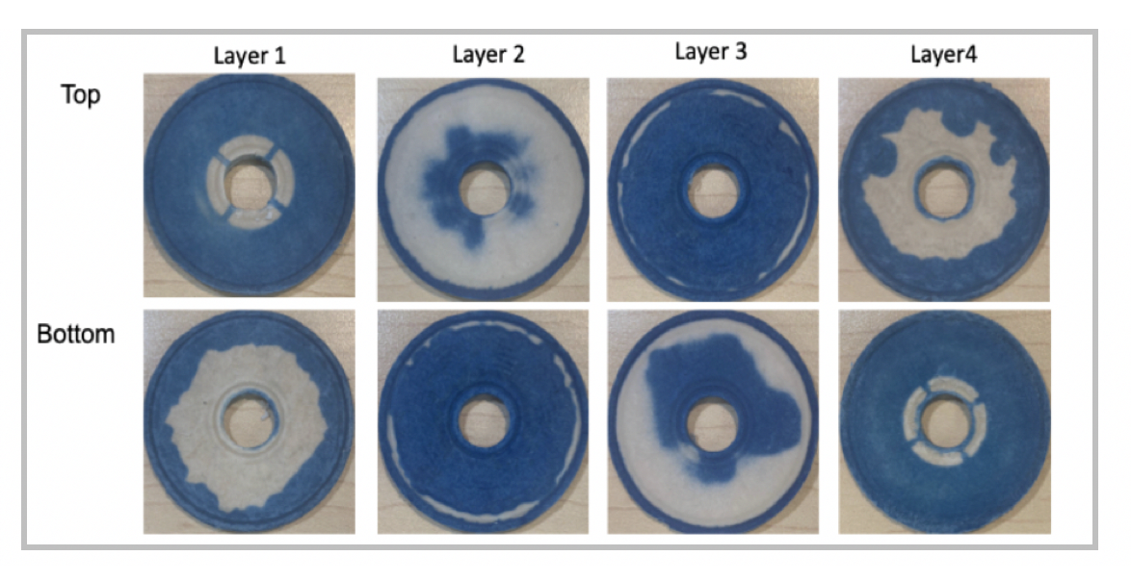
Figure 5 – Images of the top and bottom surfaces of the four layers of PDH4 media within a single Pall SupracapTM 50 filter capsule at the end of the dye binding experiment. Layers are numbered in the order in which they are housed within the capsule. Inlet flow enters between Layers 2 and 3 as shown in Figure 1.

4.2 Residence time distribution
The computed and experimentally measured residence time distributions for flow rates of 1.0 and 4.0 ml/min are shown in Figure 6. CFD predictions are in qualitative agreement with experimental data, with two notable discrepancies. First, the simulation results predict a greater time lag before breakthrough at both flow rates, and a slightly faster increase to complete breakthrough at long times. This is shown more quantitatively in Table 2, with the lag times evaluated as the time at which the dye concentration at the outlet reaches 5% of the feed concentration, i.e., C/C₀ = 0.05. The time lag predicted by simulation is 24% larger than the experimental measurement for 1.0 ml/min, with this difference increasing to 40% at 4.0 ml/min. A possible explanation for this difference could be greater radial bypass through path 4 in the experiments compared to the simulations. Path 4 has the shortest lag time of the four flow paths identified in the simulations; about 4 min at a flow rate of 1.0 ml/min, consistent with the experimentally observed lag time. More extensive radial bypass through path 4 could occur as a result of channeling arising from non-uniformity in the permeability of the filter media, a feature that is not included in the CFD simulations.

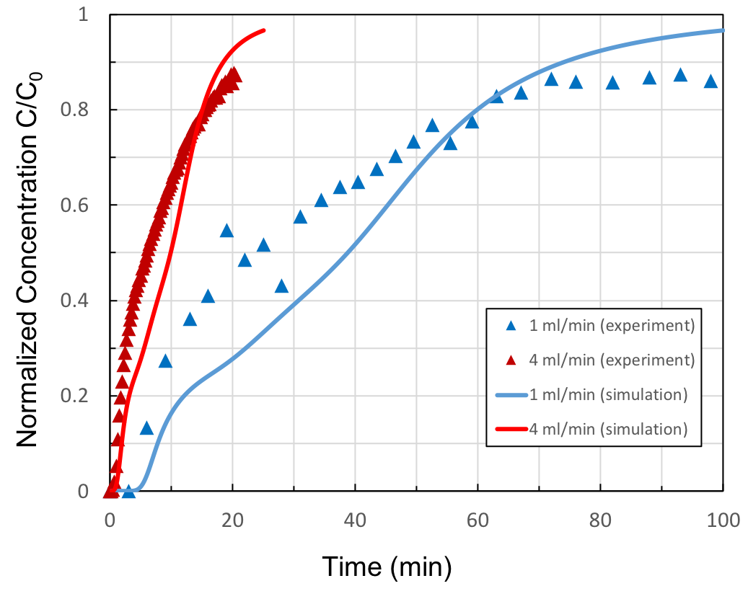
Figure 6. Comparison of residence time distributions in the SupracapTM 50 capsules from experiments and CFD simulations.

Table 2. Lag times for different flow rates evaluated at C/C_{o} = 0.05
 | Lag time (min) Experiment | Lag time (min)  Simulation | % difference
1.0 ml/min | 4.1 | 5.1 | 24
4.0 ml/min | 1.0 | 1.4 | 40

The second discrepancy between the simulations and experimental data is the long-time behavior of the residence time distribution. The long-time plateau in the normalized concentration appears to approach a value of 0.95 after 200 min (not shown in Fig. 6) in the experiment with a flow rate of 1.0 ml/min, instead of the expected value of 1.0 exhibited by the simulation results. This difference is likely due to continued binding of dye within the filter media, which is not accounted for in the current CFD simulations. Including dye adsorption in the model would change the shape of the RTD curve and could account for the observed discrepancy at long times. However, adsorption of such a small dye within the media should have no effect on the flow structure; thus, we expect the flow distribution within the capsule to remain unchanged with the bypass flow through Path 4 to be the predominant pathway even when dye adsorption is included in the simulations.
Finally, the appearance of an inflection point in the simulation results is indicative of the presence of at least two dominant flow paths with widely different lag times; in this case paths 4 and 2 with respective lag times of 4 min and 40 min at a flow rate of 1.0 ml/min. The apparent absence of the inflection point in the experimental data is further indication that one of these paths is dominant in the experiments; namely, path 4 with the shorter lag time. Predominant bypass through path 4 in the experiments is also consistent with results from the dye binding experiments. The absence of overlap between colored regions on the top of Layer 2 and the bottom of Layer 1 (see Figure 5) indicates that very little flow occurs through the ideal flow path (path 2). The same behavior is seen with the bottom of Layer 3 and the top of Layer 4. In fact, the dye binding experiments suggest that most of the flow occurs through paths 1 and 4. This is most likely due to non-uniform permeability of the filter media, which can promote channeling through the larger pores. This channeling effect would be expected to be most pronounced in the K 700P media since it has much larger mean permeability, thereby rendering path 4 the dominant radial bypass route, consistent with the experimentally observed lag time in the residence time distribution.

5 Conclusions
This paper presents the first detailed analysis of the flow and pressure distributions in a small-scale commercial depth filter, the SupracapTM 50 capsule containing 2 layers of K 700P and 2 layers of KS 50P media, each with diatomaceous earth. The inlet flow enters the outer annulus of the capsule through the feed port, spreading azimuthally outward around the annulus and creating a relatively uniform radial flow into the central gap between the internal K 700P media. The CFD analysis identified four distinct flow paths through the capsule. Surprisingly, only 11% of the flow followed the ideal flow path that passes through both the K 700P and KS 50P media, with 60% of the flow entering the more permeable K 700P layer and then exiting radially through the inner edge of media.
These surprising results were confirmed experimentally using a combination of residence time distribution and dye binding experiments. The Cibacron Blue dye uniformly colored the internal surfaces of the K 700P media as expected; a similar uniform flow was seen on the external surfaces of the KS 50P media where the permeate collects. However, the other surfaces of the media show highly non-uniform flow distribution, consistent with the dominant flow path that passes into the K 700P and then leaves radially through the inner edge of the annular disk. Model calculations for the RTD were in qualitative agreement with the experimental measurements, with the observed discrepancies likely due to non-uniformity in the filter permeability which leads to additional bypass flow.
The high degree of bypass flow in this small-scale filter is likely to have significant implications for the performance of the SupracapTM 50 capsule. In particular, the CFD analysis indicates that more than half of the flow does not pass through the tighter pore size KS50P media, which could significantly compromise the filter’s ability to remove smaller particles and debris from the feed. In addition, the flow distribution in the depth filter modules used for large-scale commercial processes is likely to be very different than that in the SupracapTM 50, which would complicate the design and scale-up of depth filtration processes using the PDH4 media. It is important to note that the flow distribution evaluated in this study is for the clean (unfouled) filter. Particle / cell deposition on and within the filter will significantly alter the flow, shunting fluid away from blocked regions within the media, leading to a reduction in the amount of bypass flow through the K 700P layer. Future studies will be required to account for these phenomena to describe the performance and scale-up of depth filtration processes for clarification of bioprocessing streams.

Acknowledgements
The authors would like to acknowledge Merck Sharp & Dohme Corp., a subsidiary of Merck & Co., Inc., Kenilworth, NJ, USA for their financial support of this project.

References
[1] V.N. Burganos, C.A. Paraskeva, A.C. Payatakes, Three-dimensional trajectory analysis and network simulation of deep bed filtration, J. Colloid Interface Sci. 14 (1992) 167–181. https://doi.org/10.1016/0021-9797(92)90125-6
[2] C. Geerling, M. Azimian, A. Wiegmann, H. Briesen, M. Kuhn, Designing optimally‐graded depth filter media using a novel multiscale method, AIChE J. 66 (2020) e16808. https://doi.org/10.1002/aic.16808
[3] R. van Reis, A.L. Zydney, Bioprocess membrane technology. J. Membr. Sci. 297 (2007)16-50. https://doi.org/10.1016/j.memsci.2007.02.045
[4] D.J. Roush, Y. Lu, Advances in primary recovery: Centrifugation and membrane technology, Biotechnol. Prog. 24 (2008) 488–495. https://doi.org/10.1021/bp070414x
[5] S.R. Hadpe, V. Mohite, S. Alva, A.S. Rathore, Pretreatments for enhancing clarification efficiency of depth filtration during production of monoclonal antibody, (2020) e2996. https://doi.org/10.1002/btpr.2996
[6] A. Pegel, S. Reiser, M. Steurenthaler, S. Klein, Evaluating disposable depth filtration platforms for MAb harvest clarification, Bioprocess Int. 9 (2011) 52–56.
[7] M. Prashad, K. Tarrach, Depth filtration: Cell clarification of bioreactor offloads. Filtr. Sep. 43 (2006) 28-30. https://doi.org/10.1016/S0015-1882(06)70950-8
[8] H.R. Charlton, J.M. Relton, N.K.H. Slater, Characterisation of a generic monoclonal antibody harvesting system for adsorption of DNA by depth filters and various membranes, Bioseparation 8 (1999) 281–291. https://doi.org/10.1023/A:1008142709419
[9] O. Khanal, X. Xu, N. Singh, S.J. Traylor, C. Huang, S. Ghose, Z.J. Li, A.M. Lenhoff, DNA retention on depth filters, J. Memb. Sci. 570-571 (2019) 464–471. https://doi.org/10.1016/j.memsci.2018.10.058
[10] N. Singh, K. Pizzelli, J.K. Romero, J. Chrostowski, G. Evangelist, J. Hamzik, N. Soice, K.S. Cheng, Clarification of recombinant proteins from high cell density mammalian cell culture systems using new improved depth filters, Biotechnol. Bioeng. 110 (2013) 1964–1972. https://doi.org/10.1002/bit.24848
[11] B. Tipton, J.A. Boose, W. Larsen, J. Beck, T. O’Brien, Retrovirus and parvovirus clearance from an affinity column product using adsorptive depth filtration, BioPharm. 15 (2002) 43-50.
[12] D. Yu, M. Mayani, Y. Song, Z. Xing, S. Ghose, Z.J. Li, Control of antibody high and low molecular weight species by depth filtration‐based cell culture harvesting, Biotechnol. Bioeng. 116 (2019) 2610–2620. https://doi.org/10.1002/bit.27081
[13 M. Collins, H. Lari, S. Anderson, R. Leibnitz, A. Kumar, R. Kuriyel, Investigating flow distribution and its effects on scale-up. Bioprocess Int. 7 (2009) 46-51.
[14] A.U. Krupp, C.P. Please, A. Kumar, I.M. Griffiths, Scaling-up of multi-capsule depth filtration systems by modeling flow and pressure distribution, Sep. Purif. Technol. 172 (2017) 350-356. https://doi.org/10.1016/j.seppur.2016.07.028
[15] O. Iliev, Z. Lakdawala, G. Printsypar, On a multiscale approach for filter efficiency simulations, Comput. Math. with Appl. 67 (2014) 2171-2184. https://doi.org/10.1016/j.camwa.2014.02.022
[16] G.A. Fimbres-Weihs, D.E. Wiley, Review of 3D CFD modeling of flow and mass transfer in narrow spacer-filled channels in membrane modules, Chem. Eng. Process. Process Intensif. 49 (2010) 759-781. https://doi.org/10.1016/j.cep.2010.01.007
[17] L. Zhuang, H. Guo, G. Dai, Z-L. Xu, Effect of the inlet manifold on the performance of a hollow fiber membrane module-A CFD study. J. Memb. Sci. 526 (2017) 73-93. https://doi.org/10.1016/j.memsci.2016.12.018
[18] F. Li, W. Meindersma, A.B. De Haan, T. Reith, Optimization of commercial net spacers in spiral wound membrane modules. J. Memb. Sci. 208 (2002) 289-302. https://doi.org/10.1016/S0376-7388(02)00307-1.
[19] J. Schwinge, D.E. Wiley, D.F. Fletcher, A CFD study of unsteady flow in narrow spacer-filled channels for spiral-wound membrane modules, Desalination 146 (2002) 195-201. https://doi.org/10.1016/S0011-9164(02)00470-8.
[20] J.S. Vrouwenvelder, C. Picioreanu, J.C. Kruithof, M.C.M. van Loosdrecht, Biofouling in spiral wound membrane systems: Three-dimensional CFD model based evaluation of experimental data, J. Memb. Sci. 346 (2010) 71-85. https://doi.org/10.1016/j.memsci.2009.09.025
[21] Y.Z. Wang, Y.K. Wang, C.S. He, H.Y. Yang, G.P. Sheng, J.Y. Shen, Y. Mu, H.Q. Yu, Hydrodynamics of an electrochemical membrane bioreactor, Sci. Rep. 5 (2015) 10387. https://doi.org/10.1038/srep10387
[22] S. Zhang, P. Sukitpaneenit, T.S. Chung, Design of robust hollow fiber membranes with high power density for osmotic energy production, Chem. Eng. J. 241 (2014) 457-465. https://doi.org/10.1016/j.cej.2013.10.063
[23] D. Hasson, A. Drak, C. Komlos, Q. Yang, R. Semiat, Detection of fouling on RO modules by residence time distribution analyses. Desalination. 204 (2007) 132-144. https://doi.org/10.1016/j.desal.2006.03.537
[24] N. Nejatishahidein, E.E. Borujeni, D.J. Roush, A.L. Zydney, Effectiveness of host cell protein removal using depth filtration with a filter containing diatomaceous earth, Biotechnol. Prog. (2020) e3028 (early view). https://doi.org/10.1002/btpr.3028

