Effect of Processing Parameters and Strut Dimensions on the Microstructures and Hardness of Stainless Steel 316L Lattice-Emulating Structures Made by Powder Bed Fusion
Cole Britt¹, Colt J. Montgomery², Michael J. Brand², Zi-Kui Liu¹, John S. Carpenter², Allison M. Beese^{1,3,*}
¹ Department of Materials Science and Engineering, Pennsylvania State University, University Park, PA 16802, United States
² Sigma Division: Metallurgy and Manufacturing Science, Los Alamos National Laboratory, Los Alamos, NM 87545, United States
³ Department of Mechanical Engineering, Pennsylvania State University, University Park, PA 16802, United States
*beese@matse.psu.edu
Abstract
This work presents the effects of input processing parameters and strut thickness (in square struts) on microstructure and properties in laser powder bed fusion additively manufactured stainless steel 316L lattice-emulating structures. Lattice-emulating X-structures with square cross-sections of 1.5, 1.0, and 0.5 mm were fabricated using three different parameter sets with varying power, speed, and therefore, linear energy density. Grain size and morphology were shown to be dictated by epitaxial growth, which was dependent on weld pool morphology. Additionally, grain size and morphology were shown to change across the thickness direction of the struts (from the bottom inclined surface to the top inclined surface). The spatial variation in grain size was reflected by changes in hardness through the thickness of each strut. The 0.5 mm struts exhibited more significant grain elongation in the strut direction and larger sub-grain solidification cell diameters than their thicker counterparts. The larger sub-grain solidification cell diameters in the 0.5 mm samples resulted in correspondingly lower hardness values when compared to samples of higher thicknesses.
Keywords:
Additive manufacturing; Powder bed fusion; Stainless steel; Lattice structures; Microstructure

Introduction
Additive manufacturing (AM) provides the ability to fabricate parts with geometries that are challenging or impossible to produce with traditional subtractive methods, including lattice structures and other topologically optimized geometries [1,2]. Lattice structures are three-dimensional networks of unit cells that offer high elastic modulus, specific strength, and energy absorption capacity; thus these structures may provide routes for lightweighting of components [1,3,4]. Stainless steel 316L (SS316L) may be viewed as an alternative to Ti-6Al-4V in AM lattice structures, commonly selected for its high specific strength and corrosion resistance, based on the higher ductility, lower sensitivity to residual stress and cracking, and lower cost of SS316L [5]. However, before these lattices and other topologically optimized structures are employed, it is imperative to understand how the properties of the struts and nodes differ from those of bulk components.
During AM, high cooling rates, repeated thermal cycling, and spatially and temporally varying thermal gradients during layer-by-layer melting with a high-power laser lead to complex non-equilibrium microstructures. Cellular solidification structures in AM SS316L are caused by the non-equilibrium conditions during solidification leading to constitutional supercooling in the liquid and rejection of solute into the cell walls, in this case primarily Mo and Cr [6–12]. As a consequence of the enrichment of these larger elements, the cell walls are densely populated with geometrically necessary dislocations [6–8,10,13–15]. The cellular structure, along with grain boundary strengthening, has been hypothesized to be a key factor resulting in the high strength of parts made by AM due to the impediment of dislocation motion [6–8,10,13–16]. For FCC crystals, these columnar cells grow preferentially in the <100> directions along the maximum thermal gradient, occurring perpendicular to the weld pool boundary [17–24]. However, nucleation energy can be decreased by growing epitaxially from the crystal below the melt pool. This epitaxial growth can occur in either the same primary direction, or a secondary growth direction, which is perpendicular to the primary direction and in this case adopts the same crystal orientation by cubic symmetry. This epitaxial growth often leads to elongated grains along the vertical build direction [19–21,23–26].
However, the minimization of mismatch angle between the epitaxial direction and maximum thermal gradient can lead to varied growth preferences resulting in significant changes in grain morphology. Several studies have shown that differences in scanning strategy can result in {100} or {110} texture preferences along the vertical build direction based on the effects of weld pool stacking, defined by the multitudes of variations in weld pool shape and the relative locations of each weld pool, controlled by processing parameters such as power, speed, and hatch spacing, on the thermal gradient and mismatch angle [19,20,23,24].
As established by welding literature, solidification structures in AM can be described by the thermal gradient in the liquid at the solid-liquid interface, G, and the growth rate of the solidification front, R, of the melt pool. The different ratio of G/R dictates the morphology of the solidification structures, which can be cellular structures, columnar dendrites, or equiaxed dendrites. The cooling rate, GR, determines the size of the solidification structures [17]. Cooling rate in laser PBF has also been shown to be roughly inversely proportional to linear energy density (LED, power/velocity) [22]. Therefore, changing LED should impact solidification behavior without significantly affecting part density, as long as hatch spacing and layer thickness are appropriately controlled [27–29].
In studies attempting to optimize design for AM lattice structures, relative density, repeat unit size, unit geometry, strut length, and strut thickness are often altered [30,31]. Finite element analysis is commonly used to predict and optimize the mechanical properties of these complex lattice structures with varying shapes and sizes; however, these methods are often not validated by experiments as they assume isotropic bulk mechanical properties for the lattice struts and nodes. Microstructural non-homogeneities coupled with significant differences between as-designed and as-built geometry in the form of surface roughness leads to property differences between as-modeled and as-fabricated lattices [32–34]. With increasingly small feature size, fewer grains are present within single struts, increasing the importance of understanding how variations in microstructure (e.g., grain size, morphology, and texture), and the proportionally large importance of surface roughness, impact lattice properties compared to bulk materials.
While researchers have characterized microstructure in bulk AM stainless steels, there are limited published studies on the effects of complicated part geometry on microstructure and resultant properties for SS316L. Relationships between geometry, microstructure, and hardness have been explored in analogous studies of AM Ti-6Al-4V and AlSi10Mg [35–43]. These studies have observed finer microstructural features in general, and in Ti-6Al-4V, appearance of α’ [36,38,39,41–43]. These fine features, associated with higher cooling rates caused by lower total heat input locally within each layer in thin samples, corresponded to an increase in hardness in thin block and fin geometries compared with bulk samples [36,39–43]. Changes in total heat input have also been shown to impact microstructures in AM SS316L. Piazza et al. fabricated cylindrical and cone shaped SS316L bulk parts with equal base diameters finding that the hardness values of the cylindrical part were more sensitive to changes in processing parameters [44]. The upper layers of the cylindrical part had larger areas requiring higher cumulative heat inputs, which exceed the heat extraction capacity of the geometry below; thus; when higher energy processing parameters were employed, the cylindrical part underwent more drastic heat accumulation which resulted in slower cooling rates [44]. Similarly, Mohr et al. demonstrated how feature geometry may restrict heat flow, contribute to heat accumulation, and alter microstructure by fabricating bulk prisms atop 2 and 6 mm connections to the base plate that then connected to the bulk [45]. Leicht et al. and Niendorf et al. both demonstrated grains were elongated along the vertical direction in vertical and inclined struts similar to bulk material [46,47]. At the surface of the vertical struts, small randomly oriented grains were elongated toward the center of vertical struts [46,47]. Wang et al. showed similar changes at the edge of the struts, and a transition from <110> to <100> texture in vertical struts below a thickness of 0.25 mm due to changes in heat flow [16]. Pauzon et al. fabricated 1 and 3 mm thickness tensile specimens and observed a possible variation in sub-grain solidification structures, though with low certainty, and no difference in hardness was observed [48]. While it is clear that part geometry impacts AM microstructures, relationships between process parameters, structure, and properties have not been well established for SS316L parts with small geometries. There are a lack of investigations that report local changes in microstructure when fabricating an inclined strut over powder, and how different processing parameter sets affect these changes. This is particularly important in struts that are 1 mm and thinner, as these are proportionally more affected by edge effects. Furthermore, there has been limited quantitative information on the effects of processing and thickness on SS316L sub-grain solidification structures in thin struts.
The aim of this study was to separate the effects of input processing parameters and strut thickness on grain and sub-grain characteristics in AM SS316L inclined lattice structures. Lattice-emulating X-structures were fabricated using laser powder bed fusion (PBF). Three different parameter sets were used, and each parameter set was used to fabricate structures with different strut thicknesses. Grain size (in terms of an equivalent grain diameter), grain morphology, and sub-grain cell diameters were compared for each parameter set and strut thickness. Additionally, grain size and morphology were characterized as a function of position across the struts. Hardness was also measured and compared between parameter sets and thicknesses as well as a function of position across the struts (i.e., from the bottom inclined surface to the top inclined surface, referred to here as along the strut thickness).

Methods

Fabrication
Samples in this study were fabricated using an EOS M290 with a laser spot size of 100 µm and a maximum power of 400 W. Powder composition is given in Table 1. Three parameter sets that varied LED by changing power and scanning velocity were selected for this study as shown in Table 2. Parameter set 1 (P1) corresponds to the optimized settings from the machine manufacturer, parameter set 2 (P2) increased LED by decreasing speed and maintaining power, and parameter set 3 (P3) had the same LED as (P2) but at a lower power and a correspondingly lower scanning speed. All samples were fabricated on one build plate, where processing parameters were varied within the single build.
Table 1. Chemical composition of powder used for the X-samples and SS316L plate used for single-track testing (weight percent). Average particle size = 27.7 μm.
 | Fe | Cr | Ni | Mo | Mn | Si | N | O | C | Cu | S | P
Powder | 64.7 | 18.07 | 13.17 | 2.26 | 0.91 | 0.71 | 0.072 | 0.03 | 0.02 | 0.015 | 0.011 | 0.006
316L Plate | Bal | 17.11 | 10.09 | 2.06 | 1.22 | 0.46 | 0.052 |  | 0.016 | 0.310 | 0.001 | 0.030

Table 2. PBF parameters for fabrication of the lattice emulating X-samples. Percent porosity is reported for the 1.5 mm samples.
 | Power,  P (W) | Scanning Velocity,  v (mm/s) | Linear Energy Density,  LED (J/mm) | Hatch Spacing, h (µm) | Layer Thickness,  t (µm) | Volumetric Energy Density,  VED (J/mm³) | Measured Percent Porosity
P1 (Nominal) | 214 | 928 | 0.23 | 100 | 40 | 57.5 | <0.01%
P2 (High LED) | 214 | 535 | 0.40 | 130 |  | 76.9 | 0.2%
P3 (Low P, High LED) | 100 | 250 | 0.40 | 110 |  | 90.9 | 1.2%
Up-skin | 150 | 515 | 0.29 | 100 |  | 72.8 | -
Down-skin | 74 | 951 | 0.08 | 90 |  | 21.6 | -

To determine appropriate hatch spacings for each parameter set, single-track laser scans, without powder, were conducted on a SS316L plate, with the composition (provided by supplier, Outokumpu) given in Table 1, similar to He et al. [49]. Single-track samples were sectioned, mounted, and polished using standard metallographic techniques to a final polish of 0.05 µm alumina, and electrolytically etched using 10% oxalic acid to reveal weld pools. The depths, widths, and morphologies of the weld pools were characterized. Single-track samples without powder provide a conservative approximation of weld pool geometry as the plate provides an optimal heat transfer condition with no radiative heat transfer in the downward vertical direction or contact resistance between powder particles, which would result in heat losses if powder were present; therefore, performing these measurements without powder results in the smallest weld pool geometries, providing conservative estimations of required hatch spacing and layer height. The hatch spacing necessary for dense PBF builds was determined based on the width of the track at the depth corresponding to the PBF layer height, 40 µm, as shown in Figure 1. This ensures higher density values for the resulting bulk samples produced with powder as any welds produced will be equal or larger in size to what is predicted from the plate values.
Figure 1. Single-track melt pool morphologies for the (a) nominal (P1), (b) high LED (P2), and (c) high LED, low power (P3) parameter sets. (d) Example of measurements taken from cross-sections to determine hatch spacing.
X-shaped structures, with the geometry shown in Figure 2 were fabricated using each parameter set to emulate the thin struts in lattice structures with thicknesses of 1.5, 1.0, and 0.5 mm. The P3, 0.5 mm samples were not successfully built and were not included in this analysis. The X-shaped structures were designed to provide a simplified planar structure compared to lattice structures for streamlined characterization. The X-shaped planar structures differ from fully three-dimensional lattices, and therefore do not represent an identical match in thermal history to a full lattice structure; however, they allow for a direct connection between thickness, parameters, microstructure, and hardness. Samples of the same thickness were spaced 0.35 mm apart for improved buildability and support on a standard build plate of 1030 carbon steel from EOS. The different thicknesses were spaced 20 mm apart. A bi-directional scan pattern was employed with 60° rotations between each layer. For all three parameter sets, lower energy contours were used for the top and bottom 120 µm of each inclined surface (shown in Figure 3) as indicated by the up-skin and down-skin surface parameters in Table 2. The surface parameters were selected based on recommendations from the manufacturer. As the focus of this study was on changes to bulk parameter settings in thin struts, contour settings were kept constant across samples to isolate the effects between samples to the changes in bulk parameter sets and strut thickness. The hatch spacings of each parameter set, determined by the width of the track at the 40 µm depth in single-track laser scans, are also listed in Table 2. It is worth noting that changes to hatch spacing have impacts on total heat input, represented here by volumetric energy density [27,28].
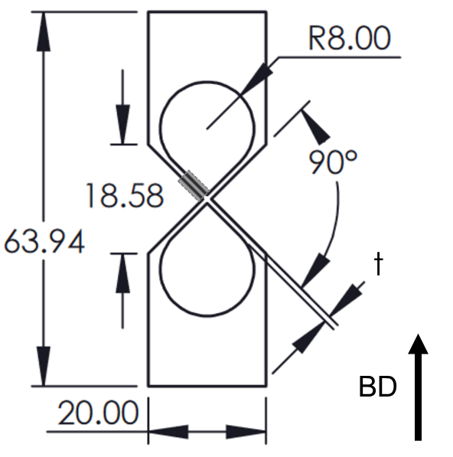
Figure 2. Engineering drawing for the X-samples. Thickness (t) also corresponds with out of plane thickness (all dimensions in mm). Area of analysis in the upper strut for EBSD and grain analysis, SEM for cell size analysis, and positional hardness analysis is marked in gray.
X-ray computed tomography was conducted using a ZEISS Xradia Versa 520 with a voxel size of 12.6 μm, providing the ability to resolve pores with dimensions greater than about 38 μm, to collect porosity percentages in the 1.5 mm samples. Measured values are presented in Table 2.

Characterization
Following polishing, electron backscatter diffraction (EBSD, Oxford Symmetry) analysis was conducted with a step size of 3.0 μm. Grain characterization was performed in MTEX [50]; grains were segmented with a threshold angle of 10° and grains with areas less than 10 pixels were removed.
Samples were etched for weld pool and solidification structure characterization via scanning electron microscope (SEM, ThermoFisher Scientific Apreo). For characterization of cell size, images were collected in which cells had grown primarily out of plane as shown in a representative image in Figure 3. To ensure statistical significance, 12 images were collected for each sample: 6 at the node and 6 at the center of each strut. MATLAB image processing was used to measure the diameters of the cellular solidification structures [51]. Cellular structures are assumed to be long cylinders where any deviation in the orientation of the cells can be accounted for by measuring the minor axis of the cells, which is equal to the diameter of the cylinder.
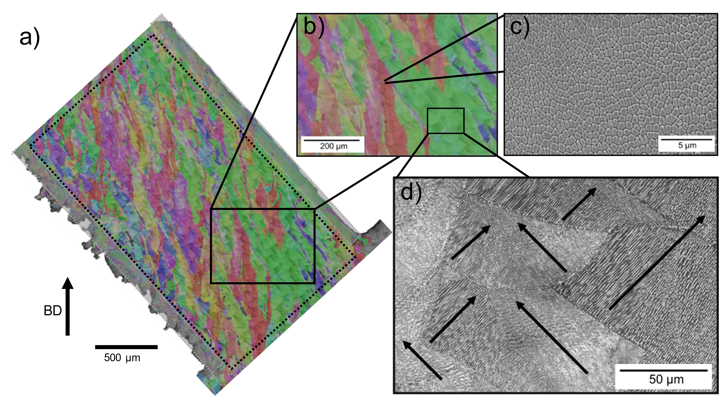
Figure 3. (a) Optical micrographs of etched sample overlaid by its build direction inverse pole figure (IPF) map for the nominal (P1) sample’s upper strut with (b) grains spanning many weld pools due to epitaxial growth. Gray regions indicate surface area where up-skin/down-skin surface parameters were applied. Area outlined with dotted lines represents region used for grain size analysis in Figure 6. SEM images of cellular structures (c) growing out of plane and (d) epitaxially with a {110} texture preference in the build direction. Arrows indicate the <100> growth direction of cells. Cells growing perpendicular to one another have the same crystal orientation by symmetry.
Vickers microhardness measurements were performed with a force of 100 g and 10 sec dwell (Leco MHT Series 200). Hardness measurements taken at nodes and across the struts were spaced according to ASTM E92-17, with spacings greater than 3 indentation diagonal lengths [52].

Simulation of Cooling Rates to Predict Cell Diameters
To estimate cooling rates for the three different process parameter combinations, approximate temperature fields were calculated using Rosenthal’s solution for a moving point heat source, which gives [53,54]:
$T=T_{o}+\frac{PA}{2πkR}\exp\left(\frac{-v\left(x+R\right)}{2α}\right),$ Eqn. 1
where R is the distance from the point source, x is the horizontal distance from the point source, T₀ the ambient temperature, k the thermal conductivity, $α$ the thermal diffusivity, and A the absorptivity. The thermal parameters were taken at the melting point and assumed constant with the values given in Table 3, while power (P) and velocity (v) were varied according to parameter set. The solution assumes a semi-infinite plate, radiant loss is not considered, and latent heat of solidification is not considered. Additionally, the Rosenthal calculations do not consider laser energy distributions or powder bed absorption. Calculations were performed in MATLAB with 1 µm resolution for each parameter set in this study.
Table 3: List of properties for SS316L used in Rosenthal calculations.
Property | Value | Reference
Ambient temperature (T₀) | 200 °C
Melting temperature (T_{m}) | 1375 °C | [55]
Thermal conductivity (k) | 29.5 W/mK | [56]
Thermal diffusivity (α) | 0.05 cm²/s | [57]
Absorptivity (A) | 0.35 | [58]

Results and Discussion

Grain Size and Morphology
As shown in Figure 1, the single-track melt pool morphologies of the three parameter sets varied widely. While the nominal (P1) and high LED, low power (P3) samples appeared to be within the conduction mode, the shapes of the weld pool boundaries are slightly different. The high LED parameter set (P2) had a drastically different weld pool geometry, indicating that these parameters are approaching keyhole melting.
Etched images of the 1.5 mm X-shaped structures are overlaid with the vertical build direction inverse pole figure (IPF) maps in Figure 4. For each parameter set, grains extended across multiple weld pools along both the horizontal and vertical direction. A higher magnification image of the nominal parameter set (P1) is shown in Figure 3, along with examples of the solidification structure and EBSD of each upper strut is shown in Figure 5. Different weld pool shapes, as seen in single-track samples, and hatch spacings lead to different grain morphologies based on the varied alignments of thermal gradients and possibilities for epitaxial growth. Since growth occurs perpendicular to the weld pool boundaries, the difference in weld pool interactions caused by weld pool shape and parameter hatch spacings likely led to the differences in grain morphology shown in Figure 4.
Figure 4. Optical micrographs of etched samples overlaid by their corresponding build direction IPF maps for the (a) nominal (P1), (b) high LED (P2), and (c) high LED, low power (P3) samples. Grains span many weld pools, differently shaped for each process, due to epitaxial growth.
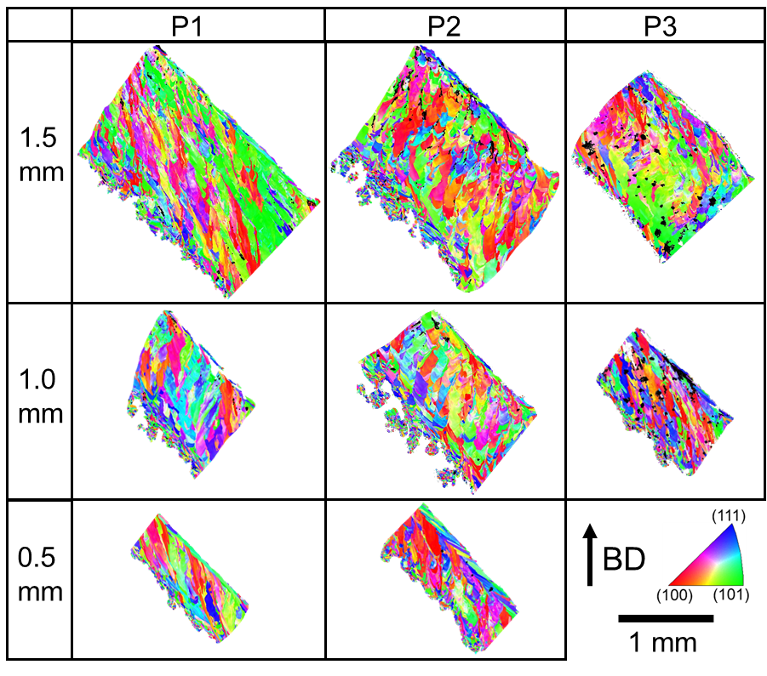
Figure 5. Build direction IPF maps of the upper struts of each thickness for the nominal (P1), high LED (P2), and high LED, low power (P3) samples.
Distributions of the equivalent grain diameters and aspect ratios of the upper struts for each sample are shown in Figure 6. Surface grains were removed from these distributions, i.e., any grains with centroids less than 150 μm away from the top inclined surface of the strut or with centroids that extended past the planned strut thickness, corresponding to the roughness at the bottom inclined surface as shown in Figure 3. A limited number of grains are available for quantitative analysis, constrained by the large grains in limited areas; thus, caution is advised in observing these data as overly quantitative, particularly in the 0.5 mm samples, which include around 200 grains, compared to around 800 grains in the 1.5 mm samples.
Each parameter set, as shown in Figure 5, had impacts on grain morphologies based on different preferences of epitaxial growth regardless of strut dimensions: the grains in the nominal sample (P1) were elongated in either the vertical direction or at a slight angle, the grains in the high LED sample (P2) were scallop shaped and elongated slightly off of vertical, and the grains in the high LED, low power sample (P3) changed elongation direction more frequently. Quantification of equivalent grain diameters and aspect ratios indicates little to no variation as process parameters are varied. For instance, the average equivalent grain diameter and aspect ratio of the nominal parameter set (P1) are slightly higher than the high LED sample (P2) in the 1.5 mm samples, but the opposite is true in the 1.0 mm samples. The small number of grains, however, could impact whether or not these trends are accurate. The lack of changes in these metrics despite the obvious visual differences in microstructure are noteworthy as they illustrate the shortcomings of equivalent grain diameter/aspect ratio metrics in non-equiaxed and heterogeneous grains present in AM; this is amplified by the limited area present in thin struts and the lack of three-dimensional information.
While there does not appear to be a consistent trend in changes to equivalent grain diameters and aspect ratios between the processing parameters, when observing the measured grain aspect ratios in combination with the EBSD images in the 0.5 mm samples there appears to be an increase in aspect ratio in these thinner samples. This is likely caused by changes in heat flow promoting grain elongation along the strut direction. When melting over powder, as opposed to dense solidified metal of previous layers, heat flow is limited along the vertical direction and is primarily directed toward the bulk of the preceding layers along the strut direction. The 0.5 mm samples are proportionally more impacted by the influence of the powder and because there is less surrounding dense material to conduct heat, are more thermally restricted compared to thicker samples, with the heat most readily being conducted along the strut direction. This results in a higher preference for elongation in the strut direction and correspondingly higher grain aspect ratios in the 0.5 mm samples. Wang et al. observed a similar effect of the effect of changes in heat flow in very thin vertical struts, which resulted in a high preference for <100> growth in the vertical direction compared to <110> preferences in thicker struts [16].
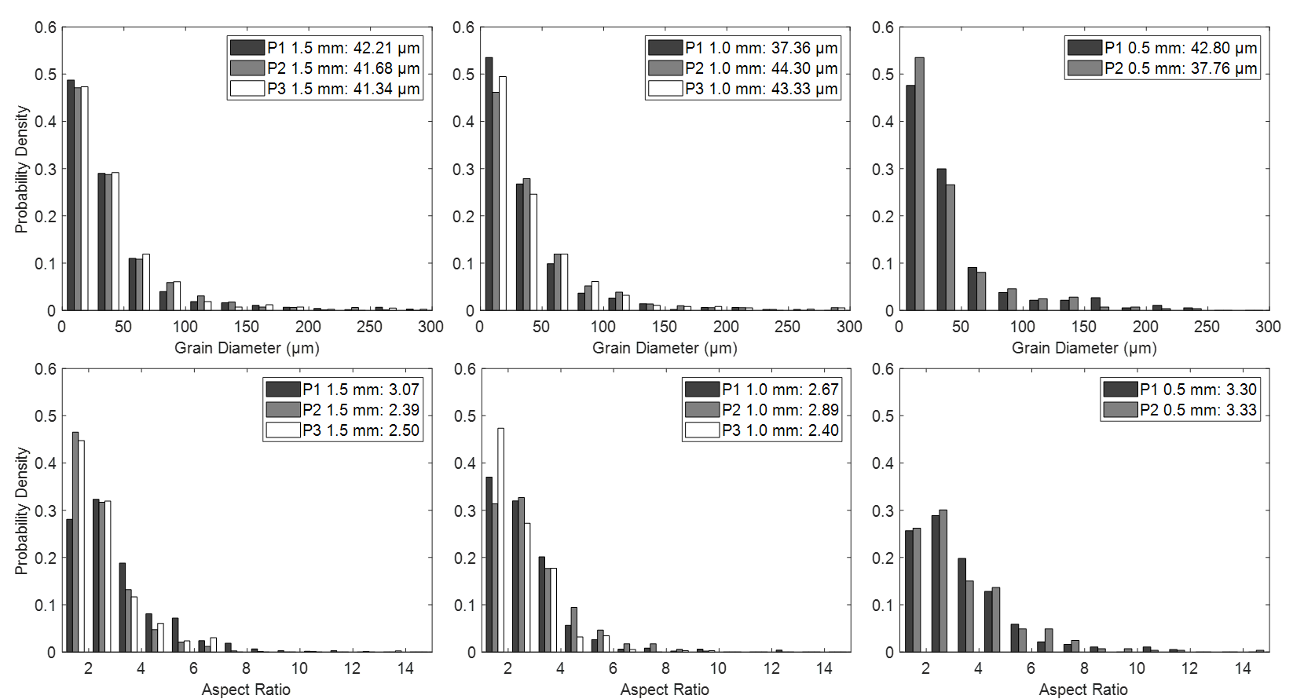
Figure 6. Equivalent grain diameter (top) and aspect ratio (bottom) distributions for the struts of each 1.5 mm (left), 1.0 mm (center), and 0.5 mm (right) sample. Averages are reported in the legend.

Dependence of Grain Morphology on Position
To further describe the effects of small part geometries on microstructure, grain size variation across a strut is investigated as shown in Figure 7 by plotting a simple moving average of equivalent grain diameter, G_{i}, versus the moving average of the distance of the grains from the bottom edge, X_{i}, with these variables given as:
$G_{i}=\frac{\sum_{i=1}^{n}{D_{i}}}{n}, X_{i}=\frac{\sum_{i=1}^{n}{d_{i}}}{n}$, Eqn. 2
where D_{i} is the equivalent diameter of each grain, d_{i} is the distance of each grain centroid from the top edge, and n is the number of grains over which the moving average is calculated, in this case 50 grains. Note that the bottom inclined surface is defined based on the designed distance from the top smooth surface (i.e. x=0 in Figure 7 is 1500 µm away from the top edge for the 1.5 mm sample). The approximate up-skin and down-skin regions are denoted as 120 µm from the top and 120 µm from the assumed bottom of the strut.
Across parameter sets and thicknesses, equivalent grain diameters were considerably lower at the bottom edge of the strut, increasing toward the center of the strut until gradually leveling out about 400 µm away from the bottom of the strut. The effective grain diameter at the center of the strut reached a maximum and was approximately constant until a slight decrease in grain diameters about 150 µm away from the top of the strut.

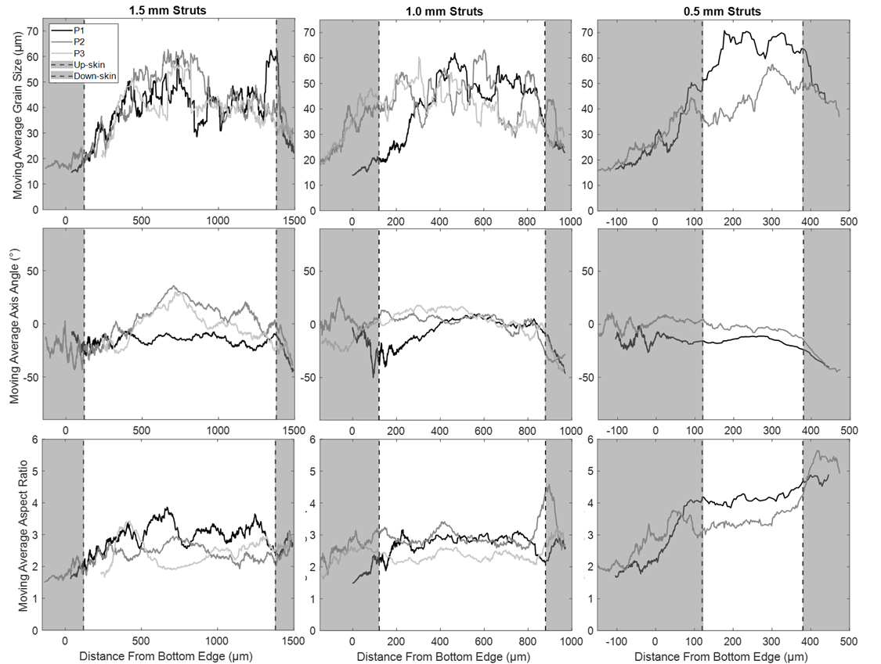
Figure 7. Moving average equivalent grain diameter (top), moving average axis angle (center), and moving average aspect ratio (bottom) for the 1.5 mm (left), 1.0 mm (center), and 0.5 mm (right) nominal (P1), high LED (P2), and high LED, low power (P3) samples. Grayed out regions correspond to areas for which up-skin and down-skin parameters were applied. Negative values correspond to grains that extended past the designed thickness such as roughness at the bottom inclined surface.
Similar to the positional grain analysis plots, simple moving averages of grain axis angles, $Ω$, and aspect ratios, Α, are plotted versus the moving average of the distance of the grains from the bottom edge in Figure 7 according to the following equations:
$Ω_{i}=\frac{\sum_{i=1}^{n}{ω_{i}}}{n}, Α_{i}=\frac{\sum_{i=1}^{n}{α_{i}}}{n}$, Eqn. 3
where ω_{i} is the angle of the major axis from the vertical direction of each grain based on an elliptical fit, α_{i} is the aspect ratio of each grain, and n is the number of grains over which the moving average is calculated, in this case 50 grains. The grains in the centers of the struts were primarily elongated along, or slightly off from, the vertical direction, but the grains at the edges of the samples were shown to elongate along the strut direction. The change in axis angle is less clear in the bottom of the strut due to the inclusion of partially sintered powder, which is composed of small equiaxed grains. As discussed in Section 3.1, the 0.5 mm samples demonstrate higher aspect ratios than the other thicknesses because heat flow is more strongly directed along the strut direction towards the node or baseplate.
While the partially sintered powder along the bottom surface of the struts is included in these figures, the change in effective grain diameters extends well beyond the areas that include any partially sintered powder. The differences in effective grain diameters and elongation occurred across larger thicknesses than the regions where up-skin and down-skin parameters were active (120 µm) suggesting additional contributing factors to grain development beyond the change in parameters, especially in the down-skin region.
At the top of the strut, the grain elongation at the edges of the strut was caused by consistently stacking the weld pools preferentially to one side. As shown in Figure 8, the application of the up-skin contour resulted in weld pools at the edge stacking optimally for grain elongation along the strut direction. There is an alignment between the crystal orientation of the unmelted portion of the preceding melt pool and the maximum thermal gradient of the new melt pool, leading to epitaxial growth along the strut direction.
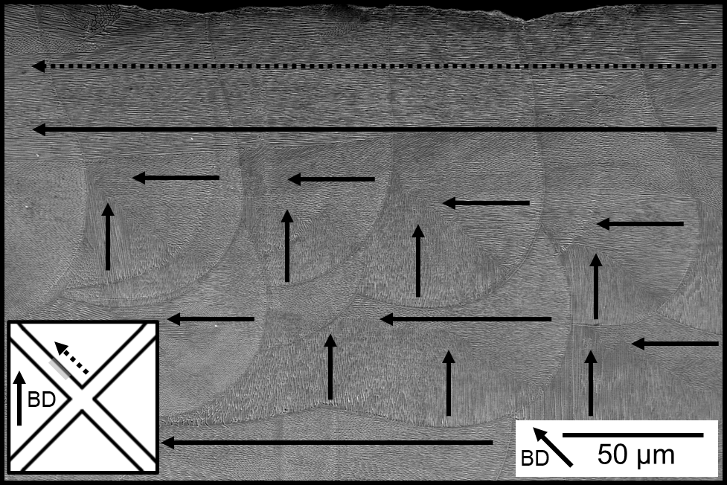
Figure 8. SEM image of top edge (schematically marked in gray) of the nominal 1.5 mm sample (P1) upper strut showing grain elongation in the strut direction (from right to left in the figure, also indicated by the dotted arrow) caused by weld pool stacking and epitaxial growth. Arrows indicate the <100> growth direction of cells. Cells growing perpendicular to one another have the same crystal orientation by symmetry.
At the bottom incline of the strut, in addition to the stacking of weld pools to one side, the structure underwent grain selection and changes in heat flow, which contributed to grain elongation along the strut direction. Without an established texture, grain selection occurred from the bottom of the struts when building over powder. Rai et al. computationally and experimentally studied grain selection in overhangs in a T-shaped IN718 sample [59]. They showed that initially, many columnar grains grow at a variety of orientations, but as the build advances the grain structure coarsens through grain selection as grains with less favorable growth directions are blocked by those with more favorable orientations. This process has been demonstrated through simulations and experiments for SS316L and other alloys with grain selection and texture development still occurring for over 1 mm into the build [59–63]. Since grain selection occurred for around 400 µm for each thickness in the present work, the 0.5 mm samples only just reached maximum grain size. This suggests that struts with lower thicknesses may not undergo sufficient grain selection before reaching a maximum grain size.
The combination of initial grain formation from the powder, changes in heat flow, and consistent stacking of weld pools resulted in a grain structure with small grains elongated along the strut direction at the bottom of the strut transitioning into coarser grains elongated along the vertical and strut directions as grain selection continued into the centers of the struts. Changes in grain morphology have been shown to occur across similar AM thin structures in vertical SS316L struts and angled struts of other materials [16,46,47,64–66]. The present study demonstrates this effect occurring across different thickness and parameter sets well past the regions where down-skin parameters were applied and illustrates the impacts of heat flow directions as geometries become exceedingly thin.

Sub-Grain Solidification Structures
Combined averages, standard deviations, and 95% confidence intervals of cell diameters for each process and sample from the first build are show in Table 4. Distributions of cell diameters taken from each parameter set of 1.5 mm samples and each thickness from the nominal (P1) parameter set are given in Figure 9. Probability densities are aggregated by equally weighting the probability density of each image. When aggregating averages and standard deviations, the cell diameters of each image were treated as subgroups and combined into a single group for each sample. Standard deviations of each subgroup (image) were combined while correcting for the deviance of each image from the main group (sample) as recommended for combining alternative sets of the same data by the Cochrane handbook [67]. No significant difference in cell diameters was detected between the node and the center of the struts for each sample.
No significant difference was observed between the higher thickness (1.5 and 1.0 mm) samples of the same processing parameters. However, the solidification cells in the 0.5 mm samples were about 30% larger than in the thicker samples. This difference is postulated to be due to a slower cooling rate resulting from the 0.5 mm struts having less surrounding dense material to extract heat and the more thermally insulative powder beneath the strut impacting a larger portion of the sample. This finding is dissimilar to the literature on the effects of microstructure on thin geometries in Ti-6Al-4V, where finer microstructural features are attributed to lower total heat input in thin parts; however, these studies were primarily conducted on larger length scales, comparing 1 and 5 mm sample thicknesses, and in primarily vertically built geometries [36,39–42]. In both cases of vertical struts and thicker samples, the effects of powder surrounding the part would be less extensive.
Table 4. Aggregated average cell diameters (n=12) and hardness (n=15) values for each thickness of the nominal (P1), high LED (P2), and high LED, low power (P3) samples as well as upper and lower bounds of the 95% confidence intervals.
 |  | Cell Diameter (μm) |  |  |  | Hardness (HV)
 |  | Average | Standard Deviation | Lower Limit | Upper Limit | Average | Standard Deviation | Lower Limit | Upper Limit
1.5 mm | P1 | 0.55 | 0.11 | 0.48 | 0.61 | 226 | 7.39 | 221 | 230
 | P2 | 0.60 | 0.13 | 0.53 | 0.66 | 227 | 10.5 | 221 | 233
 | P3 | 0.67 | 0.14 | 0.59 | 0.75 | 217 | 9.59 | 211 | 223
1.0 mm | P1 | 0.55 | 0.11 | 0.49 | 0.62 | 227 | 9.10 | 222 | 232
 | P2 | 0.57 | 0.13 | 0.50 | 0.64 | 223 | 13.9 | 215 | 230
 | P3 | 0.70 | 0.15 | 0.62 | 0.79 | 213 | 10.8 | 207 | 218
0.5 mm | P1 | 0.75 | 0.21 | 0.63 | 0.86 | 199 | 8.14 | 194 | 203
 | P2 | 0.77 | 0.22 | 0.64 | 0.89 | 208 | 8.49 | 203 | 212

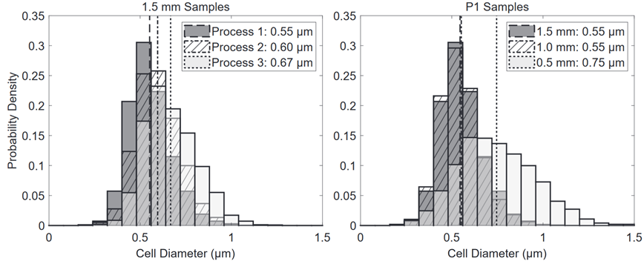
Figure 9. Aggregated cell diameter distributions for the 1.5 mm samples of each process (nominal (P1), high LED (P2), and high LED, low power (P3); left) and the nominal (P1) samples of each thickness (right). Average cell diameters are presented in the legend.

Calculation of Cell Diameters by Rosenthal Simulations
To support the experimental results, Rosenthal simulations were conducted for each of the parameter sets used in this study. Similar to Bertoli et al. [22], the temperature fields were calculated according to Eqn. 1 and used to compute the maximum thermal gradient, G, by summing the component vectors of G_{x} and G_{z}, the temperature gradients in the x and z directions, respectively. The solidification rate, R, was then calculated as [68]:
$R=v\cos\left(\tan^{-1}{\frac{G_{z}}{G_{x}}}\right),$ Eqn. 4
where v is the scanning velocity.
The cooling rate at the center of the weld pool, $\dot{T}=GR$ , of each sample was assumed to be related to the resulting cell diameter, δ, according to the following equation (with the constants of 80 and 0.33 pertaining to stainless steels) [69]:
$δ=80∙{\dot{T}}^{0.33}.$ Eqn. 5
Bertoli et al. performed Rosenthal simulations across a variety of processing parameters and observed a direct relationship between LED and solidification cell diameters [22]. Here, the cell diameter calculations were accurate in the two higher thicknesses (1.5 and 1.0 mm) for the nominal (P1, 0.57 µm) and high LED, low power (P3, 0.69 µm) samples, but the predicted cell diameters for the high LED sample (P2, 0.69 µm) were about 20% larger than the experimental measurements in Table 4. Although not measured experimentally, the up-skin (LED=0.29 J/mm) is predicted to have comparable cell diameters of 0.62 µm. The down-skin was not calculated as the thermal properties are expected to change drastically at the bottom of the strut when printing over powder. This effect is not well reflected in the simplifying assumptions for Rosenthal simulations and also explains the change in cell diameters in the thinnest struts. The relationship between high LED and large cell diameters was observed in the two higher thicknesses (1.5 and 1.0 mm) of the experimental samples here between the nominal (P1) and high LED, low power (P3) sample, but not between the nominal and high LED samples at the same power, (P1) and (P2). The disparity in the predictions versus experimental observations in the high LED sample (P2) is most likely due to the transition to the keyholing regime in these samples, which is poorly represented by the point source used in predictions.

Hardness
Hardness values taken at the nodes of each sample from the first build are shown in Table 4. Kolmogorov-Smirnov tests and an ANOVA multiple comparison test were used to confirm normality and test for significance between hardness for different process parameters and thicknesses [70–73]. The hardness data for the 1.5 and 1.0 mm samples with the same processing parameters exhibited statistically equivalent values. The high LED, low power parameter set (P3) displayed a statistically significant, albeit small, variation in hardness compared to the other parameter sets. The nominal (P1) and high LED (P2) 0.5 mm samples also displayed significant differences in hardness in comparison to the higher thickness samples of the same parameter set. The differences in hardness correlate to the difference in cell diameters observed in these samples, associated with a lower dislocation density.
Hardness data were also collected along the thicknesses of the struts for the dense parameter sets (nominal (P1) and high LED (P2)). No statistically significant difference in hardness was observed between the node and the center of the struts for each sample. When hardness overlays moving average of inverse root of the equivalent grain diameter, it follows a Hall-Petch relationship for the majority of the strut as shown in Figure 10. The 0.5 mm samples follow a similar Hall-Petch relationship across the strut but at lower hardness values, corresponding to the larger cell diameters, which correspond to a lower dislocation density. The Hall-Petch relationship is inconsistent near the bottom incline surface of the strut, related to an unknown through-thickness uneven surface beneath the hardness measurements caused by dross at the down-skin. Additionally, the grains at the bottom of the strut were affected by different factors as explained previously; the material at the bottom of the strut underwent an entirely different thermal history, included partially sintered powder, and grain selection was still occurring.
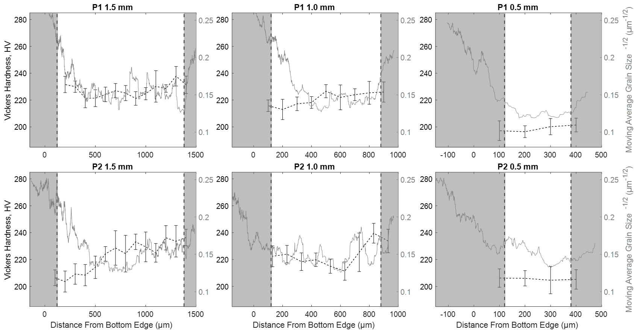
Figure 10. Hardness measurements versus position within struts overlaid with moving average of inverse root of equivalent grain diameter for the 1.5 mm (left), 1.0 mm (center), and 0.5 mm (right) nominal (P1, top) and high LED (P2, bottom) samples.

Conclusions
The present work provides insights into the impacts of processing parameters and geometry on the microstructure and hardness of SS316L thin, lattice emulating structures fabricated via PBF AM. Three sets of process parameters were applied with two having the same laser power but different LED and two having the same LED but different power (and velocity). Weld pools were shown through single bead studies to be stable and amenable to fabrication of lattice-type structures. Thicknesses were varied between 1.5, 1.0, and 0.5 mm across these three sets of parameters. The primary findings are as follows:
- Epitaxial growth was shown as the primary phenomenon impacting grain size and morphology, agreeing with observations in the literature, in struts and nodes. Variations in bulk parameter sets were shown to alter grain morphology due to the interactions of melt pool morphology and hatch spacing. Outside of the influence of surface parameters there was little difference in equivalent grain diameters between AM parameter sets or sample thicknesses despite changes in morphology. The study of these particular interactions has only just begun in the literature but will have great impacts on the understanding of AM microstructures. This is especially important in the context of thin lattice structures where the number of grains across a strut is small.
- Across each AM parameter set and strut thickness, large grains were elongated along or slightly off the vertical direction through the center of the struts due to epitaxy. Up to about 400 µm away from the bottom of the struts and 150 µm away from the top of the struts (despite surface parameters only being active for 120 µm), grains were smaller and elongated along the strut direction. In the 0.5 mm struts, changes to heat flow also resulted in increased elongation of grains throughout the strut. A larger area of the 0.5 mm struts was occupied by smaller grains along the surface, highlighting the impacts of surface versus bulk grains in small-feature size components fabricated using AM.
- Cell diameters were shown to vary between AM parameter sets, with the low power parameter set demonstrating larger cell diameters. No variations in cell diameters were present between 1.5 and 1.0 mm sample thicknesses with the same processing parameters; however, the 0.5 mm samples had larger cell diameters due to reduced available material for heat extraction.
- Hardness at the nodes remained constant between 1.5 and 1.0 mm samples with the same processing parameters but different thicknesses. Variations in processing parameters displayed only small differences in hardness, with no significant variation between the nominal (P1) and high LED (P2) sample and a less than 10% lower hardness in the low power, high LED (P3) sample. The 0.5 mm samples demonstrated lower hardness than their thicker counterparts. The lower hardness in these samples is caused by their larger cell diameters and therefore comparably low dislocation density. This could indicate that as feature sizes become exceedingly small, the strength observed in bulk AM material may no longer be present.
- In all thicknesses of the nominal (P1) and high LED (P2) samples, the hardness across the strut followed a Hall-Petch relationship with the moving average equivalent grain diameters across the strut, with the 0.5 mm samples at lower hardness than their thicker counterparts due to the lower contribution of strength from the larger solidification structures and corresponding lower dislocation density.

Acknowledgments
The authors gratefully acknowledge the financial support for this research from the Department of Defense and Los Alamos National Laboratory through subcontract 293402, work order 528821. Los Alamos National Laboratory is operated by Triad National Security, LLC, for the National Nuclear Security Administration of the U.S. Department of Energy under contract number 89233218NCA000001. The X-ray computed tomography data were collected by Lindsey Kuettner and Brian M. Patterson at Los Alamos National Laboratory.

References
[1] T. Maconachie, M. Leary, B. Lozanovski, X. Zhang, M. Qian, O. Faruque, M. Brandt, SLM lattice structures: Properties, performance, applications and challenges, Mater. Des. 183 (2019) 108137. doi:10.1016/j.matdes.2019.108137.
[2] L. Hao, D. Raymont, C. Yan, A. Hussein, P. Young, Design and additive manufacturing of cellular lattice structures, in: Innov. Dev. Virtual Phys. Prototyp. - Proc. 5th Int. Conf. Adv. Res. Rapid Prototyp., 2012: pp. 249–254. doi:10.1201/b11341-40.
[3] A.A. Zadpoor, Mechanical performance of additively manufactured meta-biomaterials, Acta Biomater. 85 (2019) 41–59. doi:10.1016/j.actbio.2018.12.038.
[4] X.Z. Zhang, M. Leary, H.P. Tang, T. Song, M. Qian, Selective electron beam manufactured Ti-6Al-4V lattice structures for orthopedic implant applications: Current status and outstanding challenges, Curr. Opin. Solid State Mater. Sci. 22 (2018) 75–99. doi:10.1016/j.cossms.2018.05.002.
[5] A. Mertens, S. Reginster, H. Paydas, Q. Contrepois, T. Dormal, O. Lemaire, J. Lecomte-Beckers, Mechanical properties of alloy Ti–6Al–4V and of stainless steel 316L processed by selective laser melting: influence of out-of-equilibrium microstructures, Powder Metall. 57 (2014) 184–189. doi:10.1179/1743290114Y.0000000092.
[6] Y.M. Wang, T. Voisin, J.T. McKeown, J. Ye, N.P. Calta, Z. Li, Z. Zeng, Y. Zhang, W. Chen, T.T. Roehling, R.T. Ott, M.K. Santala, P.J. Depond, M.J. Matthews, A. V. Hamza, T. Zhu, Additively manufactured hierarchical stainless steels with high strength and ductility, Nat. Mater. 17 (2018) 63–70. doi:10.1038/NMAT5021.
[7] K. Saeidi, X. Gao, Y. Zhong, Z.J. Shen, Hardened austenite steel with columnar sub-grain structure formed by laser melting, Mater. Sci. Eng. A. 625 (2015) 221–229. doi:10.1016/j.msea.2014.12.018.
[8] Z. Li, T. Voisin, J.T. McKeown, J. Ye, T. Braun, C. Kamath, W.E. King, Y.M. Wang, Tensile properties, strain rate sensitivity, and activation volume of additively manufactured 316L stainless steels, Int. J. Plast. 120 (2019) 395–410. doi:10.1016/j.ijplas.2019.05.009.
[9] T.R. Smith, J.D. Sugar, C. San Marchi, J.M. Schoenung, Strengthening mechanisms in directed energy deposited austenitic stainless steel, Acta Mater. 164 (2019) 728–740. doi:10.1016/j.actamat.2018.11.021.
[10] K. Saeidi, X. Gao, F. Lofaj, L. Kvetková, Z.J. Shen, Transformation of austenite to duplex austenite-ferrite assembly in annealed stainless steel 316L consolidated by laser melting, J. Alloys Compd. 633 (2015) 463–469. doi:10.1016/j.jallcom.2015.01.249.
[11] J.R. Trelewicz, G.P. Halada, O.K. Donaldson, G. Manogharan, Microstructure and Corrosion Resistance of Laser Additively Manufactured 316L Stainless Steel, Jom. 68 (2016) 850–859. doi:10.1007/s11837-016-1822-4.
[12] M. Ziętala, T. Durejko, M. Polański, I. Kunce, T. Płociński, W. Zieliński, M. Łazińska, W. Stępniowski, T. Czujko, K.J. Kurzydłowski, Z. Bojar, The microstructure, mechanical properties and corrosion resistance of 316 L stainless steel fabricated using laser engineered net shaping, Mater. Sci. Eng. A. 677 (2016) 1–10. doi:10.1016/j.msea.2016.09.028.
[13] Z. Li, B. He, Q. Guo, Strengthening and hardening mechanisms of additively manufactured stainless steels: The role of cell sizes, Scr. Mater. 177 (2020) 17–21. doi:10.1016/j.scriptamat.2019.10.005.
[14] M. Shamsujjoha, S.R. Agnew, J.M. Fitz-Gerald, W.R. Moore, T.A. Newman, High Strength and Ductility of Additively Manufactured 316L Stainless Steel Explained, Metall. Mater. Trans. A Phys. Metall. Mater. Sci. 49 (2018) 3011–3027. doi:10.1007/s11661-018-4607-2.
[15] Z. Sun, X. Tan, S.B. Tor, W.Y. Yeong, Selective laser melting of stainless steel 316L with low porosity and high build rates, Mater. Des. 104 (2016) 197–204. doi:10.1016/j.matdes.2016.05.035.
[16] X. Wang, J.A. Muñiz-Lerma, O. Sánchez-Mata, M. Attarian Shandiz, M. Brochu, Microstructure and mechanical properties of stainless steel 316L vertical struts manufactured by laser powder bed fusion process, Mater. Sci. Eng. A. 736 (2018) 27–40. doi:10.1016/j.msea.2018.08.069.
[17] S. Kou, Welding Metallurgy, John Wiley & Sons, Inc., Hoboken, NJ, USA, 2002. doi:10.1002/0471434027.
[18] W. Kurz, D.J. Fisher, Fundamentals of solidification, (2005) 305 p. file://catalog.hathitrust.org/Record/009932452.
[19] S.H. Sun, K. Hagihara, T. Nakano, Effect of scanning strategy on texture formation in Ni-25 at.%Mo alloys fabricated by selective laser melting, Mater. Des. 140 (2018) 307–316. doi:10.1016/j.matdes.2017.11.060.
[20] Z. Sun, X. Tan, S.B. Tor, C.K. Chua, Simultaneously enhanced strength and ductility for 3D-printed stainless steel 316L by selective laser melting, NPG Asia Mater. 10 (2018) 127–136. doi:10.1038/s41427-018-0018-5.
[21] M.L. Montero-Sistiaga, M. Godino-Martinez, K. Boschmans, J.-P. Kruth, J. Van Humbeeck, K. Vanmeensel, Microstructure evolution of 316L produced by HP-SLM (high power selective laser melting), Addit. Manuf. 23 (2018) 402–410. doi:10.1016/j.addma.2018.08.028.
[22] U. Scipioni Bertoli, B.E. MacDonald, J.M. Schoenung, Stability of cellular microstructure in laser powder bed fusion of 316L stainless steel, Mater. Sci. Eng. A. 739 (2019) 109–117. doi:10.1016/J.MSEA.2018.10.051.
[23] X. Wang, J.A. Muñiz-Lerma, O. Sanchez-Mata, S.E. Atabay, M. Attarian Shandiz, M. Brochu, Single-crystalline-like stainless steel 316L with different geometries fabricated by laser powder bed fusion, Prog. Addit. Manuf. 5 (2020) 41–49. doi:10.1007/s40964-020-00123-9.
[24] S.H. Sun, T. Ishimoto, K. Hagihara, Y. Tsutsumi, T. Hanawa, T. Nakano, Excellent mechanical and corrosion properties of austenitic stainless steel with a unique crystallographic lamellar microstructure via selective laser melting, Scr. Mater. 159 (2019) 89–93. doi:10.1016/j.scriptamat.2018.09.017.
[25] S. Bahl, S. Mishra, K.U. Yazar, I. Raju Kola, K. Chatterjee, S. Suwas, Non-equilibrium Microstructure, Crystallographic Texture and Morphological Texture Synergistically Result in Unusual Mechanical Properties of 3D Printed 316L Stainless Steel, Addit. Manuf. 28 (2019) 65–77. doi:10.1016/j.addma.2019.04.016.
[26] U. Scipioni Bertoli, A.J. Wolfer, M.J. Matthews, J.P.R. Delplanque, J.M. Schoenung, On the limitations of Volumetric Energy Density as a design parameter for Selective Laser Melting, Mater. Des. 113 (2017) 331–340. doi:10.1016/j.matdes.2016.10.037.
[27] J.A. Cherry, H.M. Davies, S. Mehmood, N.P. Lavery, S.G.R. Brown, J. Sienz, Investigation into the effect of process parameters on microstructural and physical properties of 316L stainless steel parts by selective laser melting, Int. J. Adv. Manuf. Technol. 76 (2015) 869–879. doi:10.1007/s00170-014-6297-2.
[28] P. Bajaj, J. Wright, I. Todd, E.A. Jägle, Predictive process parameter selection for Selective Laser Melting Manufacturing: applications to high thermal conductivity alloys, Addit. Manuf. 27 (2018) 246–258. doi:10.1016/j.addma.2018.12.003.
[29] A. Röttger, K. Geenen, M. Windmann, F. Binner, W. Theisen, Comparison of microstructure and mechanical properties of 316 L austenitic steel processed by selective laser melting with hot-isostatic pressed and cast material, Mater. Sci. Eng. A. 678 (2016) 365–376. doi:10.1016/j.msea.2016.10.012.
[30] Y. Tang, Y.F. Zhao, A survey of the design methods for additive manufacturing to improve functional performance, (2015). doi:10.1108/RPJ-01-2015-0011.
[31] J. Plocher, A. Panesar, Review on design and structural optimisation in additive manufacturing: Towards next-generation lightweight structures, Mater. Des. 183 (2019) 108164. doi:10.1016/j.matdes.2019.108164.
[32] D. Mahmoud, M. Elbestawi, Lattice Structures and Functionally Graded Materials Applications in Additive Manufacturing of Orthopedic Implants: A Review, J. Manuf. Mater. Process. 1 (2017) 13. doi:10.3390/jmmp1020013.
[33] A. Seharing, A.H. Azman, S. Abdullah, A review on integration of lightweight gradient lattice structures in additive manufacturing parts, Adv. Mech. Eng. 12 (2020) 168781402091695. doi:10.1177/1687814020916951.
[34] G. Dong, Y. Tang, Y.F. Zhao, A survey of modeling of lattice structures fabricated by additive manufacturing, J. Mech. Des. Trans. ASME. 139 (2017). doi:10.1115/1.4037305.
[35] D. Downing, M. Leary, M. McMillan, A. Alghamdi, M. Brandt, Heat transfer in lattice structures during metal additive manufacturing: numerical exploration of temperature field evolution, Rapid Prototyp. J. 26 (2020) 911–928. doi:10.1108/RPJ-11-2018-0288.
[36] Y.H. Kok, X.P. Tan, N.H. Loh, S.B. Tor, C.K. Chua, Geometry dependence of microstructure and microhardness for selective electron beam-melted Ti–6Al–4V parts, Virtual Phys. Prototyp. 11 (2016) 183–191. doi:10.1080/17452759.2016.1210483.
[37] Z. Dong, X. Zhang, W. Shi, H. Zhou, H. Lei, J. Liang, Study of Size Effect on Microstructure and Mechanical Properties of AlSi10Mg Samples Made by Selective Laser Melting, Materials (Basel). 11 (2018) 2463. doi:10.3390/ma11122463.
[38] X. Tan, Y. Kok, W.Q. Toh, Y.J. Tan, M. Descoins, D. Mangelinck, S.B. Tor, K.F. Leong, C.K. Chua, Revealing martensitic transformation and α/β interface evolution in electron beam melting three-dimensional-printed Ti-6Al-4V, Sci. Rep. 6 (2016) 1–10. doi:10.1038/srep26039.
[39] P. Wang, X. Tan, M.L.S. Nai, S.B. Tor, J. Wei, Spatial and geometrical-based characterization of microstructure and microhardness for an electron beam melted Ti-6Al-4V component, Mater. Des. 95 (2016) 287–295. doi:10.1016/j.matdes.2016.01.093.
[40] S.M.J. Razavi, B. Van Hooreweder, F. Berto, Effect of build thickness and geometry on quasi-static and fatigue behavior of Ti-6Al-4V produced by Electron Beam Melting, Addit. Manuf. 36 (2020) 101426. doi:10.1016/j.addma.2020.101426.
[41] W. Toh, P. Wang, X. Tan, M. Nai, E. Liu, S. Tor, Microstructure and Wear Properties of Electron Beam Melted Ti-6Al-4V Parts: A Comparison Study against As-Cast Form, Metals (Basel). 6 (2016) 284. doi:10.3390/met6110284.
[42] X. Tan, Y. Kok, Y.J. Tan, G. Vastola, Q.X. Pei, G. Zhang, Y.W. Zhang, S.B. Tor, K.F. Leong, C.K. Chua, An experimental and simulation study on build thickness dependent microstructure for electron beam melted Ti-6Al-4V, J. Alloys Compd. 646 (2015) 303–309. doi:10.1016/j.jallcom.2015.05.178.
[43] X.Y. Cheng, S.J. Li, L.E. Murr, Z.B. Zhang, Y.L. Hao, R. Yang, F. Medina, R.B. Wicker, Compression deformation behavior of Ti-6Al-4V alloy with cellular structures fabricated by electron beam melting, J. Mech. Behav. Biomed. Mater. 16 (2012) 153–162. doi:10.1016/j.jmbbm.2012.10.005.
[44] S. Piazza, B. Merrigan, D.P. Dowling, M. Celikin, The effects of geometry and laser power on the porosity and melt pool formation in additively manufactured 316L stainless steel, Int. J. Adv. Manuf. Technol. 111 (2020) 1457–1470. doi:10.1007/s00170-020-06196-8.
[45] G. Mohr, N. Scheuschner, K. Hilgenberg, In situ heat accumulation by geometrical features obstructing heat flux and by reduced inter layer times in laser powder bed fusion of AISI 316L stainless steel, in: Procedia CIRP, Elsevier B.V., 2020: pp. 155–160. doi:10.1016/j.procir.2020.09.030.
[46] A. Leicht, U. Klement, E. Hryha, Effect of build geometry on the microstructural development of 316L parts produced by additive manufacturing, Mater. Charact. (2018) 0–1. doi:10.1016/j.matchar.2018.04.040.
[47] T. Niendorf, F. Brenne, M. Schaper, Lattice structures manufactured by SLM: On the effect of geometrical dimensions on microstructure evolution during processing, Metall. Mater. Trans. B Process Metall. Mater. Process. Sci. 45 (2014) 1181–1185. doi:10.1007/s11663-014-0086-z.
[48] C. Pauzon, A. Leicht, U. Klement, P. Forêt, E. Hryha, Effect of the Process Gas and Scan Speed on the Properties and Productivity of Thin 316L Structures Produced by Laser-Powder Bed Fusion, Metall. Mater. Trans. A Phys. Metall. Mater. Sci. 51 (2020) 5339–5350. doi:10.1007/s11661-020-05923-w.
[49] Y. He, C. Montgomery, J. Beuth, B. Webler, Melt pool geometry and microstructure of Ti6Al4V with B additions processed by selective laser melting additive manufacturing, Mater. Des. 183 (2019) 108126. doi:10.1016/j.matdes.2019.108126.
[50] F. Bachmann, R. Hielscher, H. Schaeben, Grain detection from 2d and 3d EBSD data-Specification of the MTEX algorithm, Ultramicroscopy. 111 (2011) 1720–1733. doi:10.1016/j.ultramic.2011.08.002.
[51] MATLAB and Image Processing Toolbox Release 2020a, (2020).
[52] ASTM E92-17, E92-17 Standard Test Methods for Vickers Hardness and Knoop Hardness of Metallic Materials, ASTM Int. i (2009) 3128. doi:10.1520/E0092-17.2.
[53] J.M. Dowden, The mathematics of thermal modeling: An introduction to the theory of laser material processing, 2001.
[54] W.M. Steen, J. Mazumder, Laser material processing: Fourth edition, Springer London, 2010. doi:10.1007/978-1-84996-062-5.
[55] K. Mills, Recommended values of thermophysical properties for selected commercial alloys., Woodhead, Cambridge, 2001.
[56] O. Umezawa, K. Ishikawa, Electrical and thermal conductivities and magnetization of some austenitic steels, titanium and titanium alloys at cryogenic temperatures, Cryogenics (Guildf). 32 (1992) 873–880. doi:10.1016/0011-2275(92)90353-C.
[57] Design guidelines for the selection and use of stainless steel, Specialty Steel Industry of the United States, Washington D.C., 1993.
[58] J. Trapp, A.M. Rubenchik, G. Guss, M.J. Matthews, In situ absorptivity measurements of metallic powders during laser powder-bed fusion additive manufacturing, Appl. Mater. Today. 9 (2017) 341–349. doi:10.1016/j.apmt.2017.08.006.
[59] A. Rai, H. Helmer, C. Körner, Simulation of grain structure evolution during powder bed based additive manufacturing, Addit. Manuf. 13 (2017) 124–134. doi:10.1016/j.addma.2016.10.007.
[60] A. Rai, M. Markl, C. Körner, A coupled Cellular Automaton–Lattice Boltzmann model for grain structure simulation during additive manufacturing, Comput. Mater. Sci. 124 (2016) 37–48. doi:10.1016/j.commatsci.2016.07.005.
[61] O. Zinovieva, A. Zinoviev, V. Ploshikhin, Three-dimensional modeling of the microstructure evolution during metal additive manufacturing, Comput. Mater. Sci. 141 (2018) 207–220. doi:10.1016/j.commatsci.2017.09.018.
[62] O. Zinovieva, A. Zinoviev, V. Romanova, R. Balokhonov, Three-dimensional analysis of grain structure and texture of additively manufactured 316L austenitic stainless steel, Addit. Manuf. 36 (2020) 101521. doi:10.1016/j.addma.2020.101521.
[63] O. Andreau, I. Koutiri, P. Peyre, J.D. Penot, N. Saintier, E. Pessard, T. De Terris, C. Dupuy, T. Baudin, Texture control of 316L parts by modulation of the melt pool morphology in selective laser melting, J. Mater. Process. Technol. 264 (2019) 21–31. doi:10.1016/j.jmatprotec.2018.08.049.
[64] X. Wang, J.A. Muñiz-Lerma, O. Sanchez-Mata, M. Attarian Shandiz, N. Brodusch, R. Gauvin, M. Brochu, Characterization of single crystalline austenitic stainless steel thin struts processed by laser powder bed fusion, Scr. Mater. 163 (2019) 51–56. doi:10.1016/j.scriptamat.2018.12.032.
[65] A.A. Antonysamy, J. Meyer, P.B. Prangnell, Effect of build geometry on the β-grain structure and texture in additive manufacture of Ti6Al4V by selective electron beam melting, Mater. Charact. 84 (2013) 153–168. doi:10.1016/j.matchar.2013.07.012.
[66] J. Yu, D. Kim, K. Ha, J.B. Jeon, W. Lee, Strong feature size dependence of tensile properties and its microstructural origin in selectively laser melted 316L stainless steel, Mater. Lett. 275 (2020) 128161. doi:10.1016/j.matlet.2020.128161.
[67] J. Higgins, J. Thomas, J. Chandler, M. Cumpston, T. Li, M. Page, V. Welch, eds., Cochrane Handbook for Systematic Reviews of Interventions, 5th ed., Cochrane, 2019. https://handbook-5-1.cochrane.org/chapter_7/7_7_3_8_combining_groups.htm.
[68] T. DebRoy, H.L. Wei, J.S. Zuback, T. Mukherjee, J.W. Elmer, J.O. Milewski, A.M. Beese, A. Wilson-Heid, A. De, W. Zhang, Additive manufacturing of metallic components – Process, structure and properties, Prog. Mater. Sci. 92 (2018) 112–224. doi:10.1016/j.pmatsci.2017.10.001.
[69] S. Katayama, A. Matsunawa, Solidification microstructure of laser welded stainless steels, in: LIA (Laser Inst. Am., Laser Inst of America, 2015: pp. 2–10. doi:10.2351/1.5057623.
[70] G. Marsaglia, W.W. Tsang, J. Wang, Evaluating Kolmogorov’s distribution, J. Stat. Softw. 8 (2003) 1–4. doi:10.18637/jss.v008.i18.
[71] F.J. Massey, The Kolmogorov-Smirnov Test for Goodness of Fit, J. Am. Stat. Assoc. 46 (1951) 68. doi:10.2307/2280095.
[72] W. Thomas, Multiple comparison procedures, by Yosef Hochberg and Ajit C. Tamhane, Chemom. Intell. Lab. Syst. 5 (1989) 189–190. doi:10.1016/0169-7439(89)80040-1.
[73] R.M. Mickey, O.J. Dunn, V.A. Clark, Applied Statistics: Analysis of Variance and Regression, 3rd Edition, 3rd ed., Wiley, 1974.

