The Effect of Sweet and Sour Foods on Stress Level
By Macy Bosshard
November 30, 2015

ABSTRACT: In this study, the effect of sweet and sour foods on stress levels was analyzed in Penn State students through an experiment to fulfill a course requirement. Students first reported their stress level on a scale from 1-10, 10 being the highest. Then they were randomly assigned by flipping a coin to eat either a sweet or sour food. After they ate the food they recorded their stress levels again. Data was analyzed using descriptive statistics and T-tests. Both the sweet and sour foods showed no relationship (p<0.05) with stress. Some limitations included having a small sample size as well as limited time and research. The purpose of the writing is to fulfill course requirements for BBH 411W and to stand as a personal writing sample, but the findings should not be treated as generalizable research

Introduction:
Everyone experiences some stress in their lives whether it is about money, school, relationships, etc. and everyone copes with stress differently. Often, people turn to food as a coping mechanism against stress. In fact, one study found that 71% of people report increasing their food intake under stress.¹ A different experimental study found that individuals under high stress were more likely to eat energy dense, sweet, and high fat foods compared to those who were not as stressed.² Another study also supported the fact that individuals with higher cortisol levels had a higher level of caloric intake and ate sweeter foods than those with lower cortisol levels.³ The need for comfort food is due to the action of glucocorticoids, steroids released during stress, that increase abdominal fat depots and the need for pleasurable activity.⁴ In an experimental study with rats, once the adrenal glands and glucocorticoids were removed, the rats no longer ate the high fat and sweet foods. ⁴
In this experiment, levels of stress, the outcome variable, were measured on college students before and after a sweet or sour candy treatment, the predictor variable. Based off the research, I hypothesize that the sweet candy treatment will significantly decrease stress levels more than the sour candy treatment

Methods:
To test the effect of food on stress, a not anonymous simple randomized experimental design was conducted as a mandatory participation in a college class. Before participating, a consent message was given to the students stating, “in this experiment, you will either eat a Starburst or a Sourpatch.” Once the students consented, they rated their stress level on a scale from 1-10, 1 having no stress and 10 being the most stressed. This baseline measurement served as the control of this experiment. Then, they flipped a coin to see what treatment they would get. Heads represented a Sourpatch and tails represented a Starburst. After the students had eaten either the Starburst or the Sourpatch, they rated their stress level again on a scale from 1-10, 1 having no stress and 10 being the most stressed. The whole process didn’t take any longer than 5 minutes. Since one variable is quantitative and the other is categorical with 2 categories, two T- tests were conducted to compare means and p-values between the baseline stress levels and the stress levels after the two different treatments. For the analysis, the treatment for Starburst was recoded into 0 and the treatment for Sourpatch was recoded into 1.

Results:
Of the 51 respondents, 41% were treated with a Starburst and 59% were treated with a Sourpatch. The first T-test that included the baseline measurements showed no significance (p< 0.05) with a mean baseline stress level for those who had a Starburst of 5.00 +/- 1.761 and a mean baseline stress level for those who had a sourpatch of 4.70 +/- 1.664 (t=612, p value=.982, df= 49). The second T-test for stress levels after the treatment also showed no significance (p< 0.05) with a mean stress level after the Starburst of 4.24 +/- 1.700 and a mean stress level after the Sourpatch of 4.23 +/- 1.775 (p-value= .729, t= .010, df= 49). The data can be seen in figure 1 below.

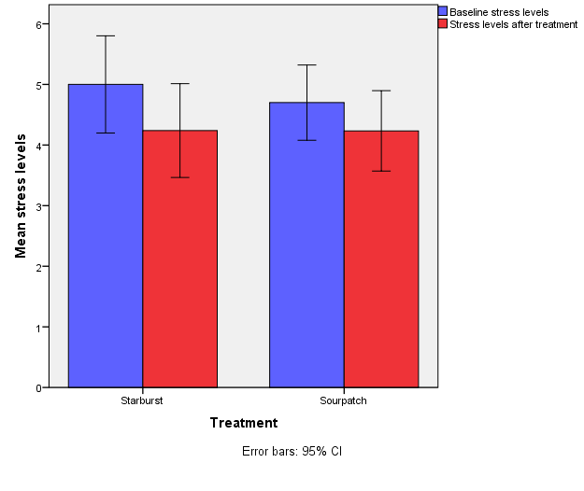
Figure 1. The first T-test that included the baseline measurements showed no significance with a mean baseline stress level for those who had a Starburst of 5.00 +/- 1.761 and a mean baseline stress level for those who had a Sourpatch of 4.70 +/- 1.664 (t=612, p value=.982, df= 49). The second T-test for stress levels after the treatment also showed no significance with a mean stress level after the Starburst of 4.24 +/- 1.700 and a mean stress level after the Sourpatch of 4.23 +/- 1.775 (p-value= .729, t= .010, df= 49).

Discussion:
The results of this experiment did not match my hypothesis that those treated with a Starburst will have a significantly greater decrease in stress than those who were treated with a Sourpatch. This could be due to a small sample size of only 51 participants. Also, participants had to self-report their stress levels before and after treatment making them feel pressured into altering their stress level after the treatment. According to the Stress Management Society, sugars actually increase epinephrine in the body, which is a significant part of the body’s stress response.⁵ Dr. Mercola notes that sugary starchy foods are actually the worst foods for somebody to eat when they are stressed because it can contribute to mood swings by helping the body resist insulin and leptin and suppressing the activity of BDNF.⁶ Leafy green vegetables, fermented foods, blueberries, and pistachios are some of the most stress reducing foods.⁶ The limitations of this experiment included a small sample size, a small budget resulting in small samples of the treatments, and lack of resources to take biological measurements of stress such as cortisol. Overall the results of this experiment did not support my hypothesis, but with further research it seems more evident to me that even though people may tend to crave sweet and high fat foods when stressed, sweet foods are not the best way to reduce one’s stress level.

References:
1. Zellner, Debra A., Susan Loaiza, Zuleyma Gonzalez, Jaclyn Pita, Janira Morales, Deanna Pecora, and Amanda Wolf. "Food Selection Changes under Stress." Physiology & Behavior 87.4 (2006): 789-93. Web. 16 Oct. 2015. <http://www.sciencedirect.com/science/article/pii/S0031938406000424>.

2. Oliver, Georgina, Jane Wardle, and E. Leigh Gibson. "Stress and Food Choice: A Laboratory Study." Psychosomatic Medicine 62.1 (2015): 853-65. Web. 16 Oct. 2015. <http://journals.lww.com/psychosomaticmedicine/Abstract/2000/11000/Stress_and_Food_Choice__A_Laboratory_Study.16.aspx>.

3. Epel, Elissa, Rachel Lapidus, Bruce Mcewen, and Kelly Brownell. "Stress May Add Bite to Appetite in Women: A Laboratory Study of Stress-induced Cortisol and Eating Behavior." Psychoneuroendocrinology 26.1 (2001): 37-49. Web. 16 Oct. 2015. <http://www.sciencedirect.com/science/article/pii/S0306453000000354>.

4. Dallman, M. F., N. Pecoraro, S. F. Akana, S. E. La Fleur, F. Gomez, H. Houshyar, M. E. Bell, S. Bhatnagar, K. D. Laugero, and S. Manalo. "Chronic Stress and Obesity: A New View of "comfort Food"" Proceedings of the National Academy of Sciences 100.20 (2003): 11696-1701. Web. 16 Oct. 2015. <http://www.ncbi.nlm.nih.gov/pmc/articles/PMC208820/>.

5. "Diet And Nutrition Stress Effects." Diet And Nutrition Stress Effects. The Stress Management Society. Web. 16 Oct. 2015. <http://www.stress.org.uk/Diet-and-nutrition.aspx>.

6. Mercola. "10 Superfoods That Reduce Stress." Mercola.com. 27 Apr. 2015. Web. 16 Oct. 2015. <http://articles.mercola.com/sites/articles/archive/2015/04/27/10-stress-relieving-superfoods.aspx>.

